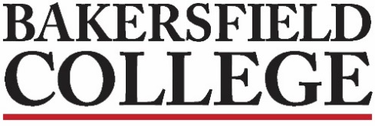
President’s Cabinet
Agenda
November 28, 2022
CCEast 2nd Floor Room 231

Zav Dadabhoy  Debi Anderson  Jennifer Achan  Reggie Bolton  Amalia Calderon  Tony Cordova  Todd Coston  Rebecca Farley  Nicky Damania | Carla Gard  Mike Giacomini  Joe Grubbs  Dan Hall  Craig Hayward  Christie Howell  Jennifer Jett  Sooyeon Kim  Ronnie Knabe | Lora Larkin  Marisa Marquez  Rich McCrow  Brett Redd  Billie Jo Rice  Derek Robinson  Brian Rodriguez  Marcos Rodriguez  Norma Rojas-Mora | Cheryl Scott  Monika Scott Imelda Simos-Valdez  Michelle Smith  Ashlea Wagner Ward  Stephen Waller  Steven Watkin  Mindy Wilmot  Jessica Wojtysiak  Visitor:

 | Agenda Topics:
A. | President’s Report  - Chancellor’s Winter Retreat  - We will be meeting today for only 30 minutes to allow for the Budget Open Forum from 3:00-5:00 | Dadabhoy
B. | Google Space Cap | Redd
C. | BC Academic Calendar | Strobel
D. | Update on Info from your areas for all to be aware of | Misc
E. | Dates to Note:  Various Dates: Financial Aid Workshops  November 28: Budget Open Forum, 3:00-5:00PM, CC231  November 29: AIDS Awareness Symposium and Luncheon, 11:30AM-1:30PM, Renegade Ballroom East, RSVP requested  December 1: Season of Light at the Planetarium, 7:30-9:00PM, advance purchase of tickets from Vallitix online  December 1: Phlebotomy Info Session, 6:00PM, Zoom with registration required  December 1: “Family Guy” Writer Ken Goin, 6:30-9:00PM, Levan Center  Renegade Sport teams competing this week: Men’s and Women’s Basketball, Women’s Volleyball, Wrestling
 | Next meeting: February 27, 2023 in CC-231

Please submit any agenda items by 5:00PM on the Thursday before our monthly meetings.

