KCCD District Consultation Council
Tuesday, January 25, 2022
https://committees.kccd.edu/committee/district-consultation-council
Notes from the KCCD Management Association

Access to Agenda:
- Link to agenda

Approval of Minutes:
- Approval of DCC meeting minutes from November 23, 2021

Chancellor’s Update:
- Chancellor’s Report to Consultation Council
  - Chancellor’s Goals
    - Advance Student Success and Equity: SCFF metrics
    - Resource Development: Grants, philanthropy and other resources to support the colleges
    - Develop Inter-District Collaboration and Cooperation: Improve efficiencies and effectiveness by integrating work across the district. Examples: Shared programs, joint appointment of administrative positions, faculty leadership positions.
    - Develop Technology Infrastructure to Support Colleges: Modernize processes for recruitment and retention of students. Examples: Dual Enrollment, Use of data analytics in adult learner recruitment processes.
  - Board of Trustees Retreat topics included
    - Early College Enrollments
    - Adult Learner Recruitment
    - Supplemental Allocation Review
    - Facilities Space Utilization and Planning
    - College and Foundation Resource Development

- 2022-23 Administrative Unit Review (AUR) Position Planning

Educational Services Updates:
- Dual and Concurrent Enrollment Transition Team Presentation (Cerro Coso Team)
  - Dual and Concurrent Enrollment Transition Team Presentation_ Cerro Coso Community College
  - Gradual increase over the last several years on Dual Enrollment metrics (slight decrease last year due to COVID)
  - D.E. retention rate of 98%, and success rate of 92%
  - Working with four districts (13 high schools) and 17 other high schools not currently implementing dual enrollment (typically smaller, and primarily online)
  - Programs in:
    - Liberal Studies AA degree
    - Medical Assisting certificate
    - Business certificate
  - Making a specific emphasis on recruiting and retaining African American students

- AB927 CCC Statewide Baccalaureate Degree Program (Coston & Rozell)
  - AB927 CCC Statewide Baccalaureate Degree Program Presentation
  - 2014- BC applied for a baccalaureate pilot program in Industrial Automation, since permanentized
  - AB927 passed on October 6, 2021
  - BC applied for a second baccalaureate degree in Research Laboratory Technology
  - Porterville and Cerro Coso may also apply for a baccalaureate program in future cycles. The District will select and submit one of those applications to the CCCCO for consideration. Proposals are due by May (for August 15 deadline), and October (for January 15 deadline). No sunset date yet.
  - Chancellor’s message: Our baccalaureate attainment rates in Kern County are very low. We have the Chancellor’s support to expand our baccalaureate degree offerings.

- Strategic Plan Addendum (Coston)
  - KCCD Strategic Plan Update Presentation
  - Sunsets on June 30, 2022
  - We will create an addendum to the existing plan rather than completely revamping the plan
  - Will strive to complete addendum by the end of April
  - KCCD Strategic Goals:
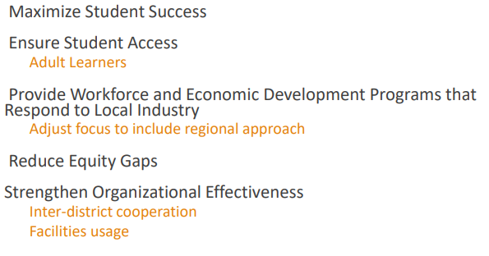

Business Services Updates:
- Budget Update (Harmon)
  - The Districtwide Budget Committee will review the Internal Allocation Model, as well as the Governor’s budget.

Business Services Updates (continued):

- 2022 CCCCO Joint Analysis of Governor’s Budget Update (Harmon)
  - COLA is set at 5.33%
  - Community Colleges funded at the same relative rate as the UCs and CSUs
  - Several one-time funds available
  - The Districtwide Budget Committee will thoroughly review and report on the Governor’s Budget in anticipation for significant funding opportunities for next year to support many KCCD initiatives and priorities (DEI, adult learning, etc…)
  - KCCD needs to position ourselves to compete for these statewide funds

- Board Policy Chapter 6, Business and Fiscal Affairs – Second Reading/Update (Harmon)

Human Resources Updates:
- Board Policy Chapter 6, Human Resources – First Reading (Rhoades)
  - Feedback due by February 8th

General Counsel Updates:
- No report

Operations Updates:
- None

Constituency Updates:
- None

Next Meeting:
- Tuesday, February 22, 2022

