VP Report
Academic Senate

WebAIM-Accessibility

Accessibility Capability Maturity Model (ACMM)
    - The California Community Colleges Accessibility Center is proud to introduce the Accessibility Capability Maturity Model (ACMM), which takes the broad concept of accessibility and breaks it down into achievable goals and milestones so colleges and districts can drive accessibility forward. The ACMM mitigates risk through iterative improvement and proactively addresses Office of Civil Rights (OCR) settlement requirements in a manageable timeline based on-campus resources. The ACMM also aligns with Diversity, Equity, Inclusion, and Accessibility efforts outlined in the CCC Vision for Success.

ACMM Focus Areas
    - 10 goals and associated milestones which integrate accessibility into existing business processes in the following focus areas:
      - Governance
      - Business Processes
        - Procurement of Information and Communication Technology
        - Websites and Applications
        - Digital Content (Instructional Materials, Student & Employee Services)
        - Collaborative Efforts
      - Training and Professional Development
      - Culture and Communication

ACCM Visit
    - ACMM will be coming to our district on 9/28 & 9/29
    - Bakersfield College ADA & Accessibility Task Force members will be present.
    - Members of the District Accessibility Task Force will also be present.

ACMM and the 10+1
    - #6-District and college governance structures, as related to faculty roles.
      - Why? Areas of focus include governance. Also, during the meeting, Rob Carr stated “If a public entity has 50 or more employees, then it does need to have an ADA Coordinator.” This is a position that we do not currently have, but has been something recommended to us by the 2018 Gier Dietrich Report and by the District-Wide Accessibility Task Force
    - #8-Policies for faculty professional development activities.
      - They will be looking to integrate Accessibility into current Professional Development Activities.

Other Areas of Potential Senate Interest
    - When the ACMM goes to campuses they utilize a rubric, which is provided prior to their arrival.

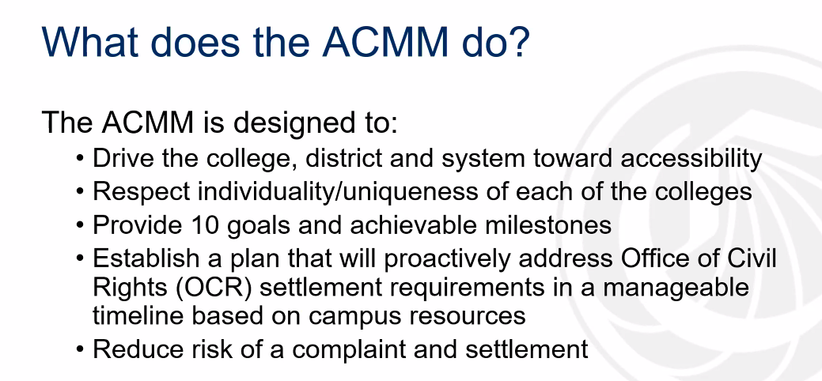

Bots in Classes Roster
  - It has been reported that bots have been found in classes.
  - Information Technology is working on the issue.
  - Please contact Jennifer Achan in Admission & Records and Financial Aid with suspected bot enrollment, prior to removing them from your course.

Canvas Senator Orientation
  - Creating an Academic Senator Orientation
    - Initial Modules will focus on:
      - Academic Senate Constitution & Bylaws
      - Robert’s Rules of Order
      - The Brown Act

