**Porterville College Mission Statement**:

With students as our focus, Porterville College provides our local and diverse communities quality education that promotes intellectual curiosity, personal growth, and lifelong learning, while preparing students for career and academic success.

In support of our values and philosophy, Porterville College will:

1. Provide quality academic programs to all students who are capable of benefiting from community college instruction.
2. Provide comprehensive support services to help students achieve their personal, career and academic potential.
3. Prepare students for transfer and success at four-year institutions.
4. Provide courses and training to prepare students for employment or to enhance skills within their current careers.
5. Provide developmental education to students who need to enhance their knowledge and understanding of basic skills.
6. Recognize student achievement through awarding degrees, certificates, grants, and scholarships.

**Guided Pathways Framework**:

1. Clarify the Path: Create clear curricular pathways to employment and further education.
2. Enter the Path: Help students choose and enter their pathway.
3. Stay on the Path: Help students stay on their path.
4. Ensure Learning: Ensure that learning is happening with clear outcomes.

**Program Mission Statement**:

The Student Equity and Achievement (SEA) Program, established in Education Code (EC) 78222, consolidates the Basic Skills Initiative (BSI), Student Equity (SE) and the Student Success and Support Program (SSSP) with the intent of supporting Guided Pathways and the system wide goal to eliminate achievement gaps.

The Student Equity & Achievement (SEA) Program at Porterville College ensures a smooth and equitable transition to college and continued support for all students throughout their educational journey. The college understands that many underrepresented students face disproportionate barriers to academic success and we are dedicated to removing those barriers. Porterville College identifies and provides services/resources to address gaps in student achievement and foster academic excellence. Staff will assist students beginning with entry to the college through the completion of your academic program.

**Current Service Area Outcomes (SAOs)**:

|  |  |  |
| --- | --- | --- |
| **BSI** SAO Statement | Describe assessment results and discussion of this SAO | Describe how the results impact your goals and needs going forward |
| 1. Students will complete transfer-level coursework in English and math within a one-year timeframe and for-credit ESL students will complete transfer-level coursework in English within a three-year timeframe. | This is a new SAO and will be assessed over the next three-year review period. It will be assessed via the Student Success Dashboard and reviewing the number of students completing transfer-level coursework and ensure the number is increasing. | The SAO has not been assessed as of now. |
| **Equity** SAO Statements | Describe assessment results and discussion of this SAO | Describe how the results impact your goals and needs going forward |
| 1. Students who have been historically underrepresented and/or underserved in higher education will report equitable access to and use of college, technology, information, resources, and support. | This is a new SAO and will be assessed over the next three-year review period. It will be assessed via student surveys and focus groups. | The SAO has not been assessed as of now. |
| 1. Underrepresented students will report finding academic counselors/advisors practices to be engaging, proactive, and culturally relevant. | This is a new SAO and will be assessed over the next three-year review period. It will be assessed via student surveys/focus group. | The SAO has not been assessed as of now. |
| **SSSP** SAO Statements | Describe assessment results and discussion of this SAO | Describe how the results impact your goals and needs going forward |
| 1. Students will indicate that they encountered academic and support services frequently in pathways, so that support is unavoidable and therefore less stigmatized. | This is a new SAO and will be assessed over the next three-year review period. It will be assessed via Navigate and Cognos data reports. | The SAO has not been assessed as of now. |
| 1. Students will explore career/college options, choose a program of study, and develop a full-program plan as soon as possible. | This is a new SAO and will be assessed over the next three-year review period. It will be assessed via Cognos and DegreeWorks data reports. | The SAO has not been assessed as of now. |

**Prior Student Equity Service Area Outcomes (SAO):**

1. *Strengthen collaboration with community partners to increase the number of students who access the college.*

Strong collaboration/communication has been established over the past three years with various partners that include the following:

Porterville, Burton and Lindsay High School District Partnerships

* + Annual Principal and Guidance Counselor Retreat
  + Counselors/Advisors assigned to high school sites
  + Workshops/Presentations provided throughout year at each site
  + PC Connection for high school seniors
  + College and Financial Aid Night for students and parents
  + Matriculation steps offered on-site at high schools: placement, orientation, counseling, and abbreviated ed plans.

Adult School Partnership

* + Monthly meetings with adult school staff
  + Monthly District Adult Education Consortium meetings
  + Counselor/Advisor assigned to site to recruit students
  + Workshops/Presentations provided all year

Additional Community Partnerships/Collaborations include:

* + Tule River Reservation
  + Tule River Education Center
  + CSET
  + Proteus
  + Tulare County Health and Human Services
  + Tulare County Office of Education
  + Employment Connection
  + See & Company
  + Stafford’s
  + City of Porterville
  + California Farmworkers Foundation
  + United Farm Workers Foundation (UFW)
  + Tulare County Public Defender’s Office

1. *Monitor and provide support efforts that increase course completion rates in all areas and for all disproportionately impacted groups of students.*

The list below provides a summary of activities in which college staff support students by providing supplies, backpacks, materials and resources needed for academic success.

* + Welcome Back Festivities
  + Veterans Welcome Orientation
  + Native American/Alaskan Native Welcome Orientation
  + Foster Youth Welcome Orientation
  + Foster Youth Welcome Orientation
  + Umoja Welcome Orientation, Umoja Workshops
  + End of Year Milestone Recognitions
  + 45+ unit completion call/email campaigns that target students near completion

The chart below displays First Time First Year Student Success rates by Ethnicity from Fall 2017-Fall 2020:

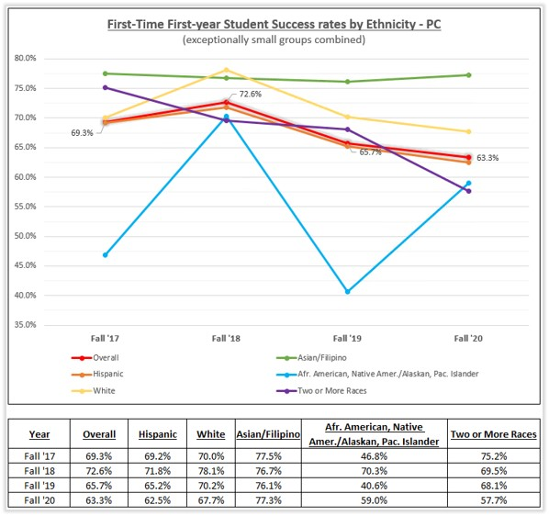

1. *Provide faculty and key personnel the support needed to develop and implement basic skills completion.*

The following professional development opportunities related to basic skills completion were provided for faculty and support staff over the past three years:

A team led by Professor Melissa Long attended the 3rd Annual CAP Conference from February 21-23rd, 2019 in Sacramento, CA. The team included Counselor Ana Ceballos, ESL Professor Bulmaro Cisneros, and Math Professor Ian Onizuka.

In Summer 2019, ESL faculty and adjuncts created an initial design for a guided self-placement model. A soft launch was planned for Spring 2020 to meet AB-705 regulations.

English Professor Melissa Long presented at the Strengthening Student Success Conference in San Francisco, CA in a session entitled, “Adapting Best Practices from Basic Skills and Beyond to the Corequisite Classroom” on October 9-11th, 2019.

English Professor Melissa Long and ESL Professor Bulmaro Cisneros attended the AB-705 Implementation Regional Convening in Fresno, CA on November 15th, 2019.

1. *Provide comprehensive student support resources and intervention strategies for entering freshman.*

To mitigate the confusion among many entering freshmen, several resources and services have been developed. The following are examples of efforts to address onboarding:

PC Counselors are assigned to work with incoming freshman prior to the students first semester. Students receive a welcome freshman email and then counselors are given a freshman caseload that they are responsible for, the following areas are covered with the students:

* Communicate with students via phone, email and text
* Complete CSEP, Promote DegreeWorks
* Encourage 15 To Finish
* Identify missing matriculation components
* Encourage enrollment for TimelyCare
* Promote usage of Navigate
* Review Freshman Student Success Checklist
* Promote Programs/Resources such as EOPS, DRC, CalWORKs, CARE, etc.
* Refer to Financial Aid to follow up on financial aid status and ensure support documents have been completed

Also, early outreach/onboarding is provided at all local high schools. Counselors/Advisors/Staff visit the high schools monthly. The following services are available at the high school sites:

* Career and Major Exploration Workshops
* CCCApply Admission Workshops
* Orientation Workshops
* FAFSA Workshops
* Educational Plan Session with Counselors
* Early Registration
* Counselor/Advisor Sessions

Also, the PC Promise Program serves first-time college students through their first year by offering a complete plan of support to complete a certificate, degree or transfer requirements. A counselor is assigned to work directly with Promise students to guide them through their first year and complete a comprehensive educational plan early on to help students stay on track with their educational goals.

1. *Promote Degree Completion and transfer to a four-year university.*

The following resources/services are offered to students every year to support degree completion and encourage students to take 15 units a year to complete their degree on-time.

**15 To Finish**

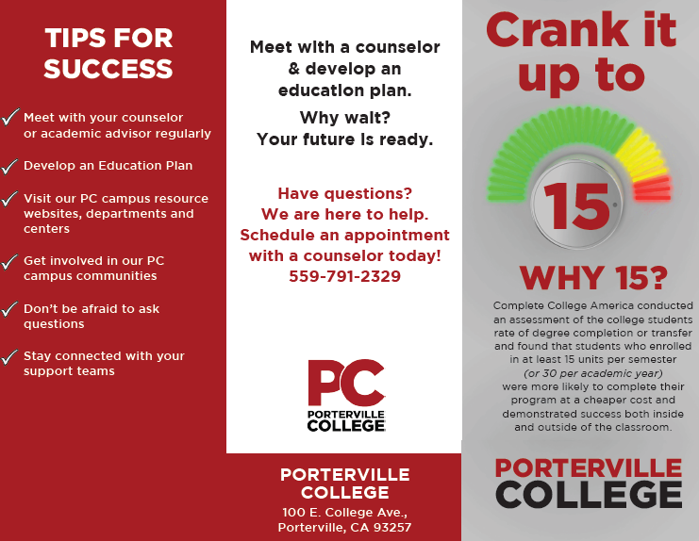

**Be Grad Ready**

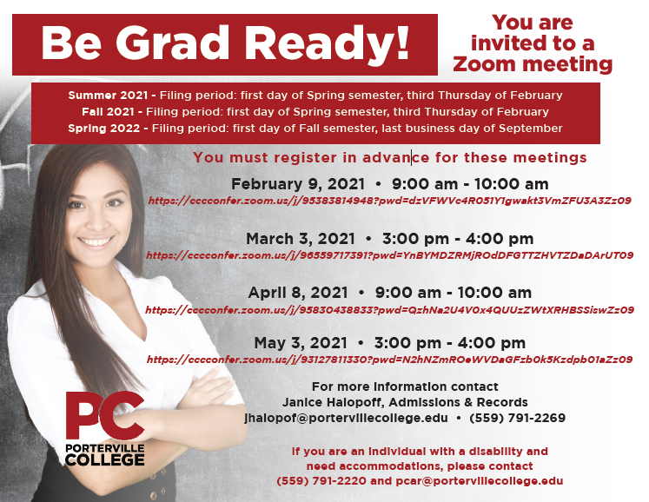

**Transfer Center**

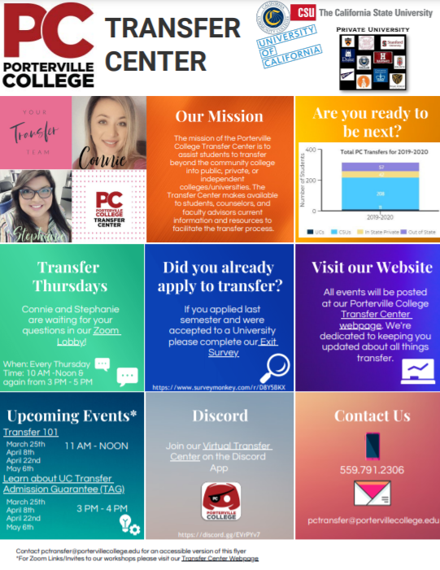

**Transfer Fair**

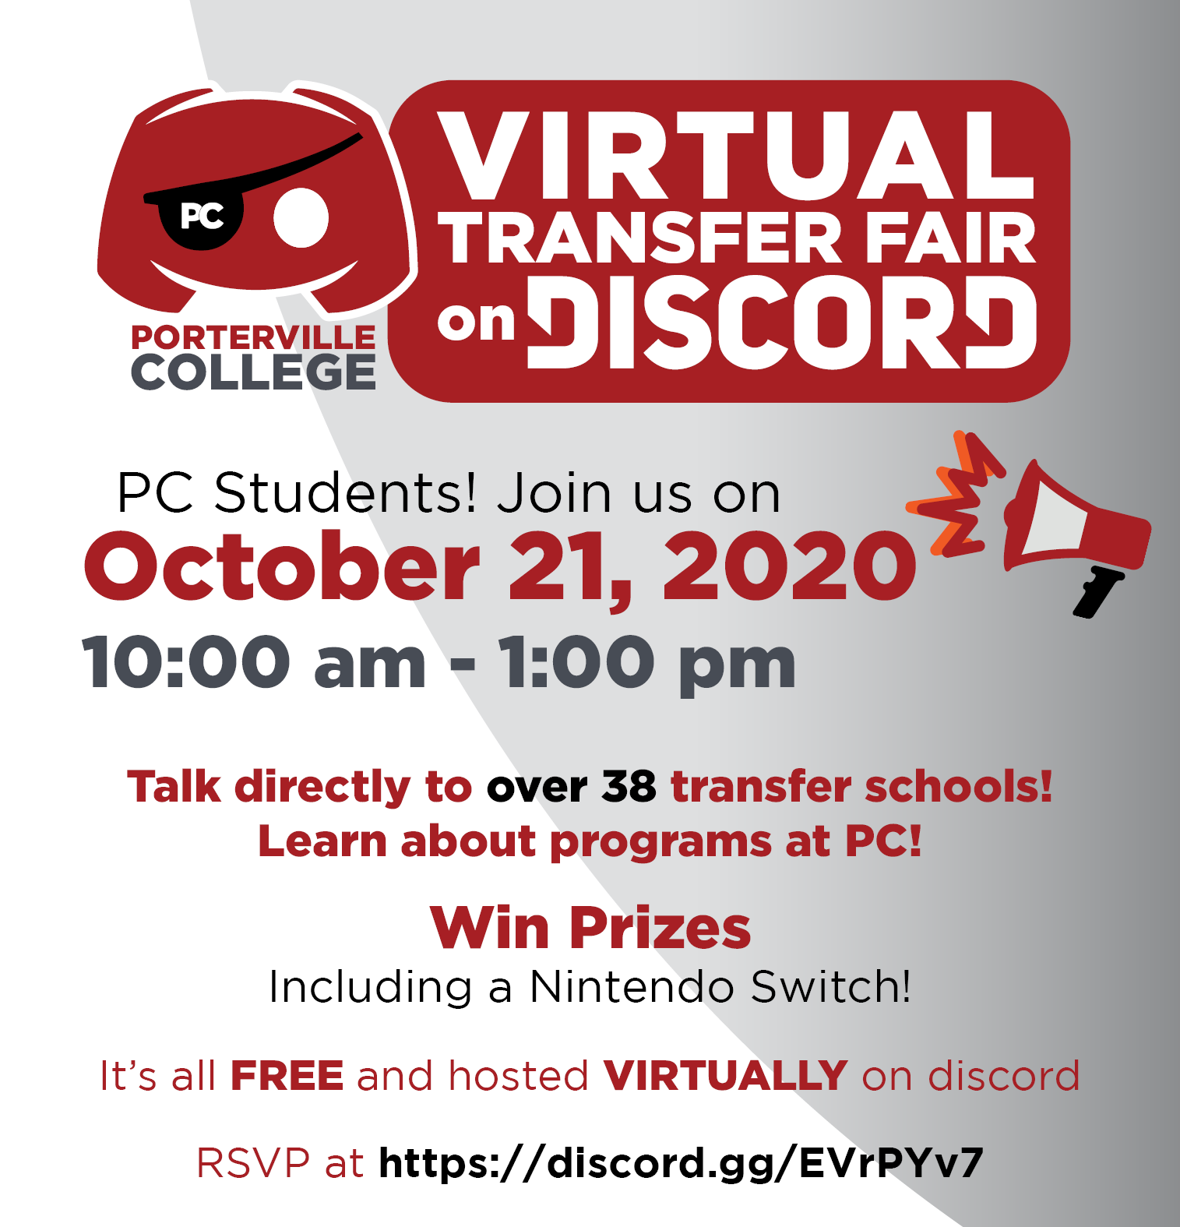

**Prior SSSP Service Area Outcomes (SAO):**

1. *The number of students completing each of the SSSP components will be monitored using Cognos and COMEVO. The objective is to have as many students as possible complete each of the components (Orientation, Assessment, Counseling (Ed. Plan) and Follow Up). The desired outcome is to have at least a 2% increase in each area above on an annual basis.*

A student survey was sent to 2,709 students during the spring 2019 semester. We received 119 responses back. Questions asked were the following:

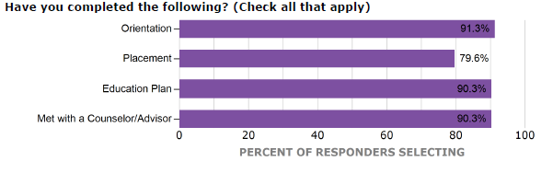

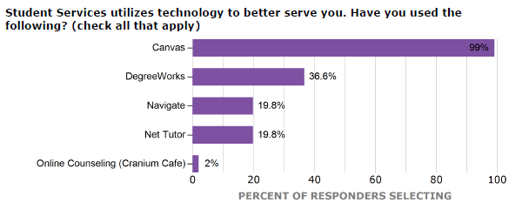

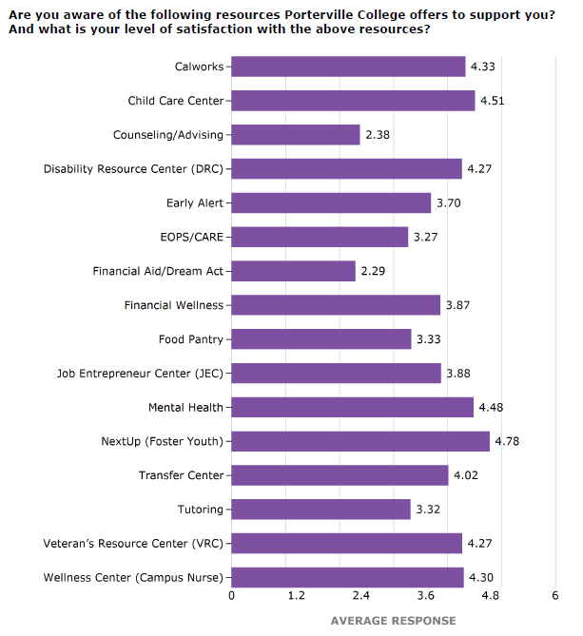

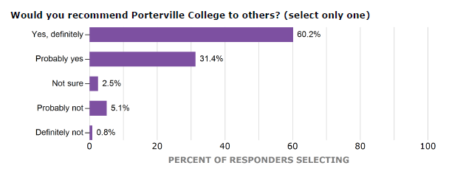

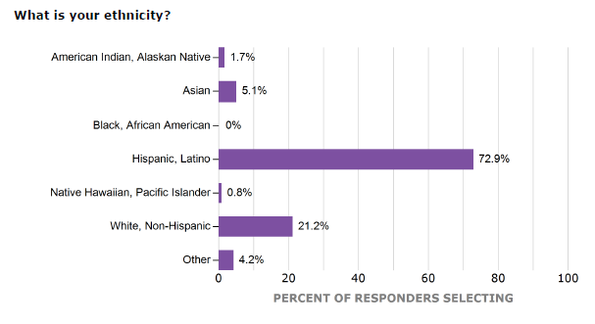

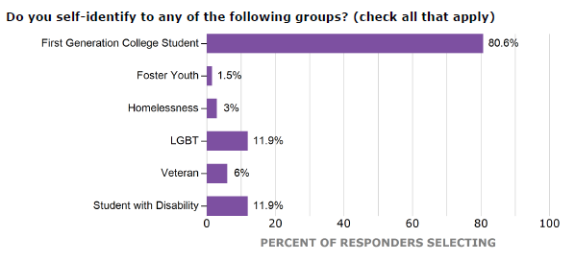

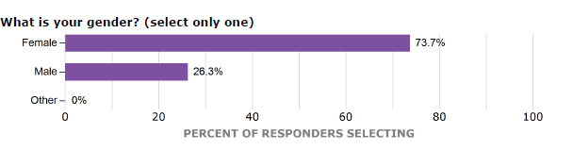

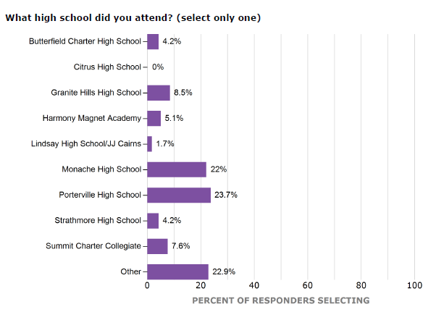

Enrollment numbers have decreased since the onset of the pandemic. The chart below shows data from the 2016-2017 to 2020-2021 school years for first time students attending PC. Assessment/Placement, Orientation, Counseling, and educational plans are all matriculation steps that incoming freshman are advised to completed. Follow Up services are recognized as wrap around services where counselors and advisors connect with students for various purposes throughout the academic year.

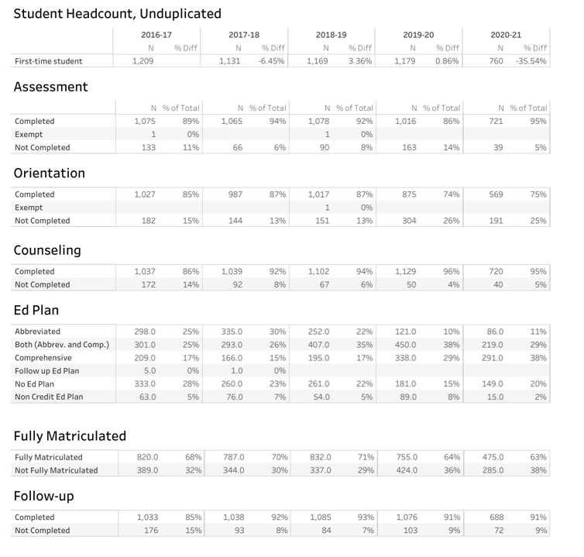

1. *As the division of students services implement new technology to better serve the student population of the college, it is also important to monitor and promote student use of technological resources available. Processes and activities will be developed to promote the use of technology by students.*

The following new/continuing technology was available for student use and promoted during the past three years:

* DegreeWorks
* Cranium Café (New)
* Zoom (New)
* TimelyCare (New)
* Navigate
* CampusCast
* Ocelot (Patches) (New)

1. *Usage of EAB Campus and Navigate platform will increase by 3% annually to assist students with the enrollment process at the college.*

Navigate Usage Data During 2019-2020 School Year

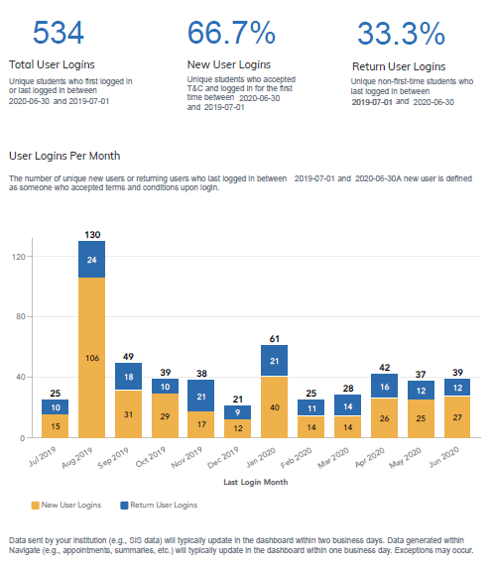

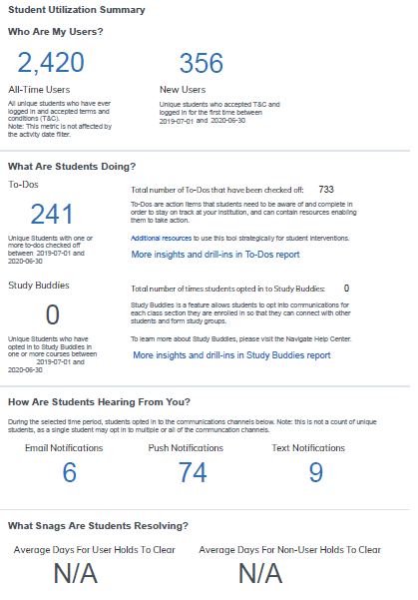

Navigate Usage Data from 2020-2021 School Year

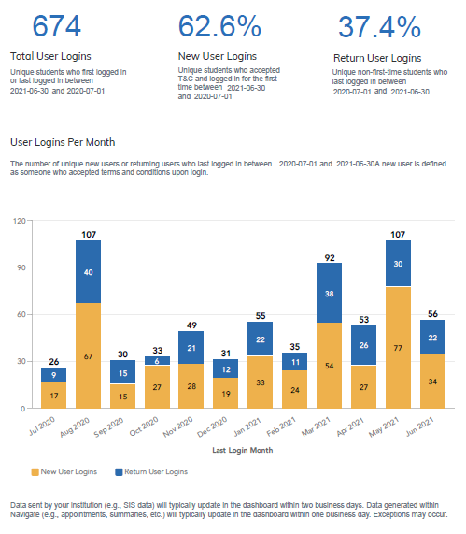

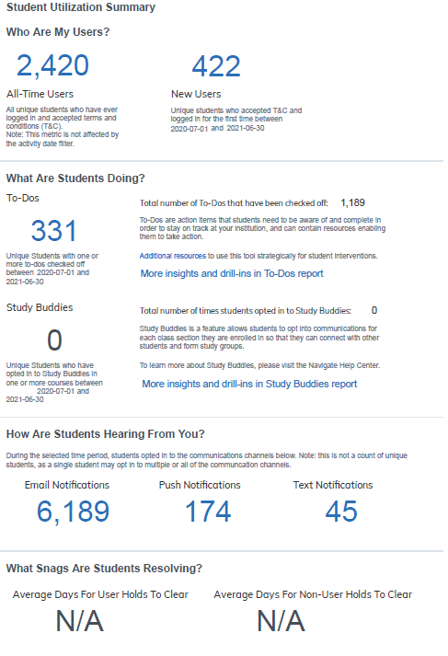

The new Navigate Student App went live during Summer 2021. Students are able to monitor to-do lists such as missing matriculation steps, view resources, see important updates regarding upcoming registration, view class schedules, etc.

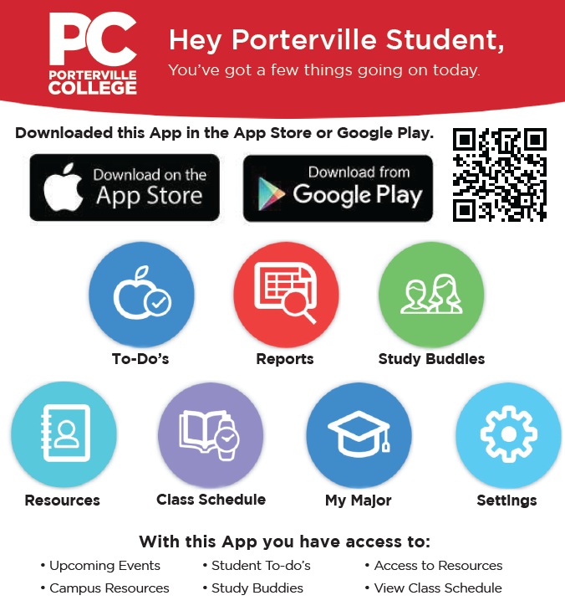

1. *Student use of DegreeWorks will increase by 2% annually. This technology provides students information about their academic progress toward completing their educational goal.*

While we hoped that the DegreeWorks system would be able to show data usage reports, we discovered that there is no way to know how many users are logging into DegreeWorks for any particular period of time. After discussion with District Office, we determined that we are only able to query how many users are logged into DegreeWorks at any moment.

Counselors/Advisors use DegreeWorks when meeting with students to show them how to use the degree planning tool and where students are with completion of their programs. We also offer DegreeWorks workshops throughout the year for students to receive one-on-one guidance using the student portal.

1. *The implementation of Cranium Cafe will allow counselors and advisers to provide services to distance learners. This will provide distance learners as well as non-traditional students access to a virtual counseling or advising environment.*

Cranium Café was used as our main online platform system to provide online services to students. To help with the transition, a series of Cranium Café sessions as well as one on one sessions were conducted by our Online Counselor. Counselors and Educational Advisors who attended the training learned to utilize the different functions of Cranium Café to conduct online sessions with students. Our Online Counselor also created a Cranium Café Training Guide to provide additional support for the staff.

Since the onset of the pandemic and working remote at the time, we began to have technology issues with Cranium Café. We slowly integrated Zoom into remote counseling/advising appointments. After discussion with the Student Services division, it was determined that we would only use Zoom. As of June 2021, we discontinued using Cranium Café and now utilize Zoom for meeting and virtual/remote appointments.

**Prior Basic Skills Initiative Outcome:**

*1. Increase the number of students that complete basic skills courses and transition into transfer-level English and Math courses.*

Due to AB-705 regulations that we are ensuring that we are maximizing the probability that a student will enter and complete transfer-level coursework in math, this SAO is no longer assessed. New SAO outcome that was created for BSI has not been assessed and the assessment method will be discussed in AB-705 Workgroup.

**Program Analysis and Trends**

***BSI***

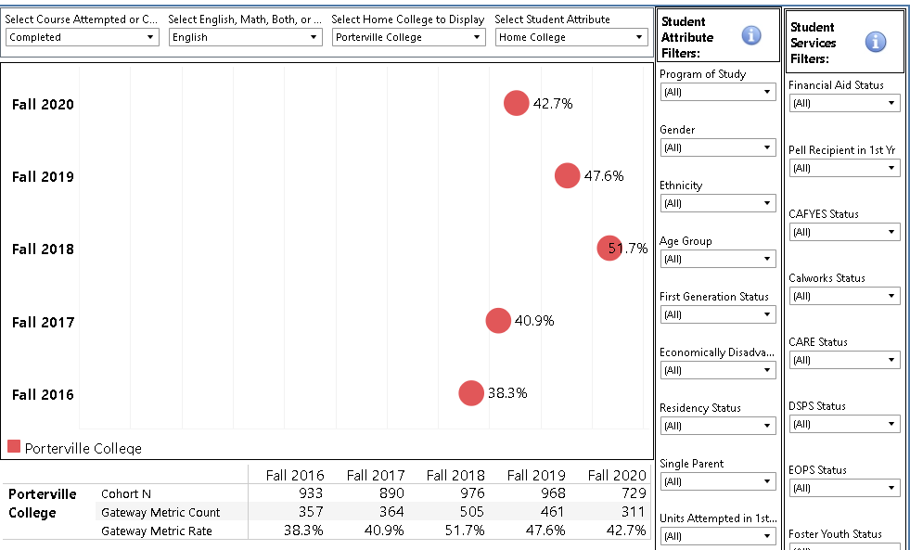

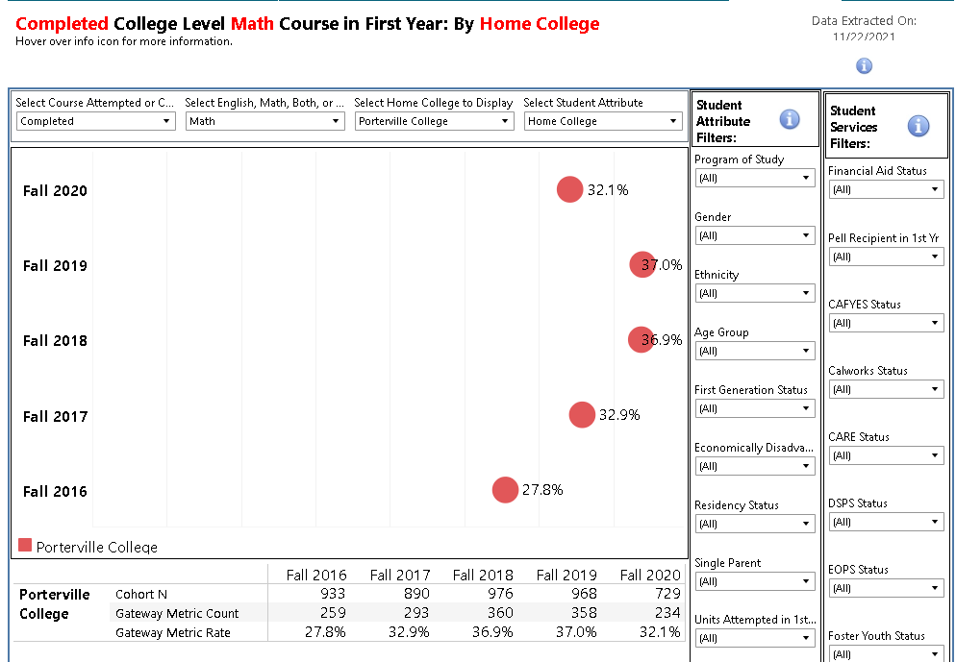

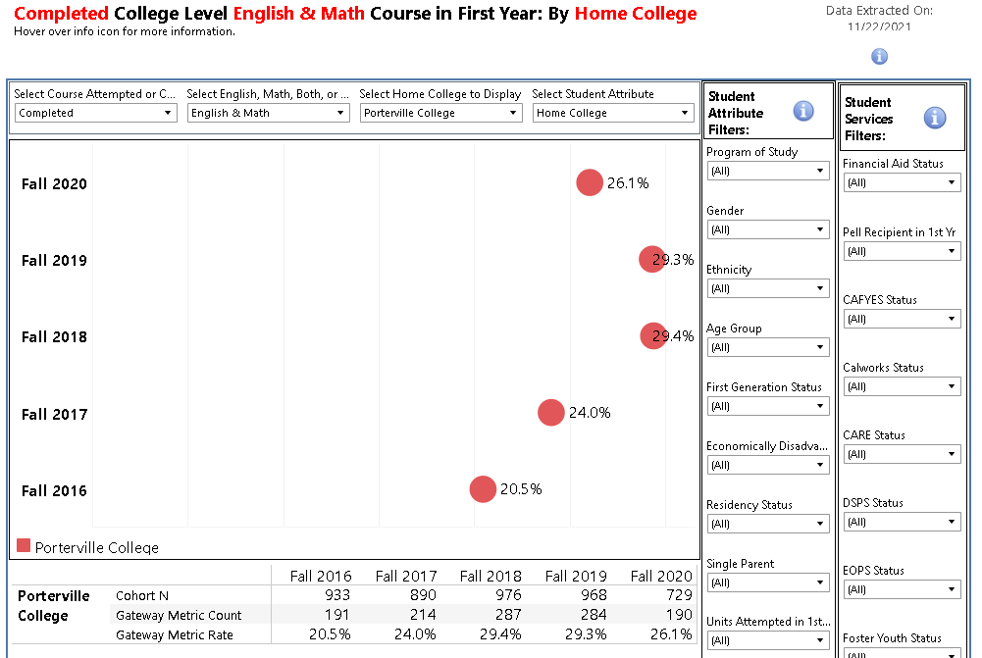

***SSSP***

Current performance trends over the past three years indicate Matriculation components such as Orientation, CSEP Completion, and Counseling & Advising contacts have fluctuated.

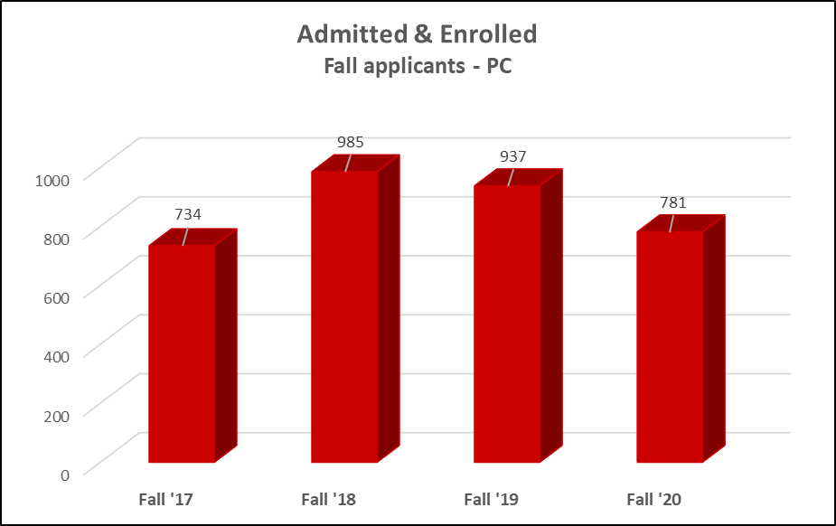

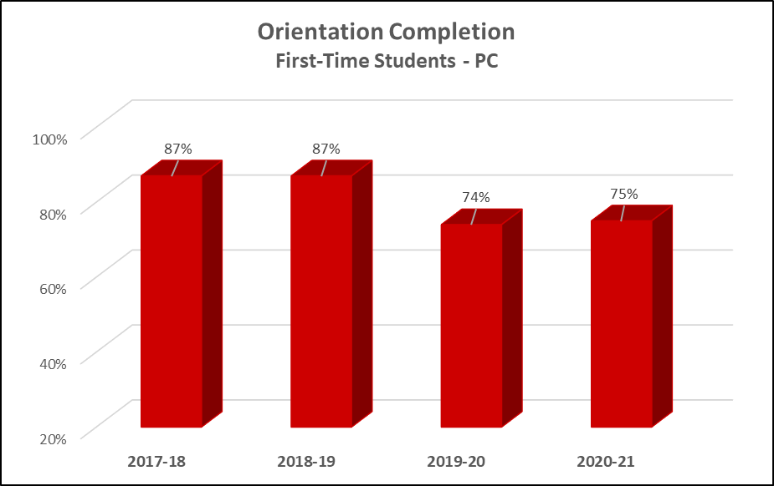

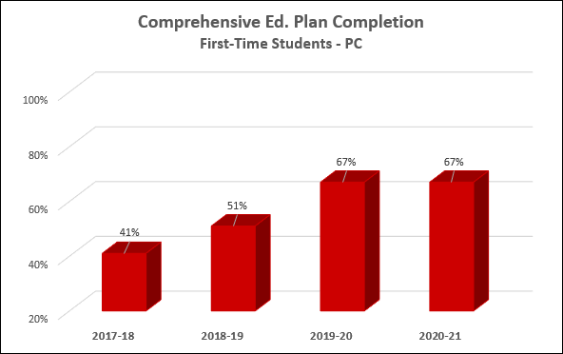

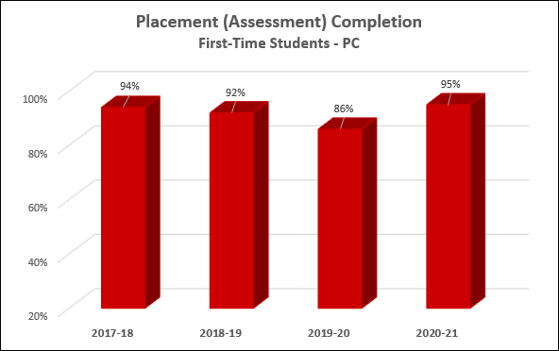

Our target student audience for the core services of the SSSP is any new incoming Porterville College student. Since new students at our college fall into two specific groups: incoming high school seniors and all other new students, different types of activities and delivery strategies are employed to meet our responsibility under title 5 section 55531 and to successfully guide students to an academic pathway.

All new students who apply to the college are encouraged to complete the orientation. The orientation is available to students online and in-person. The in-person orientation is available in English and Spanish. Students who need to take the ESL self-placement participate in the orientation for ESL students.

The orientation process begins at the point of initial interest in attending Porterville College. Marketing and advertising Porterville College to the community is important. All new students who have not taken part of an in-person orientation at their high school must successfully complete an online orientation instead.

Porterville College maintains working relationships with college counselors, students and staff with the local high schools. We currently partner with Porterville Unified School District and Burton School District to provide high school students with an orientation on their high school campus. The high school orientations are held in fall of their senior year prior to registration.

A part-time counselor and full-time program technician work closely with the high schools to schedule matriculation components in-person at all local high school sites. They reserve computer lab space on high school campuses and coordinate times for students to complete various workshops, in-person orientation and educational plans with PC counselors.

The online orientation is conducted via COMEVO, an online platform which facilitates the orientation through various modules. Similar to the in-person orientation, the online orientation includes important information that is required with Title 5, Section 55521 topics below:

* Academic expectations and progress and probation standards pursuant to section 33031.
* Maintain registration priority pursuant to section 58108.
* Prerequisite or co-requisite challenge process pursuant to section 55003.
* Maintain Board of Governors Fee Waiver eligibility pursuant to section 58621.
* Description of available programs, support services, financial aid assistance, and campus facilities, and how they can be accessed.
* Academic calendar and important timelines.
* Registration and college fees.
* Available education planning services.
* Other issues, policies, and procedures the college determines as necessary to provide a comprehensive orientation to students.

In order to complete the online orientation students are required to pass a quiz at the end of each section and at the end of the entire orientation module. This provides a way to control the retention of information so that students become familiar with the content.

All completed orientation sessions are recorded into the Banner for reporting purposes. In-person orientations are recorded in Banner by the Program Technician at Porterville College. Completed online orientations are automatically recorded into Banner within a 24-hour period via a pre-scheduled data refresh monitored by District Office personnel.

***Placement***

For SSSP, the target audience is all new students to Porterville College. Placement is required of all Porterville College students who take an English or math course, or take courses which have English, reading or math prerequisites.

We partner with Porterville Unified School District and Burton School District to review all high school seniors’ transcripts prior to completing an educational plan. This is completed in spring of their senior year. Guidance counselors from the high schools identify the high school seniors and provide transcripts that PC counselors review for placement into Banner.

Porterville College has an ESL Guided Self-Placement for grammar and writing for students in which English is their second language. It assists in determining the appropriate English as a Second Language (ESL) course a student may need.

***Counseling/Advising***

Porterville College understands the importance of counseling/advising for students to achieve their educational goals. The counseling department has employed a variety of delivery strategies to assist new and continuing students in academic, career and personal counseling.

Counseling services are available to all current and prospective students prior to registration at Porterville College. Services include: academic, career, and personal counseling. Counselors/Advisors assist students to understand educational options, identify educational and career goals, and to create individual education plans for graduation and/or transfer. They also provide guidance in helping students to identify appropriate resources to support academic success. They help students understand personal strengths, learning styles, motivation, interests and abilities. Once a student enrolls, they will have access to the full scope of counseling services throughout their time at Porterville College.

Walk-in counseling is available year-round; scheduled counseling/advising appointments are also available. Virtual/Remote student appointment are also available to students since the pandemic. Outreach to new or potential students is conducted throughout the year via outreach events and workshops.

A variety of Interdisciplinary Studies (INST) and Student Success (STSS) classes that are aimed at supporting students personal growth through academic and career related classes. Topics include: college planning, success strategies, leadership, personal and career exploration, strategies for personal and academic success, effective learning strategies and skills. Students receive guidance on how to complete student education plans and reasons for the importance of meeting with a counselor/advisor for on-time completion to complete their academic program.

The DegreeWorks online tool allows students to view their academic progress toward their goal. It also leverages the amount of information counselors are able to provide students by offering digital education plans. Degree Works interfaces with our student information system, Banner.

Students, Counselors, Faculty and Staff utilize Navigate to help students stay on track. Navigate is designed to give students a college onboarding experience with tools that will help them create an academic roadmap to graduation and a timeline to degree completion. Navigate also serves as a primary communication channel for students with their counselors and advisors.

Student Services partners and schedules days/times at the local high schools (Porterville Unified School District and Burton School District) where high school seniors can complete abbreviated educational plans with our counselors in one-on-one sessions at the high school site.

Counselors/Educational Advisors coordinate regular visits at the local high schools each month and are scheduled to meet with students to provide counseling/advising services, resources and answer questions regarding Porterville College.

To better assist distance learners and/or students who can’t make it to the campus, Counseling and Advising services are available remote by using Zoom.

***Follow Up***

Porterville College defines at-risk students enrolled in basic skills courses, students who have not identified an educational goal and course of study, and students on academic and/or progress probation. Our target student audience is students in these identified categories.

Students are notified by email at the end of each semester regarding their academic standing once grades have been entered. Depending on the student’s academic standing, the email outlines what is required to improve their academic standing. The emails outline the steps to improve academic standing: completing a student success contract, restriction of units to a maximum of 12, counselor/advisor must approve the next semester’s class schedule, completion of progress report during the 5th and 12th week of the semester, and for disqualification students (unit restriction to 7 units, enroll in education class designed to help the student achieve academic success, meet with counselor regularly and receive approval for any change to schedule).

Early Alert provides the opportunity for faculty to identify students with academic and personal difficulties. The Early Alert Program facilitates communication and encourages students to begin and continue to interact with their instructors and the Early Alert counselor throughout the semester.

BENEFITS OF EARLY ALERT:

* Facilitates communication and collaboration to assist students
* Alerts and assists students in a timely manner
* Make students aware of their progress
* Discuss and provide information regarding specific study skills based on students’ needs
* Refer students to resources/services on campus
* Inform students regarding programs, services on campus and provide important information
* Provide academic, personal, transfer and career counseling services as needed

The referral will go to the student and the Early Alert counselor/advisor. Once the student receives the referral, the student usually contacts the instructor. This is then followed by the counseling intervention when the counselor provides information and counseling services based on the student’s needs and makes sure to refer the student to other campus support services.

***Equity***

The college provides multiple programs and services to ensure that each of its students has the opportunity to succeed, regardless of their background and goals. Student Equity is integrated into all aspects of the activities and governance processes at Porterville College. Faculty and staff are committed to ensuring student equity in all educational programs and services.

The college strives to provide educational equity by creating environments and a supporting culture where every student has the opportunity to fully develop their potential. This includes structuring learning environments that promote full academic support and engagement by all students as well as providing disproportionally impacted students with additional support and opportunities they need to achieve success.

Porterville College’s Equity Plan is aligned with multiple institutional, district and the State Chancellor’s Office Student Success Goals. Equity planning is a continuing institutional effort at Porterville College to improve proportional student academic outcomes and to more carefully and formally assess and evaluate student equity planning. The College recognizes that equity planning and assessment, as well as expansion of its data collection to further examine the academic needs of an increasingly diverse student population, is critical to the achievement of student equity and the fostering of academic excellence for all our educational programs.

The Pathways to Success and Equity Committee (PSEC is charged to coordinate and communicate college-wide planning for identifying and implementing student success strategies across the campus. The focus of this committee is to focus on the California Community Colleges Student Success and Equity initiatives including Guided Pathways planning and Achieving the Dream.

The Pathways to Success and Equity Committee has worked conscientiously to collaborate with various constituent groups within the college community to ensure that the Student Equity planning process is inclusive, diverse and aligned with the college’s Strategic Plan, as well as the Chancellor’s Office Vision for Success, and department/area program reviews. Our college seeks continuous engagement of all persons at the institution and solicits courageous conversations, about improving equitable practices within an institutional culture that values the importance of student equity and understands why this work is so important.

Data provided by the KCCD Office of Institutional Research for five equity metrics revealed that specific groups are not achieving in some areas. Intervention strategies and support to achieve equitable outcomes were needed for these student populations. The Office of Institutional Research provided disaggregated data as it relates to the following metrics:

* Access: Successful Enrollment
* Retention: Fall to Spring
* Transfer to a Four-Year Institution
* Completion of Transfer Level Math and English
* Earned Credit Certificate Over 18 Unit or Associate Degree

**Target Student Equity Populations**

Based upon campus-based research, the following subgroups are the college’s primary equity target populations:

* African American/Black Students
* LGBT Students
* American Indian Students
* Students with Disabilities
* White Students
* Foster Youth Students

The subgroups mentioned above are disproportionately impacted in several metrics at Porterville College. In addition, Veterans and Asian students are disproportionately impacted within some indicators as well. Targeted support within the equity plan is prioritized by focusing on the students who are underperforming in most areas and are historically underrepresented. The college acknowledges that there are groups such as LGBT and homeless students that may be disproportionately impacted but extensive research has not been conducted.

The main goal of the student equity is to continue to expand progress made through previous plan implementation of activities intended to achieve student success for the targeted groups of students who have been identified as being disproportionately impacted. The goals of this plan have been aligned with the Strategic and Enrollment Management Plans as well as the Local Vision Goals. Furthermore, integration with the PC Promise Program has focused on ensuring that students from groups who are historically underrepresented in college are provided with additional support, thereby increasing their college access and success. Considerable focus has been dedicated to ensuring successful integration and goal achievement.

Also, the college has continued to coordinate the integrated programs with other equity-related categorical programs including: Veterans, Foster Youth, DRC, EOPS, CARE, CalWORKs, Umoja and Financial Aid. In addition, efforts also include hunger and homelessness that impact PC students.

While the ongoing pandemic has impacted the campus and our enrollment, goals and activities for each metric regarding student populations demonstrating disproportionate impact as well as for the college’s overall student population are as follows:

1. **Access: Successful Enrollment**

For the Access metric, Porterville College currently is enrolling 37.74% of applicants, with significant variation among demographic groups. Our overall goal is to increase this to 40%. For the various disproportionately impacted groups, we are setting targets that narrow the access gap by approximately half. This results in the following targets:

|  |  |  |
| --- | --- | --- |
|  | **2017-18** | **2021-22** |
| American Indian Female | 28.83% | 35% |
| American Indian Male | 24.04% | 32% |
| Asian Female | 19.23% | 30% |
| Asian Male | 6.85% | 24% |
| African American Female | 21.51% | 31% |
| African American Male | 23.40% | 32% |
| Pacific Islander Female | 10.53% | 25% |
| Unknown Female | 7.69% | 24% |
| Unknown Male | 4.07% | 22% |
| White Female | 34.08% | 37% |
| White Male | 31.70% | 36% |
| LGBT Female | 28.00% | 34% |
| LGBT Male | 13.66% | 27% |
| Veteran Female | 12.50% | 26% |

1. **Retention: Fall to Spring**

For the Retention metric, Porterville College currently retaining 69.84% of students from fall to spring. Our overall goal is to increase this to 71%. For the disproportionately impacted groups, we are setting targets that narrow the access gap by approximately half. This results in the following targets:

|  |  |  |
| --- | --- | --- |
|  | **2017-18** | **2021-22** |
| African American Female | 38.46% | 54% |
| White Female | 64.36% | 67% |
| White Male | 63.16% | 67% |

1. **Transfer to a Four-Year Institution**

Porterville College had 299 recorded transfers to four-year institutions in 2016-17. Our overall goal is to increase this to 359, or by 20%. For each of the disproportionately impacted groups, we created a target that is 20% greater than our overall target (or 24%). However, given the small numbers of most of these groups, the practical impact of this is that our actual target for many of these groups is an increase of one:

|  |  |  |
| --- | --- | --- |
|  | **2016-17** | **2021-22** |
| Females with disability | 10 | 12 |
| Males with disability | 5 | 6 |
| American Indian Male | 0 | 1 |
| Asian Male | 1 | 2 |
| First Generation Male | 56 | 69 |
| Foster Youth Female | 0 | 1 |
| Foster Youth Male | 1 | 2 |
| LGBT Male | 1 | 2 |

1. **Completion of Transfer Level Math and English**

For the completion of transfer math and English metric, Porterville College currently has a success rate of 9.93%. We believe with our recent and ongoing interventions, we can double this rate for an overall goal of 20%. For the disproportionately impacted groups, we are setting targets that narrow the access gap by approximately half. However, the groups we are targeting, all of which are small, had an actual completion rate for this metric of 0%, so this results in a goal of 10% for each.

|  |  |  |
| --- | --- | --- |
|  | **2017-18** | **2021-22** |
| Females with disability | 0% | 10% |
| Males with disability | 0% | 10% |
| Foster Youth Male | 0% | 10% |
| LGBT Female | 0% | 10% |

1. **Earned Credit Certificate Over 18 Units and Associate Degree**

Porterville College had 444 students in 2016-17 who completed the Vision Goal. Our overall goal is to increase this to 511, or by 15%. For each of the disproportionately impacted groups, we created a target that is 20% greater than our overall target (or 18%). However, given the small numbers of some of these groups, the practical impact of this is that our actual target for many of these groups is an increase of one:

|  |  |  |
| --- | --- | --- |
|  | **2017-18** | **2021-22** |
| Males with Disability | 8 | 9 |
| American Indian Male | 0 | 1 |
| African American Female | 1 | 2 |
| Two or More Races Male | 0 | 1 |
| White Male | 22 | 26 |
| Foster Youth Female | 3 | 4 |
| Foster Youth Male | 2 | 3 |
| LGBT Female | 2 | 3 |

***Changes in Programs Over the Last Three Years***

**BSI**

The BSI program has undergone a tremendous change in the last three years with the onset of full implementation of AB-705 in Fall 2019. AB-705 shifted the focus of the basic skills program from providing acceleration options for students in math and English courses to creating corequisite support courses that will enable students to enter transfer-level English and math courses. Corequisite courses would provide just in time remediation for students to gain the necessary skills to pass their transfer level English and math courses.

For the ESL program, AB-705 led to the creation of a guided self-placement model created by ESL faculty and adjuncts to ensure that students are selecting the correct level of ESL for themselves. The ESL program continues to expand to offsite locations in Terra Bella, Strathmore, Poplar, Earlimart and Richgrove with various offsite locations in Porterville, the Lutheran Church and Ola Raza.

In Spring 2021, Porterville College and the Porterville Adult School came to agreement to enable Porterville Adult School ESL program completers to be placed at the intermediate level at PC. This pathway from the Adult School to PC will help to increase the number of students that transition from the Adult School to college. With the agreement, PC will offer an intermediate EL2 course each semester at the Adult School to help with the transition process for Adult School students.

**SSSP**

The Student Success and Support Program has undergone numerous changes in the last three years. Here are some of the highlights:

**Full Implementation of Multiple Measures Placement/AB705**-The English and Math Divisions along with our division lead counselor revised the placement charts and codes that counselors use when meeting with first time students.

**My Degree Path (Degree Works)** had a major upgrade and Counselors were no longer using paper method to complete student educational plans. All counselors were trained to use My Degree Path. All counselors and advisors utilize My Degree Path when meeting with students to determine where they are in completing their program of study.

**Online/Remote Counseling/Advising-**Since the onset of the pandemic in Spring 2020, all in person services were transitioned to online services. Cranium Café was used as our main online platform system to continue providing online services to students. To help with the transition, a series of Cranium Café sessions as well as one on one sessions were conducted by our Online Counselor. Counselors and Academic Advisors who attended the training learned to utilize the different functions of Cranium Café to conduct online sessions with students. Our Online Counselor also put together a Cranium Café Training Guide to provide additional support for the staff. As of June 2021, we discontinued using Cranium Café and now utilize Zoom for virtual appointments.

**Education Careers Program-** The Education Careers Program houses students pursuing a career in education who are all majoring in a variety of majors at PC. In order to assist and support the Education Careers Program objectives in regards to increasing student graduation and transfer rates, services, activities, and resources for students were implemented and coordinated by Teacher Education Counselor Ana Ceballos and Educational Advisor Jacqueline Escareno with the support of the Teacher Education Task Force.

**ESL Program Support**-The ESL team consists of an ESL counselor, ESL educational advisor, admissions and records technician, and a full-time faculty ESL instructor. The counselor assists ESL students with the development of the credit and non-credit educational plans, providing information about the ESL classes as well as registration assistance. The ESL advisor also assists with the registration process and providing outreach services. Additional services provided by the ESL team includes guidance with the Porterville College admissions application, orientation, and guided self-placement assessments. Both the ESL Counselor and Advisor coordinate scheduled visits to the local Adult School to meet with students interested in bridging over to Porterville College upon the completion of their academic program. ESL Express Enrollment events are held throughout the years to help students with registration need for upcoming semesters.

**Promise Program-**The Promise Counselor must comply with both Porterville College academic counseling and advising standards as well as being knowledgeable of Promise eligibility requirements. The Promise Counselor ensures that all students complete their college courses, persist to the next academic term, and achieve their educational goal through admissions, orientation, placement, counseling, and student follow-up.

**Early Alert Program-**The Early Alert Program is designed to assist students who are facing personal or academic difficulties in the classroom by providing immediate counseling and advising services. Instructional faculty refer students to the Early Alert Staff, creating an institutional effort to help the student succeed. Once faculty refers students to the Early Alert staff, they contact the student immediately to discuss any difficulties the student is facing and provide advising/counseling services as needed. Students are referred to appropriate resources and services on or off campus. The Early Alert Program transitioned from SARS ALERT to the Navigate system and continued to provide services using the new system during the Fall 2019 semester.

Changes with the Transition from SARS ALERT to the Navigate System:

* Students are not notified of the referral when faculty submit the referral
* Students are notified of the referral by the Early Alert Advisor during the first contact via phone, email and/or via a Navigate appointment campaign
* Faculty can track the referrals by accessing the Navigate Case Notes made by the Early Alert Staff regarding each referral submitted and receive an email of the referral outcome when cases are closed

**Ask a Counselor a Question**-“Ask a Counselor a Question” is an online feature that allows students to submit their questions online via email 24 hours a day, 7 days a week. This feature is accessible for students on the Porterville College Website. Students who submit their questions need to provide the following information: name, email address, student ID, phone number, student type and subject line along with their message. This information allows the Online Counselor to better assist students or direct them to a specific department for further assistance.

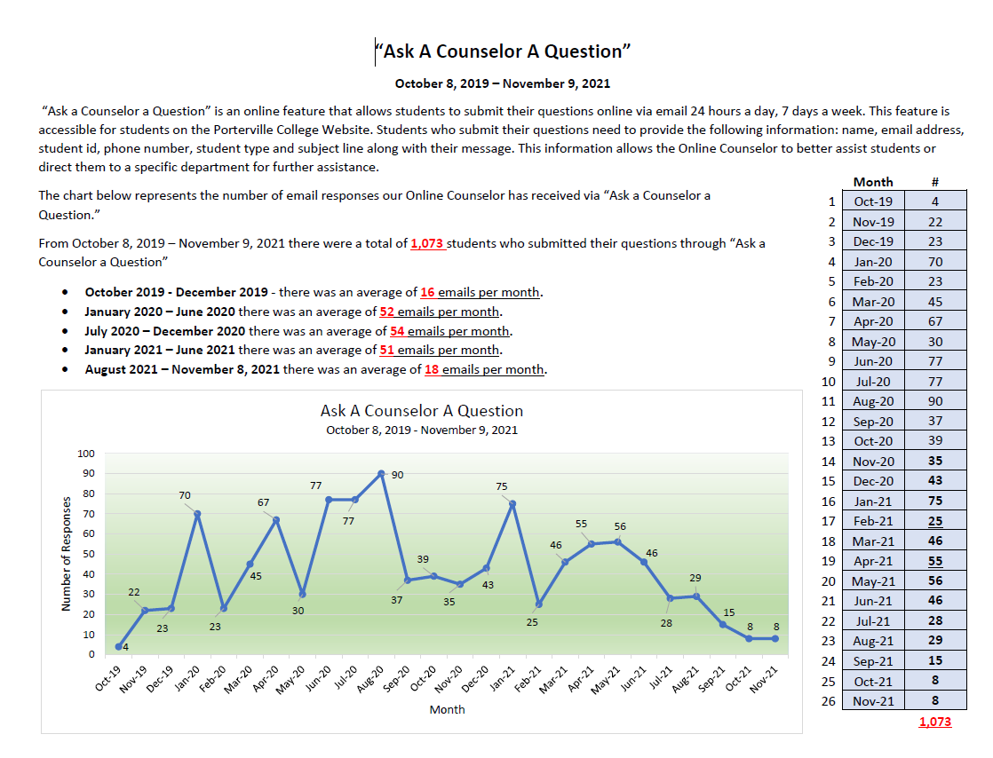

**Guided Pathways/Pirate Success Teams**-Counselors and Educational Advisors are assigned divisions to represent and report to any parts regarding the Pirate Map implementation. Counselors/Advisor and additional staff from Student Services are integrated into the implementation of the Success Teams

**Moving Paperless-** The counselors were encouraged to add electronic forms on the website so students could have access and not have to print the forms. The counselors were also encouraged to email any forms to students and create electronic file system.  This idea was enhanced by the introduction of purchasing a scanner imaging technology to have the department eventually have no more filing cabinets (no student files) and go paperless. The pandemic has moved us into keeping electronic copies instead due to working remote.

**Student Health and Wellness-**A dedicated counselor was hired and assigned to student health and wellness including mental health services in the Counseling Center. Developed a new webpage with student resources and the BIT Referral process all in one location. Various resources/materials were created including a Student Health and Wellness guide for faculty and staff was created, crisis rubric, folder detailing steps to take when dealing with a crisis or emergency situation.

**Student Case Management**-Lead counselors and advisors focus on specific student populations.

General counselors and advisors meet with all students who are not part of a categorical program but also take the lead on serving specific student groups such as Veterans, Athletes, Native American, ESL, etc.

**Equity**

**PC UMOJA Program**

Porterville College’s African American student population currently accounts for less than 1% of the student body. Per the 2018 Edition of the Elements of Student Success KCCD Institutional Research report, African American students who are attending Porterville College are completing 12 College-Level units in their 1st term of enrollment at a rate of 12.3% and complete remedial Math (within 2 years) at a rate of 7.1%. While African American students are showing stronger completion rates for remedial English (44% within 2 years), successful completion of Math and English are not only vital to overall program success but especially critical to program success and ability to transfer into a four-year university. Per the most recent transfer cohort, only 15.4% of our African American students completed and/or transferred within 3 years.

Program development began in Fall 2019 and the program was slated to launch in Spring 2020. The launch was postponed to Fall 2020 due to COVID-19 and a pending grant application decision. This funding was critical to Porterville College’s ability to create the dedicated support needed for the betterment of African American student success. The program goal was to enroll 10% of the African American student population within the first active year. Porterville College uses existing partnerships to expand outreach for prospective UMOJA program participants. Recruitment efforts focus on high school students as well as incoming/continuing Porterville College students. Active marketing for the Fall 2020 program launch began in Summer 2020. Although the initial student response has been low, we are confident the expanded marketing efforts and active virtual support programs will prove beneficial in engaging our black and African American students. In October 2020, the PC UMOJA Program was awarded $12,000 in UMOJA Grant funding to support program operations. The funding was used towards the implementation of wrap around student services including but not limited to: Personal and professional development workshops, an orientation, counseling support, tutoring, cultural awareness activities, and peer mentorship.

**PC Social Justice**

In support of identified opportunities to expand the campus’ Equity efforts to align with Social Justice principles, and the world-wide Social Justice movements observed, a team was created to assess Social Justice opportunities at Porterville College. The team, at the time was led by Kimanthi Warren Program Director of Equity and Education Services and Miles Vega Academic Division Chair and Counselor, consists of diverse campus representation. The group operates under 4 core objectives; define the group’s mission, assess current PC operational practices, identify strengths and areas of opportunity, and to provide recommendations. The PC Social Justice Team meets regularly and is now led by Julian West, Director of Equity and Student Success. They have completed the development of a team mission which has been the framework of subsequent discussions related to PC and Social Justice. The team has been conducting a SWOT Analysis. Through this analysis they have been assessing the Strengths, Weaknesses, Opportunities and Threats associated to PC’s ability to promote Social Justice.

Updates regarding the team’s progress has been shared in College Council Meetings, Student Services Team Meetings, PSEC meetings and with Enrollment Management. In support of expanding anti-racism training, several virtual professional development opportunities have been offered. Presentations on Social Justice and Student Empowerment were shared during PC Promise Days, Student Services Information Sessions and the Fall 2020 Associated Student Government (ASG) Retreat. Additionally, Porterville College has joined the USC Community College Alliance in association with the USC Race and Equity Center. The alliance consists of representation of over 60 community colleges and over 200 campus representatives participate. There were 12 sessions, each focused on a research-based Equity and Social Justice topic. Porterville College selects 5 campus community reps to attend each session. The goal and intention were to select different reps for each session so that the conversations are naturally diversified and the opportunity is extended to as many campus areas as possible.

**Equity Series**

PC staff, faculty and administration attended the Tulare County Office of Education series during the Fall 2020 semester. Topics included the following:

* A Deep Dive on Understanding Equity and Inequity
* Equity Literacy: A Transformative Framework for Equitable Schools
* Ditching Deficit Ideology, Deepening Our Equity Commitments
* Getting Serious about Racial Equity: Beyond Celebrating Diversity
* Getting Serious about Racial Equity Part 2
* Apply an Equity Lens to Popular Education Programs

**Pathways to Equity Virtual Conference**

The conference brought together a diverse community of college practitioners and students to discuss the implementation of the Guided Pathways framework with an equity lens. The focus was focused on embedding anti-racist strategies in our equity work.

**FirstGen**

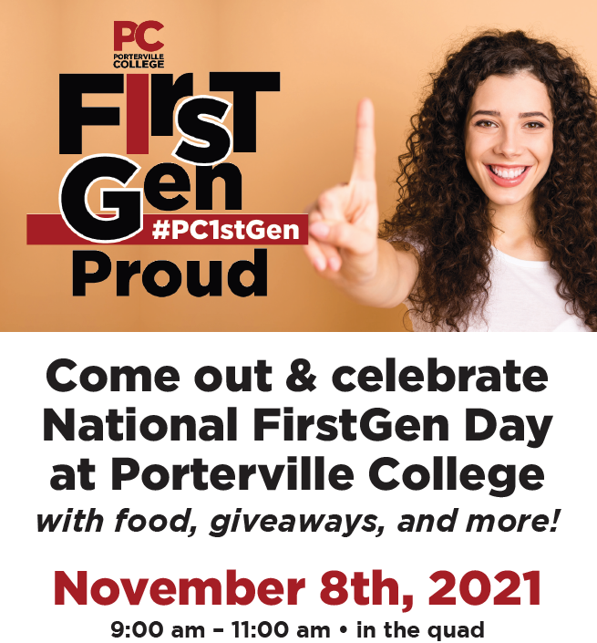

**Undocumented/Dream Liaison/DREAMer’s Success Center**

Porterville College provides a safe and welcoming environment for undocumented, AB540, and/or DACA students and supporters. Our goal is to provide guidance by raising awareness of the laws as well as the rights and opportunities available for undocumented students in the United States, specifically California. Through the DREAMer’s Success Center, we hope to inform undocumented students of the information needed to apply for college in addition to the resources available to help fund their education. Valuable information regarding free immigration services, financial support, admissions processes, and much more are available to students.

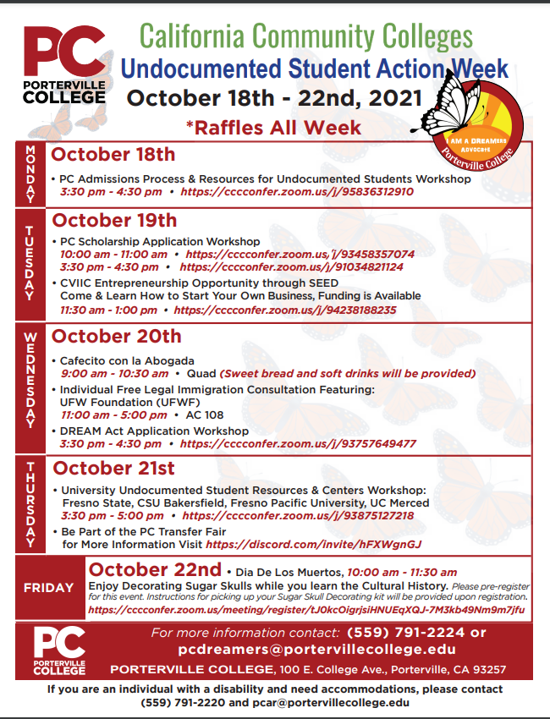



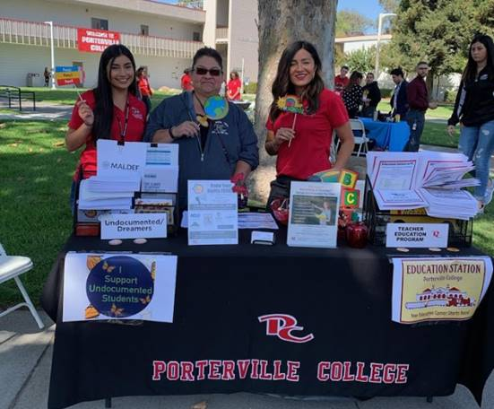

**Student Focus Groups**

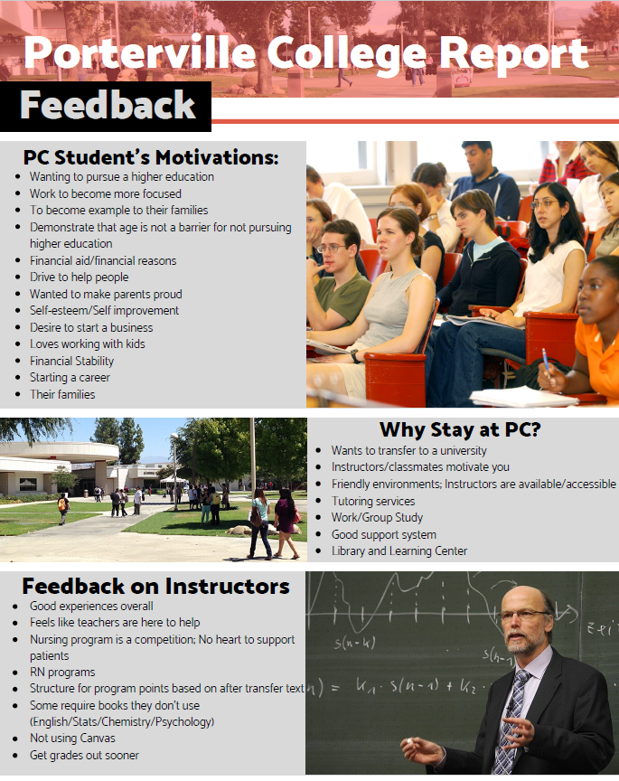

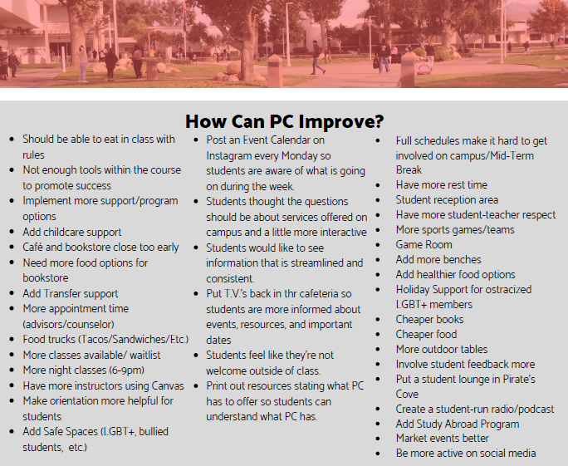

**California Community College Racial Equity Leadership Alliance**

PC selected several staff to participate in a 12-month econvening series shown here.

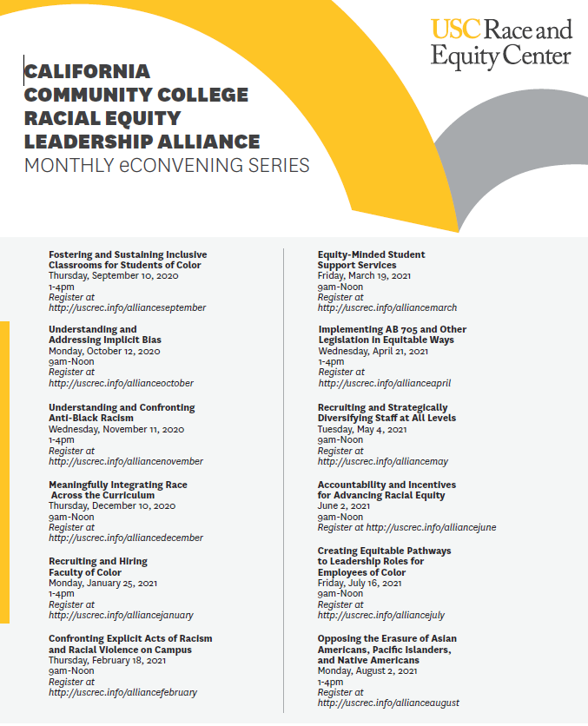

**A Clean Slate**

PC students can receive free legal help to clean up their criminal record. In coordination with the Tulare County Public Defender Office’s, several workshops have been conducted to assist students.

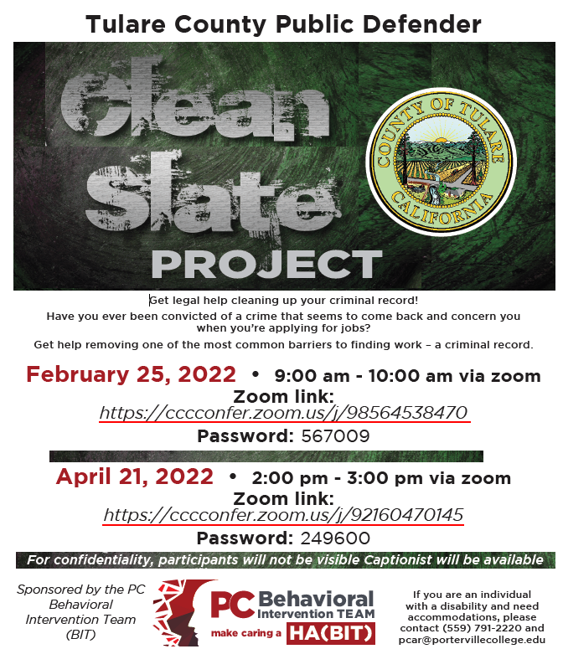

**PC Equity Summit**

Equity and Education Services hosted an Equity Summit.  Over 75 Porterville College Staff, Administration, Faculty, Students and Community Members joined in an educational experience.  The theme was transformative change and the presenter panels included leaders as well as difference-makers both within the industry of equity and education.  The topics ranged from Equity in Action to an open forum discussion where the participants were given an opportunity to share how they support the charge of promoting equity within their environments.  There was also a student panel that included first-generation college students, members of the LGBTQ plus, and students who were re-entering after raising a family.  Per the survey results (40% response rate), 66% stated that the summit exceeded their expectations and 83% stated that they found the information presented helpful.

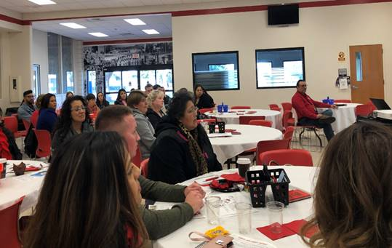 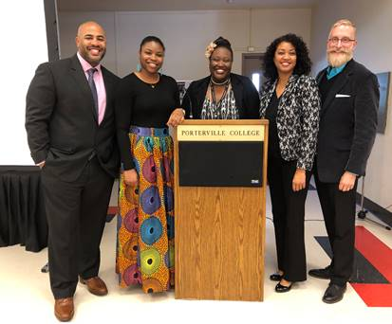

**Student Technology Support Program**

In response to student technology accessibility needs identified during the campus-wide transition to virtual in compliance with the COVID-19 safety mandates, a student technology support team was created. The team consisted of representation from IT, Student Services, and Instruction. The preliminary objective of the team was to assess available campus resources that could be used to support the students’ technology needs. To support this effort, campus departments lent their lab and program specific laptops for distribution to students in need. Further assessment confirmed that a longer-term solution was needed. Grant funding was secured to support the purchase of laptops and internet hotspots. During the Fall 2020 semester, over 400 technology support materials have been distributed (i.e. 95 Laptops, 357 hotspots and 34 Chromebooks for ESL students). The program also partnered with the Financial Aid Office, the SEA Program, EOPS and the CARES ACT for Technology Support. Through this partnership, over 100 students were offered a technology voucher to purchase a personal laptop.

***Report on Previous Goals***

|  |  |
| --- | --- |
| **SSSP/Equity/BSI Goals** | **Status/Progress** |
| 1. Strengthen collaboration with community partners to increase the number of students who access postsecondary education | Timeline for Completion: Ongoing  Progress to date: Completed goal but collaboration continues yearly, strong relationships have been built and continue to thrive.  Person(s) Responsible: Various across Student Services and Instruction  Obstacles to completion: N/A  Mission Statement: 1, 2,3, 4, 5  Guided Pathways Pillar: 1, 2 |
| 2. Implement Cranium Cafe to scale within student services to better provide counseling and advising to distance learners | Timeline for Completion: Completed January 2019  Progress to date: Completed goal, however, we no longer utilize Cranium Café for staff or students as of June 2021.  Person(s) Responsible: Dean, Student Success and Counseling, Online Counselor, Counseling/Advising Staff  Obstacles to completion: N/A  Mission Statement: 2, 3  Guided Pathways Pillar: 1, 2, 3, |
| 3. Maintain and update the online orientation modules as it relates to changes in programs offered, fees, resources etc. | Timeline for Completion: June 2020, however, updates are continuously made to the Comevo orientation platform.  Progress to date: Completed goal  Person(s) Responsible: Dean, Student Success and Counseling, Program Technician, SSSP Counselor  Obstacles to completion: N/A  Mission Statement: 1, 2, 3, 4,  Guided Pathways Pillar: 1, 2, 3, |
| 4. Implement the goals developed within the integrated SSSP, Student Equity, and BSI Integrated Plan | Timeline for Completion: June 2018  Progress to date: Goal completed, the SSSP, Equity and BSI Integrated Plan was for one year. Goals were completed and replaced with the Student Equity and Achievement Program (SEA) instead.  Person(s) Responsible: Dean, Student Success and Counseling, Program Technician, Program Manager  Mission Statement: 2, 3, 4, 5, 6  Guided Pathways Pillar: 1, 2, 3, 4 |
| 5.Leverage resources to implement a lending library to assist students in completing coursework | Timeline for Completion: Goal Completed  Progress to date: Goal completed, however, continuous improvements and updated books/materials are ordered for the lending library.  Person(s) Responsible: Program Director, Title V; Librarian; Director of Equity and Student Success  Obstacles to completion: Increased cost of textbooks and editions of books changing continuously and thus needing to update books  Mission Statement: 2  Guided Pathways Pillar: 3, 4 |

***Program Strengths***

**BSI:**

* ESL Pathway from Porterville Adult School to PC and continuing to work together to increase the number of ESL students that transition to the College
* Increased number of students that are placed in transfer-level English and math courses.
* AB-705 Workgroup that continues to review data and participate in various national and statewide studies on PC’s implementation of AB-705.
* Full implementors of AB-705 for math, English and ESL.

**SSSP**

* The Student Services Division including Counselors, Advisors, Administrators and Front-Line Staff worked efficiently and collaboratively to serve students since the onset of the pandemic. Everyone transitioned to the virtual environment during the Spring 2020 semester within a couple of weeks and helped one another through the pandemic changes. Student Services went from using paper to paperless immediately due to working remote. Staff utilize Navigate, Zoom, and Banner on a daily basis and have incorporated Canvas and Discord. The staff participated in various drive thru events, registration events, welcome week festivities, outreach events on and off campus, various campaigns, technology pick up and drop offs, etc.
* Navigate links counselors, advisors, faculty, students and resources in a coordinated care network. This allows the staff to proactively manage student success through Navigate which assists in identifying at-risk students and provide follow-up services.
* DegreeWorks assists students, faculty and staff with degree audits and educational planning to help students graduate on-time.
* Partnership with local high schools to provide graduating seniors with all the necessary tools needed to complete the core components of the Student Success and Support Program by bringing a team to the high schools. Seniors have access to the following on their high school campus: Career and Major Workshops, Orientation, CCCApply Application Assistance, Financial Aid Application Assistance, and Educational Plan Completion, Appointments with Counselors/Advisors on the high school campuses. The annual “PC Connection” registration event for high school seniors each spring and the “Become a Pirate in a day” registration event throughout the year that allows students to meet with all staff including counseling to receive one-on-one counseling and registration assistance in one location for enrollment assistance. Students receive vital information regarding financial aid and all support programs available.
* Student Services hosts the annual “High School Counselor/Principal Retreat” with the local high school partners. Porterville College Faculty, Staff and Administrators provide important updates and valuable information to the high schools to take back to their campuses. This includes updates on the following: state and federal, counseling office, financial aid/admissions, Student Success components, concurrent/dual enrollment and other support services available.

**Equity**

Student Equity funding/resources support various programs and services to provide the necessary support to achieve the goals and objectives identified in this Student Equity Plan and increase student success. The current programs include:

* Student Support and Success Program (SSSP)-Comprehensive process and pathway with multiple points of contacts: Orientation, Assessment (Placement), Counseling, Advising and Education Planning services.
* Financial Aid-Offers financial assistance with educational costs including fee waivers, grants and federal work-study program.
* Basic Skills Initiative (BSI)-The faculty and staff who serve on this committee are committed to raising English, Math and ESL basic skills through course offerings below the transfer level; providing academic and career counseling; and providing basic skills and ESL students with academic support.
* Extended Opportunity Programs and Services (EOPS)-Offers grants, counseling and other services to students who are both economically and educationally disadvantaged.
* CalWORKs-Supports students receiving special assistance through educational programming and the provision of childcare assistance.
* Cooperative Agency Resources for Education (CARE)- Provides additional support services such as childcare, transportation, books, and supplies to EOPS students.
* Disability Resource Center (DRC)-Provides support and reasonable accommodations, as defined by state and federal laws, such as readers, note takers, specialized equipment use to students with documented physical, communication, learning, psychological or other medical conditions.
* Foster Youth Success Initiative (FYSI)-Identifies foster youth as recognized through either Tulare County or FAFSA responses and provides such youth with programs, services, information, and support necessary to maximize their college options and outcomes. College Liaison for foster youth to connect with as a support resource.
* Veterans Resource Center-Serves the needs of qualifying veterans. Students receive counseling services and assistance with benefits and community resources.
* Student Success Lab-Multi-functional lab used for orientations, workshops and Student Services professional development meetings/trainings.
* Learning Resource Center/Library-Features multiple resources and instructional services to support learning. Support is also provided for the lending library.
* Transfer Center-Allows students to research information regarding California State University and the University of California Systems and meet with university representatives. • Student Clubs and Activities-Provides leadership development opportunities through extracurricular student activities.
* Working Families Success Network (WFSN)-creates pathways and provides integrated services that prepare low-income students for jobs with family-sustaining wages.

These programs have an impact on increasing student achievement and student retention, as well as to provide support to students in overcoming barriers. The programs are to address barriers to access and student success which include the need for financial aid assistance to cover the costs of an education (fees, books, supplies, childcare services, transportation).

Equity funding is also available to support various equity initiatives across the campus throughout the year. Professional development funding is designated for both student services staff as well as instructional faculty.

***Areas for Improvement***

**BSI**

* For the English and Math program, continued training for Counselors and Educational Advisors about the different mathematics pathways for students and the transfer-level English research course.
* For the ESL program, creation of a vocational ESL program to provide students who would like to gain job training skills an option for support.
* For the ESL program, the lack of enrollments despite various outreach activities. Courses continue to be cancelled.
* For the ESL program, review of the non-credit certificate offerings to reduce the number of credit and non-credit options to streamline the program.

**SSSP**

* Redesigned Student Onboarding through Guided Pathways-Coaching is ongoing with Dr. Solano to review and improve entry steps for an enhanced student experience. Various tools, trainings and resources have been provided. Ongoing discussions and trainings with the Outreach Committee members continues as we review Student Support (Re)defined Six Success Factors” that include: Directed, Focused, Nurtured, Engaged, Connected and Valued.
* Development of Communication Calendar-Working with other departments throughout the campus to coordinate sending important messages to students.
* Matriculation Component Completion-Team members will regularly send nudges to students to remind them of the importance of completing all matriculation components. These email/text campaigns will be monitored by Program Technicians.
* Increase CSEP Completion-Counselors will contact various students assigned to them and schedule CSEP appointments with those students. March Ahead campaigns are held yearly to promote the importance of completing an educational plan in order to complete their certificate or degree on-time.
* Case Management-Ongoing training has been coordinated with the Foundation for California Community Colleges/Guided Pathways team to introduce case management to Counseling. The goal is to create, customize and finalize a student case management model by Summer 2022 to improve the student experience.

**Equity**

* Improving data collection by conducting research on specific services offered. Survey targeted populations on progress made or improvements needed within student services activities intended for student success.
* Continue to develop and train Student Ambassadors to provide services aimed at reducing the achievement gap in access to the college (outreach and in-reach) and transfer. Expand activities to include student driven initiatives directed at supporting student success in use of technology for degree completion and course completion (Navigate, Degree Works).

**Goals** (This section is for you to report on progress on ***new SEA goals***. If your program is addressing more than 3 goals, please add rows.

Note that for the Mission Statement column, please list the numbered goal(s) from the college Mission Statement and Guided Pathways Pillars (see page 1) that would be furthered if this goal were accomplished.)

|  |  |  |  |  |  |  |
| --- | --- | --- | --- | --- | --- | --- |
| Goal(s) | Timeline for completion | Needed resources | Person(s) Responsible | Obstacles to completion (if any) | Mission Statement | Guided Pathways Pillars |
| 1. Review English, mathematics, and ESL placement metrics to ensure that practices are maximizing the probability that a student will enter and complete transfer-level coursework in English and math within a one-year timeframe and for credit ESL students to complete transfer-level coursework in English within a three-year timeframe (AB-705). | Ongoing | Professional development opportunities for faculty | Dean of Instruction, Chair of Language Arts Division, Chair of Mathematics Division | Continued effects of COVID-19 pandemic | 3, 5 | 1, 2, 3, 4 |
| 2. Prominently feature in the catalog, outreach materials, website, and any written communication by a college counselor to a student about the student’s course placement options (AB 1805). | Ongoing | Technology | Counselors/Advisors, Dean, Student Success and Counseling, Marketing Director/Staff | N/A | 1, 3, 5 | 1, 2, 3, 4 |
| 3.Increase ESL enrollments in subsequent course sequences that lead to certificates | Ongoing | Outreach, marketing,  Educational Planning  Technology  Supports | Faculty  Ed Advisors  Counselors | Low ESL enrollments, lack of access, low enrolled courses | 1, 2, 4, 6 | 3, 4 |
| 4.Develop a college Puente learning community that aligns with the state sponsored Puente organization. | Fall 2022 | Support staff, student participation | Director of Equity and Student Success, assigned counselor | Student enrollment/participation in program | 1, 2, 3, 4, 6 | 1, 2, 3, 4 |
| 5. Expand outreach of Umoja program to include students who identify as biracial (African American). Also, ensure that athletic programs (particularly Basketball) are incorporated into the Umoja program and efforts are integrated. | Spring 2022 | Support staff, student participation | Director of Equity and Student Success, Umoja Counselor, Program Technician, Dean of Student Success and Counseling | Student enrollment/participation in program | 1, 2, 3, | 1, 2, 3 |
| 6. Provide professional development for faculty, classified staff, and management as it relates to institutional data, equitable mindsets, and equitable practices. | Ongoing | Funding | Student Services and Instructional Administrators | Scheduling, staff participation | 1, 2 | 3, 4 |
| 7. Ensure that there are events on-campus (or on Zoom for the campus population) that reflect the diversity of cultures, ethnicities, races, and perspectives. | Ongoing | Coordination/Planning | Dean of Student Success and Counseling, Director of Equity and Student Success, Program Manager, Program Technician and various outreach staff | Continued effects of COVID-19 pandemic including student participation/engagement | 1, 2 | 1, 2, 3, 4 |
| 8. Ensure all Porterville College clubs are provided adequate training and resources related to equity and inclusion. | Yearly | Coordination/Planning | Program Manager, Director of Equity and Student Success | N/A | 2 | 4 |
| 9. Develop various data instruments to evaluate the equitable mindset and practices at PC. These tools should include both quantitative and qualitative measures that examine the student experience at PC. The results should be shared widely and discussed across all college departments. | Ongoing | Technology, Coordination/Planning | Institutional Research, Director of Equity and Student Success, Dean of Student Success and Counseling | N/A | 1, 2, 3, 4, 5, 6 | 1, 2, 3, 4 |

**BSI Staffing:**

***Current Staffing Levels***

|  |  |  |  |
| --- | --- | --- | --- |
| Full-time | | Part-time | |
| Faculty |  | Faculty |  |
| Temporary |  | Temporary |  |
| Classified |  | Classified | 1 |
| Management |  | Management |  |

***Request for New/Replacement Staff***

None at this time for BSI

|  |  |  |  |  |
| --- | --- | --- | --- | --- |
|  | Title of Position | Classification  (Faculty, Classified, or Management) | Full or Part  Time | New or Replacement |
| Position 1 |  |  |  |  |
| Position 2 |  |  |  |  |
| Position 3 |  |  |  |  |

Justification:

N/A

**SSSP Staffing:**

***Current Staffing Levels***

|  |  |  |  |
| --- | --- | --- | --- |
| Full-time | | Part-time | |
| Faculty | 1 | Faculty | 1 |
| Temporary |  | Temporary |  |
| Classified | 5 | Classified | 1 |
| Management | 2 | Management |  |

***Request for New/Replacement Staff***

None at this time for SSSP

|  |  |  |  |  |
| --- | --- | --- | --- | --- |
|  | Title of Position | Classification  (Faculty, Classified, or Management) | Full or Part  Time | New or Replacement |
| Position 1 |  |  |  |  |
| Position 2 |  |  |  |  |
| Position 3 |  |  |  |  |

Justification:

N/A

**Equity Staffing:**

***Current Staffing Levels***

|  |  |  |  |
| --- | --- | --- | --- |
| Full-time | | Part-time | |
| Faculty |  | Faculty |  |
| Temporary |  | Temporary |  |
| Classified | 2 | Classified |  |
| Management | 3 | Management |  |

***Request for New/Replacement Staff***

None at this time for Equity

|  |  |  |  |  |
| --- | --- | --- | --- | --- |
|  | Title of Position | Classification  (Faculty, Classified, or Management) | Full or Part  Time | New or Replacement |
| Position 1 |  |  |  |  |
| Position 2 |  |  |  |  |
| Position 3 |  |  |  |  |

Justification:

**Resource Requests**

The following four sections are for requesting resources, such as technology, facilities, safety/security, and professional development. Please include all needs, even if you already have identified funds for them. Requests made here should be linked to needs identified in earlier sections (outcomes, areas for improvement, goals). If you have no needs in a particular area, just type NA.

TECHNOLOGY REQUEST

Use this section to list any technology needs for your program. If you have more than two technology needs, add rows below.

|  |  |
| --- | --- |
| Technology Need | Justification |
| Item 1 |  |
| Item 2 |  |

FACILITIES REQUEST

Use this section to list any facilities needs for your program. If you have more than two facilities needs, add rows below.

|  |  |
| --- | --- |
| Facilities Need | Justification |
| Item 1 |  |
| Item 2 |  |

SAFETY & SECURITY REQUEST

Use this section to list any safety & security needs for your program. If you have more than two safety & security needs, add rows below.

|  |  |
| --- | --- |
| Safety & Security Need | Justification |
| Item 1 |  |
| Item 2 |  |

PROFESSIONAL DEVELOPMENT REQUEST

Use this section to list any professional development opportunities you would like to have available for your program. If you have more than two professional development needs, add rows below.

|  |  |
| --- | --- |
| Professional Development Need | Justification |
| Item 1 |  |
| Item 2 |  |

**BSI Budget**

BSI is a categorical budget with no match account (GU001)

There are no additional budget needs at this time.

|  |  |  |  |
| --- | --- | --- | --- |
|  | Current Budget | Amount of Change | Revised Total |
| 2000 (Student Workers Only) | 15,768 | 0 | 15,768 |
| 4000 | 2,000 | 0 | 2,000 |
| 5000 | 10,599 | 0 | 10,599 |
| Other | 0 | 0 | 0 |

BSI has approximately $12,600 to use in the 4000 - 6000 accounts each year. This money is spent towards instructional needs.

**SSSP Budget**

SSSP is a categorical budget with one match account (GU001)

There are no additional budget needs at this time.

|  |  |  |  |
| --- | --- | --- | --- |
|  | Current Budget | Amount of Change | Revised Total |
| 2000 (Student Workers Only) | 54,432 | 0 | 54,432 |
| 4000 | 12,500 | 0 | 12,500 |
| 5000 | 289,629 | 0 | 289,629 |
| Other 6000 | 10,479 | 0 | 10,479 |

SSSP has approximately $312,609 to use in the 4000 - 6000 accounts each year. This money is spent on various areas within instruction, student groups/activities and student services.

**Equity Budget**

Student Equity is a categorical budget only (No GU001 match accounts)

There are no additional budget needs at this time.

|  |  |  |  |
| --- | --- | --- | --- |
|  | Current Budget | Amount of Change | Revised Total |
| 2000 (Student Workers Only) | 18,723 | 0 | 18,723 |
| 4000 | 26,000 | 0 | 26,000 |
| 5000 | 149,101 | 0 | 149,101 |
| Other | 0 | 0 | 0 |

Student Equity has approximately $175,101 to use in the 4000 - 6000 accounts each year. This money is spent on various areas within instruction, student groups and student services.