**Road Map to Institutional Effectiveness and Student Success**

The following pages include the initiatives developed for each of the 2015-2018 Strategic Directions. The intent is to complete the initiatives over the course of the three-year cycle. Each year the College will evaluate the progress it has made on each initiative.

**Fall Committee Reports due in early November** will focus on the status of the initiatives aligned with committee work. Using the icons below, the committees will report on their progress. Green means an initiative has been completed, green and yellow together represent work perpetually in progress, yellow indicates the work is in progress, and red shows that work has not yet begun. Initiatives with yellow or red icons will need to include action plans for completion. Committee Reports will be directed to the Accreditation and Institutional Quality Committee (AIQ) for review. Following its charge, AIQ will “review and monitor evaluation activities to ensure they result in integrated, meaningful, and sustained college improvement.” AIQ will analyze the Committee Reports, create a summary, and present the information to College Council in early December.

**At the end of each academic year, committees will follow the same process**, with AIQ presenting the analysis to the annual College Leadership Year-End Review & Planning Meeting.

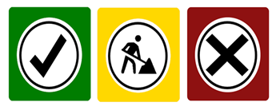

Green means an initiative has been completed.



Green and yellow together represent work perpetually in progress.



Yellow indicates the work is in progress.



Red shows that work has not yet begun.

Initiatives with yellow or red icons will need to include action plans for completion.