Strategic Directions and Planning for BC’s Future
December 5, 2014 from 10:00 a.m. to 12:00 p.m.
Fireside Room

Present: Judy Ahl, Somaly Boles, Barbara Braid, Sonya Christian, Grace Comisso, Todd Coston, Zav Dadabhoy, Lisa Fitzgerald, Janet Fulks, John Giertz, Nan Gomez-Heitzberg, Steven Holmes, Shane Jett, Odella Johnson, Veronica Lucas, Richard Marquez, Kate Pluta, Craig Rouse, Liz Rozell, Michael Self, Ann Tatum, Kris Toler, Sue Vaughn

The Strategic Directions Core Team presented the Setting the Stage: Planning for BC’s Future Powerpoint presentation.

Attendees broke into 3 groups and brainstormed possible new goals or changes to the current goals.

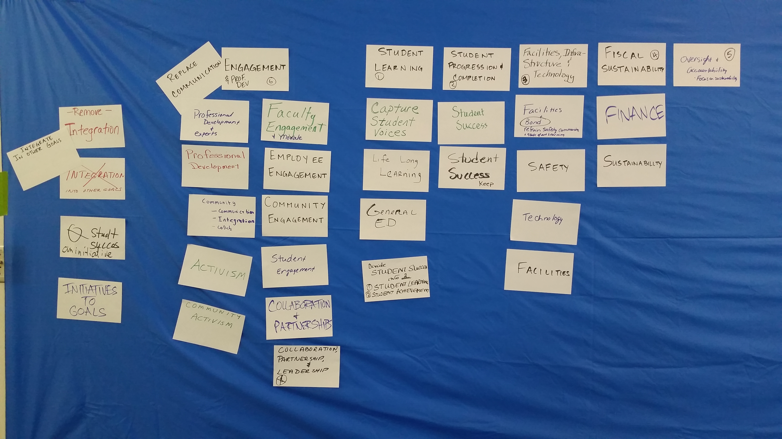

The final recommendation was to change the goals to the following:

- Student Learning
- Student Progression and Completion
- Facilities, Infrastructure, and Technology
- Fiscal Sustainability
- Oversight and Accountability
- Engagement

The next Core Group meeting will be on Thursday, December 11th from 3:30 p.m. to 5:00 p.m. in SE 57.

