Strategic Directions, Planning/Initiatives Review
April 30, 2015
Final review of initiatives in Excel.
- Student Learning Liz 19 initiatives
- Student Progression and Completion Grace 27 initiatives
- Facilities Craig 22 initiatives
- Oversight and Accountability Kate 18 initiatives
- Leadership and Engagement Todd 22? initiatives
Somaly is converting to Excel format.
Do we delete “Potential Initiatives” and label the first column “Initiatives”?
Check for formatting consistencies?
Planning May 1 (10-12 in Fireside)
Original Planning Document
College Leadership End-of-Year Review
Friday, May 1, 10:00 to 12:00 in Fireside Room (immediately following College Council)
Invitees include:
- Strategic Directions Core Team and Task Force
- College Council
- Committee Co-Chairs
- President’s Cabinet
- Academic Senate Executive Board
- Should we invite FCDC?

Focus: Reviewing last year (evaluating) and Planning for next year
Outcome: Set up system for annual evaluation of our planning and resource allocation process in a retreat format with all college leadership; Use process to plan for next year.

Activities

Evaluation (for year and for this review)
- For year: use current initiatives and expand with 3 icons
- For today: use 3 question survey—reflection piece
  - End of day or before planning begins or both?

Planning
- Final review/fine-tuning initiatives—what will be our initiatives for the next 3 years?
- We are setting committee work plans/framework for next year—embedded within each committee
- Focus group for comments to deepen it.
- Committees will have completed their year-end reports of accomplishments. (Jennifer needs to develop and send our accomplishments to have for that day.)
- What format would be most helpful?
  - Committee accomplishments
  - Evaluation of committee work
  - Plans for next year?

See image for Sonya’s notes this week (see my translation/notes below):
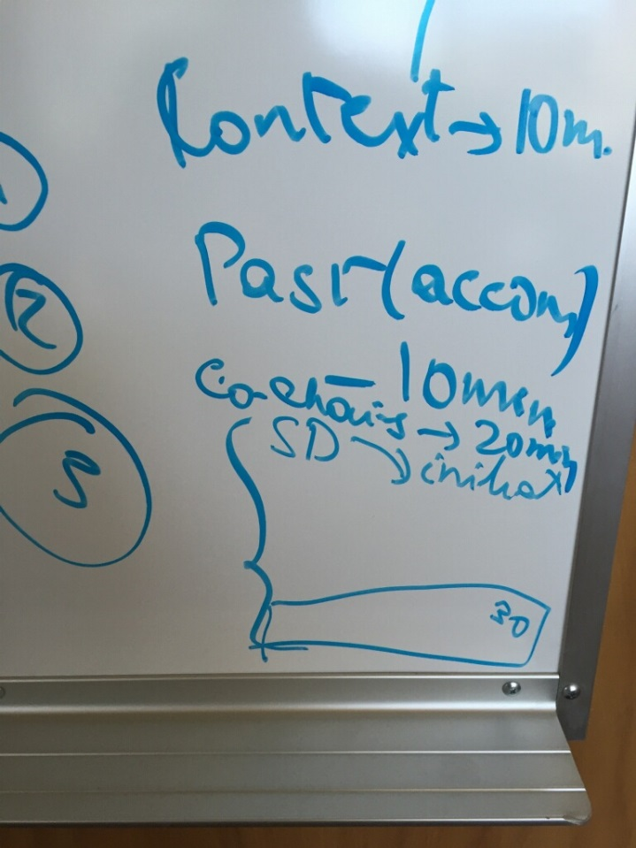
My translation:
- Context 10 minutes
- Past Accomplishments 10 minutes
- Co-Chairs share 1 big accomplishment 20 minutes
- Strategic Directions & Initiatives 40 minutes
- Getting started on work plans 30 minutes
- Wrap up 5-10 minutes (my addition)

Handouts? Projected attendance = 30-35
Red Strategic Initiatives (approved version)
Accomplishments (need minor revisions in PPT with new icons for
Goal 1 #2 in progress
Goal 4 #4 in progress
Goal 6 #1-3 not sure
Initiatives--handout

Powerpoint

