- ASSESSMENT CYCLE & TIMELINE AT BAKERSFIELD COLLEGE
  - Assessment Cycle
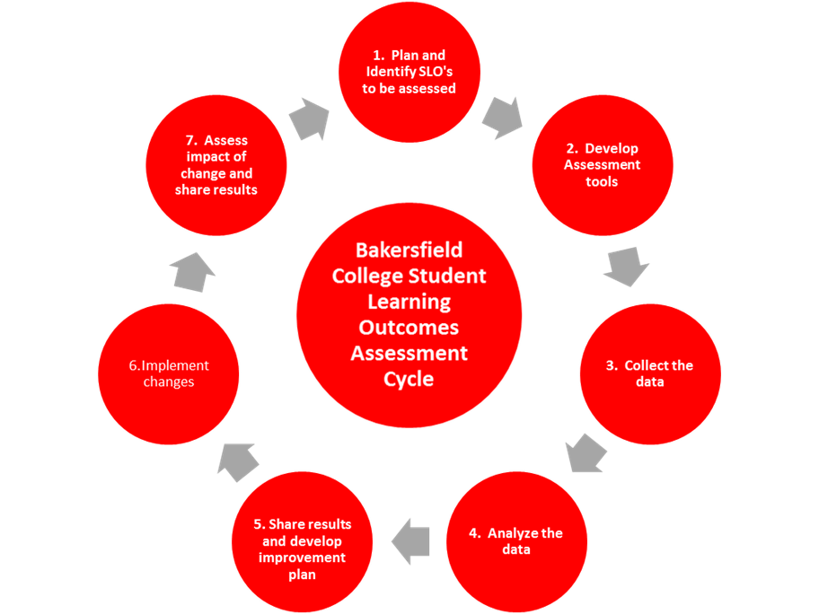

  - Assessment Timeline
    - All SLOs for a course need to be assessed at least once within a three-year cycle.
    - To spread the workload of assessment over the three-year cycle while adhering to the ACCJC standard of continuous quality improvement, faculty are encouraged to assess at least one course SLO each time you teach a course.
    - The frequency of assessment will ultimately depend on the number of course SLOs and frequency with which the course is offered.
*Example Timeline below:
 | Semester 1  (WK 1-2) | End of Semester 1 | Semester 2 | Semester 3 | End of Semester 3
Plan SLO(s) to be assessed and develop assessment tool
Collect the data

Analyze the data, share the results, and develop improvement plan
Implement the changes
Assess Impact of change and share the results
*Timeline demonstrates ability to assess, make changes and reassess in a 3 semester period*
The assessment cycle is ongoing and continuous. The steps of the assessment cycle were developed using the above ten principles and are defined below:

  - Plan and Identify Student Learning Outcomes (SLO’s)
Faculty will review SLO’s from COR. Faculty will decide which SLO(s) will be assessed that semester. This information can be found on the assessment committee website under department assessment plan. Each SLO must be assessed every 3 years. All faculty from the discipline are asked to agree on the learning outcomes to be assessed and the planning of the SLO assessment. This does not mean that faculty will be required to deliver the course contents in the same method, but what is expected is that faculty across all sections of the course will assess the same SLOs using the same agreed upon assessment tools regardless of where or how it is taught (Semester 1 – Wk 1-2).
  - Develop Assessment Tools
After the SLO(s) to be assessed is(are) identified, faculty will choose the appropriate assessment tool to effectively identify student learning. Assessing learning outcomes for courses should be important to all faculty in the discipline. Therefore, all faculty should engage in meaningful dialogue regarding to this process. This process is more equitable and the participation of all faculty results in a full appreciation of the importance of student learning outcomes, the worth of assessing them, and the value of coming together for meaningful discussions about both. (Semester 1 – Wk 1-2)
  - Collect the Data
Complete assessment in course sometime during the semester (End of Semester 1)
  - Analyze the data & Share results and develop improvement plan
Program faculty should meet to discuss the assessment results, and plan ways to improve student learning and program effectiveness. Utilizing online assessment system, faculty will enter in their course assessment summaries to include results (aggregate or student level), assessment tool, documentation of planned changes to improve outcome attainment and documented dialog among faculty (Semester 2).
  - Implement changes
To the extent possible, in the following semesters, implement changes to teaching, curriculum, course delivery, etc. utilizing the agreed upon plan for improvement.(Semester 3).
  - Assess the impact of the change and share results
During subsequent semester, reassess SLO’s and analyze results. Depending on the type of improvement (ex. curriculum changes) it may be necessary to delay reassessment. Document re-assessment results (End of semester 3)

