Porterville College Mission Statement:

With students as our focus, Porterville College provides our local and diverse communities quality education that promotes intellectual curiosity, personal growth, and lifelong learning, while preparing students for career and academic success.

In support of our values and philosophy, Porterville College will:

- Provide quality academic programs to all students who are capable of benefiting from community college instruction.
- Provide comprehensive support services to help students achieve their personal, career and academic potential.
- Prepare students for transfer and success at four-year institutions.
- Provide courses and training to prepare students for employment or to enhance skills within their current careers.
- Provide developmental education to students who need to enhance their knowledge and understanding of basic skills.
- Recognize student achievement through awarding degrees, certificates, grants, and scholarships.

Guided Pathways Framework:

- Clarify the Path: Create clear curricular pathways to employment and further education.
- Enter the Path: Help students choose and enter their pathway.
- Stay on the Path: Help students stay on their path.
- Ensure Learning: Ensure that learning is happening with clear outcomes.

Program Mission Statement:

The Natural Science Division supports the mission of Porterville College and is committed to making the learning of science interesting, meaningful, and enjoyable to our students, while providing full coverage of course topics to meet the expectations of the Student Learning Outcomes in each course and program. The division does so by providing a vocational program prerequisite and transfer-level instruction in biological and physical sciences.

Student Learning Outcomes:

Each course has SLOs, and assessments have been conducted on various courses in Natural Science. Timeframes vary from 4–6-year cycles. Assessment tools include whole exams, exam questions, laboratory activities and submitted laboratory work/reports and faculty make changes accordingly. Examples of changes made have been retooling lab assignments or creating new labs, focusing more closely on difficult topics in lecture and providing extra resources for students. Faculty have not been diligent, however, in completing the SLO Outcome Cycle Rotation Completion Form. This is an area where the division can improve.

Program Learning Outcomes:

(For each associate’s degree, certificate of achievement, and job skills certificate in your divisions, please complete the table below describing how the assessment results have been discussed in the division and how they impact your goals and needs. If your award has more than five PLOs, please add rows. Duplicate this table for each award offered.)

There are 4 programs within the division: AA Biological and Physical Sciences, AS Biological and Physical Sciences, Biology AS-T, and Environmental Science AS-T. The first two have 8 PLOs each that are related, the difference being which courses count for each. More science courses count for the AA rather than the AS in Biological and Physical Sciences. Two PLOs are discussed each fall in a division meeting according to an assessment schedule. Neither AS-T degree have had their PLOs evaluated; both faculty that instituted them and taught the core courses retired but the PLOS are listed below and will begin assessment cycles this year.

AA in Biological and Physical Sciences
PLO Statement | Describe assessment results and discussion of this PLO | Describe how the results impact your goals and needs going forward
1. Apply the scientific method to analyze physical and biological processes. | Using quiz or exam questions, 92% of students passed with 70 percent or higher by one measure, and the average score on the assessment was 84% by another measure. | This student learning objective is being met. Individual instructors have plans to make adjustments to their learning activities.
2. Use scientific terminology appropriately. | Using questions on exams, exam scores or laboratory report scores, 76% of students passed with 70 percent or higher by one measure, and the average score on the assessment was 77% by another measure. | Incorporate required use of Quizlet for one course, utilization of Canvas.
3. Draw appropriate conclusions from laboratory activities and society. | Not assessed during this program review cycle
4. Identify the relationships between natural science, human | Not assessed during this program review cycle
5. Identify levels of organization within natural systems and relate to biological and/or physical processes. | Based on assessments, the average of averages was about 84%. Many students appear to be proficient, however there is still room to improve student learning. Division faculty are continually evaluating and improving material in courses in science. | Increase the use of Canvas or other online tools for face-to-face instruction. Improve communication with students.
6. Describe the structure and properties of matter, transfer of energy, and the relationships between matter and energy within biological and/or physical systems. | Assessments averaged 81% over many science classes. | Increase the use of Canvas or other online tools for face-to-face instruction. Improve communication with students.
7. Explain basic physical, chemical and/or biological processes. | With an average of 88.8% students passed (in some classes) and 74.8% answered correctly (in other classes), students could improve their learning here. | Much of the discussion focused on the lack of hands-on work available to students while taking online science classes. Also discussed was the decreased level of engagement.
8. Select the appropriate qualitative and quantitative methods to analyze physical systems | With an average of 78% students passed (in some classes) and 71% answered correctly (in other classes), students could improve their learning here. | Much of the discussion focused on the lack of hands-on work available to students while taking online science classes. Also discussed was the decreased level of engagement.

AS in Biological and Physical Sciences
PLO Statement | Describe assessment results and discussion of this PLO | Describe how the results impact your goals and needs going forward
1. Apply the scientific method to analyze physical and biological processes. | Using scores on lab assignments and quiz/exam questions, 97.5% of students scored 70% or higher by one measure and students earned an average of 82% on the assessment by another measure. | Devote more in-class time for material on this topic. Individual instructors have plans to make adjustments in learning activities.
2. Use scientific terminology appropriately. | Assessed using exam questions, lab reports. In one measurement, 81% passed with 70% or higher, in another measurement, the average score was 76%. | Incorporate required use of Quizlet for one course, utilization of Canvas.
3. Evaluate results from laboratory activities. | Not assessed during this program review cycle
4. Assess the relationships between natural science, human activities, and society. | Not assessed during this program review cycle
5. Identify levels of organization within natural systems and relate to biological and/or physical processes. | Based on assessments, the average of averages was about 84%. Many students appear to be proficient, however there is still room to improve student learning. | Division faculty are continually evaluating and improving material in courses in science. Increase the use of Canvas or other online tools for face-to-face instruction. Improve communication with students.
6. Describe the structure and properties of matter, transfer of energy, and the relationships between matter and energy within biological and/or physical systems. | Assessments averaged 82% over many science classes. Increase the use of Canvas or other online tools for face-to-face instruction. | Improve communication with students.
7. Explain and apply knowledge of basic physical, chemical and/or biological processes. | With an average of 84.5% students passed (in some classes) and 75.1% answered correctly (in other classes), students could improve their learning here. | Much of the discussion focused on the lack of hands-on work available to students while taking online science classes. Also discussed was the decreased level of engagement.
8. Apply the appropriate qualitative and quantitative methods to analyze and solve problems in physical systems. | With an average of 80.5% students passed (in some classes) and 71% answered correctly (in other classes), students could improve their learning here. | Much of the discussion focused on the lack of hands-on work available to students while taking online science classes. Also discussed was the decreased level of engagement.

AS-T Biology
- Apply the scientific method by proposing hypothesis based on observations, testing hypotheses, and analysis of experimental data to develop a conclusion.
- Evaluate results from laboratory activities and scientific research.
- Use scientific terminology appropriately.
- Describe biological processes, levels of organization, inheritance, and evolution, and ecological relationships.

AS-T Environmental Science
- Identify and describe major local, regional, and global environmental issues.
- Use the scientific method to analyze and interpret quantitative data and visual representations of data to identify and evaluate potential solutions to major environmental issues.
- Identify and evaluate relationships between human actions and environmental issues.
- Evaluate the impacts of the relationships between environmental issues and human populations.

Program Analysis and Trends:

Data Review
Degrees Awarded:
The Natural Science Division currently awards 4 degrees, AS-T Biology, AA Biological and Physical Sciences, AS Biological and Physical Sciences and the as yet unawarded AS-T Environmental Science. Two other AA-T degrees rely on courses in the Natural Science Division, the AA-T Elementary Teacher Education and AA-T Kinesiology. Another degree, which has been discontinued, is the Liberal Arts: Math and Science degree with which some students still graduate. Below are data for the last five years showing each individual degree and those in and relying on the division.
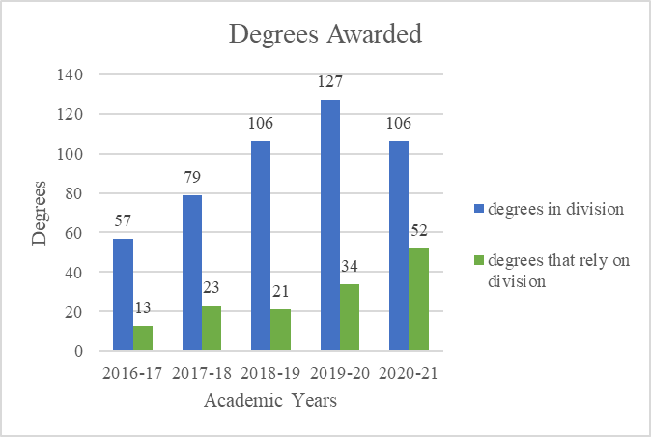
The number of degrees within the divisions programs was highest in the 2019-20 academic year, falling to 2018-19 levels in the most recent academic year. This drop in awards can be placed on the difficulties of online science courses while the school remained mostly closed to in person classes. The number of degrees awarded in programs that rely on the division has quadrupled over 5 years, mostly due to elementary teacher education program (above). Below is a breakdown of the degrees awarded by program including those that rely on the division.
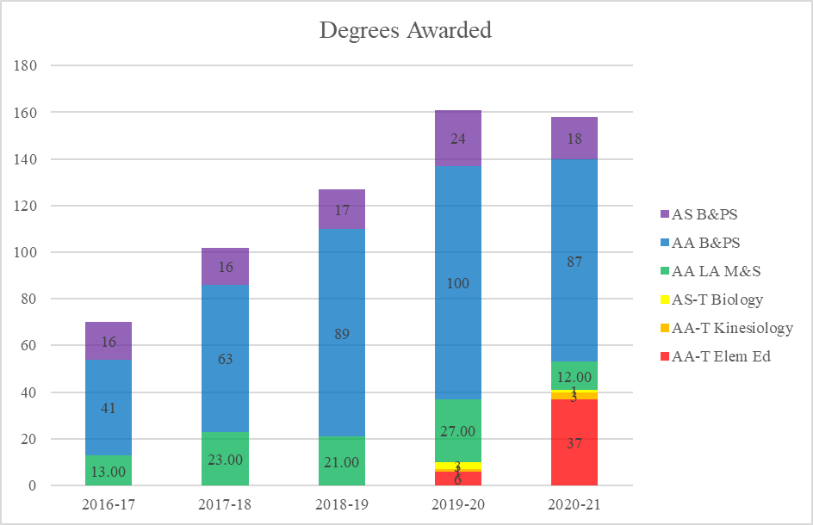

Success Rates
Until the most recent academic year, the success rates of the division have mirrored or bested the success rates of the college as a whole. The difficulties of the 2020-21 academic year, where the full year’s classes were either completely online or hybrid, are manifested in the large drop in student success rates. These data do not include counts of students who received an excused withdrawal for Covid-19 related reasons which would lower the rate for the division for the 2019-20 school year to 74.3% from 79.0%. Over 100 students took EWs from science division courses in the terms between Spring 2020 and Summer 2021, the vast majority in the Spring 2020 semester.
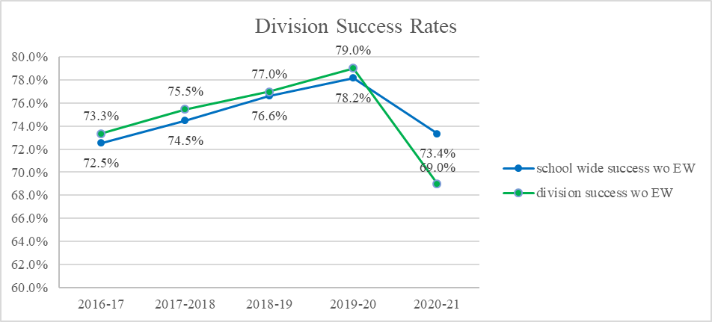
Demographics and Success Rates
For the most part, enrollment and success rates among different student populations mirror the college though it appears the science division lost more male student enrollments in the 2020-21 academic year that the whole college. Success rates for men in natural science dropped by a greater margin than they did for women over the last two years. Between the two highest reported ethnic groups for students, both Hispanic and white students saw the same percent degrees in success, of 5-6%.

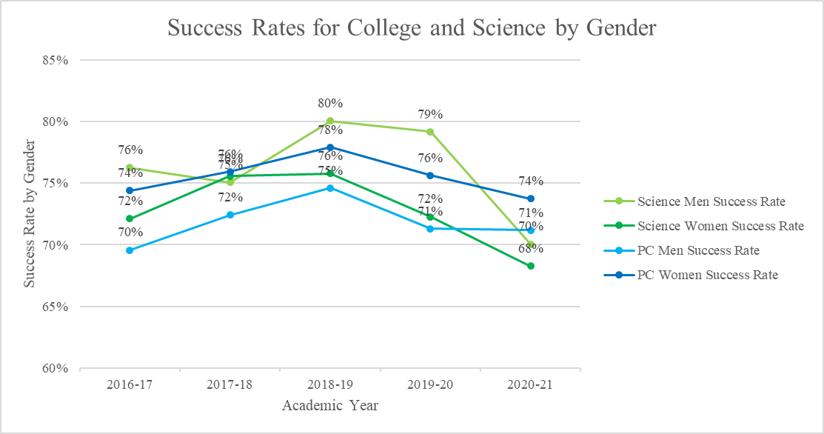
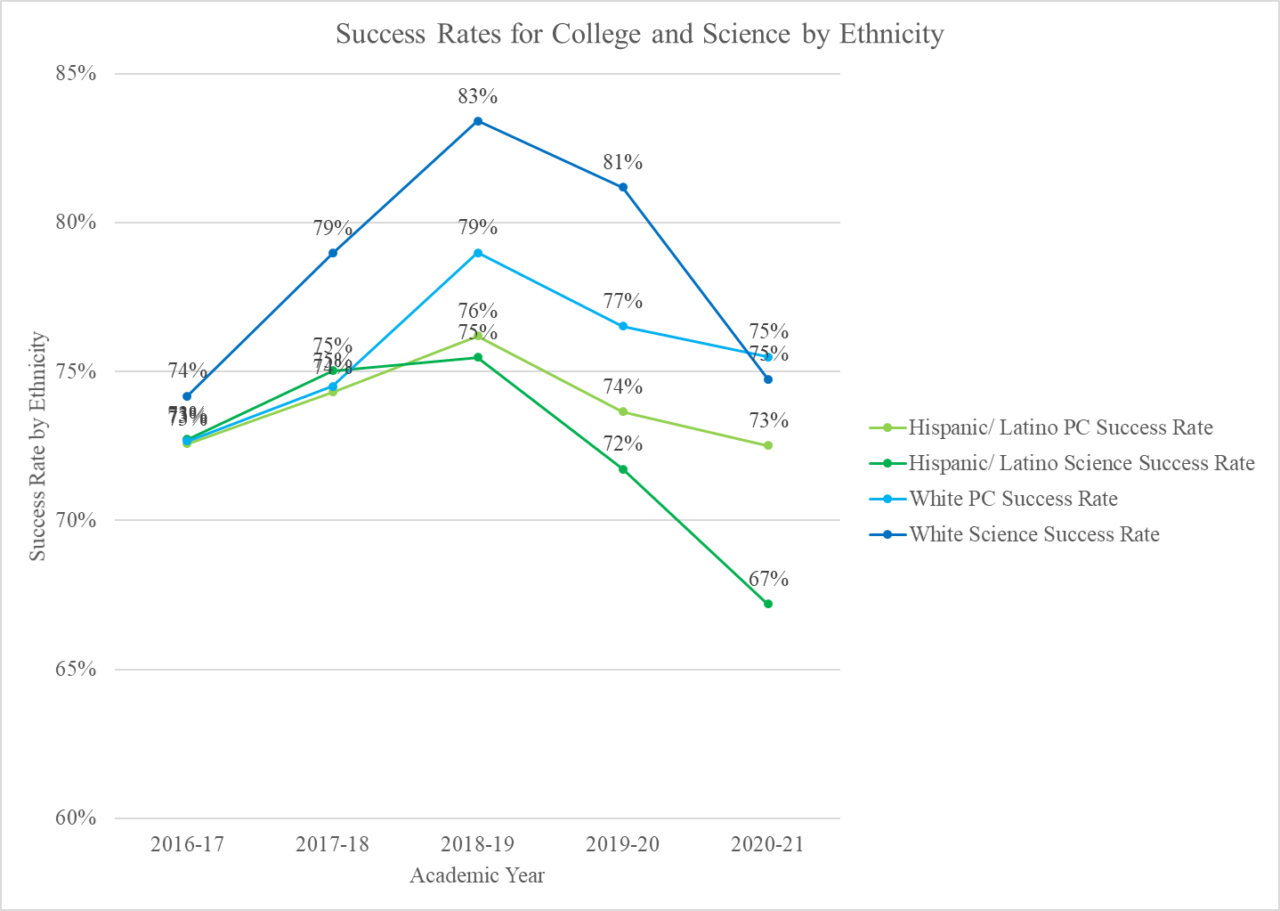
However, in reviewing student success data among different student populations there were a few categories with glaring discrepancies between groups: student type, first gen status, and economically disadvantaged and/or participants in CalWORKS, CARE, or EOPS. These are shown and discussed below.
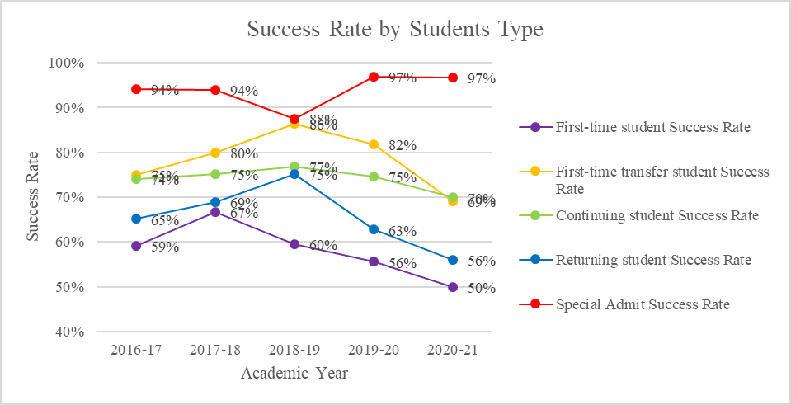
In the above chart, while success for most have dropped, both returning students and first-time student success rates have dropped precipitously in the last two to three years. (Special Admit are dual enrollment students who appear to have an exceptionally high success rate.)

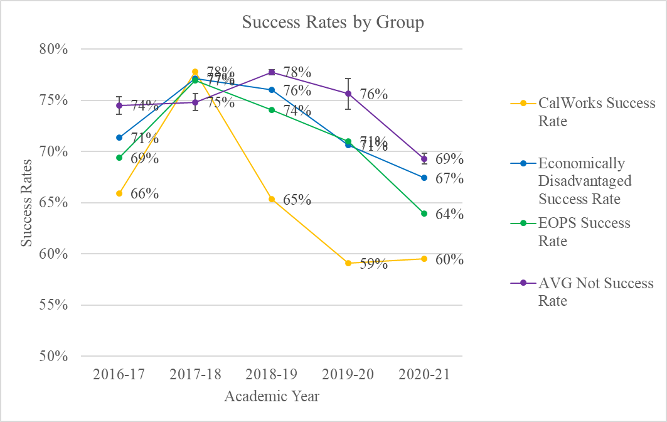
In the above chart, multiple categories are shown. Each group, CalWORKS, CARE, EOPS, and economically disadvantaged, have data compared to students who are not in the program or group. (CARE was omitted from the graph due to less than 30 students in the group.) The success rates of the “not in X” were very similar and combined into the top line with standard deviation error bars shown. Each group is declining in success rates from 2017-2018 from an almost equal point, but the CalWORKS success rate shows a much more significant decline.

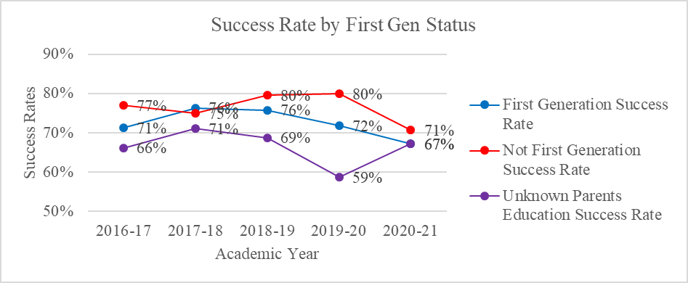
In this chart, apart from the 2017-2018 academic year, there is a large discrepancy between first generation students and non-first-generation students, most notably in the 2019-2020 school year. Whether this is a fluke due to the Spring 2020 semester remains to be seen.

Courses, Enrollment, Waitlists, FTES and FTEF
 | 2016-17 | 2017-18 | 2018-19 | 2019-20 | 2020-21
Course Count | 16.0 | 17.0 | 18.0 | 17.0 | 17.0
Section Count | 45.0 | 46.0 | 56.0 | 52.0 | 60.0
First Day Enrollment | 1,306.0 | 1,333.0 | 1,615.0 | 1,464.0 | 1,642.0
Census Enrollment | 1,358.0 | 1,362.0 | 1,642.0 | 1,490.0 | 1,569.0
Students Per Section | 29.8 | 30.2 | 30.1 | 30.4 | 25.1
First Day Waitlist Total | 454.0 | 478.0 | 491.0 | 542.0 | 537.0
Waitlist/section | 10.1 | 10.4 | 8.8 | 10.4 | 9.0
FTES | 304.9 | 309.3 | 360.5 | 355.6 | 327.5
FTEF | 17.8 | 18.2 | 21.3 | 20.9 | 23.3
FTES to FTEF Ratio | 17.2 | 17.0 | 16.9 | 17.0 | 14.0

Above is a general summary of the enrollments in the Natural Science Division. Since the 2016-17 academic year, the section count has increased by 33%. This can be attributed to the hiring of a new faculty member in 2018 and expanding the adjuncts teaching courses. Though some classes do have higher waitlists than others, on average the number of students on waitlists is between 9 and 10 per course. The dip in FTES to FTEF ratio in 2020-2021 can be attributed to some classes having smaller class sizes due to ongoing restrictions on lab classes, also seen in the students per section.
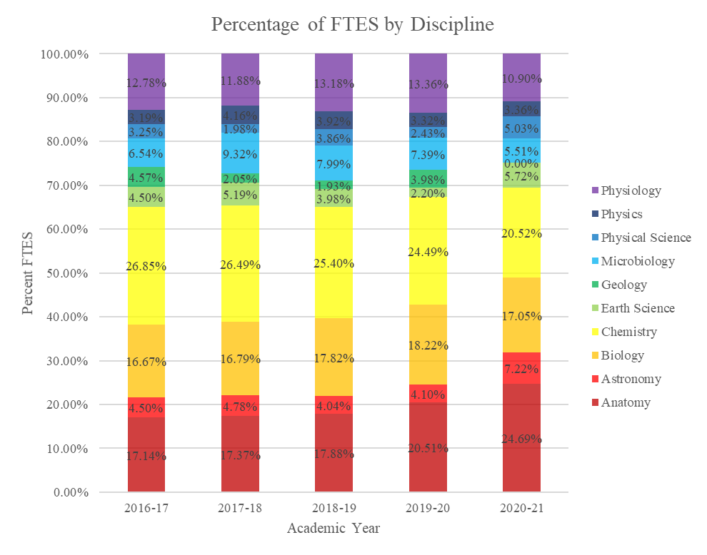
Above is the percentage of FTES by discipline. The largest are anatomy and chemistry courses, though both of those disciplines offer multiple courses. ChemP106 and AnatP110 are very popular courses for future nursing students and for others exploring science and science-adjacent majors. The earth science, physical science, and geology are expected to become a larger source of FTEF in the future.

Below, the contributions of adjuncts, overload, and summer school are shown in the increase in FTEF over the five-year period. The science faculty regularly teach overload. The adjunct FTEF has also increased.
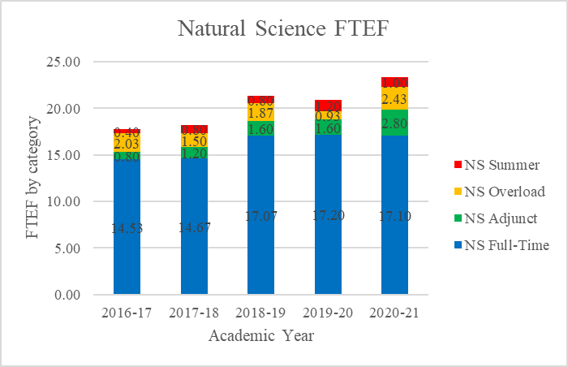

Changes in Program over Last Three Years
Many changes have occurred in the division over the last three years, most significantly in the last two years. The division began awarding a biology AS for transfer in the 2019-20 academic year. This degree is designed for the many Natural Science Division students who intend to transfer to CSUs and pursue degrees in biology or pre-medicine, dental, and veterinary programs. The liberal arts in math and science degree was discontinued as planned. Many of those students pursued the elementary teacher education AA-T which requires several courses from the science division: ERSCP110, PHSCP112, and BIOLP110. The kinesiology division also began offering an AA-T which requires a choice of courses from the science division: BIOLP110, ANATP110, PHYLP101, and CHEMP101A. The chemistry faculty have noticed that there is another optional course on the transfer model curriculum for the kinesiology degree which would negate the need for them to take the first semester of the majors’ course and is working on adding it to the curriculum. This new chemistry course would also better prepare nursing students for physiology and microbiology courses instead of taking the introductory chemistry class and would retain space in the majors’ course for chemistry and biology majors.

The response to Covid-19 pandemic in March 2020 turned the division inside out. All courses were forced to move online, a move to which the division had been averse in the past, especially for the lab component of courses. The faculty were quickly inundated with canvas and zoom tutorials and regularly helped each other out with tips, tricks, and zoom happy hours. Courses continued to be online as the Fall 2020 semester started, while faculty worked frantically to get labs to return to campus and/or procure adequate materials to send home to students, resulting in a spending spree. The Porterville College Lending Library staff and the lab technician played a vital role in distributing this material to students. In Spring 2021, some courses were allowed back on campus for labs in a reduced capacity, which still required students and faculty to complete some parts of lab outside of class. Finally in Fall 2021, courses were able to return to campus for lecture and lab, most continuing to operate on a reduced class size, from 30 to 24 or 15 students. The division plans to maintain 24 students in most classes to match both lab safety guidelines, pedagogical guidance, and the other science courses offered in the district.

While online, courses saw the drop in success mentioned in the data review. Academic integrity became a major issue as students were not getting the experience and confidence they needed while attending class online and online assessment made the temptation to cheat very strong. The cheating was a symptom of the problems arising from online teaching of science courses. Science is a team sport; no one does science alone. The interaction and discussion with peers are mandatory; discussion with peers in a breakout room is not effective. If students feel stronger as a student, learning is easier, desperation does not set in, and students are more successful.

Two long term faculty members decided to retire early at the end of the Spring 2021 semester. The two positions were posted for replacement, but one was deemed unsuccessful. A new biological sciences faculty member was hired to begin in the Fall 2021 school year. The unsuccessful search prompted a summertime one-year temporary faculty search for earth sciences which through an unfortunate sequence of events resulted in a last-minute cancellation of all scheduled classes in the earth sciences for the Fall 2021 semester. Additionally, an adjunct/dual enrollment faculty member retired.

It wasn’t all bad, the Natural Science division has increased its course offerings taught by adjunct faculty. New hires in chemistry and earth sciences have served to supplement course offerings online and in the evening, in addition to the retention of adjunct faculty teaching anatomy courses. Two new adjuncts were found to teach late start classes to compensate for the loss of the earth science and geology sections in Fall 2021.

In another update from the previous program review, the science division was about to start offering two sections of majors biology (BIOLP105&106) before the pandemic hit and while still planning on doing so, is waiting to see the demand go back up to levels from two years ago. The same is planned for majors chemistry courses (CHEMP101A&B).

Report on Previous Goals
Goal | Status/Progress
1. Articulate C-ID approved Physical Science P112 with Fresno State’s NSCI 1A/w lab | Complete
2. Develop a Certificate of Achievement for Allied Health | Both certificate plans have been put on hold to determine their impact on other degrees, i.e., would students not pursue an associates if they earned a certificate
3. Develop a Certificate of Achievement for Science Career
4. Enable tech lab instructional resources to keep pace with additional labs offered. | The division was able to get more laptop computers to enable more than one class to use them at a time
5. Discontinue the AA in Liberal Arts – Emphasis in Math & Science | Complete-Elementary Teacher Education AA-T degree has replaced the need for this degree.
6. Offer more sections of science classes to meet the needs of students | ongoing

Program Strengths
The Natural Science Division prides itself on having full and rigorous courses that challenge students to stretch their critical thinking skills while working closely and collaboratively with each other. The division is focused on student success, not just in the current class but in preparing students to be successful in subsequent courses. The ability of faculty to seek out alternative lab activities while courses were taught 100% online is to be commended along with the ability of students and faculty alike to persevere through so much uncertainty and last-minute changes in the way courses would be offered. Faculty were and are eager to teach their students in face-to-face modality, especially for lab components and over the course of the emergency have worked with administration and Maintenance and Operations (M&O) to bring students back in the safest way possible. During the middle of the online Fall 2020 semester, the Natural Science Division pulled together some bullet points in support of in-person labs in particular:
- Students can improve their lab grades by getting immediate feedback (professors can't see what they're doing or writing on Zoom).
- Students can then improve their understanding of the material as a whole.
- They can build relationships with classmates and instructor. They have the ability not only to see others, but they can hear other conversations for reinforcement instead of being separated in a Zoom breakout room.
- In person labs would then build confidence in their abilities to learn and do the material leading to less desperation on any assessment.
- In person labs would create more interest and engagement with the material.
- It would allow students to take advantage of different learning styles. Labs access the kinesthetic learning modality making the learning more concrete. When students can physically be in lab, they utilize all learning styles and can be more successful.

The division offers the necessary required prerequisites for students to transfer and major in any biological science, chemistry, or physics emphasis. Healthcare careers are commonly mentioned - (Pre-Medical, Pre-Dental, Pharmacy, Veterinary Medicine, Physical Therapy, Occupational Therapy, Respiratory Therapy, 2 or 4-year RN programs, Radiology Technician, Dental Hygiene, Psychiatric Technician). The division offers courses during the day and evening and recently began offering labs on Friday afternoons because of limitations of laboratory space. In the Fall 2021 semester, six different courses had their labs in the evening, nearly maxing out the space upstairs, while two were held on Friday afternoons. The division is expanding its summer course offerings, offering 2-3 sections in the summer, including offering online courses the last two summers. The division is balancing the challenge of hybrid courses and maintaining high standards for students and faculty.

The Natural Science Division has long had a recommended “pathway” for pre-nursing students to follow and has worked with Guided Pathways to create pathways for all possible iterations a Biological and Physical Science AA or AT student might pursue, along with pathways for the AS-T majors. Members of the division are working with Central Valley Higher Education Consortium (CVHEC) to align PC pathways with UC Merced. In another effort to make pathways clearer, the division is moving to recode biological science classes with biology rather than separate anatomy, physiology, and microbiology designations. It is hoped that with a new numbering system, students will be more inclined to take classes in the best order for success.

Division members are well represented in committees on campus and involved in the community. Science faculty have been advisors for campus clubs such as Mecha, PTK, and CCM, serve on the Environmental Science Academy advisory board at Monache High School and Harmony Academy of Engineering, represent faculty for the Porterville College Foundation, Strategic Planning, Data Team, and the Dual Enrollment committee, headed the Curriculum Committee, as well as serve on each committee that requires a division representative like Academic Senate, Outcomes Committee, Scholarship, Curriculum, Enrollment Management, and College Council.

Areas for Improvement
The Natural Science Division is offering around 30 labs per week from 8 am in the morning until 9 pm in the evening. This is in the four upstairs lab rooms connected to the prep lab and will soon again include the lab room on the first floor of the Science-Math (SM) building. The division has one lab tech whose job it is to prepare lab items, move them in and out of labs, and order supplies. Many colleges have a separate lab tech for biological and physical sciences as the courses exist in different departments. Student workers have helped with the minutiae of the lab preparation and cleanup but that is not sufficient and certainly will not be enough when two new faculty arrive. There are simply not enough hours in the day, and this can lead to mistakes in lab preparation when it is critical for students’ experiments. In addition, there is uncertainty around quarantine procedures during the ongoing pandemic. If the lab tech is out, many labs will not be able to run. The division and the lab tech need the support of another full-time lab technician.

Physical space for labs is always an issue. The division has spread out to Friday afternoons to hold labs as well as almost every evening but cannot add many more classes for logistical reasons. It is hoped that space may be found in the new Allied Health building or to make use of SM-101A&B which has storage space that could be used by lab courses that do not need as much infrastructure. Even if lectures were held in a different space, there is not enough time in the class schedule to hold back-to-back labs all day, and with the aforementioned lab tech being stretched to shift items around, labs with 5-minute periods between them would not be feasible. The division uses four labs connected to the prep room upstairs and there is one lab room downstairs that can be used for dry labs; it does not have multiple sinks, gas and vacuum lines, and hoods like the upstairs rooms. The furniture in the downstairs room also needs a revamp. Discussions with M&O about replacing the furniture were put on hold when a new full-time earth science instructor was not hired. The division will continue to schedule courses as well as it can until more space is made available.

Finding adjuncts in Science is challenging. Porterville and the surrounding area have very few people with a master’s degree. Effort is being made each semester to look for qualified adjuncts, meaning a masters degree in the discipline with higher level course and lab work. Student wait lists show that Science could add classes each semester, however lecture and lab room usage is tight during the day between 8:00 AM - 4:10 PM when pedagogically “puzzle-piecing” 6 hr/wk and 9 hr/wk classes in the needs for lecture and labs (especially due to live lab materials not being able to be delivered Monday or Tuesday morning). Adjuncts who can come in for late afternoon and evening classes would benefit the many students that are on waitlists.

Though all PC students have always needed both a physical and biological science course to earn their degrees, the influx of Elementary Teacher Education AA-T students increased demand for both physical science (PHSCP112) and earth science (ERSCP110). The addition of a biological science professor in 2018 helped to increase the Introduction to Biology (BIOLP110) offerings. The need for earth science and physical science have outpaced the available sections and is an area of concern for the division. Both courses, but especially physical science, have proven difficult to find qualified adjuncts to teach. Throughout the emergency orders, the classes have been able to be offered online, but should the emergency end, courses would need to be taught in person or hybrid with the lab component being in person. The division has requested both a replacement and new faculty positions to meet this need.

In looking at the success data for students, the division will endeavor to increase success for first time students, first gen students, and students from CalWORKS and CARE. It is unknown to which degree these categories overlap but the division would like to focus on first time students and first-generation students. The demands on science students' time and study habits can be more than expected for new students. In addition to first day communication with students, the division would like to offer something else to help students be successful. Some ideas have been a science major orientation, student success class geared towards science students, and/or a bridge program for incoming students. The division would also like to work more closely with the new STEM Center and encourage students to become involved in activities there. Additionally, the division can better utilize PASS leaders, the problem being not enough students take advantage of a PASS leader when available. In order to assist economically disadvantaged student populations, the division is looking into Open Education Resources (OER) textbook sources to alleviate some costs of taking courses. The division will continue to be cognizant of these inequities in success rates and seek to rectify them.

Goals (This section is for you to report on progress on new goals. If your program is addressing more than 3 goals, please add rows.
Note that for the Mission Statement column, please list the numbered goal(s) from the college Mission Statement and Guided Pathways Pillars (see page 1) that would be furthered if this goal were accomplished.)
Goal(s) | Timeline for completion | Needed resources | Person(s) Responsible | Obstacles to completion (if any) | Mission Statement | Guided Pathways Pillars
1. increase section offerings | ongoing | Physical space, qualified adjuncts | Division chair | Physical space, availability of qualified adjuncts | 1, 3, 4 | 3, 4
2. Recode biological science classes to all have BIOL course code | Spring 2022 | n/a | Curriculum representative | Time, cooperation with other disciplines who will be affected | 1-3 | 1-3
3. Add chemistry course for kinesiology majors and allied health students | Spring 2022, offered Fall 2023 | Will require some new lab equipment | Chemistry faculty | Curriculum committee, cooperation with other disciplines who will be affected | 1, 3, & 4 | 1-3
4. Increase success in student populations of concern | Spring 2025 (next Program Review) | Depends on what form this takes | all | Funds for orientation or bridge program, time for student success curriculum | 1-3 | 3-4
5. Align courses with UC Merced for program mapper | Spring 2022 | n/a | Division chair, curriculum rep, biology faculty | Courses may not be offered at PC | 3 | 3-4
6. Close loop on SLOs | Fall 22 | n/a | Division faculty | Finding time to do so | 1 | 4

Staffing:

Current Staffing Levels

Please use the table below to describe current staffing levels, by employee type. Raw numbers are sufficient, not FTE.

Full-time |  | Part-time
Faculty | 8 | Faculty | 5
Temporary | 0 | Temporary
Classified | .92 | Classified
Management | 0 | Management

Request for New/Replacement Staff

Use one line for each position requested. Justify each position in the space below.

 | Title of Position | Classification  (Faculty, Classified, or Management) | Full or Part  Time | New or Replacement
Position 1 | Earth Science/Geology | faculty | full | replacement
Position 2 | Physical Science Professor | Faculty | full | new
Position 3 | Additional lab technician | classified | full | new

Justification:
(Address each position requested. Note that a position need should be demonstrated in earlier sections, such as your needs for improvement or to meet specific goals)
The two position requests are necessary for the support of the AA-T Elementary Teacher Education and AS-T Environmental Science. Student demand for the courses in this program exceeded the section count even before the previous faculty member retired. Additionally, the requirements to teach the courses are rarely found in the same individual.
As mentioned previously, with expanding lab sections, an additional lab tech position is necessary to ensure the smooth and safe functioning of the laboratories.

Resource Requests

The following four sections are for requesting resources, such as technology, facilities, safety/security, and professional development. Please include all needs, even if you already have identified funds for them. Requests made here should be linked to needs identified in earlier sections (outcomes, areas for improvement, goals). If you have no needs in a particular area, just type NA.

TECHNOLOGY REQUEST
Use this section to list any technology needs for your program. If you have more than two technology needs, add rows below.

Technology Need | Justification
iWorx replacements for physiology classes | Those currently in use are old and not functioning
Item 2

FACILITIES REQUEST
Use this section to list any facilities needs for your program. If you have more than two facilities needs, add rows below.

Facilities Need | Justification
Remodel SM-125 | New furnishings in SM-125 and more lab space
Replace 10-foot projector screens with 7 foot screens | The SM modernization of 2008 installed larger screens over the whiteboards, however Science lessons often require calculations or notes in real time while the media projector is on. These are done on the whiteboard on either side of the media. The media projectors only cast about a 7-foot wide image. We lost precious white board space with the 10-foot screens.
Electrical outlets put onto north wall of SM-210, SM-222, and SM-125 | The SM modernization of 2008 did not enable the lab rooms to their previous state of use. Currently extension cords must run across sinks and walk ways to allow extra microscopes for student use along the back (north) walls of the lab rooms.
Replace metal key on-off switches on chemistry fume hoods with regular on-off light switches. | For ease of use and being proactive against lost keys. Fume hoods do not need to have special key only on-off switches. Regular switches that students can turn on and off are safe and practical.
The instructional station (lectern/ELMO) needs to be upgraded in the forum, along with other requests, see addendum. | The Natural Science division (as more classes are being offered) is combining lab classes into single lectures (64 students) in the forum. Science classes need to use the ELMO for class lectures. It is currently inconveniently placed on a student seat area. This is in the way of some students’ view of the screen when used.

SAFETY & SECURITY REQUEST
Use this section to list any safety & security needs for your program. If you have more than two safety & security needs, add rows below.

Safety & Security Need | Justification
Item 1 | Additional lab technician to ensure proper storage, handling, and disposal of chemicals.
Four door handles replaced at the lab door/prep room doorway | Moving students into an interior room is important to their safety in the minutes before a campus-wide lockdown of doors is achieved. Presently the door punch lock is on the wrong side of the door. A perpetrator can get into the inner preparatory room instead of us being able to lock him out. Also students always have access to the prep room where hazardous chemicals are stored and expensive instruments/equipment is kept.

PROFESSIONAL DEVELOPMENT REQUEST
Use this section to list any professional development opportunities you would like to have available for your program. If you have more than two professional development needs, add rows below.

Professional Development Need | Justification
Best practices in STEM/orientation/equity workshop | Learn how to conduct an orientation or develop a student success course with an eye for advancing equity in the classroom.
OER training & modification | Learn more about OER for science courses, which ones can be modified and how to modify them.
Lab safety | Get updated on current procedures, both for faculty and lab technicians.

Budget

(Please include all budget needs, even if your program is funded entirely by categorical funds. (Do not include staffing in this section.)

 | Current Budget | Amount of Change | Revised Total
2000 (Student Workers Only)
4000 | $25,000 | $0 | $25,000
5000 | $6,000 | $0 | $6,000
Other-6419 Other equipment | $3,500 | $0 | $3,500

Justification:

(Please justify all significant expenditures. Note that budget needs should be demonstrated in earlier sections, such as your needs for improvement or to meet specific goals)
4000 – Instructional Supplies: Increase in cost of laboratory specimens, chemicals, media, labware, supplies and other instructional materials, which are required to support quality academic programs, prepare students for transfer to four-year institutions, as well as provide skill and career training.
4000 – Non-Instructional Supplies: These funds office supplies and lab prep room supplies for faculty and staff. This includes typical office supplies, toner for our printer, lab gloves for aseptic procedures, etc.
5000 – This account funds the biological and chemical waste disposal costs, deionized water service microscope maintenance costs, scientific equipment repair, and new software licenses.
6000 – Microscopes need to be replaced on a regular basis. $3500.00 provides funds to purchase three microscopes each year and to retire the oldest ones on a continual basis, eliminating the need for the division to request $20,000-$25,000 to replace microscopes every 10-15 years. While not specifically requested in the budget, the division is heavily dependent on expensive equipment, chemicals, and supplies in order to offer science lab classes. In the future, the division may need to request funds to replace defective equipment or to pay for supplies for added classes.

