Porterville College Mission Statement:

With students as our focus, Porterville College provides our local and diverse communities quality education that promotes intellectual curiosity, personal growth, and lifelong learning, while preparing students for career and academic success.

In support of our values and philosophy, Porterville College will:

- Provide quality academic programs to all students who are capable of benefiting from community college instruction.
- Provide comprehensive support services to help students achieve their personal, career and academic potential.
- Prepare students for transfer and success at four-year institutions.
- Provide courses and training to prepare students for employment or to enhance skills within their current careers.
- Provide developmental education to students who need to enhance their knowledge and understanding of basic skills.
- Recognize student achievement through awarding degrees, certificates, grants, and scholarships.

Guided Pathways Framework:

- Clarify the Path: Create clear curricular pathways to employment and further education.
- Enter the Path: Help students choose and enter their pathway.
- Stay on the Path: Help students stay on their path.
- Ensure Learning: Ensure that learning is happening with clear outcomes.

Program Mission Statement:

The Learning Center supports the mission of Porterville College by offering academic support to students at every level of skill and ability through peer and faculty tutorial services, peer mentorship in English and Mathematics, and a supervised learning software lab.

Vision:

The Learning Center provides outstanding, multi-faceted academic support to Porterville College students, partnering with them to facilitate the achievement of their goals.

Values:

In support of our mission statement and vision, the Learning Center is committed to the following core values:

Students—The Learning Center values each student and is committed to the College Mission Statement’s opening statement: “With students as our focus . . . .”

Learning—The Learning Center exists to support student learning and provides customized assistance to facilitate student success

Assessment—The Learning Center is committed to an on-going process of assessment designed to monitor and improve the effectiveness of our service to students.

Service Area Outcomes (SAOs):

(For each Service Area Outcome (SAO) identified by your program, please complete the table below describing how the assessment results have been discussed in the program and how they impact your goals and needs. If your program has more than two SAOs, please add rows.)

SAO Statement | Describe assessment results and discussion of this SAO | Describe how the results impact your goals and needs going forward
1. Students that utilize the Learning Center services will improve their course completion rate | This will be assessed on a yearly basis with data from the Learning Center tracking software compared to Cognos course completion data. Data was gathered from the Learning Center starting from 2013-2014 academic year to 2021-2022 academic year and was compared to current and historical data in Cognos. Learning Center success rate data continually show increasing improvement regarding students utilizing the Learning Center vs those who do not. 2018-19 data has a 5% difference and an even wider gap that doubled in 2019-20 showing the students utilizing the Learning Center services have a greater opportunity for student success. | Based on the results for the past three academic years, a continuing goal is to increase the number of students utilizing the Learning Center services. The investment of staff and student workers (E.g., PASS Leaders, Tutors) will help to increase the number of subjects and timeframes we are able to provide support.
2. Students are aware of the Learning Center services. | This will be assessed every semester with the end of the semester survey data. The end of semester survey will be used to assess student awareness of tutoring services and determine ways to increase rates in which students learn about and take part in the tutoring services provided. Results of the survey display that 96.2% of students are aware of services provided. This shows that our outreach to students is effective in spreading awareness of services provided. 80 out of 800 (10%) of student within the parameters (Students that utilized the Learning Center/Innovation Centers or students with a 2.0 or below GPA) responded to the survey. | Based on the end of semester survey for Fall 2021 the goal is to turn student awareness into utilizing our services.

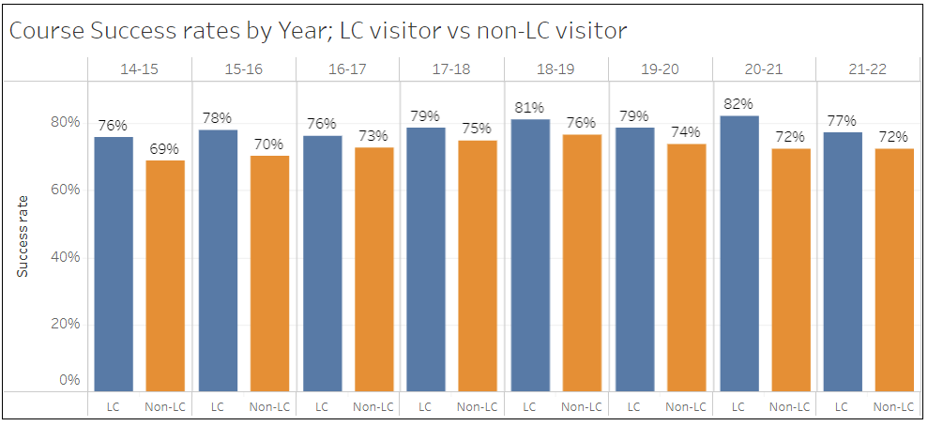
FALL TO FALL COMPARISON
Type | Fall 2020 | Fall 2021 | Difference | % Change
Appointments | 440 | 833 | 393 | 89.32%
Unduplicated Students | 127 | 263 | 136 | 107.09%
Type | Fall 2020 | Fall 2021* | Difference | % Change
Appointments | 440 | 552 | 112 | 25.45%
Unduplicated Students | 127 | 210 | 83 | 65.35%
* Without Testing

Program Analysis and Trends:

(This section is intended to evaluate your program, including data review, changes over the past three years, progress on previous goals, strengths of the program, and areas for improvement.)

Data Review

(Please review data provided by the KCCD Office of Institutional Research here. Discuss trends in your program including things such as enrollment, offerings, demographic trends, course success rates, and awards. Be sure to address any equity issues in your data, including course success rate differences.)

The Learning Center served 397 unduplicated students in the 2020-21 academic year, a 33.83% decrease in the number of unduplicated students the LRC served in 2019-20 (approximately 600 unduplicated students). This decrease in unduplicated students stems from a decrease in enrollment for 2020-21 in comparison to 2019-20. The Learning Center’s headcount is largely a reflection of Porterville College’s current student headcount with the Learning Center serving approximately 10% of the PC’s headcount. The Learning Center transitioned from SARS to Navigate in October 2020, so the data from SARs with the number of students is inaccurate particularly as student workers would clock in and out via SARS.

Learning Center Overview
The overall success of the Learning Center was reviewed by two studies. The first study compared the students who used the Learning Center services to students who did not use the Learning Center to see if students who used the Learning Center services were more likely to pass their course. The study disaggregated the data to see if the number of times a student visited the Learning Center had an effect on their completion rate. To better understand the Learning Center’s effective on student completion, the data was separated according to English, math, and all other courses. The data indicated that the more times students visit the Learning Center the more likely they are to successfully pass their course.

English Courses:
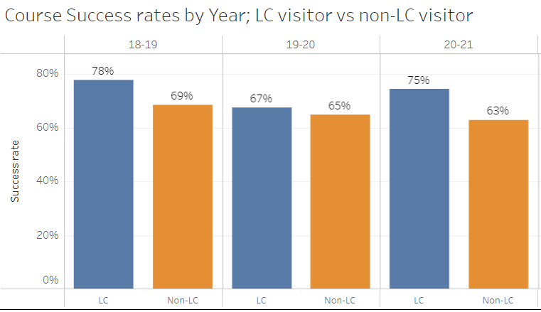

Math Courses:
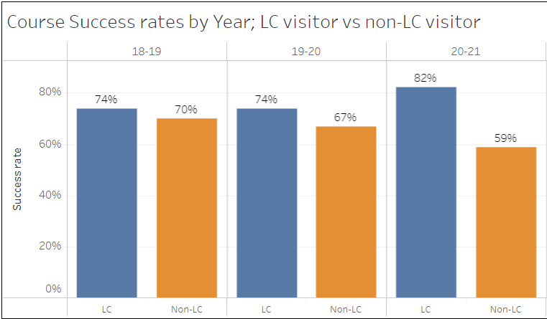

All Other Courses:
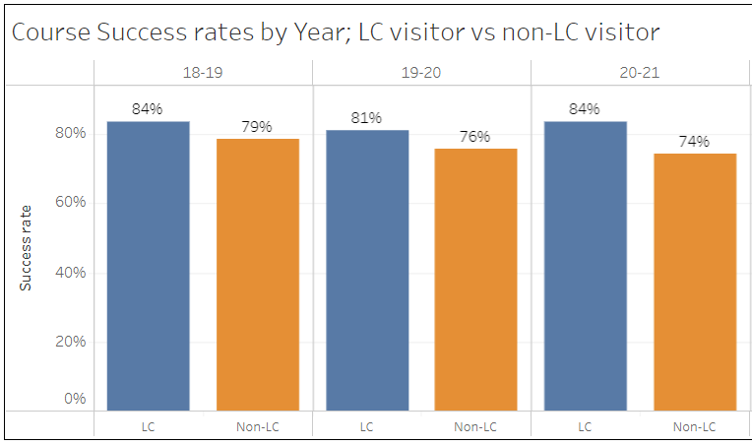
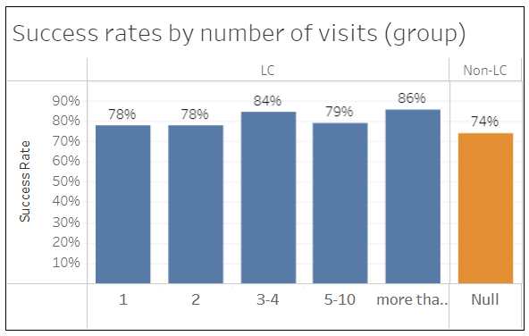

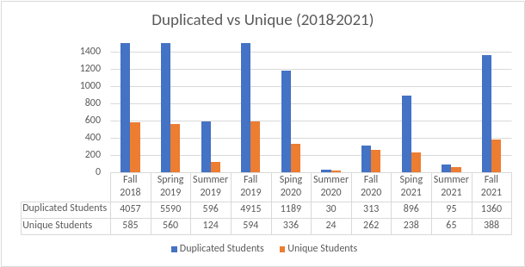

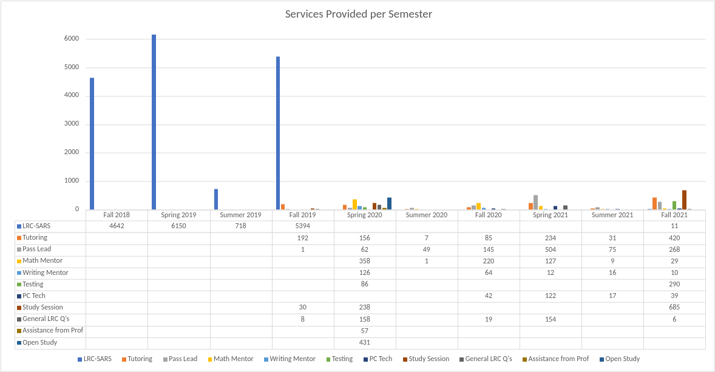
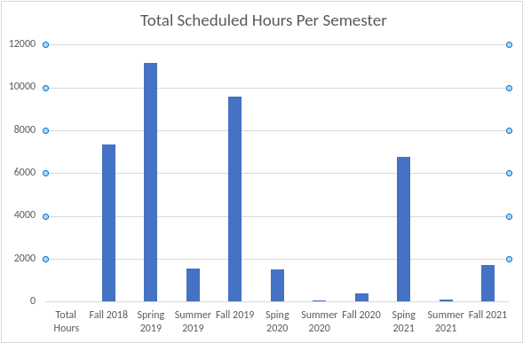

CRLA Training
Academic Year | Total
2017-18 | 7
2018-19 | 8
2019-20 | 2
2020-21 | 10
TOTAL | 27

The second study used the End of the Semester Survey to determine if students who had at or below a 2.0 GPA were aware of the Learning Center services and for the students that did utilize our services how could we better support them in their courses. The questions that were used for this survey were centered around the students' experiences and awareness of the Learning Center. The questions were asked to collect data on how the students have learned about our services, issues faced, how students would want to be contacted, areas of assistance, and student success. The end of semester survey questions are attached, and the results are below:
- Students had different suggestions on how to improve their experiences (Question 1 in ¼), these suggestions included services outside of the learning centers control.
- Of all the pathways, the top four ways students hear about our services included through instructors, advisors and counselors, email and through their peers. (Question 2 in ¼)
- Out of all the methods of communications the top three ways students wanted to be contacted was through canvas, email, and text messages. (Question 1 in 2/4)
- The areas students needed the most assistance was in homework, terms and concepts, and study skills.
- Of the 96.2 percent of students that were aware of the Learning Centers services, 46.84 percent have utilized the services provided. Of the students that did not seek support (50.63%) 61.11 percent believed that learning center support services would have helped them to be more successful. (¾)
- To gain a deeper level of understanding of the students it was asked what the biggest obstacles were faced this semester and the results displayed that students’ faced problems with time management, personal issues, and their courses.
- Per question 8 (4/4) the learning centers have proven to be very helpful or helpful in Math, English, Science, other languages, other courses, and tech support.
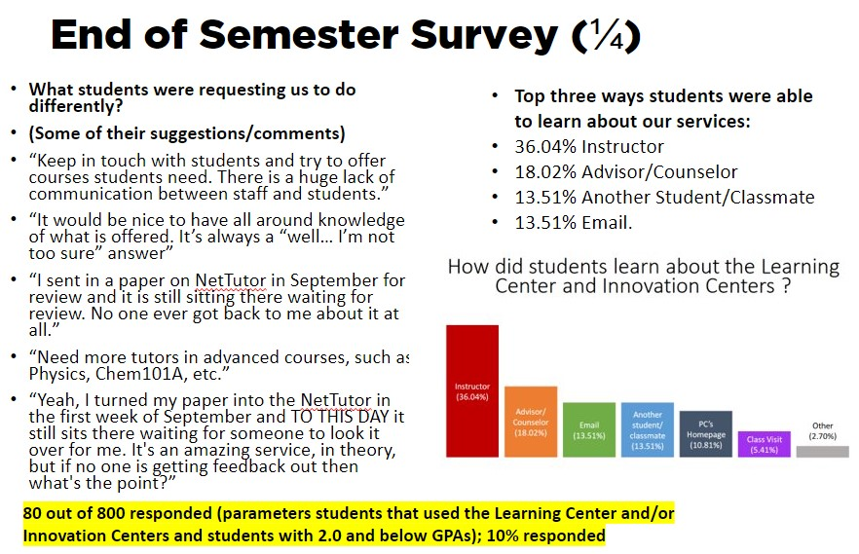
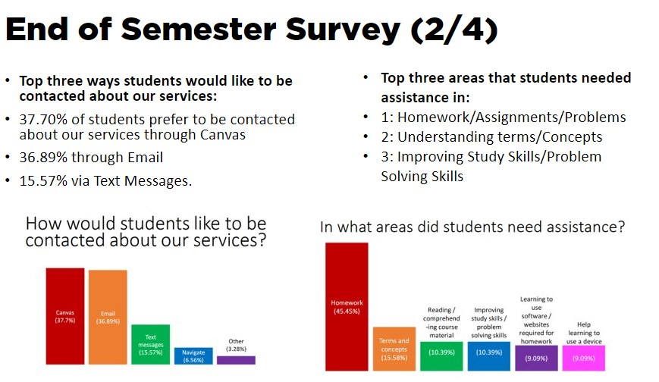
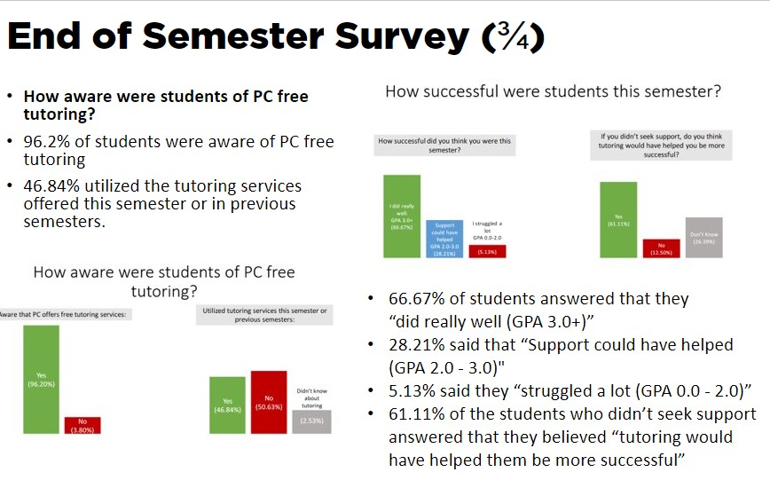
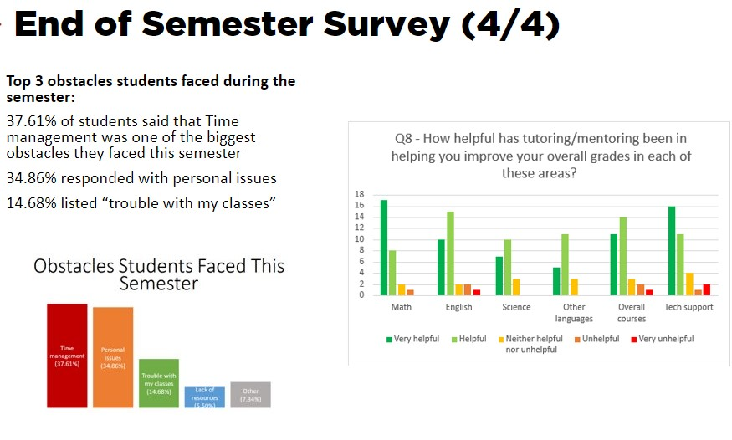

Testing

The Learning Center in Fall 2019 added Pearsonvue testing to ensure students who have access to much needed industry certifications. Unduplicated students using testing services: during the Fall 2018 semester, 188 unduplicated students used the provided Learning Center testing services with 32% of them being DRC students, 61 unduplicated. The Spring 2019 semester had 145 unduplicated students and 44% being DRC students, 64 unduplicated. During the 2018-2019 year, 289 unduplicated students used testing services and 32% being DRC Students, 93 unduplicated. The total number of testing appointments during Fall 2018 was 464 with 56% being DRC students, 258 DRC and 206 non-DRC. Spring 2019 had 417 testing appointments with 71% being DRC students, 294 DRC and 123 non-DRC Students. For 20189-2019, 881 students used testing services with 63% being DRC students, 552 DRC and 329 non-DRC students.

During the 2019-20 year, Fall 2019 had 46 unduplicated DRC students and 95 non-DRC students. During spring 2020, there were 100 appointments for testing that had to be canceled due to COVID-19 and transferring to virtual. There was no testing done until Fall 2021.

2018-19 Unduplicated Students Testing Appointments
Term/Academic Year | Total Unduplicated Student Testing in Learning Center | % of DRC Unduplicated Students who Tested in Learning Center | Unduplicated DRC Students | Unduplicated Non-DRC Students
Fall 2018 | 188 | 32% | 61 | 127
Spring 2019 | 145 | 44% | 64 | 81
2018-19 | 289 | 32% | 93 | 196

2018-19 Testing Appointments
Term/Academic Year | Total Testing in Learning Center | % of DRC Testing in Learning Center | DRC Testing | Non-DRC Testing
Fall 2018 | 464 | 56% | 258 | 206
Spring 2019 | 417 | 71% | 294 | 123
2018-19 | 881 | 63% | 552 | 329

2019-20 Unduplicated Students Testing Appointments
Term/Academic Year | Unduplicated DRC Students | Unduplicated Non-DRC Students | Total Unduplicated Student Testing in Learning Center | % of DRC Unduplicated Students who Tested in Learning Center
Fall 2019 | 46 | 95 | 141 | 33%
Spring 2020
2019-20

2019-20 Testing Appointments
Term/Academic Year | DRC Testing | Non-DRC Testing | Total Testing in Learning Center | % of DRC Testing in Learning Center
Fall 2019 | 160 | 142 | 302 | 53%
Spring 2020*
2019-20

*COVID-19 pandemic so testing was cancelled in the LRC.
Changes in Program over Last Three Years

(Please review significant changes in your division in the past three years, including things such as new or revised curriculum, programs added or discontinued, program growth or decline, significant changes in personnel or policy, local, state or federal policy changes that might impact the program, new or reduced resources, or changes in how the program is organized and managed at the college.)

As of Fall 2018, the Learning Center serves students 14 hours/day Monday – Thursday (7:00 a.m. – 9:00 p.m.) and 4 hours on Friday (8:00 a.m. – noon) for a total of 60 hours/week. The Learning Center serves about 300 students each academic year through the Peer Assisted Study Session (PASS) Leaders, Writing Mentors, Math Mentors, and Peer and Embedded Tutors. The Learning Center now conducts all DRC testing needs. Each program in the Learning Center now has a Student Lead who provides training and guidance to brand new tutors, PASS Leaders, and writing and math mentors. The implementation of Leads has enabled the LRC to maintain uniform tutoring and PASS sessions.

The area in front of the Learning Center was redesigned Summer 2021 to create a student learning space that is more student-centered and service driven. The redesign entailed the purchase of brand new furniture and a new ClearTouch Interactive TV to provide consistent up-to-date information to students. In Spring 2019, Peer and Embedded Tutors program was recertified as College Reading & Learning Association (CRLA) Tutor Level I Certification. This program has normed all training for Peer and Embedded Tutors, so that they can provide more comprehensive tutorial services to students. As of Spring 2021, 10 Peer/Embedded Tutors have completed their CRLA Tutor Level I Certification and currently 27 Peer/Embedded Tutors are being trained.

The Learning Center joined the STAR-CA program Fall 2019. STAR-CA is a California wide program that unites the community colleges to provide support to students with tutoring in a wide variety of subjects. Porterville College taking part in this program is beneficial to student success and is helpful for students to have accessible tutoring in subjects that we may not be able to provide.

The Learning Center became a PearsonVUE testing site in Fall 2019 to offer industry certifications to our students including CSET and CBEST testing.

Report on Previous Goals

(In this section, report on goals established in your previous program review. Please include progress to date, including whether the goal is complete, revised, and how any circumstances might have impacted your completion of the goal. If you had more than three goals, please add rows.)

Goal | Status/Progress
1. Identify and adopt a system for data collection on academic impact of drop-in and scheduled tutorial services | This goal was completed Fall 2020 using Navigate. All student workers and professional experts were trained in Fall 2020 on how to use the software to add students to their schedules. This created uniformity in how all student workers collect data for programmatic review.
2. Engage in outreach to increase the number of students who utilize the Learning Center | This goal is ongoing but Fall 2021 saw an increase in the number of students that utilize the Learning Center. With the Learning Center now using Navigate, it is a more accurate system to measure data whereas before the SARs system was also used to clock in and out for student workers.
3.

2021-22 FALL TO FALL COMPARISON – Goal #2
Type | Fall 2020 | Fall 2021 | Difference | % Change
Appointments | 440 | 833 | 393 | 89.32%
Unduplicated Students | 127 | 263 | 136 | 107.09%
Type | Fall 2020 | Fall 2021* | Difference | % Change
Appointments | 440 | 552 | 112 | 25.45%
Unduplicated Students | 127 | 210 | 83 | 65.35%
Program Strengths

(Based on a review of your outcomes assessments, data, recent changes, and anything else you would like to highlight, please review your current areas of strength.)

The Learning Center was renewed for College Reading and Learning Association (CRLA) Level I Tutoring Certification in Spring 2019. With the new certification, The Learning Center is able to certify Peer/Embedded Tutors as Certified Tutors. The certification sets professional standards of skill and training for tutors, thus enabling Peer/Embedded Tutors to provide exemplary tutorial services to PC students.

The Learning Center has bi-weekly mandatory student worker meetings to ensure student workers are aware of ongoing projects, events and training available. These bi-weekly meetings have ensured that all student workers are engaged

The creation of the Discord for the Learning Center to transition to a virtual timecard system, while also serving as a tool for students to connect on shared hobbies and coursework. Some PASS Leaders will slowly start offering their services via Discord as their online option.

In the onset of the COVID-19 pandemic, the Learning Center created the Virtual Learning Center which hosted all the services that we offered in the physical location in an online environment.

In Fall 2019, the Learning Center implemented subject specific campaigns via Navigate focused on at-risk students. This service has helped the Learning Center to steadily start regaining the number of students that it lost with regular foot traffic when the Learning Center wasn’t online. It also has provided an avenue for student workers to reach out to students before their appointments to remind them to bring their textbooks or their prompts. In Spring 2022, we are implementing students' ability to self-schedule appointments with our student workers through Navigate.

Areas for Improvement

(Based on a review of your outcomes assessments, data, recent changes, and anything else you would like to highlight, please review your current areas for improvement. Note that the areas of strength and improvement identified here should inform the goals, budget, and other resource requests later in the document.)

There has not been a Director for the Learning Center and Library for more than ten (10) years. It is necessary to have a director who is responsible for comprehensive academic support services programming that provides students with additional learning assistance outside of the classroom; as well as streamlining the support services in this area. It will also help to streamline the data collection practices for each program. Currently, the Learning Center is staffed with one full-time technician and one part-time technician.

With the increase in testing in Fall 2018 due to DRC testing moving to the Learning Center, one full-time and one part-time technician is no longer meeting the needs of the Learning Center. If the Learning Center had two full-time technicians, the Learning Center would have ample coverage to assist DRC testing needs. Furthermore, the two positions alone do not meet the growing student demand for tutoring, mentoring, and supplemental instruction. An additional full-time position is needed to meet the student demand.

Goals (This section is for you to report on progress on new goals. If your program is addressing more than 3 goals, please add rows.
Note that for the Mission Statement column, please list the numbered goal(s) from the college Mission Statement and Guided Pathways Pillars (see page 1) that would be furthered if this goal were accomplished.)

Goal(s) | Timeline for completion | Needed resources | Person(s) Responsible | Obstacles to completion (if any) | Mission Statement | Guided Pathways Pillars
1. Increase the number of students that utilize STAR-CA for online services | Spring 2023 | Training of students and student workers on STAR-CA software | Dean of Instruction  Program Director  Chair of Divisions | Meeting with STAR-CA representatives to ensure that we can have interpreters and transcribers for the service | 2 | 3 & 4
2. Increase the number of faculty that participate in the embedded tutor program for dual enrollment/concurrent enrolled students | Spring 2023 | Faculty recommendations | Dean of Instruction  Program Director  Chair of Divisions | N/A | 2 | 3 & 4
3. Increase the number of student workers and subjects to increase our tutoring services | Fall 2022 | Faculty recommendations | Dean of Instruction  Program Director  Chair of Divisions | N/A | 2 | 3 & 4

Staffing:

Current Staffing Levels

Please use the table below to describe current staffing levels, by employee type. Raw numbers are sufficient, not FTE.

Full-time |  | Part-time
Faculty |  | Faculty
Temporary |  | Temporary
Classified | 1 11 month Learning Center Technician | Classified | 1 19 hr/week Learning Center Technician
Management |  | Management

Request for New/Replacement Staff

Use one line for each position requested. Justify each position in the space below.

 | Title of Position | Classification  (Faculty, Classified, or Management) | Full or Part  Time | New or Replacement
Position 1 | Learning Center Technician | Classified | Full | New
Position 2 | Director of the Learning Center and Library | Management | Full | New
Position 3

Justification:
(Address each position requested. Note that a position need should be demonstrated in earlier sections, such as your needs for improvement or to meet specific goals)

1. Learning Center Technician, Full-Time: Currently the Learning Center is staffed with one full-time technician and one part-time technician. Student demand for tutoring, mentoring, and supplemental instruction are growing. In order to meet the needs of student demand and provide adequate coverage of the Learning Center during peak times, it is necessary to hire a second full-time Learning Center Technician to work in the afternoon and evening hours to provide more operating hours to meet the demand.
Salary (1000): $37,284.24 B
enefits (3000): $27,131.41
2. Director of the Learning Center and Library: This position would be responsible for the Learning Center and the Library. These areas are vital to the success of Porterville College students. There has not been a Director for the respective areas for more than ten (10) years. It is necessary to have a director who is responsible for comprehensive academic support services programming that provides students with additional learning assistance outside of the classroom. The supervision and coordination that the director will bring to the Library and Learning Center are vital to the success of these support services.
Salary (1000): $102,704.39
Benefits (3000): $43,491.66

Resource Requests

The following four sections are for requesting resources, such as technology, facilities, safety/security, and professional development. Please include all needs, even if you already have identified funds for them. Requests made here should be linked to needs identified in earlier sections (outcomes, areas for improvement, goals). If you have no needs in a particular area, just type NA.

TECHNOLOGY REQUEST
Use this section to list any technology needs for your program. If you have more than two technology needs, add rows below.

Technology Need | Justification
Item 1

Item 2

FACILITIES REQUEST
Use this section to list any facilities needs for your program. If you have more than two facilities needs, add rows below.

Facilities Need | Justification
Item 1

Item 2

SAFETY & SECURITY REQUEST
Use this section to list any safety & security needs for your program. If you have more than two safety & security needs, add rows below.

Safety & Security Need | Justification
Item 1

Item 2

PROFESSIONAL DEVELOPMENT REQUEST
Use this section to list any professional development opportunities you would like to have available for your program. If you have more than two professional development needs, add rows below.

Professional Development Need | Justification
Item 1

Item 2

Budget

(Please include all budget needs, even if your program is funded entirely by categorical funds. (Do not include staffing n this section.)

 | Current Budget | Amount of Change | Revised Total
2000 (Student Workers Only) | 30000 |  | 30000
4000 | 700 |  | 700
5000 | 500 |  | 500
Other

Justification:

(Please justify all significant expenditures. Note that budget needs should be demonstrated in earlier sections, such as your needs for improvement or to meet specific goals)

