Program Review eLumen Quick Start Guide
- Begin by logging into Inside BC
- Go to Tools
- Choose eLumen and login with your BC user name and password if prompted
Once in eLumen
- Your role should be Department Coordinator in Your Program.
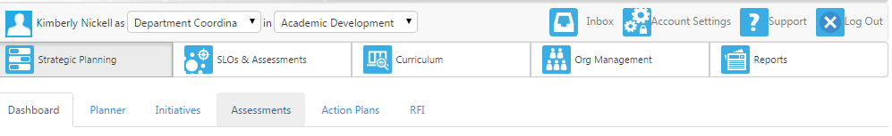
- You will click on Strategic Planning then Initiatives
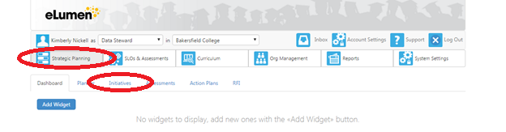Select Program Review.

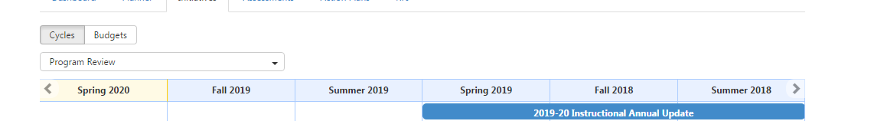

You should then see your several initiatives: Strategic Initiative or Program review; your Resource Request Initiatives for Facilities, Technology, “Other”, Classified, Faculty and Professional Development; and if you received technology from the previous cycle, you will see your Technology Assessment Initiative.
PRC will have your initiatives cloned for you already, and the department chair/director/dean will already be assigned to complete the program review.
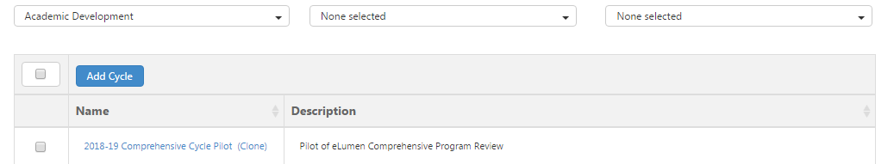

You will want to add/assign team members to be collaborators for certain sections, click Design Mode in the right corner so that it reads Active Mode then choose the Gear icon to Share with users. At this point, you are ready to begin.

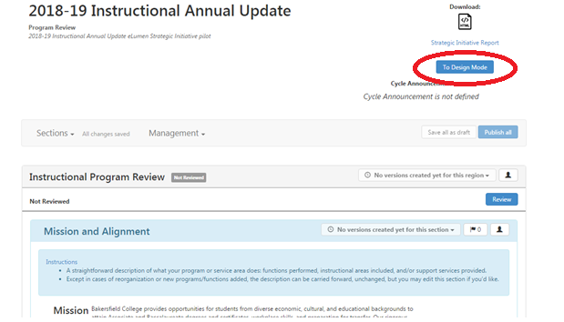
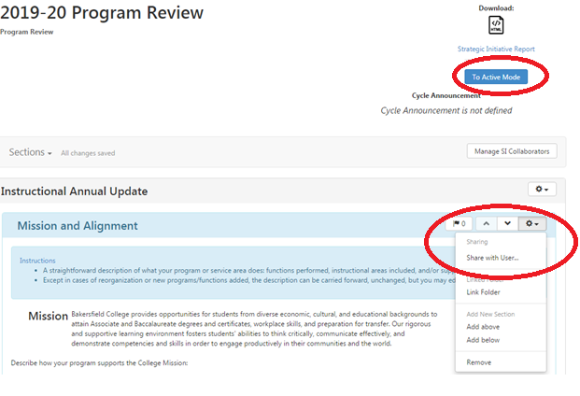
Save draft as you go until you are sure all your information is correct with no changes. Once you feel as if your document is ready, you can Publish your Strategic Initiative (your program review).

