Porterville College Mission Statement:

With students as our focus, Porterville College provides our local and diverse communities quality education that promotes intellectual curiosity, personal growth, and lifelong learning, while preparing students for career and academic success.

In support of our values and philosophy, Porterville College will:

- Provide quality academic programs to all students who are capable of benefiting from community college instruction.
- Provide comprehensive support services to help students achieve their personal, career and academic potential.
- Prepare students for transfer and success at four-year institutions.
- Provide courses and training to prepare students for employment or to enhance skills within their current careers.
- Provide developmental education to students who need to enhance their knowledge and understanding of basic skills.
- Recognize student achievement through awarding degrees, certificates, grants, and scholarships.

Program Mission Statement:

The mission of the Financial Aid Office (FAO) is to make higher education accessible for the
Porterville College student body by: awarding and delivering federal, state and institutional need based financial aid; partnering with other entities to recruit and retain a highly diverse student body; being committed to supporting the educational excellence of our students through the use of
financial aid-related technology; and administering its aid programs in an efficient and fiscally
responsible manner.

Services Area Outcomes:

- Students will demonstrate knowledge and understanding of the Satisfactory Academic
Progress (SAP) Policy for financial aid purposes.
- The Financial Aid Office will provide students with good to excellent customer service
during in person, phone, email, and/or letter communication.
- Upon completion of the financial aid application, students will understand the next steps
leading to their financial aid award and disbursement.
The Service Area Outcomes (SAOs) 1-3 will be assessed through an online financial aid student survey. The survey is administered through an online platform, Comevo. The survey will be available and emailed to all financial aid recipients for completion at the end of each Spring semester. Assessment will be conducted during the staff meeting in July after the survey has been completed. SAOs will further be discussed throughout the year during the staff meetings.

Results and analysis:

- Students will demonstrate knowledge and understanding of the Satisfactory Academic Progress (SAP) Policy for financial aid purposes.

The conclusion after the 2018-2019 and 2019-2020 Academic Year FAO Survey shows students have self-assessed an increase in knowledge of the SAP Policy. With an 8% increase from 2018-2019 to 2019-2020, 69% of those students responding to the survey feel they are familiar with the SAP Policy. However, the next question proves the same students are not as familiar with the SAP Policy. To maintain satisfactory academic progress and remain eligible for financial aid, students must maintain a minimum cumulative grade point average of 2.0. The 2018-2019 survey response correlated with the grade point average response at 61%, however the 2019-2020 survey only 51% responded correctly to this question which was just about 20% below the self-assessment. Next, to maintain satisfactory academic progress, students are required to complete 67% of the number of cumulative units attempted. The 2018-2019 and 2019-2020 survey responses were higher than the 69% self-assessment, as students’ responses indicated 82% correct. Although students have shown the understanding of the qualitative side of the SAP Policy, students are not as knowledgeable on the quantitative side of the SAP Policy. This may be due to the way the questions are provided to the students. First, the GPA portion is multiple choice with four options, while the units completed portion is a true false response. Based on the survey results, the FAO must develop additional ideas to ensure our students understand the SAP Policy.

2019-2020 Survey Questions on SAP Policy
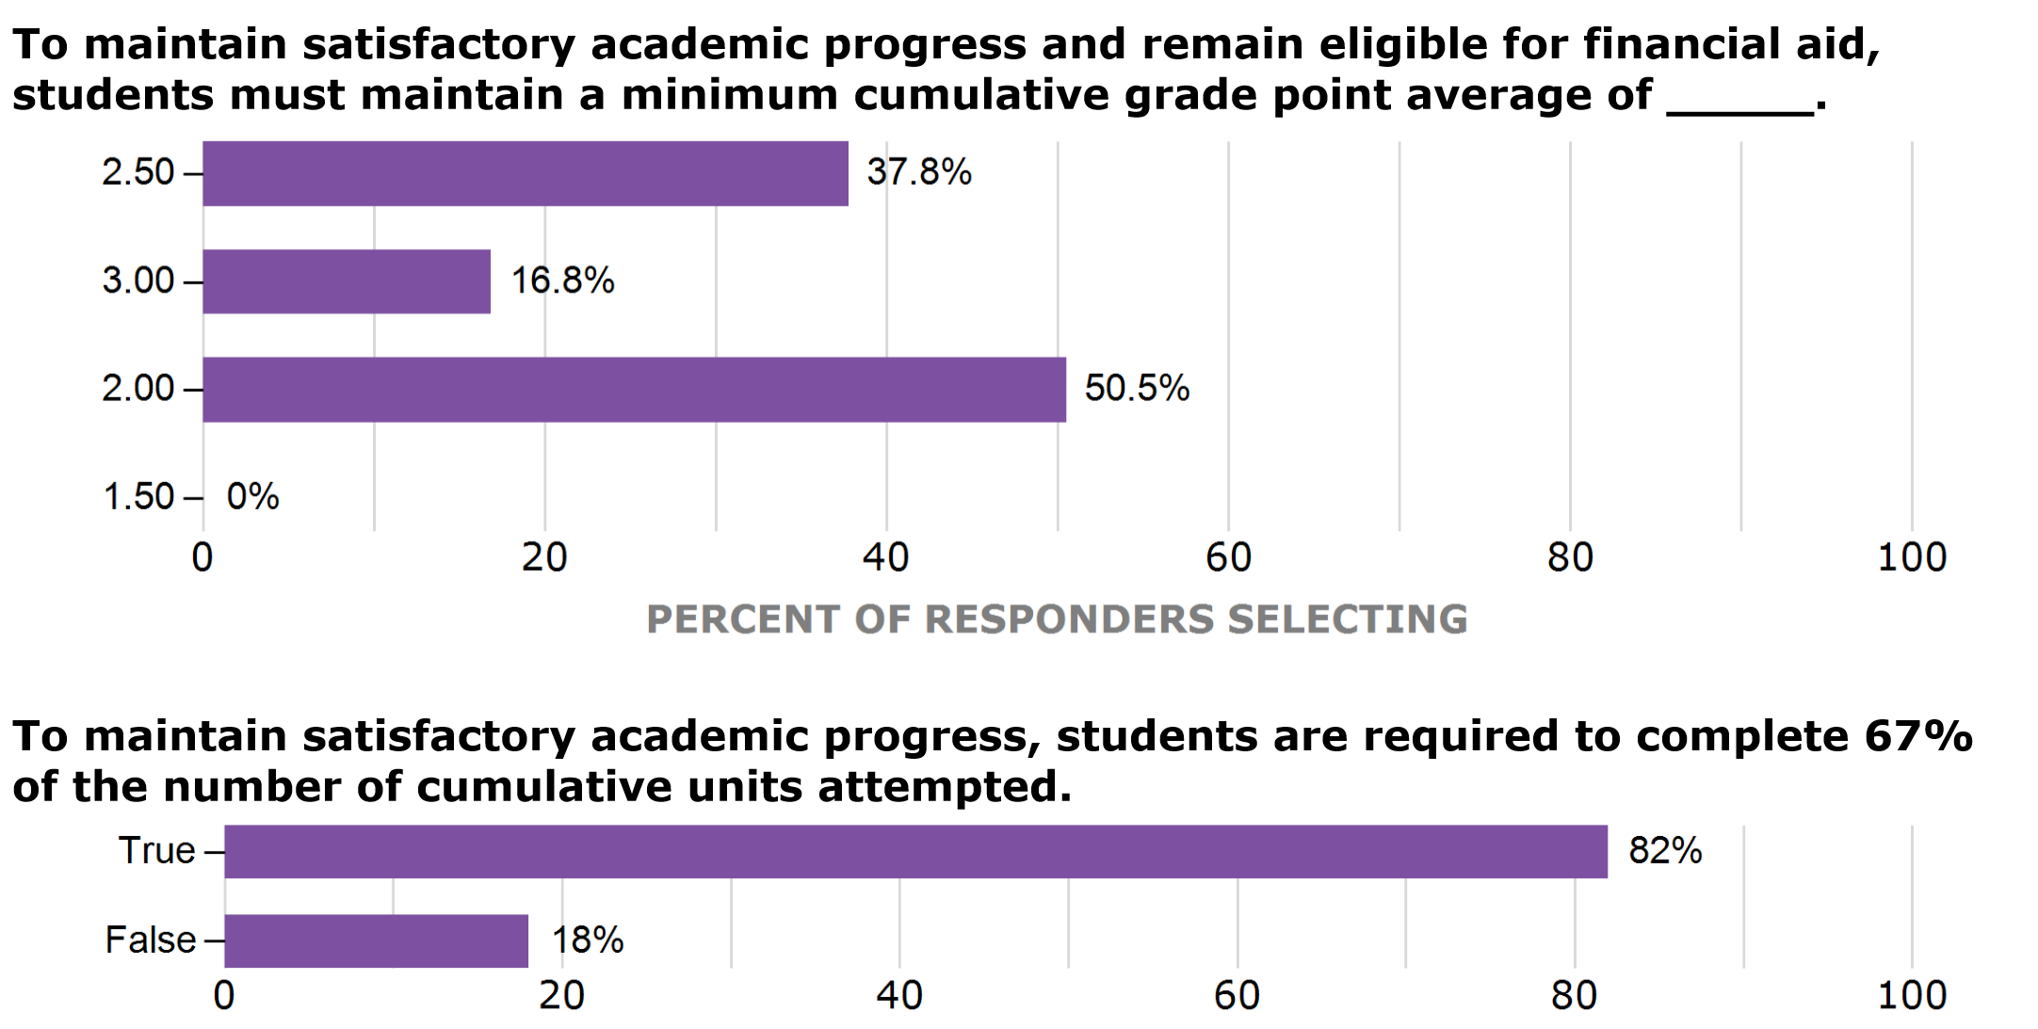

- The Financial Aid Office will provide students with good to excellent customer service
during in person, phone, email, and/or letter communication.

The conclusion after the 2018-2019 and 2019-2020 Academic Year FAO Survey shows students have experienced a significant increase in service experience provided by the FAO. The quality, knowledge, courtesy, and overall experience ranged from 1.81-1.92 in the 2018-2019 survey and this increased to 3.72-3.99 in the 2019-2020 survey. Those surveyed had a good experience. Of those surveyed, students in 2018-2019 used in person services more frequently, where those surveyed in 2019-2020 used online services more frequently. In addition, those survey responded at 89.7% with an average to excellent overall rating of their experience with the FAO visit. The FAO would like to see this number increase and reach the 4+ range during the next Program Review. Staff will continue to complete trainings and webinars to refresh their customer service and growth with the new generations and environment we encounter.

2019-2020 Survey Questions on Experience
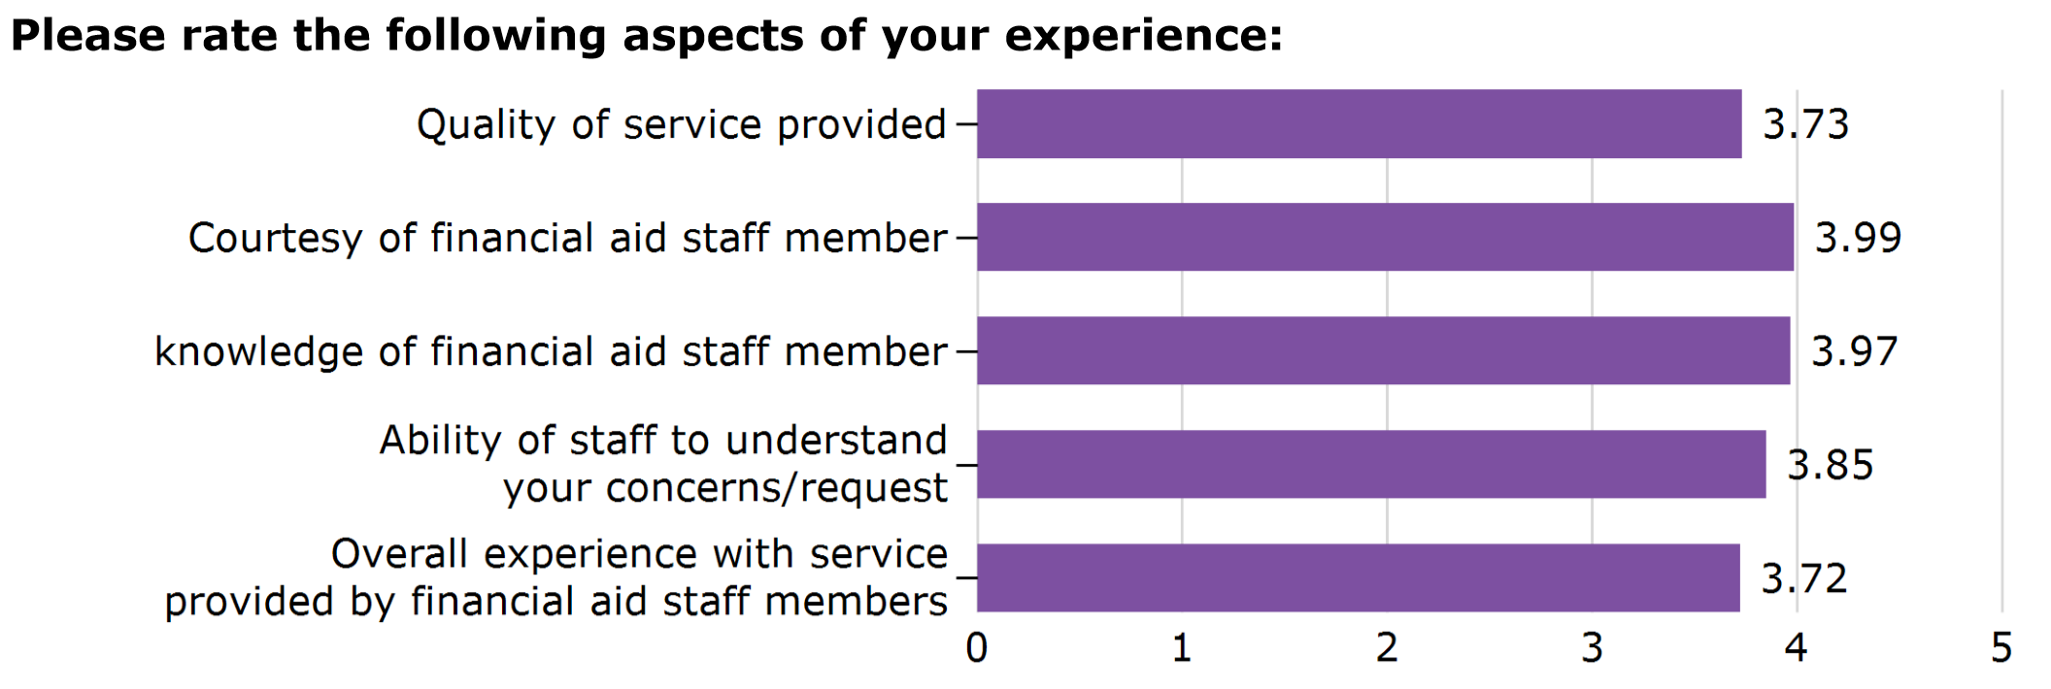
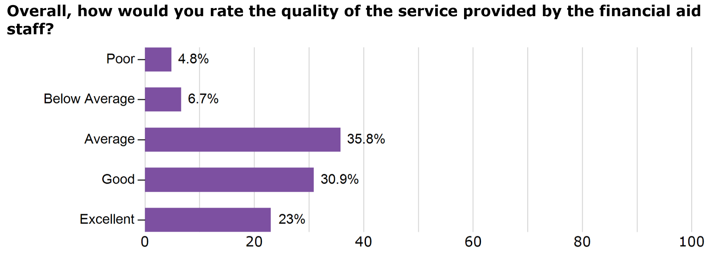
- Upon completion of the financial aid application, students will understand the next steps
leading to their financial aid award and disbursement.

The conclusion after the 2018-2019 and 2019-2020 Academic Year FAO Survey 67% is the average for those responding with an understanding of the next steps leading to your financial aid award and disbursement. This percentage is just about average, although not at our expectation for our Financial Aid recipients. This number must increase, as our students should understand each step during the processing of their financial aid. The FAO will undergo additional workshops and trainings to better prepare, assist, and educate our students on the financial aid process specifically each individuals own process.

2019-2020 Survey Question on Financial Aid Understanding
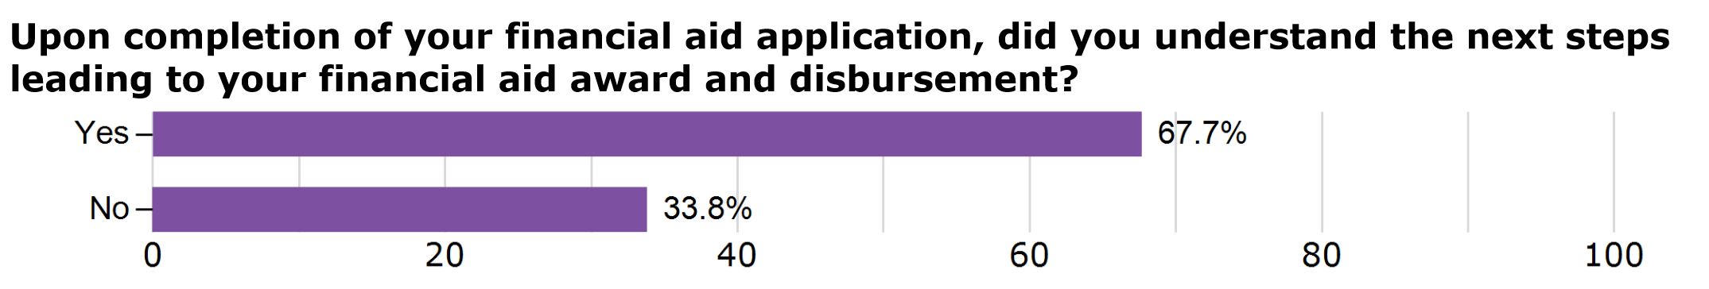

Program Analysis and Trends

The Financial Aid Office (FAO) supports quality education that promotes intellectual curiosity, personal growth, and lifelong learning, while preparing students for career and academic success by guiding students on how to successfully fund their education based on various circumstances that each student may experience. We take pride in our exploration of advanced ways to simplify the financial aid process, ensure compliance, and give the max amount of award to each student.

The Federal Pell Grant Program has been in existence for just over 55 years and the number of students who benefit from the Pell Grant Program has greatly increased each year. With the increase of students receiving Pell Grant awards, we have further experienced an increase in rules, regulations, laws regulated by local, state, and federal resources while maintaining program integrity and compliance. The FAO is responsible for application import and export, processing of verified and non-verified files, determining eligibility, awarding funds, disbursing funds, and remain in compliance with all local, state, and federal resources.

Programs included in federal funding, Title IV Programs include Federal Pell Grant, Federal Supplemental Education Opportunity Grant (FSEOG), Federal Work-Study, Direct Loan Programs, and Federal CARES Act Grant. Programs included in state programs are CA Promise Program Fee Waiver, Cal Grant B, Cal Grant B with Dependents, Cal Grant C, Cal Grant C with Dependents, Student Success and Completion Grant, State Emergency Grants, Chaffee Grant, and the Hunger Free Campus Program. Programs included in local programs consist of scholarships on and off campus funded, WIOA, CARE, CalWORKs, EOPS, NextUp, SEA, Promise, and Basic Skills. While overseeing all the above listed federal and state programs and administering the awards listed under local awards, there are several critical components to operating an efficient and effective operation. The critical components include:

Staff: The staff is the key to successful operations. Staff will provide exceptional service if they feel that management are meeting their basic needs. This may include training opportunities, professional development, workshops, workspace, various forms of support, or monthly staff meetings. The operation of the office will run effectively by providing trainings, feedback on job performance, the evaluation process, and setting goals and objectives with the staff, the support the staff members receive. This allows for inclusion in decision making, so employees are more committed to the process.

Assistance to students when completing the Free Application for Federal Student Aid
(FAFSA) and CA Dream Act Application (CADAA) online process: The Financial Aid Office provides assistance in English and Spanish to students applying for financial aid. In October 2011, AB 131 was signed into law and allows students eligible for AB 540 to also apply for state financial aid and Board of Governors fee waivers, Cal Grants and state emergency grants.

Computer Lab: The Financial Aid Office has a computer lab to assist students with their online
application process. The computer lab consists of four computers and a printer dedicated to student
use while completing the required applications and forms during the financial aid process. Over the past year, the computer lab has been closed due to the COVID-19 Pandemic.

Financial Aid Counter: The Financial Aid Office provides assistance to students as they enter the
office. The Financial Aid Assistant provides full‐time coverage at the counter offering daily
assistance in completing the FAFSA electronically in the computer lab. This assistance has
decreased the error rate in applications, thereby improving the disbursement of funds to students.

Virtual Financial Aid Office: The Virtual Office was established in April due to the COVID-19 Pandemic and campus closure. The virtual office is open Monday-Thursday in a zoom setting. Students are able to access the waiting room to be assisted much like the in-person office setting and at the convenience of the student. Staff assist students with share screen access and can assist with all aspects of Financial Aid in real time. The assistance is confidential and students remain in the waiting room until it is their turn to be assisted. Feedback from the students has been positive and we are implementing an assessment tool for further feedback.

- In Person Office Visits/Virtual Assistance (Beginning the latter part of March, 2020)
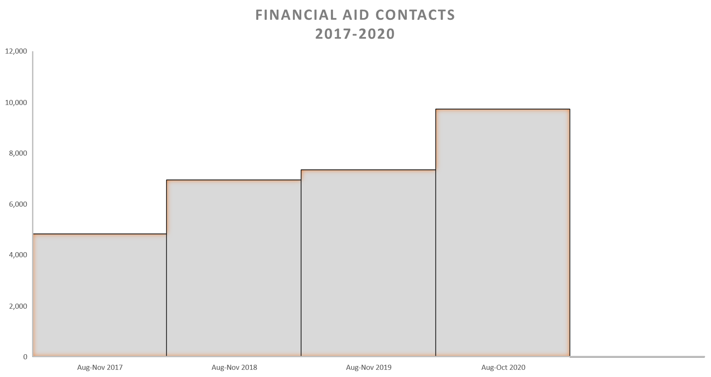
- Staff members track their contacts on a weekly log sheet for data collection in the virtual environment.
- Upon return to campus, staff will continue the weekly log for online contacts.
- Office visits will be working toward tracking student contacts through EAB by way of a kiosk through iPad sign-in and sign-out.

Outreach and In‐Reach Services: The Financial Aid Office provides a variety of outreach and in‐
reach services by conducting on and off campus workshops and attending community events in
addition to meeting with high schools/middle schools from Porterville Unified and Burton School
Districts. The financial aid directors coordinate outreach activities with all feeder high schools,
specifically, before the March 2 Cal Grant application deadline and after the applications become available October 1 of each year.

Assistance to Foster Youth: The Financial Aid Office has a Foster Youth Liaison that provides
one‐on‐one assistance to foster youth students who are referred through the statewide contact list
provided by the California Student Aid Commission (CSAC) and in partnership with the NextUp Program located on the Porterville College Campus. The Financial Aid Office has
participated in the Foster Youth Success Initiative (FYSI) efforts mandated by the California
Community Colleges Chancellor’s Office. The FAO has established a Foster Youth Taskforce and
Handbook to help guide our Foster Youth efforts. The FAO also coordinates with all support
services on and off campus to provide assistance to our foster youth population.

Compliance: The staff and directors attend federal and state workshops in addition to trainings and webinars to increase levels of competence, refresh their knowledge, reinforce good practices, and keep current on changes in laws and regulations. Currently, the staff and directors attend online workshops to increase their knowledge and skill set in a particular area. The staff and director meet
regularly to discuss rules and procedural updates that are specific to their expertise. The meetings are held biweekly, in the form of one-on-one meetings and a combined staff meeting. In addition, we have daily updates as needed.

- FAFSA Special Condition Appeal of income changes due to use of prior prior year income submitted on the application. Oversight given to Director of Financial Aid.
- Dependency Override Appeal available to students who are unable to provide parental information due to safety reasons, deceased parents, or another situation. Oversight by the Director of Financial Aid, if granted the students EFC will be re-calculated and status changed.
- SAP Policy: Qualitative Standard – Grade Point Average: To maintain satisfactory academic progress and remain eligible for financial aid, students must maintain a minimum cumulative grade point average of 2.00. KCCD will review each student’s academic progress at the time of determining eligibility and after each payment period. Quantitative Standard – Unit Progress: To maintain satisfactory academic progress, students are required to complete 67% of the total number of cumulative units attempted. Unit progress is evaluated by comparing the number of cumulative units attempted with the cumulative units completed to determine whether the student is progressing at a rate that will allow him/her to complete the program within the maximum time frame. The calculation of unit progression will be rounded up to the nearest tenth.
- AB540 became law in 2001 and the California Dream Act became law in 2011 thru the passage of two Assembly Bills, AB130 and AB131. AB130 allows students who meet AB540 criteria to apply for non-state funded scholarships for public colleges and universities. AB131 allows students who meet AB540 criteria to apply for state funded financial aid such as institutional grants, community college fee waivers, Cal Grant and Chafee Grants. An affidavit must be on file with Admissions and Records for students in this category and is subject to audit for awards given to these students.
- Financial Wellness Education is provided by the FAO to students throughout each semester to educate students about key financial aid concepts to assist in making educated decisions regarding borrowing, budgeting, loans, and financial life skills to assist in their current and future endeavors.
- Unaccompanied, self-supporting, homeless, or risk of homeless are categories that require additional verification. Student in this category may meet with the Director of Financial Aid to complete a questionnaire and sign to move forward with an independent status for financial aid purposes.
- Updates to system software for compliance changes throughout each year. This is a district wide effort by the FAO Directors and the District Office IT staff.

Educational Advisement: The Financial Aid Office has a part‐time Counselor to
assistance with Educational Study Plans for financial aid appeals, Promise Program requirements, Cal Grant C Certificate programs, and change of major as needed based on home college updates, and to complete Student Success contracts in the Financial Aid Office.

Documentation Process: The Financial Aid Office provides assistance to students in gathering the
appropriate documentation to complete the application process, which will determine their
eligibility for local, federal and state student financial aid.

Determining Eligibility: The application process for financial aid is an annual cycle that has overlapping aid periods for the staff to decipher during certain times of the year. Financial Aid is applied for the Fall, Spring, and then Summer if conditions are meet for additional year-round Pell or standard Pell has not been fully paid. Due to overlapping aid periods and year-round Pell, the processing, verifying, determining eligibility and awarding takes place for far more students than are enrolled with Porterville College. Student turn in applications much earlier that the enrollment period and may not get into classes or go to another college prior to the first day of classes. Staff are required to process every application they receive and pay each student once they have a valid application, a package completion date on file and are eligible.

By way of the Department of Education or Student Aid Commission, students complete the Free Application for Federal Student Aid (FAFSA) or CA Dream Act Application (CADAA) based on citizenship status. Each applicant adds a school code to their application and their Student Information Record is then transmitted to the school. Students will receive a Student Aid Report (SAR) during this time which further indicates if the student is selected for verified or non-verified processing. Staff complete this process daily through an import process in Banner. Each evening the student is then placed into a budget group and their file is categorizes as verified or non-verified a process that is selected by the governing entity. Students who are selected for verification will have additional documentation to turn in based on the data provided in their application. Verification can include income, unusual enrollment history, identity verification, Selective Service Registration, or citizenship verification. Students are further able to check their verification through InsidePC under the Financial Aid tab. If verified, beginning the Summer of 2020 students are directed to CampusLogic to complete the upload of verification documents through the online platform. This platform was implemented to assist students in the virtual world we are working in due to the COVID-19 Pandemic. Furthermore, CampusLogic allows students to complete the upload of documents for convenience by phone or other tool of their chose and no longer bound to coming to an office within designated office hours. Both verified and non-verified files are reviewed and eligibility determined for awarding. Often flags are processed for files at this time for items like citizenship, Lifetime Eligibility (LEU), and signature deficiencies. Each student is processed based on their application and particular case and situation.

As a college of the Kern Community College District, Porterville College, Cerro Coso College, and Bakersfield College further work together to award students who enroll in classes at all three campuses. The staff receive a report and work with each campus to ensure a home school for the student. The home school is where the student will ultimately graduate with a certificate or degree and/or transfer and receive the Pell Grant. This allows the student to take course where they are available, receive full financial aid, and complete in a timely manner.

Packaging/Awarding of Financial Aid: The awards include local, federal and state aid such as
Pell Grant, Supplemental Educational Opportunity Grant (SEOG), Federal Work Study (FWS), Cal Grant, Student Success and Completion Grant (SSCG), Chafee Grant, EOPS awards, CARE Grant, Meal Tickets, WIOA, Fee Waivers, bus vouchers, off campus scholarships and CA Promise Grant. The workload of office staff includes monitoring/reconciliation of grants (Pell, Cal Grant, SSCG, SEOG, FWS, and CHAFEE), federal work‐study and campus-based work‐study students, WebGrants payment/reconciliation, and Foster Youth NextUp. Additional Financial Aid Technicians have proven to not only benefit the Financial Aid Office but also the campus as a whole through increased participation in outreach events at the local high schools as well as community-based events. In addition to an increase in awarding of Financial Aid from all levels, local, state, and federal.

Disburse Funds: Once a student is eligible for packaging of the above awards, they must meet Satisfactory Academic Progress (SAP). This process is complete for student who have complete a financial aid application and enrolled for the semester to be disbursed. SAP is run after grade roll for the previous term and weekly for new financial aid applicants. Funds once disbursed are refunded to students through BankMobile at the refund choice of each student. For the 2021 award year, students receive disbursements twice a semester for Pell Grants, rather than three times a semester. The benefit to this is students receive their funds at the beginning of the term prior to census and this process aids in the decrease in the bad debit occurred on our campus. All other awards have one disbursement date and for the most part occur just after census. Weekly disbursements take place for students who have newly applied for financial aid and late start classes.

Scholarships: The Financial Aid Office, the Porterville College Foundation and members of the
Scholarship Committee work closely to review scholarship applications yearly and award
approximately $220,000 annually to recipients of internal/external scholarships, PC First
scholarships and grants.

The categorical Board Financial Assistance Programs-Student Financial Aid Administration
(BFAP-SFAA) funding to the Porterville College Financial Aid Office has provided the Directors
and staff an opportunity to continue its staffing and outreach efforts.

External Agencies:

- United States Department of Education
- Selective Service Administration
- Department of Homeland Security—the Bureau of Citizenship and Immigration Services (formerly INS)
- Veterans Administration
- Social Security Administration
- BIA--Bureau of Indian Affairs

State Agencies:

- California Community Colleges Chancellor’s Office
- State and County Social Service Agencies
- California Student Aid Commission (CSAC)
- Employment Development Department (EDD)

Other Agencies:

- Independent Living Program (ILP)
- Community Services Employment Training (CSET)
- Tulare County Health and Human Services Agency
- Pre-Employ
- Community Food Bank

Financial Aid Funding Sources:

Currently Financial Aid funding sources are provided through a variety of federal, state, and local
programs:

Federal Pell Grant
The Pell Grant program is the largest grant program in the country. It is the foundation for an award
package. Pell Grants provide financial assistance to eligible part-time and fulltime students, and are
calculated based on a student’s enrollment and Expected Family Contribution (EFC). There is no
minimum unit requirement for the Pell Grant program, so a student may be enrolled in as little as
one-half unit. If a student applies late, but qualifies for a Pell Grant, he/she may be paid
retroactively.

Federal Supplemental Educational Opportunity Grant (FSEOG)
The Federal Supplemental Educational Opportunity Grant is a limited grant fund for Pell-eligible
students with the lowest EFC, who meet the priority filing deadlines, and are enrolled at least halftime. This is a campus-based program which means that funding is limited and students are awarded on a first come, first serve basis. SEOG is park of the automatic packaging process to eligible students who have completed their financial aid, have a low Expected Family Contribution (EFC), are meeting SAP, and are enrolled will be awarded.

Federal Work-Study (FWS)
Federal Work-Study is a program that provides jobs for students who demonstrate financial need
and are enrolled at least half-time. Eligible students are placed into work-study jobs, usually on
campus to help pay educational expenses. FWS allows students to work up to 19 hours a week, paid at minimum wage, and is available to eligible students. Eligible students must show financial need and have time to work each week. The FAO places 7% of Work-Study students in community service jobs as a requirement of the program.

Federal Direct Loan Program
Beginning 2019-2020 academic year, the FAO committed to the Promise Program and in turn committed Porterville College back into the Federal Direct Stafford Loan Program. This includes Federal Direct Subsidized Loan Program, the Federal Direct Unsubsidized Loan Program and the Parent Plus Loan Program. One a loan is initiated and accepted by the student, they must complete Entrance Counseling, a Master Promissory Note, Campus Counseling, Agreement, and then the loan can be disbursed. Once the student finished their time at PC, they will complete Exit Counseling and must complete timely payments after 6 months of no longer attending school.

Chafee Grant
This grant is for current and former foster youth who are under the age of 22 and have financial need, complete a financial aid application, a California Chafee Grant Application and have been verified by the California Department of Social Services as a foster youth. Program staff then complete their file and all necessary items on WebGrants to initiate payment. Payment is mailed to campus in the form of a check to be provided to the student, as long as they are enrolled in 6 or more units, meeting SAP and have financial need.

CA College Promise Grant (Formerly Board of Governors Fee Waiver)
California residents who attend community colleges may be eligible to have their Enrollment Fees
paid by the state of California. There are three ways to qualify. The Promise Grant application
includes Method A or B. The FAFSA includes Method C. PC requires all students to complete a financial aid application to qualify for a fee waiver.

Method A
For families who are receiving TANF/CalWORKs, SSI/SSP or General Assistance, current
verification is required.

Method B
To qualify students must meet the income guideline. Dependent students report only parents
income. Income includes adjusted gross income (as reported on a federal tax return), wages not
reported on a tax return, all untaxed income, and cash received or any money paid on your behalf.

Method C
Complete the FAFSA application. The Financial Aid Office will determine unmet need after a valid
Expected Family Contribution (EFC) has been established. A Board of Governor’s Enrollment Fee
Waiver will be issued to anyone with at least $1 of unmet need (Unmet Need = Student Budget –
EFC).

Special Classifications
The following special classifications are also eligible for fee waivers: Some dependents of veterans
or the National Guard; recipient or the child of a recipient of the Congressional Medal of Honor or a
dependent of a victim of the September 11, 2001 terrorist attack; or a dependent of a deceased law
enforcement officer or fire suppression personnel killed in the line of duty.

Cal Grants
Cal Grants are state-funded, need-based, cash grants given to California college students to help pay
for college. To be eligible, in addition to meeting federal aid requirements, a student must:
- Be a California resident, and
- Not have a bachelor’s or professional degree, and
- File a completed FAFSA and Cal Grant GPA Verification form by March 2nd (all students
should try to meet the March 2nd deadline for the Entitlement and primary Competitive
Grant consideration, but for California Community College students there is a second
Competitive Grant filing deadline of September 2nd), and
- Have remaining financial need.

Cal Grant B
This grant is for students who are from disadvantaged or low-income families who otherwise would
not be able to pursue higher education. This grant may be used at a community college or a
university for up to four years. Cal Grant B Entitlement Award: Every graduating high school senior
who has a G.P.A. of at least 2.0, meets the Cal Grant eligibility requirements, and applied on time, is guaranteed this award. Cal Grant B Competitive Award: Other students who meet the basic Cal
Grant eligibility requirements and who have at least a 2.0 G.P.A. may compete for this award.
Selection is based on a composite score that takes into account a variety of factors such as family
income, parents’ educational level, etc. Students who qualify with dependents may be eligible for an increased access award.

Cal Grant C
This grant helps vocationally oriented students – who do not plan to transfer to a university.
Training must lead to a recognized occupational goal: diploma, associate degree or certificate. Cal
Grant financial need criteria must be met. Students who qualify with dependents may be eligible for an increased access award.

Student Success and Completion Grant (SSCG)
The SSCG is a $2,000 a semester grant for those attending at least 15 units per semester or $649 a semester for those attending 14 units or below per semester for the entire length of their program. The purpose of the grant award is to provide the student with additional financial aid to help offset his or her total cost of community college attendance.

Finish Line Scholars Program
Finish Line will provide scholarships to community college students who are halfway through their course of study to enable them to finish their goal of completing a certificate or degree or transferring to a college or university. It will also provide emergency financial aid to students facing unexpected financial hardships. Thirty-four community colleges are eligible for the program in the three regions of California with the lowest percentage of adults who have college degrees: the Inland Empire, the Central Valley, and the Far North. The program is designed to support achievement of goal six in our Vision for Success, which focuses on reducing regional achievement gaps for students. In addition, helping more students overcome challenges and go all-in to achieve their educational goals. Plus, in the long-term, it will help build a well-prepared workforce, a strong economy, and a bright future for our community.

PC Pirate Food Pantry
The purpose of the Pirate Pantry is to provide emergency, supplemental food to students to assist in fighting food insecurities one step at a time. Food insecurities are when an individual is unaware of where their nest meal will be or having limited access to food. The learning environment on campus is increasingly impacted by the hunger and food insecurities. Food insecurities are linked to high dropout rates and not devoting time to studies. With the Pirate Pantry, we are assisting students with food insecurities and breaking a non-academic barrier that hinders student success.

Promise Program
The PC Promise Program serves first-time college students through their first year by a comprehensive plan of support to complete an associate’s degree, career technical certificate, or transfer requirements, while preparing for employment in their field of study. The program is open to students with the ability to attend full-time, with on-time completers declare a Pathway, and establish an Education Plan.

Changes in Program over Last Three Years and Data Review
The following graphic illustrates the overall success rates for Financial Aid Awarded students for the past five years. This shows similar numbers over the past five years, with a 2% increase in 2017-2018, 3% increase in 2018-2019 and a 2% decrease in 2019-2020.

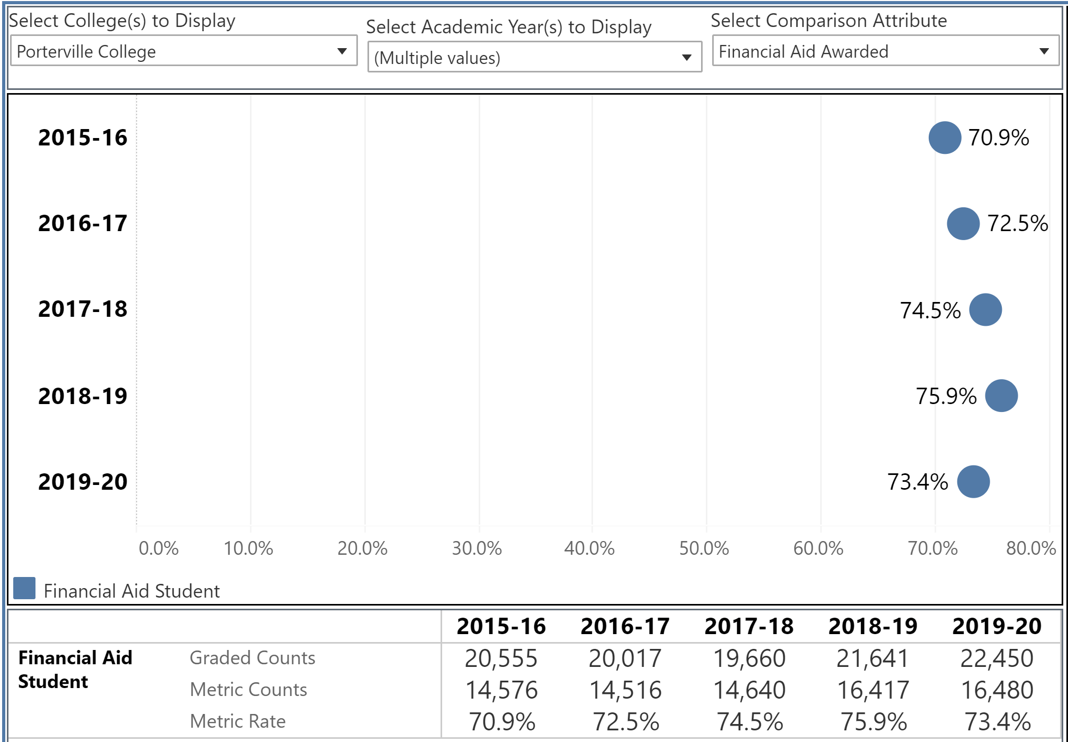

The following graphic illustrates the Completion Rates for Financial Aid students over the past five years. There has been a steady increase of 1% for the past four years. Last year there was a 2% decrease in completion in large part due to students who dropped in enrollment due to the COVID-19 Pandemic. We expect the success of our students to remain the same and increase slightly over time as the trend suggests over the past four years.

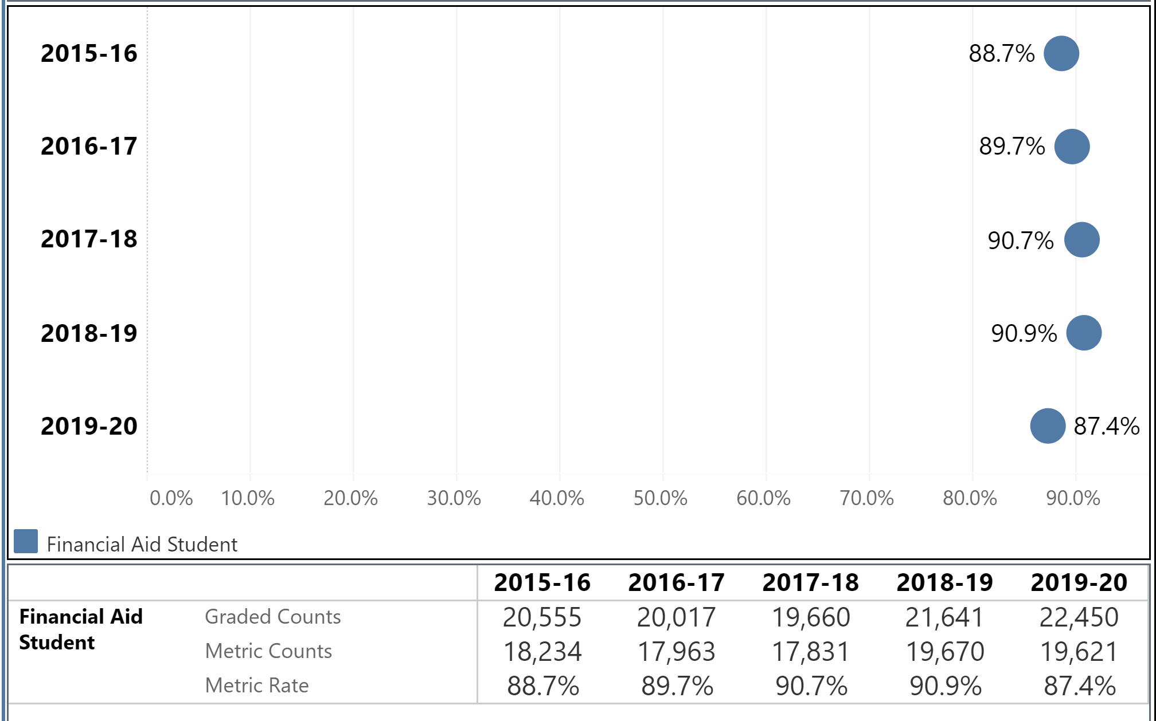

The following graphic illustrates the aid year, college campus, application code, application description and the distinct student count. Please note, California Dream Act Application, (CAL) and the Free Application Federal Student Aid, EDE are the applications of record. These numbers remain consistent with only a 2% fluctuation between the years. As mentioned previously, these totals are for all applicants, not necessarily those who are awarded.
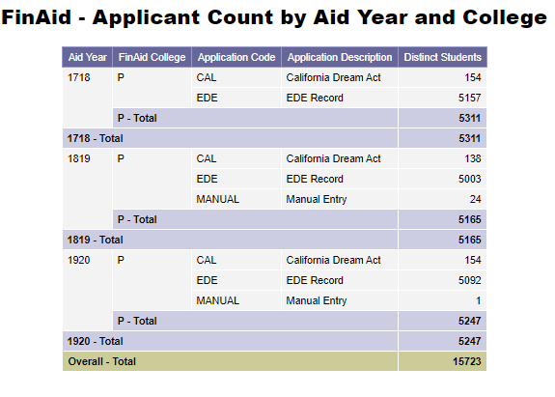

Over the past three years, the FAO has experience significant changes that have increased the administration of Financial Aid beginning with the Director to the 3 Technicians and the Assistant. In 2019, all awards provided to students on campus must be awarded, disbursed and paid through our Banner processing system of record. The FAO now works closely with campus programs, Business Services, and DO IT to complete the entire process for each award. The development, management and reconciliation is completed for each award year and by semester. The FAO awards by Financial Aid Fund Code. In 2018 the FAO operated with 9 Fund Codes. There was an increase to our Fund Codes due to the newly established Promise Program, the 3 loan programs, and 2 new Cal Grant awards. In addition to 34 newly established campus program awards through Fund Codes. The increase in large is due to regulations stating that all student awards must be included in the 1098-T process. In order to meet this regulation, we have established the new awards and collaboration between the three departments. We have increased awards from 9 to 50 in a little over two year, demonstrating a 555% increase to overall awards processed through the FAO.

The following chart shows aid year and aid received. Further illustrating the increase of aid due to the items listed in the previous two paragraphs.

Aid Year | Aid Received
2018 | $13,725,421
2019 | $15,693,855
2020 | $16,079,638

The funding increases:
- Increase to Campus Based Funding (PSEOG and PFWS), aid year 2021
- CARES Act (HEERF I) funding, upwards of $2.2 million in direct student aid. HEERF I funds are not included in the yearly totals since are excluded from income.
- Dreamer Emergency Relief Funds, $34,116, Spring 2021
- Increase of $2,354,217 in aid processing through the FAO

The Financial Aid Director receives regular emails regarding forthcoming local, State, and Federal changes for aid. These changes require implementation in a timely fashion, most include deadlines to ensure our campus remains in a positive standing to manage Title IV programs and compliance at all levels. Just this past two years the following items had to be implemented:

- Increase in Pell Grant
- Return to Title IV (R2T4) exceptions for Spring 2020
- COVID withdraws excluded from SAP Processing
- Implemented separate campus TG Numbers for all Federal reporting and campus-based funding rather than reporting and receiving annual allocations under Bakersfield College, which was a huge task and accomplishment.
- PC’s FAO now submits our own Fiscal Operations Report and Application to Participate (FISAP) reporting and consists of true numbers to evaluate and work with.
- Implemented new loan programs for the campus ranging from adding loan to our Participation Agreement with the Department of Education to documentation and processing by the Technicians.
- Implemented new Cal Grant awards with district wide FAO team for B and C with Dependents.

Finally, the FAO has made changes to the front counter and lobby where individuals come into for assistance. The walls have been resurfaced and painted, the lobby expanded by moving the front counter back for more room, plexiglass installed for the health and safety of the staff and individuals we serve, pub style tables with chairs equipped with charging stations have been added, and seating has been modernized to be more appealing and inviting.

Program Strengths (with changes over the past three years as appropriate)

- Customer service continues to improve for the FAO. Our efforts to provide quality customer service to students, campus, and community are at the forefront of all that we do. When our campus closed due to the COVID-19 Pandemic, the FAO responded by leading the campus efforts in the development of a Virtual Office to continue with quality customer service, while adapting to the environment that we were given. The FAO further oversees Federal Work-Study Students who provide further assistance to current and potential students in the Student Services Virtual Office.

- The FAO has modernized the on-time application review with the implementation of CampusLogic at the end of the 2019-2020 year. CampusLogic is an online platform used to improve the verification process. When student visit InsidePC and click on the Financial Aid tab, they will see the link for CampusLogic if they are selected for the verification process. Students must create an account which has single sign on capability for convenience. Students submit their documents online through an upload process by way of phone, iPad, laptop, or desktop. At that time the items are moved to a review process where the Financial Aid Technicians review their caseload daily. Once the documents have been reviewed they are moved to a verification folder and the staff complete the verification process in the order that they are received. During this time staff may message students, complete the verification, or make corrections. The platform although new, has decreased the time that students have normally had to wait for a package complete and award letter. Students have had to wait for upwards of 60-90 days and with CampusLogic students were packaged and awarded within 45 days. We expect this time to decrease further once the staff become better acquainted with the platform and have a year of verification with CampusLogic. In addition, CampusLogic serves as a paperless platform as all documentation is submitted virtually, eliminating file acceptance, file creation, file storage, and file purging after federal regulation allow us to do so. This aspect highlights the benefit which CampusLogic has had for the staff and office. The final highlight of CampusLogic is students can complete their verification at anytime of the day rather than being limited to submitting paper documents in person during the office hours of operation.

- The FAO continues to demonstration the ability to modify policies and day-to-day procedures owed to regularly changing state and federal guidelines while ensuring compliance and program integrity as seen in the annual audit outcomes.

- With the virtual environment created during the 2021 year, we have come to learn we are able to reach many more students and/or parents if we utilize a virtual environment. Though this has only been presented this past year, it will be interesting to host the 2022 year in a similar fashion and review the outcomes. Specifically, College and Financial Aid Night we normally host 30-50 participants in a face to face environment and for the 2021 year, we hosted 90 participants in a virtual environment. Ideally, we would like to see a hybrid approach as we are allowed.

- Regular monthly staff meetings occur to ensure the staff are up to date on the regular changing guidelines, new grant implementations, professional development, and team building. During the 2019-2020 year, the addition of SharePoint for the Financial Aid Office allows the Director the opportunity to have a shared location for all staff to access document, meeting agenda, meeting minutes, and all other items pertaining to the success of the office.

- Hiring of a full-time Director of Financial Aid as requested in the previous program review.

Areas for Improvement
- Continue to work with the District Office IT staff on all streamlining processes. First priority is the Course Program of Study (CPOS) process for compliance with Federal Regulations. This process will allow Banner and Degree Works to integrate and complete a degree audit to determine if the courses are part of the student’s selected program of study on record. Second is the Cal Grant import and export to increase efficiency and time required by the Financial Aid Technician who oversees the program.

- Continue to assist staff with developing confidence of maintaining individual
programs/responsibilities by equipping them with the training/skills needed and holding
them responsible for the program accountability

- Currently all student contact is recorded by student sign in on a physical sign in sheet. This does not provide privacy for our students. Furthermore, this process requires staff to manually count the contacts and adds to storage files. We are exploring new ideas for a streamlined sign in mechanism.

- Inreach efforts do have the opportunity to be more than it is now. We will work with other departments on campus to ensure proper information is circulating to our students, staff, faculty, and administration.

Goals (This section is for you to report on progress on previously established goals. If your program is addressing more than 2 goals, please duplicate this page)

Goal(s) | Completion Date | Needed resources | Person(s) Responsible | Obstacles to completion  (if any)
1. The Financial Aid Office would like to see student knowledge and understanding of Satisfactory Academic Progress (SAP) policy increase by 3% each semester to insure the office is reaching more students and providing the knowledge needed to remain in good financial aid standing. | Ongoing | Workshops and staff time | Financial Aid Technician | None

Which of numbered items under the Mission Statement (see page 1 of this document) will be furthered if this goal is completed? (select all that apply)

Item 1___ Item 2_X__ Item 3_X__ Item 4___ Item 5___ Item 6_X__

Progress on Goal:

____Completed (Date )
__X__Revised (Date Ongoing )

Comments: The conclusion after the 2018-2019 and 2019-2020 Academic Year FAO Survey shows students have self-assessed an increase in knowledge of the SAP Policy. With an 8% increase from 2018-2019 to 2019-2020, 69% of those students responding to the survey feel they are familiar with the SAP Policy. However, the next question proves the same students are not as familiar with the SAP Policy. To maintain satisfactory academic progress and remain eligible for financial aid, students must maintain a minimum cumulative grade point average of 2.0. The 2018-2019 survey response correlated with the grade point average response at 61%, however the 2019-2020 survey only 51% responded correctly to this question which was just about 20% below the self-assessment. Next, to maintain satisfactory academic progress, students are required to complete 67% of the number of cumulative units attempted. The 2018-2019 and 2019-2020 survey response were higher than the 69% self-assessment, as students’ responses indicated 82% correct. Although students have shown the understanding of the qualitative side of the SAP Policy, students are not as knowledgeable on the quantitative side of the SAP Policy. This may be due to the way the questions are provided to the students. First, the GPA portion is multiple choice with four options, while the units completed portion is a true false response. Based on the survey results, the FAO must develop additional ideas to ensure our students understand the SAP Policy.

After review of the results during the staff meeting the Director and staff discussed goals and expectations to increase student understanding, specifically SAP and the 3% increase. First, we made changes to our website and communication to students to provide a great foundation for the SAP Policy. Next, we discussed communication with students as we assist them in person, virtually, or during a follow-up to items requested. During this time, we will discuss SAP with students as it may fit into what we are working with the student on and further broadening the understand students have regarding the policy. It is the expectation that the staff take the approach of over explaining as we need to ensure understanding by our students. In addition, we will implement a new email message to students that will provide a link for students to view a video on our SAP Policy and opportunity to further expand their knowledge of SAP.

This goal will be used for the next Program Review cycle.

Goal(s) | Completion Date | Needed resources | Person(s) Responsible | Obstacles to completion  (if any)
2. The FA Office will hold workshops each semester and during Financial Aid Awareness week to discuss the FAFSA Application, financial aid award, and disbursement. | Ongoing | Workshop and time | Financial Aid Technician | None

Which of numbered items under the Mission Statement (see page 1 of this document) will be furthered if this goal is completed? (select all that apply)

Item 1___ Item _X_ Item 3_X__ Item 4___ Item 5___ Item 6___

Progress on Goal:

____Completed (Date )
__X__Revised (Date Ongoing )

Comments:

Based on this information the office has held workshops weekly during each academic year, in addition to Financial Aid Awareness Week. Topics of the workshops include FAFSA Application, financial aid awards, and disbursements, Grant Programs, R2T4, BankMobile, CADAA application, CHAFEE, and CAL Fresh Application and benefits. This has allowed additional opportunity for the staff to educate students regarding the process and allowed students to broaden their understanding of the Financial Aid processes. This has assisted in educating students and providing them additional customer/student service.

BankMobile has been implemented to complete the distribution of financial aid payments to our students with a variety of options. Clearly this opportunity has given students the benefit of refund selection that best suits their needs. Students no longer are bound to a paper check by mail, students are able to apply for a personal BankMobile account, direct deposit to an existing bank account, or a paper check by mail.

Goal(s) | Completion Date | Needed resources | Person(s) Responsible | Obstacles to completion  (if any)
3.) Staff receive training to ensure discussion of the FAFSA Application, financial aid award, and disbursement with students who complete their FAFSA in the computer lab prior to departing the office. | Ongoing | Training Opportunities | All Staff | None

Which of numbered items under the Mission Statement (see page 1 of this document) will be furthered if this goal is completed? (select all that apply)

Item 1___ Item 2_X__ Item 3_X__ Item 4___ Item 5___ Item 6___

Progress on Goal:

____Completed (Date )
__X__Revised (Date Ongoing )

Comments: The office continues to provide survey opportunities for our students that go out to students at the end of each academic year to assess their knowledge and understanding of the next steps leading to their financial aid award and disbursement after completing the financial aid application (FAFSA or CADAA). Based on the survey in 2018-2019, 68% of those responded understood the next steps and in 2019-2020, 69% understood the next steps. Moreover, 51% in 2018-2019 and 57% in 2019-2020 credited the Financial Aid staff as the responsible source for helping with their understanding. In addition, discussing the FAFSA or CADAA Application, financial aid award, and disbursement with students who complete their financial aid application in the computer lab or virtual environment prior to departing.

Goal(s) | Completion Date | Needed resources | Person(s) Responsible | Obstacles to completion  (if any)
4. Continue to receive an evaluation for all student workers employed through Federal Workstudy and all students meet average or about for characteristics on the Student Work-Study Performance Evaluation Form. | Continued each semester | Supervisors to complete the form and review with student | Supervisors | None

Which of numbered items under the Mission Statement (see page 1 of this document) will be furthered if this goal is completed? (select all that apply)

Item 1___ Item 2_X__ Item 3___ Item 4_X__ Item 5___ Item 6___

Progress on Goal:

____Completed (Date )
__X__Revised (Date Ongoing )

Comments: The college work-study students have demonstrated knowledge of becoming a
successful student worker in the department assigned. All work-study supervisors complete a
standard evaluation for the student worker assigned at the close of each semester. Based on the
review of each evaluation all supervisors complete the evaluation and all students are meeting
average standards and are working on areas where they can grow and meet above average standards
in the semesters to come. In addition, future employers can contact the FAO for employment references which are accurate and updated each semester.
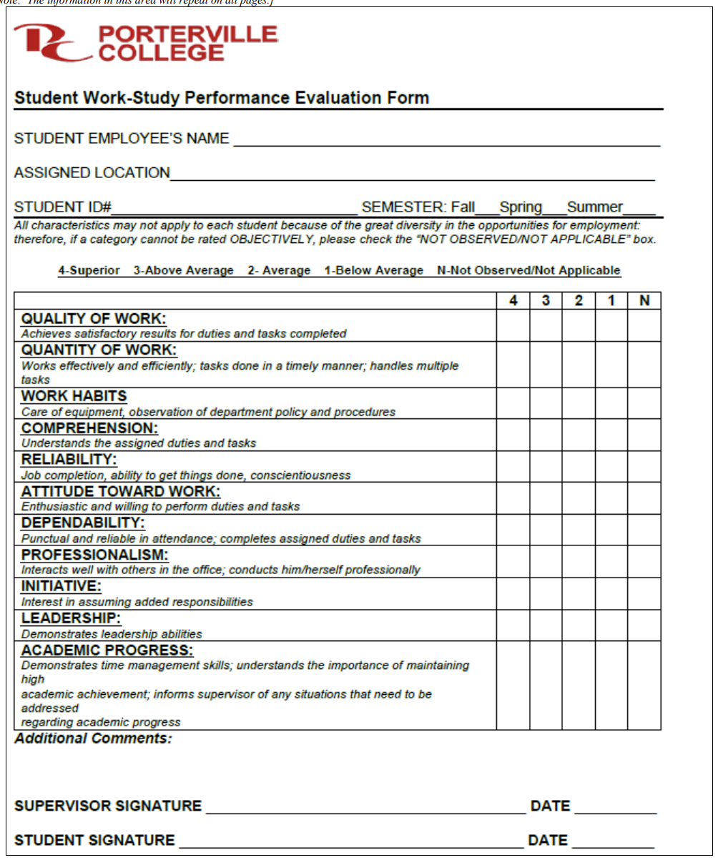

Goals (This section is for you to report new goals for your program. If your program is creating more than 2 goals, please duplicate this page)

Goal(s) | Timeline for Completion | Needed resources | Person(s) Responsible | Obstacles to completion  (if any)
1.) Increase campus communications in order to educate faculty and staff about the services and opportunities available to our students through the financial aid office. | Begin Summer 2021 and on-going | Staff time | Director, Financial Aid | None

Which of numbered items under the Mission Statement (see page 1 of this document) will be furthered if this goal is completed? (select all that apply)

Item 1___ Item 2_X__ Item 3_X__ Item 4___ Item 5___ Item 6___

Progress on Goal: N/A

____Completed (Date )
____Revised ( )

Comments: Annual communication to the campus will occur at the beginning of each academic year just prior to the start of the semester. In additional, further updates will come forth periodically during the year as items change or need addressed.

Goal(s) | Timeline for Completion | Needed resources | Person(s) Responsible | Obstacles to completion  (if any)
2.) The Financial Aid Office would like to see an increase in student knowledge and understanding of Satisfactory Academic Progress (SAP) policy increase by 3% each semester to insure the office is reaching more students and providing the knowledge needed to remain in good financial aid standing. | Ongoing | Workshop | Financial Aid Technician | None

Which of numbered items under the Mission Statement (see page 1 of this document) will be furthered if this goal is completed? (select all that apply)

Item 1___ Item 2_X Item 3_X__ Item 4___ Item 5___ Item 6_X__

Progress on Goal:

____Completed (Date )
____Revised (Date )

Comments: Continuing efforts from the current Program Review, as we would like to see this number increase by 3%.

Goal(s) | Timeline for Completion | Needed resources | Person(s) Responsible | Obstacles to completion  (if any)
3.) Increase student knowledge of Financial Aid thru strategic engagement with students by providing updates through insidePC, detailed information on the FAO main webpage and a current detailed message on the phone lines. | Begin Summer 2021 and on-going | Staff time | Director, Financial Aid | None

Which of numbered items under the Mission Statement (see page 1 of this document) will be furthered if this goal is completed? (select all that apply)

Item 1___ Item 2_X__ Item 3_X__ Item 4___ Item 5___ Item 6___

Progress on Goal: N/A

____Completed (Date )
____Revised (Date )

Comments: This goal will be reviewed at the staff meetings and a plan moving forward will be developed with input from each staff member involved. This plan will be in place the 2122 year and future years.

STAFFING REQUEST

Staff Resources:
Current Staffing Levels  Full-time Staff |  |  | Part-time Staff
Faculty |  | 0 | Faculty |  | 1
Temporary |  | 0 | Temporary
Classified |  | 4 | Classified
Management |  | 1 | Management
Project dates of temporary staff:

Request for New/Replacement Staff
Use one line for each position requested. Justify each position in the space below.

 | Title of Position |  | Classification  (Faculty, Classified, or Management) | Full or Part  Time |  | New or Replacement
Position 1 | Financial Aid Technician |  | Classified | Full-Time |  | New
Position 2
Position 3
Justification:

Our student population and overall fund management continues to increase which becomes challenging as Federal, State, and local regulations become all the time more multifaceted as new funds are added each year. Notably, we have implemented automation for as many of our process as possible, to assist with the increased student population and fund management coming from the various funding sources. Further revealed with verification through CampusLogic to assist in timely disbursements. With that said, our current staffing has set forth challenging times as automation has not assisted with these challenges. Often, we are not able to assist students as quickly as we would like, or we are not able to keep up with the daily process due to the number of new awards that the office now oversees. As illustrated in the context of this program review. Furthermore, if a staff member is out due to medical reasons, the office cannot function in an efficient manner. Maintaining an office with outreach activities overseen by one member and another out due to medical reasons leaves little to no office coverage as we have experienced far too often.

Based on the growth in our student population, the overall fund management of existing and new programs, the processing of multiple aid years beginning three months earlier due to prior prior year processing of Financial Aid and more changes coming forth from the Federal, State, and local programs the FAO would greatly benefit from adding an additional Financial Aid Technician. This Technician would relieve the additional work that is put on the Director and Technicians to an even workload for the office. In addition, the additional Technician would alleviate the long works hours and meeting deadlines provided.

TECHNOLOGY REQUEST
Use this section to list any technology needs for your program. If you have more than two technology needs, add rows below.

Technology Need | Justification
Item 1

Item 2

FACILITIES REQUEST
Use this section to list any facilities needs for your program. If you have more than two facilities needs, add rows below.

Facilities Need | Justification
Item 1

Item 2

SAFETY & SECURITY REQUEST
Use this section to list any safety & security needs for your program. If you have more than two safety & security needs, add rows below.

Safety & Security Need | Justification
Item 1

Item 2

PROFESSIONAL DEVELOPMENT REQUEST
Use this section to list any professional development opportunities you would like to have available for your program. If you have more than two professional development needs, add rows below.

Professional Development Need | Justification
Item 1

Item 2

BUDGET REQUEST
(Do not include staff increases in this section)

 | Current Budget | Amount of Change | Revised Total
2000 (Student Worker Only) | $0 |  | $0
4000 | $2,000 |  | $2,000
5000 | $10,000 |  | $10,000
Other | $ |  | $0

Justification:
(Include justification for each change requested.)

