Program Review Committee eLumen quick start guide to reading program reviews and providing feedback

Refer to the Read List that you have been provided. You will be paired with another PRC member to work on the read and feedback process.
It’s up to you and your partner how you want to approach this project. New members may want to provide feedback after reading the more senior members’ responses.

- Log into Inside BC and choose eLumen from the “Tools” drop down.
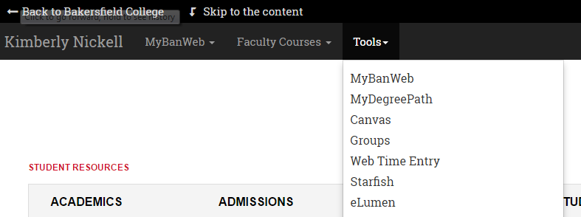

- Once you are in eLumen, you will choose your role as Initiative Review Member
- Choose Strategic Planning
- Choose Initiatives
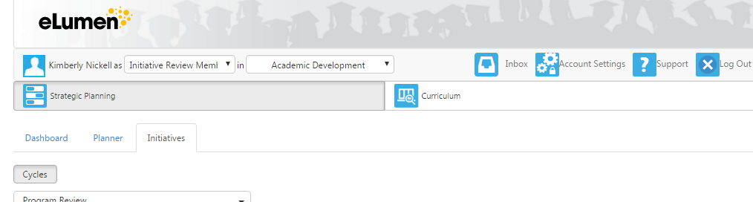
- At this point, you should see a list of Program Reviews in blue
- Click on the blue wording. This should open the Program Review
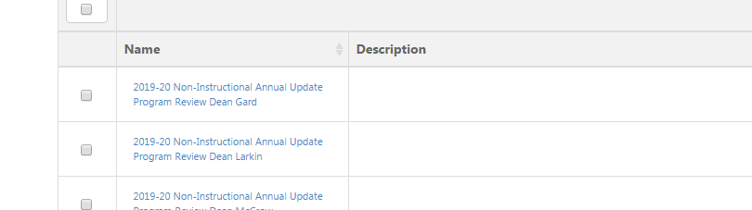

- Once the Program Review opens, you can begin filling in the text boxes marked “Review”. “Save Draft” as you provide feedback.
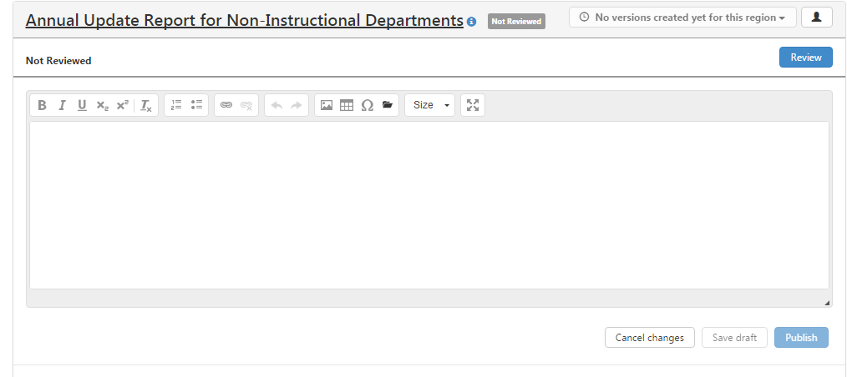

Example for feedback are provided to you.

