Outcomes Handbook

A Comprehensive Guide to Outcomes at Porterville College

Preface

Closing the Loop in Outcome Assessment
“We are what we repeatedly do. Excellence, then, is not an act, but a habit.”
—Will Durant

“I know; we are behind on our SLOs,” most faculty begin when I call to set up a meeting. Some people dread my calls more than those of telemarketers and bill collectors. When I press people (very gently) about where they are behind, my question is met with a long, audibly confused silence.
“Ummm...with SLOs.”
“Yes, but with which part?”
Silence.
I am not terribly surprised by this response because it was my own not so long ago. I took over as the SLO Committee representative for the Language Arts Division in fall 2012 in part because of my (slightly exaggerated) experience with SLOs that I had touted in my interview the year before. I had participated in assessing SLOs as an adjunct faculty member, but with this new appointment, I found myself having to cram like I was in graduate school to get a better understanding of the assessment process college-wide. All of my research kept bringing me back to the same thought: “Why are we making this so difficult?”
When I stripped away the fancy acronyms and educational jargon, SLO assessment seemed to boil down to a simple question: “Did the students learn what I was teaching?” I kept feeling as though I were missing something more complex. Good teachers ask themselves this question on a regular basis and I saw my colleagues, who were outstanding teachers, constantly evaluating how a lesson or semester went, informally assessing student learning, but immediately exhausted at the idea of assessing formally.
The other impediment to SLO assessment I have encountered, one that cannot go without acknowledgment in the assessment blame game, is Curricunet. Many instructors informed me that they had, in fact, completed their SLOs (we’ll come back to the question of what that even means to have completed SLOs later), but that the assessments were on their computer or handwritten and the faculty member could not transfer them to Curricunet without setting aside hours of his or her time (and often, that time would be spent trying to log in). I knew we needed a better way.
I set out to try to capture the effectiveness of our informal division discussions in an easy-to-use, straightforward process that came back to the same basic question—are students learning what we are teaching?
When I became the SLO coordinator in fall 2016 (after fending off many competitors for the position), I wanted to bring the same ideas of “simple” and “something we are doing already” to the rest of the campus. I am finding that as other colleges (many of which are just as behind as we are) try to find answers in more complicated technology, more complex assessments practices, and more time-consuming, box checking for the sake of box checking, our solution is to get back to basics, back to a single driving question, back to teachers questioning a lesson because they want to improve (not because they were forced to fill out a form), and back to what is truly at the heart of the education we offer at Porterville College.
In order to make outcome assessment meaningful, we must value the process. The beauty of the Outcome Assessment Cycle is that it is faculty driven and can be customized to glean whatever knowledge of student learning the faculty in a particular discipline deems important and useful. However, the Outcome Assessment Cycle is only beneficial if it is maintained. A single rotation in isolation does not provide the structure necessary for sustainable improvement in student learning. In other words, our SLOs are never complete; they are always in process.
Currently, Porterville College administration, faculty, and staff are mostly confused with SLOs, how they should be assessed, and what to do with the assessments once they have been collected. Though most divisions are assessing outcomes at the course- and program-levels on a regular basis, few are “closing the loop” (assessing, analyzing, using the analysis to inform changes, and starting again with assessment).
When we fail to close the loop as we are doing in most of our outcome assessments now, we jump around to different plots of dirt to continuously start a new and faulty foundation for a building that is never truly realized. If we are to create a culture of constant progress in teaching effectiveness and student learning, we must commit to laying a strong, permanent foundation and seeing the design through so that the construction of a solid structure (albeit one in need of constant upkeep) is a reality.
This handbook is simply the blueprint for construction; now, let’s roll up our sleeves and get to work!

Melissa Long
SLO Coordinator

Table of Contents
Preface—Closing the Loop in Outcome Assessment 2
Part I—An Introduction to Outcome Assessment at Porterville College 5
Part II—The Outcome Assessment Cycle 9
Chapter 1—Course-Level Student Learning Outcomes (SLOs) 14
Chapter 2—Program Learning Outcomes (PLOs) 25
Chapter 3—Service Area Outcomes (SAOs) 34
Chapter 4—General Education Learning Outcomes (GELOs) 42
Chapter 5—Institutional Learning Outcomes (ILOs) 47
Part III—Discipline-Specific Outcomes Assessment Information 52
Part IV—Program-Specific Outcomes Assessment Information 61
Part V—Student Learning Outcomes (SLO) Committee 70
Part VI—Frequently Asked Questions 75
Part VII—Appendices 82
Appendix A—Outcome Assessment Cycle 83
Appendix B—Resources for Developing Outcome Statements 84
Appendix C—Bloom’s Taxonomy Action Verbs 87
Appendix D—Rubric for Evaluating Learning Outcomes 88
Appendix E—Flow Chart for New or Revised SLO, PLO, or SAO Approval 89
Appendix F—Rubric on Evaluating Outcomes Methods of Assessment 90
Appendix G—Authentic Assessment 91
Appendix H—SLO/SAO Assessment Results Report Form 93
Appendix I—Outcome Cycle Rotation Completion Form 94
Appendix J—Porterville College General Education Learning Outcomes 95
Appendix K—Porterville College Institutional Learning Outcomes 96
Appendix L—ACCJC Rubric for Evaluating the SLO Process 97
Appendix M—Glossary of Terms 98
Part VIII—Outcome Assessment Worksheets 108

Part
1

An Introduction to Outcome Assessment at Porterville College
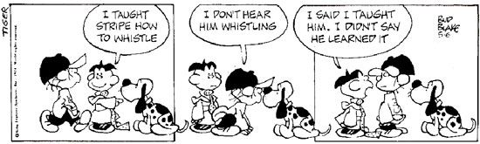

What is an outcome?
An outcome is a statement about the knowledge, skills, attitudes, and/or abilities a student is expected to have upon successful completion of an academic activity. An outcome is expressed using action verbs and is stated in terms that make it measurable.

What types of outcomes are assessed at Porterville College?
Five types of outcomes are assessed at Porterville College:
- Course-Level Student Learning Outcomes (SLOs)
- Program Learning Outcomes (PLOs)
- General Education Learning Outcomes (GELOs)
- Service Area Outcomes (SAOs)
- Institutional Learning Outcomes (ILOs)

What is the Outcome Assessment Cycle?
At Porterville College, the Outcome Assessment Cycle consists of the following four steps:
- Collect—Collect the outcome assessments
- Analyze—Analyze the collected assessments
- Identify—Identify actions based on analysis to improve instruction, service, assessment, and/or outcome statements
- Implement—Implement the actions identified
The cycle should repeat on a regular basis. Every outcome should go through the Outcome Assessment Cycle at least once every four years.

What are the benefits of assessing outcomes?
Systematic assessment of outcomes benefits the entire college community.

For students, statements of outcomes will
- provide clear guidance about the knowledge, skills, attitudes, and/or abilities expected upon successful completion of the learning or service experience
- ensure consistency across all sections of a course
- reassure students that faculty are having conversations about student success
- allow students to make informed decisions about degrees and certificates

For faculty, participating in the Outcome Assessment Cycle will
- help determine what is working and what is not working in courses and programs
- facilitate valuable campus-wide dialogue
- provide evidence to justify needed resources to maintain or improve courses and programs
- generate feedback to inform and guide future teaching practices to improve student learning

For Porterville College, outcome assessment will
- provide data for integrated planning and decision making
- demonstrate an institutional commitment to continually improving the academic programs and services offered
- keep Porterville College in compliance with the Accrediting Commission for Community and Junior Colleges (ACCJC) requirements for outcomes, specifically, that the outcome assessment process be sustainable and continuous (See Appendix L—ACCJC Rubric for Evaluating the SLO Process)

This page intentionally left blank to allow for future revisions.

This page intentionally left blank to allow for future revisions.

Part
2

The Outcome Assessment Cycle
“Learning is a process, not an event.”
—Elliott Masie

What is an Outcome Assessment Cycle?
The Outcome Assessment Cycle refers to the process of assessing outcomes, analyzing the results, and making informed decisions based on the findings. The outcome assessment process must be cyclical, so the it does not have a beginning or an ending; it is always in motion. The Outcome Assessment Cycle is a method to close the loop in outcome assessment.

Why do we have an Outcome Assessment Cycle?
In order to truly close the loop in our assessment process, we need to make the Outcome Assessment Cycle fundamental to the way we gauge learning in our classrooms and the effectiveness of services the campus provides. The Outcome Assessment Cycle should provide the framework for an ongoing dialogue. Student assessment is only the first step and though it provides necessary data, its value is in the discussion and analysis it sparks. With careful consideration and evidence-based decisions, we can continuously improve the education students receive at Porterville College.

When do we employ the Outcome Assessment Cycle?
The Outcome Assessment Cycle should be used to assess all five types of outcomes: Course-Level Student Learning Outcomes (SLOs), Program Learning Outcomes (PLOs), General Education Learning Outcomes (GELOs), Service Area Outcomes (SAOs), and Institutional Learning Outcomes (ILOs). Though the assessment methods and the parties involved in the analysis may vary, the framework provided by the Outcome Assessment Cycle should be adhered to.

What are the steps in the Outcome Assessment Cycle?
The Outcome Assessment Cycle has four steps:
- Collect
Assessments of an outcome are administered, compiled, and distributed.
- Analyze
The compiled data is reviewed and discussed.
- Identify
Opportunities for improvement in instruction, service, assessment, or outcome statements are recognized and a plan for action is developed.
- Implement
The plan for action is carried out.
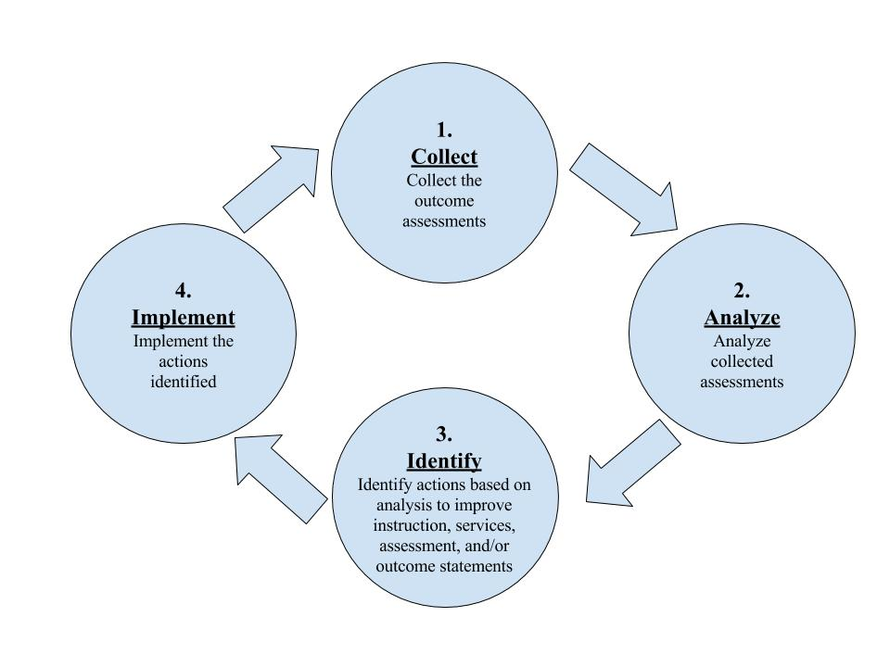
How do we apply the Outcome Assessment Cycle?
The following chapters will guide you in applying the Outcome Assessment Cycle to all five types of outcomes:
Chapter 1—Course-Level Learning Outcomes (SLOs)
Chapter 2—Program Learning Outcomes (PLOs)
Chapter 3—Service Area Outcomes (SAOs)
Chapter 4—General Education Learning Outcomes (GELOs)
Chapter 5—Institutional Learning Outcomes (ILOs)

This page intentionally left blank to allow for future revisions.

This page intentionally left blank to allow for future revisions.

Chapter 1—Course-Level Student Learning Outcomes (SLOs)

What is a Course-Level Student Learning Outcome?
A Course-Level Student Learning Outcome (SLO) is a statement about the knowledge, skills, attitudes, and/or abilities a student is expected to have upon successful completion of the course. An SLO starts with the phrase, “Upon successful completion of this course a student should be able to…”
An SLO statement meets the following four criteria:
- An SLO states the knowledge, skills, attitudes, and/or abilities a student is expected to have upon successful completion of the course
- An SLO is expressed using action verbs
- An SLO is stated in terms that make it measurable
- An SLO supports one of the Institutional Learning Outcomes (ILOs)
(To evaluate the effectiveness of an SLO statement, use Appendix D—Rubric on Evaluating Learning Outcomes.)
What is the difference between an SLO and a course objective?
As a rule of thumb, SLOs are broad whereas objectives are specific. As a result, a course will typically have more course objectives than SLOs. Often an SLO is comprised of what the student can do as a result of combining together several course objectives. That is, a cluster of objectives might support a single SLO. However, for some courses it may be appropriate for an SLO to be the same as one of the course objectives.
What is the point of assessing SLOs when students are already assigned course grades?
Grades measure the overall performance by an individual student in a certain course. Tracing back the learning of specific skills from general grades is nearly impossible. For example, if a student gets a “B” in the course, the grade alone does not illustrate the student’s level of understanding and acquisition of specific skills. Grades are student specific; SLO assessments are skill specific. Instead of how many students receive A’s and B’s in the course, faculty can see how many students are able to demonstrate a specific skill central to the course. Moreover, SLO assessments help ensure that students gain the same set of outcomes in a course regardless of which section or instructor they take.
Where are SLOs documented?
All of the SLOs for every course can be found in the Porterville College Outcomes Database located in Google Drive (https://goo.gl/LRxLA7). Each SLO should have the semester and year of the most current Outcome Assessment Cycle rotation completion as well as the projected start of its next rotation.
Should SLOs be included on the course syllabus?
Yes. Every course syllabus should contain the current SLOs for that course.
Who develops SLOs?
Faculty have the sole responsibility to create SLOs. Preferably, all faculty who teach a course will participate in the SLO development for that course.
When does one write an SLO?
Faculty members write SLOs when they create a new course or when they choose to revise the SLOs as a result of the action determined in the Outcome Assessment Cycle.
How does one write an SLO?
Faculty should write SLOs to meet the following four criteria:
Criteria 1. SLOs should make clear the knowledge, skills, attitudes, and/or abilities that instructors expect a student to have upon successful completion of the course.
Each SLO should begin with the phrase “Upon successful completion of this course, a student should be able to…”
As they develop SLOs, faculty members should ask themselves the following questions:
- Ultimately, what do they hope students will walk away with when they leave this class?
- In terms of the big picture, what do they consider to be the main goals of the course?
- What do they expect that students can do in terms of applying the knowledge or skills that the instructor has covered in the course?
Additional Issues to Consider
- If the course is required for a degree or certificate, faculty should consider whether the SLO could also serve as a Program Learning Outcome (PLO). (See chapter 2.)
- If the course is in one of the General Education Areas, faculty should consider whether the SLO could also serve as a General Education Learning Outcome (GELO). (See chapter 3.)
- The SLOs should be consistent with the course objectives and course content in the Course Outline of Record.
Criteria 2. Faculty should express SLOs using action verbs.
An action verb expresses an action that a person can do. Examples of action verbs are classify, design, summarize, contrast, or critique. (See Appendix C—Bloom’s Taxonomy Action Verbs.)
Criteria 3. Faculty should state the SLO in measurable terms.
Faculty must be able to assess the SLO; therefore, each SLO must have a demonstrable action that faculty can evaluate.
Here is an example of an SLO that is not measurable:
Upon successful completion of this course, the student should be able to write a paper.
Here is an example of an SLO that is measurable:
Upon successful completion of this course, the student should be able to write a focused, well-organized 8-12 page argumentative research paper on a topic appropriate for academic audiences that analyzes and integrates primary and secondary sources and documents sources in MLA format, exhibiting few errors in grammar, usage, mechanics, or punctuation.
Here is an example of an SLO that is not measurable:
Upon successful completion of this course, the student should be able to participate in a debate.
Here is an example of an SLO that is measurable:
Upon successful completion of this course, the student should be able to analyze, advocate, and criticize ideas through a variety of debate formats..
Criteria 4. SLOs should support one of the Institutional Learning Outcomes (ILOs). (See chapter 5).
All SLOs should be aligned with the ILOs to provide students so that the educational goals of Porterville College remain consistent across all disciplines and programs.
What is an SLO assessment?
An SLO assessment is the tool used for evaluating whether the student has successfully achieved the learning outcome.

An SLO assessment meets the following four criteria:
- Successful completion of the assessment is not based on the final course grade
- The assessment clearly identifies the criteria for student success
- The assessment clearly identifies how and when the assessment will be administered
- The assessment is authentic
(To evaluate the effectiveness of an SLO assessment, use Appendix F—Rubric for Evaluating Learning Outcomes Methods of Assessment.)
Who develops SLOs assessment methods?
Faculty have the sole responsibility to develop the assessment method for each SLO statement. Preferably, all faculty who teach a course will participate in the development of the assessment method.
What is authentic assessment?
Authentic assessment simulates a real world experience by evaluating the student’s ability to apply critical thinking and knowledge or to perform tasks that may approximate those found in the workplace or other venues outside the classroom setting. When developing the assessment method, faculty should give priority to authentic assessment methods. (See Appendix G—Authentic Assessments.)
What are direct and indirect assessments?
Direct assessments are those that are assessed by faculty and are more likely to be authentic. In a direct assessment, students demonstrate the outcome at the end of the semester. Indirect assessments are often assessed by other programs or personnel on campus and often survey the students or others as to the students’ performance of the outcome.
Direct Assessments | Indirect Assessments
- Essays  - Exam questions  - Term papers  - Field work performance, internship performance, or service learning projects  - Research projects  - Case study analysis  - Oral presentations  - Performances  - Portfolios of student work  - Pre-test and post-test  - Video production | - Alumni surveys  - Employer surveys  - External reviewers  - Licensure exam results  - Student exit interview/surveys
Course-Level SLO Assessment Cycle
SLOs are assessed according to the Outcome Assessment Cycle. The following section will describe this process in detail.
- Collect
In this step, assessments of an SLO are administered, compiled, and distributed.
- Faculty assess students.
- Generally, instructors will assess student performance during the semester when they are teaching the course. There may be some exceptions such as when a follow-up measure is used.
- Before assessing the SLO for a course, faculty who teach the course should review the division-approved assessment methods and procedures for that SLO. (See Part III.)
- Since SLOs are statements about the knowledge, skills, attitudes and/or abilities that faculty expect a student to have upon successful completion of the course, most faculty will report assessment results only for students who successfully pass the course. Faculty can assess all students, but wait to report only the assessment results for students who pass the class. On the other hand, some faculty may find more value in reporting assessment results for all students, giving a wider picture of student success and failure. Participating faculty should determine in advance what instructors will report so every faculty member teaching a course is assessing the same population of students.
- In courses that enroll a large number of students, faculty may opt to select a representative sample of student work to assess. The sample should be large enough to provide a good variety of student work and should be selected randomly.

- Faculty report assessment results.
- Faculty members report their results with answers to the following questions:
  - How did you assess this SLO?
  - How many students attempted this assessment?
  - How many students passed that assessment with a ____ percent or higher?
  - Do you need to improve on teaching and/or assessing this SLO?
  - If so, how do you plan to do so? If not, why not?
(See Appendix H—SLO/SAO Assessment Results Report Form.)
- Faculty members should also attach any relevant materials (test, quiz, essay prompt, grading rubric, etc.)

- Assessment results are compiled.
- All of the assessment results for a SLO are collated to facilitate discussion. The person or people responsible for assembling the assessment results varies by discipline. (See Part III—Discipline-Specific Outcomes Assessment Information.)

- Assessment results are distributed.
- The compiled assessment results are distributed to faculty who will participate in the analysis and discussion.
- Faculty members should be given time to study the data thoroughly before discussion.

- Analyze
In this step, the data compilation is reviewed and discussed.
- Participating faculty should analyze the compilation of assessment results.
- Faculty should study the results with the following questions driving analysis:
  - Was the overall student performance acceptable?
  - Are there concepts with which many students have difficulty?
  - How much variation was there in student performance?
  - How does this data compare to previous semesters/prior Outcome Assessment Cycle results?
  - Do students with a passing/failing course grade follow the same pattern of passing/failing the assessment?
  - In retrospect, does the assessment method still make sense, or should it somehow be modified to get more useful information the next time around?

- Discussions about the results and analysis must take place.
- Collaborative analysis is the heart of the Outcome Assessment Cycle. In this step, faculty participate in a focused, purpose-driven dialogue on effective teaching practices. The goal is energetic, dynamic, positive, constructive, and supportive conversations between faculty about how to improve student learning.
- Discussion must happen to complete the Outcome Assessment Cycle. If a course is taught by a single instructor, the faculty member should meet with other faculty in his or her discipline or area who are interested in talking about good teaching strategies and ways to improve student learning. Faculty dialogue about effective teaching strategies is valuable across courses or even across disciplines.
- Format and procedures for discussion vary by discipline. (See Part III—Discipline-Specific Outcome and Assessment Information.)

- Identify
In this step, participating faculty identify opportunities for improvement in instruction and/or assessment. Faculty also may determine that the SLO statement needs to be revised.
- Faculty recognize areas of weakness.
- During the analysis and discussion for step 2, faculty should be alert for possible changes to make instruction or assessment more effective.

- Faculty create a plan for improvement.
- In order to strengthen student success in the outcome in the future, faculty should develop a strategy that will address the area of weakness.
- Here are some examples of how discussions in step 3 can be used in step 4 to create plans:
  - Faculty dialogue about different teaching strategies and get ideas about new things to try next semester to improve student learning/success.
  - Faculty question the importance or relevance of the SLO. If this is the case, faculty will need to revise the SLO and/or develop a new SLO. (See Step 4. Implement.)
  - Faculty identify issues which may be interfering with student success on the SLO that are not necessarily related to presentation of the material or course content. For example, faculty may decide to review the prerequisite for the course or cut scores for placement tests. Or faculty may also decide to refer students to workshops to help with time management or study skills.
  - Faculty realize that the assessment method, including timing, is different between instructors. In this case, faculty should agree on the assessment method and on its timing.
  - Faculty identify resources needed to improve student learning, for example, equipment, materials, use of campus learning support services (Writing Mentors, Math Mentors, PASS, and tutoring).
  - Faculty discover that they have different interpretations about what the SLO means. If this is the case, faculty should dialogue until an agreement is reached and consider revising the SLO statement to reflect the new understanding.
  - Faculty discover that they are getting a wide variety of student responses indicating that the SLO assessment is ambiguous. In this case, faculty should revise the assessment method to make the results more meaningful.

- The actions and timeline for implementation should be established.
- In order to capitalize on the momentum of the discussion and plan creation, faculty should define what actions need to be taken to implement the plan, who is responsible for them, and when they need to happen.
- These designations should be as specific as possible.
  - Example of a vague description of action and timeline:
    - The division will revise the SLO.
  - Example of a specific description of action and timeline:
    - The division will revise the SLO at the next division meeting on September 15. John Doe, division SLO committee representative, will submit the revision to the SLO committee for its September 27 meeting agenda.

- The discussion and the plan for improvement must be documented.
- The completion of step 3 should be recorded to ensure movement in and adherence to the Outcome Assessment Cycle.
- The designated person should complete the Outcome Cycle Rotation Completion Form. (The designated person will vary according to discipline; see Part III—Discipline-Specific Outcome and Assessment Information; for form, see Appendix I—Outcome Cycle Rotation Completion Form.)
- The Outcome Cycle Rotation Completion Form simply summarizes the process and documents the planned actions for improvement.
- If possible, attach other forms of documentation of the discussion, such as meeting minutes, email exchanges (or excerpts), or online discussion transcripts.

- Implement
In this step, faculty implement the actions it identified in step 3.
- Faculty follow through with the plan it created to improve teaching, assessment, and/or the outcome statement.
- At this point, one rotation in the Outcome Assessment Cycle has been completed.
- The SLO committee representative should update the Porterville College Outcomes Database to record the date of rotation completion and enter the projected date of the next collection of assessment results (thus beginning the next rotation).

Repeat, Repeat, Repeat…
Valuable feedback and information can only be ascertained with constant and consistent adherence to the Outcome Assessment Cycle. We must close the loop in order to progress with every rotation to be more effective in what and how we teach our students.

This page intentionally left blank to allow for future revisions.

This page intentionally left blank to allow for future revisions.

Chapter 2—Program Learning Outcomes (PLOs)

An “educational program” is defined in Title 5, Section 55000(g) as “an organized sequence of courses leading to a defined objective, a degree, a certificate, a diploma, a license, or transfer to another institution of higher education.”
Each degree or certificate program must have a comprehensive list of Program Learning Outcomes (PLOs).
What is a Program Learning Outcome?
A Program Learning Outcome (PLO) is a statement about the knowledge, skills, attitudes, and/or abilities a student is expected to have upon successful completion of the requirements for the degree or certificate.
A PLO starts with the phrase, “Upon successful completion of this degree [or certificate] a student should be able to…”
A PLO statement meets the following four criteria:
- A PLO states the knowledge, skills, attitudes, and/or abilities a student is expected to have upon successful completion of the degree or certificate
- A PLO is expressed using action verbs
- A PLO is stated in terms that make it measurable
- Each PLO for the degree or certificate is identified with one of the Institutional Learning Outcomes (ILOs)
Where are PLOs documented?
The PLOs for every program can be found in the Porterville College Outcomes Database located in Google Drive (https://goo.gl/LRxLA7). Each PLO should have the semester and year of the most current Outcome Assessment Cycle rotation completion as well as the projected start of its next rotation.
How is a PLO different from an SLO?
Often the list of PLOs for a degree or certificate includes a PLO that is exactly the same as a Course-Level Student Learning Outcome (SLO) that is assessed in one of the courses required for the degree. A PLO might also be a combination of several SLOs.

The Salad Analogy for PLOs
Observe the two pictures below:
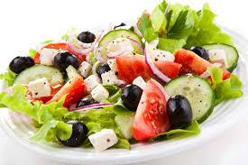
Though both images have pictures of similar ingredients the “difference in the ingredients’ degree of preparation and integration makes only one image a salad.” Though the ingredients contribute to the salad, their presence alone does not constitute a salad. Applied to learning outcomes, we can see that SLOs are ingredients or the “[i]ncremental knowledge and skills that students develop bit by bit throughout the program.” SLOs are “typically narrower than” PLOs though the two are aligned. PLOs are the salad or “what individual ingredients make once they are prepared and integrated.” PLOs should reflect “[s]tudents’ cumulative learning across courses at the end of the program.”
PLOs tend to make more sense and are easier to understand when they are closely aligned to SLOs from courses in the program.
Do all degrees and certificates need PLOs?
Yes. All degrees and certificates must have a comprehensive list of measurable PLOs describing the skills gained through successful completion of the program.
How many PLOs are necessary for a degree or certificate program?
A specific number of PLOs is not required. But the process of developing PLOs involves producing a comprehensive list of PLOs describing the “big picture” skills gained through successful completion of the program. Avoid restating a long list of SLOs from all of the major courses.
What is the point of assessing PLOs when students are already awarded degrees and certificates?
PLOs give information to faculty in the major (and employers in the field) about whether most students earning the degree or certificate actually have the skills expected upon the completion of the program. PLO assessment gives faculty information about how to improve the program and prospective employers information about the skill level of the typical graduate of the program.
Should PLOs be included on the course syllabus?
No. Including the PLOs on a course syllabus is not necessary.
PLO Assessment Cycle
PLOs are assessed according to the Outcome Assessment Cycle.
Repeat, Repeat, Repeat…
Valuable feedback and information can only be ascertained with constant and consistent adherence to the Outcome Assessment Cycle. We must close the loop in order to progress with every rotation to be more effective in what programs we offer and to what degree they benefit our students.

This page intentionally left blank to allow for future revisions.

This page intentionally left blank to allow for future revisions.

This page intentionally left blank to allow for future revisions.

This page intentionally left blank to allow for future revisions.

This page intentionally left blank to allow for future revisions.

This page intentionally left blank to allow for future revisions.

Chapter 3—Service Area Outcomes (SAOs)

What is a Service Area Outcome?
A Service Area Outcome (SAO) is a statement about the knowledge, skills, attitudes, and/or abilities a student is expected to have upon successful completion of a student services activity (e.g. counseling appointment, orientation, assessment, field trip). An SAO starts with the phrase, “Upon successful completion of this activity a student should be able to…”
An SAO statement meets the following four criteria:
- An SAO states the knowledge, skills, attitudes, and/or abilities a student is expected to have upon successful completion of the activity
- An SAO is expressed using action verbs
- An SAO is stated in terms that make it measurable
- An SAO supports one of the Institutional Learning Outcomes (ILOs)
Where are SAOs documented?
SAOs can be found in the Porterville College Outcomes Database located in Google Drive (https://goo.gl/LRxLA7). Each SAO should have the semester and year of the most current Outcome Assessment Cycle rotation completion as well as the projected start of its next rotation.
Who develops SAOs?
Faculty and Student Services administrators and staff in the assigned areas have the responsibility to create SAOs. Preferably all faculty, staff, and administrators who are involved in the activity will participate in the development or revision of the SAOs for that activity.
How does one write an SAO?
In generating ideas of SAOs, here are some questions to consider:
- Ultimately, what do you hope students will walk away with when they complete this activity?
- In terms of the big picture, what do you consider to be the main goals of this activity?
- What would you expect that students can do in terms of applying the knowledge or skills that have been developed through participation in this experience?
An SAO is expressed using action verbs. (See Appendix C—Bloom’s Taxonomy Action Verbs.)
An SAO is stated in terms that make it measurable.
Here is an example of an SAO that is not measurable:
At the conclusion of an academic counseling appointment, the student should be able to know an educational goal.
Here is an example of an SAO that is measurable:
At the conclusion of an academic counseling appointment, the student should be able to state his/her educational goal or the next step required to determine his/her educational goal.
What is an SAO assessment?
An SAO assessment is the tool used for evaluating whether or not the student has successfully achieved the outcome.
An SAO assessment meets the following four criteria:
- Successful completion of the assessment is not based on grade or score for the entire activity
- The assessment clearly identifies the criteria for student success
- The assessment clearly identifies how and when the assessment will be administered
- The assessment is authentic
(To evaluate the effectiveness of an SAO assessment, use Appendix F—Rubric for Evaluating Learning Outcomes Methods of Assessment.)
How does one develop an SAO assessment?
In developing an assessment method, area personnel will need to answer questions such as the following:
- When will the assessment occur?
- Who will administer the assessment?
- What materials and resources will the students have while completing the assessment?
- How much time will the students have to complete the assessment?
- What instructions or information will students get about this assessment?
- If there are activities that are offered through distance education formats, what logistics need to be worked out for those activities?
- What are other special considerations for this particular assessment?

SAO Assessment Cycle
SAOs are assessed according to the Outcome Assessment Cycle.
- Collect
In this step, assessments of an SAO are administered, compiled, and distributed.
- Students are assessed.
- Assessment of SAOs will occur at designated times throughout the year. This assessment method must be used consistently for the same activity even if it is conducted at different times. Assessment administration is more successful if faculty and staff dialogue early in the semester about the process.

- Assessment results are compiled.

- Assessment result compilations are distributed.
- The compiled assessment results are distributed to all who will participate in the analysis and discussion.
- Area personnel should be given time to study the data thoroughly before discussion.

- Analyze
In this step, the assessment results are reviewed and discussed.
- Participating faculty, administrators, and staff should analyze the assessment results.
- They should study the results with the following questions driving analysis:
  - Was the overall student performance acceptable?
  - Are there concepts with which many students have difficulty?
  - How much variation was there in student performance?
  - How does this data compare to previous semesters/prior Outcome Assessment Cycle results?
  - In retrospect, does the assessment method still make sense, or should it somehow be modified to get more useful information the next time around?

- Discussions about the results and analysis must take place.
- Collaborative analysis is the heart of the Outcome Assessment Cycle. In this step, area personnel participate in a focused, purpose-driven dialogue on effective practices. The goal is energetic, dynamic, positive, constructive, and supportive conversations.
- Format and procedures for discussion vary. (See Part III—Discipline-Specific Outcome and Assessment Information.)

- Identify
In this step, participating faculty and staff identify opportunities for improvement in service and/or assessment. Area personnel also may determine that the SAO needs to be revised.
- Areas of weaknesses are recognized.
- During the analysis and discussion for step 2, participants should be alert for possible changes to make in the service or assessment more effective.

- A plan is made for improvement.
- In order to strengthen student success in the outcome in the future, area personnel should develop a strategy that will address the area of weakness.
- Here are some examples of how discussions in step 3 can be used in step 4 to create plans:
  - Area personnel dialogue about different teaching strategies and get ideas about new things to try next semester to improve student success.
  - Area personnel question the importance or relevance of the SAO. If this is the case, faculty will need to revise the SAO and/or develop a new SAO. (See Step 4. Implement.)
  - Area personnel identify issues which may be interfering with student success on the SAO that are not necessarily related to the activity itself.
  - Area personnel realize that the assessment method, including timing, is a variable. If this is the case, they should agree on the assessment method and its timing.
  - Area personnel identify resources needed to improve student learning, for example, equipment, materials, expanded student support resources.
  - Area personnel discover that they have different interpretations about what the SAO means. If this is the case, they should dialogue until an agreement is reached and consider revising the SAO to reflect the new understanding.
  - Area personnel discover that they are getting a wide variety of student responses indicating that the SAO assessment is ambiguous. In this case, they should revise the assessment method to make the results more meaningful.

- The actions and timeline for implementation should be established.
- In order to capitalize on the momentum of the discussion and plan creation, area personnel should define what actions need to be taken to implement the plan, who is responsible for them, and when they need to happen.
- These designations should be as specific as possible.
  - Example of a vague description of action and timeline:
    - The division will revise the SAO.
  - Example of a specific description of action and timeline:
    - The division will revise the SAO at the next division meeting on September 15. John Doe, division SAO committee representative, will submit the revision to the SAO committee for its September 27 meeting agenda.

- The discussion and the plan for improvement must be documented.
- The completion of step 3 should be recorded to ensure movement in and adherence to the Outcome Assessment Cycle.
- The designated person should complete the Outcome Cycle Rotation Completion Form. (The designated person will vary according to discipline; see Part III—Discipline-Specific Outcome and Assessment Information; for form, see Appendix I—Outcome Cycle Rotation Completion Form.)
- The Outcome Cycle Rotation Completion Form simply summarizes the process and documents the planned actions for improvement.
- If possible, attach other forms of documentation of the discussion, such as meeting minutes, email exchanges (or excerpts), or online discussion transcripts.

- Implement
In this step, area personnel implement the actions it identified in step 3.
- Area personnel follow through with the plan it created to improve service, assessment, and/or the outcome statement.

- At this point, one rotation in the Outcome Assessment Cycle has been completed.
- The SLO committee representative should update the Porterville College Outcomes Database to record the date of rotation completion and enter the projected date of the next collection of assessment results (thus beginning the next rotation).

Repeat, Repeat, Repeat...

Valuable feedback and information can only be ascertained with constant and consistent adherence to the Outcome Assessment Cycle. We must close the loop in order to progress with every rotation to be more effective in what student services we offer and to what degree they benefit our students.

This page intentionally left blank to allow for future revisions.

This page intentionally left blank to allow for future revisions.

Chapter 4—General Education Learning Outcomes (GELOs)

What is a General Education Learning Outcome?
A General Education Learning Outcome (GELO) is a statement about the knowledge, skills, attitudes, and/or abilities a student is expected to have upon successful completion of a course in one of the General Education Areas for Porterville College. The goal of general education at Porterville College is to develop a more well-rounded individual with a broad understanding of the physical universe, people as individuals and as members of society, artistic and cultural expression, written composition, oral communication, analytical thinking, multicultural environments, and perspectives of people from other cultures and backgrounds.
Faculty have the sole responsibility to develop, review, or revise GELOs; however, because GELOs are not specific to one course, any revisions must be approved by the Curriculum Committee and must meet the following four criteria:
- A GELO states the knowledge, skills, attitudes, and abilities a student is expected to have upon successful completion of a course in one of the General Education Areas
- A GELO is expressed using action verbs
- A GELO is stated in terms that make it measurable
- A GELO supports one of the institutional Learning Outcomes (ILOs)
What are the General Education Areas for Porterville College?
Porterville College has five General Education Areas:
- Written and Oral Communication
- Natural Science and Mathematics
- Arts and Humanities
- Social, Political, Economic Institutions and Behavior, Historical Background
- Understanding and Self-Development
Where are GELOs documented?
The GELOs can be found in the Porterville College Outcomes Database located in Google Drive (https://goo.gl/LRxLA7). Each GELO should have the semester and year of the most current Outcome Assessment Cycle rotation completion as well as the projected start of its next rotation.
What is the difference between a GELO and a Course-Level Student Learning Outcome (SLO)?
GELOs are broad assessments of the knowledge, skills, attitudes, and abilities a student is expected to have upon completion of any general education course in a specific General Education Area. SLOs are statements about the knowledge, skills, attitudes, and abilities a student is expected to have upon successful completion of a specific course. Much like Program Learning Outcomes (PLOs), GELOs can be closely aligned with SLOs, but GELOs are broader and the result of integrated SLOs.
Who develops or revises GELOs?
Faculty have the sole responsibility to develop, review, or revise GELOs; however, because GELOs are not specific to one course, any revisions must be approved by the Curriculum Committee.
What are the current GELOs?
Porterville College General Education Learning Outcomes
- Communication: Students will read, write, speak, and listen effectively.
- Critical Thinking: Students will think independently, creatively, and critically so they can make informed and logical judgments of the arguments of others, arrive at reasoned and meaningful arguments and positions, and formulate and apply ideas to new contexts.
- Scientific and Quantitative Reasoning: Students will understand and apply mathematical and scientific principles and methods.
- Technology, Information Literacy, and Information Competency: Students will effectively use multiple formats, including print, computer and emerging technologies, to locate, access, analyze, evaluate, and utilize information that facilitates learning and critical inquiry.
- Social and Cultural Understanding and Ethical Development: Students will understand and be prepared to actively participate as informed and responsible citizens in political, social, cultural, and environmental matters, both locally and globally.
- Personal Development: Students will have the ability to adapt to change, learn effectively, establish a framework for aesthetic responsiveness, enhance wellness, and set personal and professional goals.

GELO Assessment Cycle
GELOs are assessed according to the Outcome Assessment Cycle.
Repeat, Repeat, Repeat…
Valuable feedback and information can only be ascertained with constant and consistent adherence to the Outcome Assessment Cycle. We must close the loop in order to progress with every rotation to be more effective in the general education we offer our students.

This page intentionally left blank to allow for future revisions.

This page intentionally left blank to allow for future revisions.

Chapter 5—Institutional Learning Outcomes (ILOs)

What is an Institutional Learning Outcome?
An Institutional Learning Outcome (ILO) is a statement about the knowledge, skills, attitudes, and/or abilities a student is expected to develop as a result of his or her total experience with any aspect of the college, including courses, programs, and student services.
What is the purpose of ILOs?
ILOs are designed to help guide the institution in the development of SLOs, PLOs, SAOs, and GELOs and to help guide planning at the college. ILOs clarify our mission to ourselves and to our students.
Where are ILOs documented?
The ILOs can be found in the Porterville College Outcomes Database located in Google Drive (https://goo.gl/LRxLA7). Each ILO should have the semester and year of the most current Outcome Assessment Cycle rotation completion as well as the projected start of its next rotation.
What is the difference between an ILO and other types of outcomes?
ILOs are the collective expression of the learning experiences the college offers to students as a result of their total experience with any aspect of the college, including courses, programs, and student services. Other types of outcomes focus on the particular skills, knowledge, abilities, and attitudes that students learn in specific courses or activities.
How are ILOs different from General Education Learning Outcomes (GELOs)?
The considerable overlap between ILOs and GELOs is deliberate. GELOs apply only to students who graduate from the college with an AA or AS degree and who thus must meet the general education requirements. In contrast, ILOs apply many of the same educational outcomes to all students, whether enrolled in transfer or occupational programs, noncredit courses, or personal enrichment classes.
How can a course meet all of the ILOs?
The ILOs represent the overall educational experiences of students at Porterville College. Because ILOs are the most universal educational outcome of the College, a single course and/or program cannot and is not expected to meet all of the ILOs. However, each course and program must contribute toward at least one ILO and all outcomes should be aligned with and mapped to an ILO.

Who develops or revises ILOs?
The Academic Senate has the primary responsibility to develop, review, or revise ILOs. The ILOs must be approved by the Board of Trustees. The review of ILOs will coincide with the review of the Mission Statement.
Which employees at Porterville College should be active participants in developing ILOs?
All employees should be involved in creating an environment that leads to student success, and ILOs are a way for Porterville College to assess whether we are and continue to be successful in that endeavor. Therefore, all employees should be active participants.
What are the current ILOs?
Porterville College Institutional Learning Outcomes
COMMUNICATION
Use language and non-verbal modes of expression appropriate to the audience and purpose.

COGNITION
Think independently, creatively, and critically in order to analyze, synthesize, and evaluate ideas and information.

INFORMATION COMPETENCY
Utilize research skills necessary to achieve educational, professional, and personal objectives.
Demonstrate knowledge of a core area of study.

SOCIAL AND CULTURAL RESPONSIBILITY
Demonstrate sensitivity to and respect for others, both locally and globally, and participate actively in group decision making.

PERSONAL DEVELOPMENT
Demonstrate self-management and ethical awareness through practices that promote physical, mental, and emotional well-being.

ILO Assessment Cycle
ILOs are assessed according to the Outcome Assessment Cycle.
Repeat, Repeat, Repeat…
Valuable feedback and information can only be ascertained with constant and consistent adherence to the Outcome Assessment Cycle. We must close the loop in order to progress with every rotation to be more effective in the education we offer our students.

This page intentionally left blank to allow for future revisions.

This page intentionally left blank to allow for future revisions.

Part
3

Discipline-Specific Outcomes Assessment Information
The division SLO Committee representative will distribute this part when it is complete for a discipline. If your discipline has not yet completed the Discipline-Specific Information Survey, please do so as soon as possible (contact your SLO Committee representative for access).

This page intentionally left blank to allow for future revisions.

This page intentionally left blank to allow for future revisions.

This page intentionally left blank to allow for future revisions.

This page intentionally left blank to allow for future revisions.

This page intentionally left blank to allow for future revisions.

This page intentionally left blank to allow for future revisions.

This page intentionally left blank to allow for future revisions.

This page intentionally left blank to allow for future revisions.

Part
4

Program-Specific Outcomes Assessment Information
The SLO Committee will work on Program Learning Outcome (PLO) assessment during the 2017-2018 school year, so the program-specific assessment process portion will be distributed in spring 2018 or fall 2018.

This page intentionally left blank to allow for future revisions.

This page intentionally left blank to allow for future revisions.

This page intentionally left blank to allow for future revisions.

This page intentionally left blank to allow for future revisions.

This page intentionally left blank to allow for future revisions.

This page intentionally left blank to allow for future revisions.

This page intentionally left blank to allow for future revisions.

This page intentionally left blank to allow for future revisions.

Part
5

Student Learning Outcomes (SLO) Committee
Because changes in the structure and mission of the SLO Committee are not yet finalized, this chapter will be drafted in fall 2017 and will be distributed for insertion in the handbook in spring 2018.

This page intentionally left blank to allow for future revisions.

This page intentionally left blank to allow for future revisions.

This page intentionally left blank to allow for future revisions.

This page intentionally left blank to allow for future revisions.

Part
6

Frequently Asked Questions
Questions for this chapter will be collected at the beginning of fall 2017. The answers will be drafted during the fall 2017 semester and the finished chapter will be distributed for insertion in the handbook in spring 2018.

This page intentionally left blank to allow for future revisions.

This page intentionally left blank to allow for future revisions.

This page intentionally left blank to allow for future revisions.

This page intentionally left blank to allow for future revisions.

This page intentionally left blank to allow for future revisions.

This page intentionally left blank to allow for future revisions.

Part
7

Appendices
Appendix A—Outcome Assessment Cycle
Appendix B—Resources for Developing Outcome Statements
Appendix C—Bloom’s Taxonomy Action Verbs
Appendix D—Rubric on Evaluating Learning Outcomes
Appendix E—Flow Chart for New or Revised SLO, PLO, or SAO Approval
Appendix F—Rubric on Evaluating Learning Outcomes Methods of Assessment
Appendix G—Authentic Assessment
Appendix H—SLO/SAO Assessment Results Form
Appendix I—Outcome Cycle Rotation Completion Form
Appendix J—Porterville College General Education Learning Outcomes (GELOs)
Appendix K—Porterville College Institutional Learning Outcomes (ILOs)
Appendix L—ACCJC Rubric for Evaluating the SLO Process
Appendix M—Glossary of Terms

Appendix A—Outcome Assessment Cycle

Appendix B—Resources for Developing Outcome Statements

A Guide to Developing Measurable Outcomes
How to Get Started:
- Begin by developing a department/service area mission statement. Make sure your mission supports or advances the broader college mission and is consistent with the college’s espoused values.
- Ask yourself: what are the most important things a student should know, be able to do or demonstrate after completing my course, program, or from utilizing my office/services?
- Make a list of these and try to write them as SLO/SAO statements using the examples and hints provided below. Relate them to the college’s strategic plan and action plan.
- Edit and review—refer to “How Do You Fix a Outcome?” below, paying careful attention to the verbs used your outcomes.
When Writing Outcomes:
- Focus on a smaller number of high priority outcomes—this will lower the burden of assessment and record keeping.
- Make outcomes as specific, focused, and clear as possible—general outcomes will be hard to measure!
The Importance of Action Verbs:
Action verbs result in overt behavior that can be observed and measured. (For a list of action verbs, see Appendix C—Bloom’s Taxonomy Action Verbs.)
Certain verbs are unclear and call for covert, internal behavior which cannot be observed or measured. These types of verbs should be avoided: appreciate, become aware of, become familiar with, know, learn, understand.
Examples of too general and very hard to measure outcomes—
- ...will appreciate the benefits of exercise.
- ...will be able to access resources at the college.
- ...will develop problem-solving skills and conflict resolution.
- ...will be able to have more confidence in their abilities.
Examples of general and hard to measure outcomes—
- ...will value exercise as a stress reduction tool.
- ...will be able to develop and apply effective problem-solving skills that would enable one to adequately navigate through the proper resources within the college.
- ...will demonstrate ability to resolve personal conflicts and assist others in resolving conflicts.
- ...will demonstrate critical-thinking skills, such as problem solving as it relates to social issues.
Examples of specific and relatively easy to measure outcomes—
- ...will be able to explain how exercise affects stress.
- ...will be able to identify the most appropriate resource that is pertinent to their college concern.
- ...will be able to assist classmates in resolving conflicts by helping them negotiate agreements.
- ...will demonstrate the ability to analyze and respond to arguments about racial discrimination.
Sidebar—
Personal goals are not necessarily outcomes:
Personal Goal: ...able to participate in physical activities at least 3 days per week.
Learning Outcome: ...able to establish a personal exercise program consistent with professional guidelines.

Personal Goal: ...able to receive a satisfactory mark on a difficult writing assignment.
Learning Outcome: ...able to apply APA format to papers and assignments.

Expectations are not necessarily outcomes:
Expectation: ...will dress appropriately.
Learning Outcome: ...will be able to describe the significance of a professional appearance at work.

Expectation: ...will turn in assignments by scheduled due date.
Learning Outcome: ...will be able to explain the importance of meeting deadlines.

How Do I Fix an Outcome?
Shortcomings can typically be seen by asking two simple questions:
- Can it be measured?
- Is learning being demonstrated?
Take a look at the following examples:
Participants will understand the nine reasons for conducting a needs assessment.
Learning is demonstrated, but this outcome will be difficult to measure.
Student will arrive on time daily.
The action can be easily measured, but learning is not necessarily being demonstrated.
We see readily that these learning outcomes have shortcomings, but we can rewrite these to make the outcomes measurable and demonstrative of learning:
Participants will be able to list nine reasons for conducting a needs assessment.
Student will be able to articulate the necessity of maintaining office hours as publicized.
Both of these outcomes answer the two questions. They are measurable and demonstrate that the student has learned!
Outcomes Template:
Try using this template for writing outcomes—
As a result of students participating in __________________________________________ they will be able to ________________________________________.

Example—As a result of students participating in the tutor training session, they will be able to write concisely, include factual details in their reports, and use language that is non-judgmental.
After creating outcomes, reference this checklist:
- Does the outcome support the course, program, or service objectives?
- Does the outcome describe what the course, program, or service intends for students to know (cognitive), think (affective, attitudinal), or do (behavioral, performance)?
- Is the outcome important/worthwhile?
- Is the outcome
  - detailed and specific?
  - measurable/identifiable?
  - a result of learning?
- Do you have or can you create an activity to enable students to learn the desired outcome?
- Can the outcome be used to make decisions on how to improve the course, program, or service?

Other Resources:
For more help on writing outcome statements, please view the following video lesson, “Assessment Quickies #2: Writing Student Learning Outcome Statements,” by Michelle Saint-Germain: https://goo.gl/1YPsXB

Appendix C—Bloom’s Taxonomy Action Verbs

Bloom’s Taxonomy Action Verbs

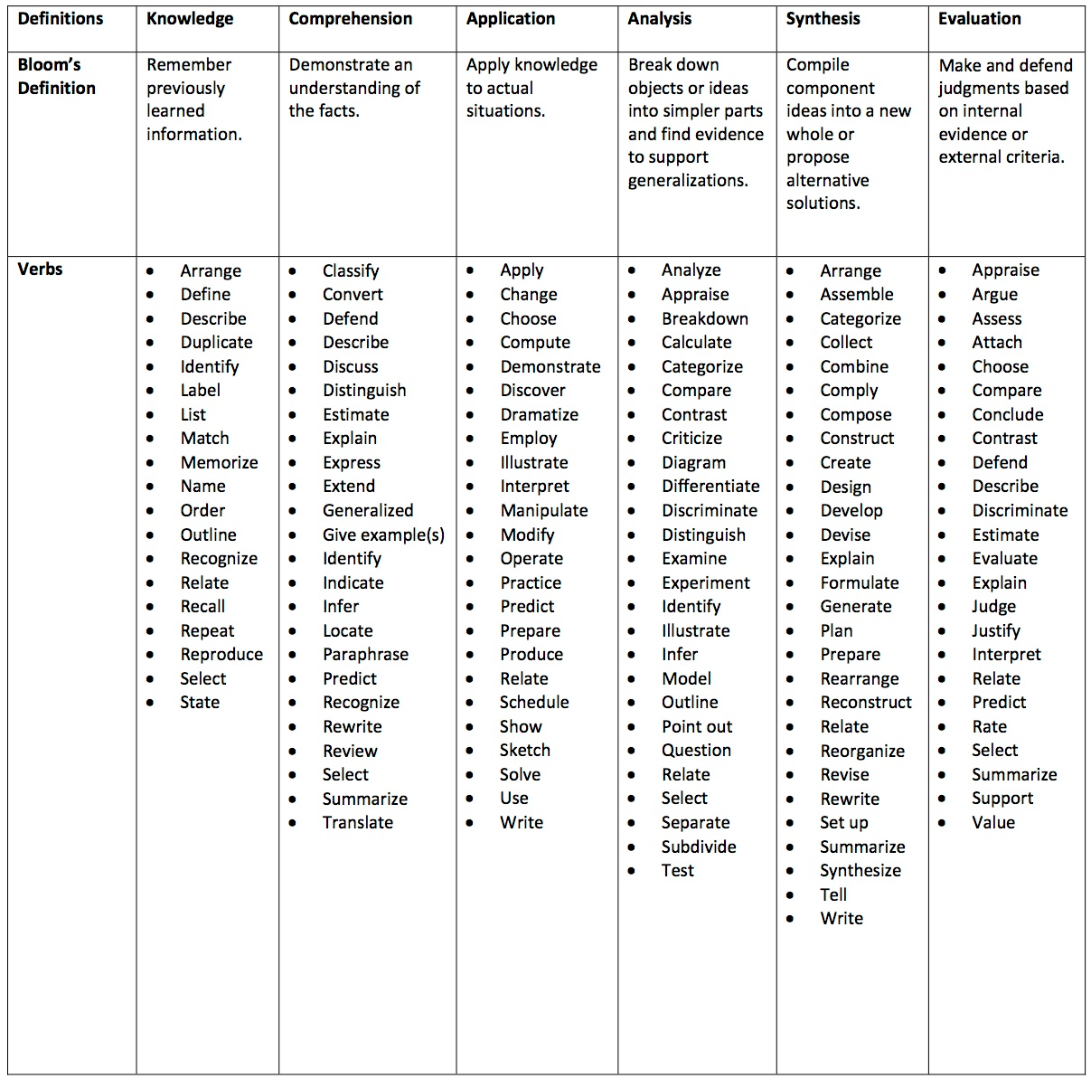

Appendix D—Rubric for Evaluating Learning Outcomes

Rubric for Evaluating Outcomes
Criteria | Meets | Does Not Meet
1—Outcome states the knowledge, skills, attitudes, or abilities a student is expected to have upon successful completion of the course. | Clearly states what the student will be able to do upon successful completion of the academic activity  Is stated as a single outcome | Does not clearly state what the student will be able to do upon completion  Combines multiple outcomes  Stated in terms of what the instructor will do rather than what the student will do
2—Outcome is expressed using action verbs. | Uses action verbs (Refer to Appendix C—Bloom’s Taxonomy Action Verbs) | Does not use action verbs (Refer to Appendix C— Bloom’s Taxonomy Action Verbs)
3—Outcome is stated in terms that make it measurable. | Criteria for successful completion are clearly identified and leave no room for confusion or varying interpretations among faculty or staff. | Criteria for successful completion are vague and ambiguous leaving room for confusion and varying interpretations among faculty or staff.
4—Outcome is aligned with one of the Institutional Learning Outcomes (ILOs) | Linked to one ILO based on the specific outcome and not on the overall course content | Linked to more than one ILO  Not linked to any ILO

Appendix E—Flow Chart for New or Revised SLO, PLO, or SAO Approval
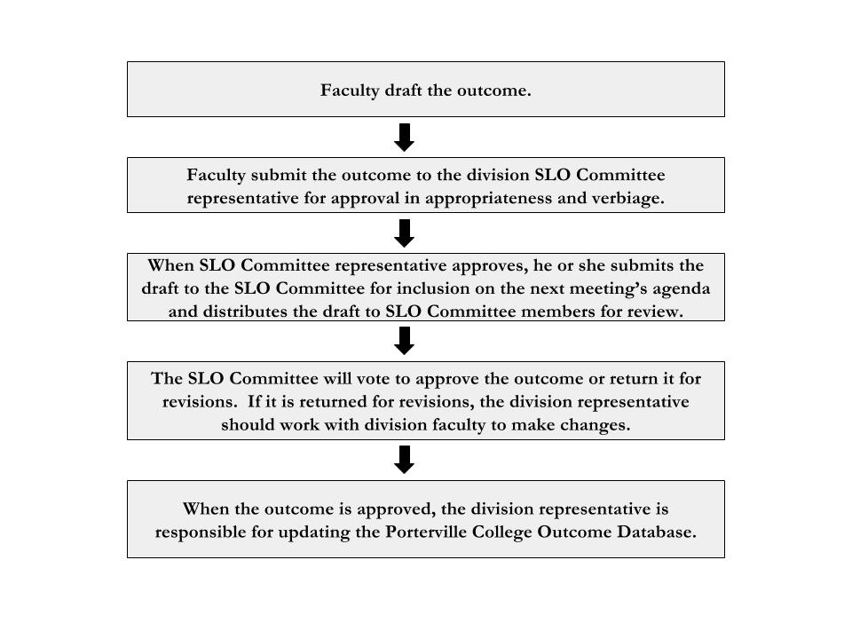

Appendix F—Rubric on Evaluating Outcomes Methods of Assessment

Rubric for Evaluating Outcomes Methods of Assessment
Criteria | Meets | Does Not Meet
1—Successful completion of the assessment is not based on the final course grade. | Successful completion of the outcome is based on the student’s performance on the specified  assessment | Successful completion of the outcome is based on the student’s final course grade
2—How and when the assessment will be administered are clearly identified. | Means (how and when) for administering the outcome assessment are clearly identified and leave no room for confusion and varying interpretations among faculty or staff | Means (how and when) for administering the outcome assessment are vague and ambiguous leaving room for confusion and varying interpretations among faculty or staff
3—The assessment is clearly written and identifies the criteria for student success. | Means for evaluating successful completion of the outcome are clearly stated  A rubric (rating tool) identifying the criteria for student success has been developed | Means for evaluating successful completion of the outcome are vague and ambiguous or missing  A rubric (rating tool) identifying criteria for student success has not been developed
4—The assessment is authentic. | Assessment tool requires students to use the acquired knowledge and skills for the specified outcome to a real world setting | Assessment tool only requires students to know the content for the specified outcome

Appendix G—Authentic Assessment

Authentic Assessment
Authentic assessment is a form of assessment in which students are asked to demonstrate meaningful application of knowledge and skills to real-life situations, issues, or examples.

If you were a golf instructor using authentic assessment you would probably not evaluate your students' golf skills by giving them a multiple choice test. Instead, you would put them out on the golf course and ask them to perform, demonstrating their skills in a round of golf. Although the potential for skill application is more obvious with athletic or technical skills, it is also works for academic subjects. We can teach students how to do math, do history and do science, not just know them. Then, to assess what our students have learned, we can ask students to perform tasks that "replicate the challenges" faced by those using mathematics, doing history or conducting scientific investigation.

Qualities of Authentic Assessment
- Students are required to perform a task (whether physical or cognitive) or to create a project or product.
- Students apply skills, knowledge, or objectives towards real-life scenarios, examples, situations, content, or issues.
- Students analyze, synthesize, and apply what they have learned in a substantial manner. As a result students create or construct new meaning, insight, or understanding during the process.

Why use Authentic Assessment?
Authentic assessment is not intended to replace other valuable forms of assessment. However, there are good reasons to add it to your toolbox of teaching techniques—

Direct Evidence: We do not want students simply to know the content of a course. Instead, we want them to be able to use the acquired knowledge and skills in the real world. So, we need to include some assessments to tell us if students can apply what they have learned in authentic situations. If a student does well on a test of knowledge, we might infer that the student could also apply that knowledge. But that is rather indirect evidence. There are more direct ways to evaluate whether students can apply what they have learned. For example, if we want to know if our students can interpret literature, calculate potential savings on sale items, test a hypothesis, develop a fitness plan, converse in a foreign language, or apply other knowledge and skills, then authentic assessments will provide the most direct evidence.
Facilitating Learning: Students learn best when the learning experience is constructive in nature; that is, when they have the opportunity to learn by working through and making sense of the material, going beyond recall and recognition of isolated facts and repetition of isolated skills. Thus, authentic tasks serve not just as assessments but also as vehicles for learning.
Integrating Teaching, Learning & Assessment: With authentic assessment, the same authentic task used to assess student learning is also used as a vehicle for student learning. For example, when presented with a real-world problem to solve, students are learning in the process of developing a solution, teachers are facilitating the process, and the students' solutions to the problem become an assessment of how well the students can meaningfully apply the concepts.
Multiple Paths to Demonstration: Students have different strengths and weaknesses in how they learn. Similarly, they are different in how they can best demonstrate what they have learned. Regarding the traditional assessments, such as multiple-choice questions, there's not much room for variability in how students demonstrate their knowledge and skills.

In contrast, within authentic assessment there is more room for variability in how students demonstrate their mastery of the course content or objectives. By carefully identifying the criteria of good performance on the authentic task ahead of time, the instructor can make comparable judgments of student performance even though student performance might be expressed in various ways. For example, the products students create to demonstrate authentic learning on the same task might take different forms (e.g., papers, oral presentations, videos, websites). Or, even though students might be required to produce the same authentic product, there can be room within the product for different modes of expression. For example, writing a good persuasive essay requires a common set of skills from students, but there is still room for variation in how a successful essay is constructed.

How do you create authentic assessments?
For an excellent step-by-step process, visit Jon Mueller's online Authentic Assessment Toolbox. http://jonathan.mueller.faculty.noctrl.edu/toolbox/index.htm

Appendix H—SLO/SAO Assessment Results Report Form

The following form is for individual faculty members to report their assessment results. The form is sent electronically during the semester of outcome assessment.
SLO/SAO Assessment Results Report Form
- How did you assess this outcome?
  - An exam
  - An exam, scored by rubric
  - A pre- and post-test
  - A paper, scored by rubric
  - A project, scored by rubric
  - A lab report, scored by rubric
  - A performance, scored by rubric
  - A demonstration, scored by rubric
  - A speech, scored by rubric
  - A debate, scored by rubric
  - A discussion, scored by rubric
  - An interview, scored by rubric
  - An observation, scored by rubric
  - A student survey
  - Other: _______________
- Brief summary of how you assessed this outcome.
- How many students attempted the assessment?
- How many students passed the assessment with a ___ percent or higher?
- Do you need to improve on teaching or assessing this outcome?
- If yes, how do you plan to improve? If no, why not?
- Please type or cut and paste any assignments, rubrics, and/or other documentation that demonstrates your assessment of this outcome.

Appendix I—Outcome Cycle Rotation Completion Form

The following form is for faculty to report a complete rotation in the Outcomes Assessment Cycle. This form should be completed after a plan for implementation (step 4: Implement) has been established. The SLO committee representative should submit it to the outcome’s folder in Google Drive and then link the folder to the Porterville College Outcomes Database.
Outcome Cycle Rotation Completion Form
- Collect
  - How did you assess the outcome?
  - How many students attempted the assessment?
  - How many students passed the assessment with a ___ percent or higher?
- Analyze
  - When were the results of this outcome assessment discussed?
  - Who participated in the discussion?
  - Summarize the discussion(s).
  - Attach documentation.
- Identify
  - Does teaching this outcome need improvement? If so, how? If not, why not?
  - Does assessing this outcome need improvement? If so, how? If not, why not?
  - Does this outcome statement need to be revised or removed? If so, how? If not, why not?
- Implement
  - What actions will happen before the next rotation in the Outcome Assessment Cycle begins? (Be sure to state the action, the responsible person or people, and when the action is expected to be completed.)
  - When will the next rotation in the Outcome Assessment Cycle begin for this outcome?

Appendix J—Porterville College General Education Learning Outcomes

Porterville College General Education Learning Outcomes
- Communication: Students will read, write, speak, and listen effectively.
- Critical Thinking: Students will think independently, creatively, and critically so they can make informed and logical judgments of the arguments of others, arrive at reasoned and meaningful arguments and positions, and formulate and apply ideas to new contexts.
- Scientific and Quantitative Reasoning: Students will understand and apply mathematical and scientific principles and methods.
- Technology, Information Literacy, and Information Competency: Students will effectively use multiple formats, including print, computer and emerging technologies, to locate, access, analyze, evaluate, and utilize information that facilitates learning and critical inquiry.
- Social and Cultural Understanding and Ethical Development: Students will understand and be prepared to actively participate as informed and responsible citizens in political, social, cultural, and environmental matters, both locally and globally.
- Personal Development: Students will have the ability to adapt to change, learn effectively, establish a framework for aesthetic responsiveness, enhance wellness, and set personal and professional goals.

Appendix K—Porterville College Institutional Learning Outcomes

Porterville College Institutional Learning Outcomes
COMMUNICATION
Use language and non-verbal modes of expression appropriate to the audience and purpose.

COGNITION
Think independently, creatively, and critically in order to analyze, synthesize, and evaluate ideas and information.

INFORMATION COMPETENCY
Utilize research skills necessary to achieve educational, professional, and personal objectives.
Demonstrate knowledge of a core area of study.

SOCIAL AND CULTURAL RESPONSIBILITY
Demonstrate sensitivity to and respect for others, both locally and globally, and participate actively in group decision making.

PERSONAL DEVELOPMENT
Demonstrate self-management and ethical awareness through practices that promote physical, mental, and emotional well-being.

Appendix L—ACCJC Rubric for Evaluating the SLO Process
Accrediting Commission for Community and Junior Colleges
Western Association of Schools and Colleges
Rubric for Evaluating Institutional Effectiveness—Part III: Student Learning Outcomes
Levels of  Implementation | Characteristics of Institutional Effectiveness in  Student Learning Outcomes Updated May 2011
Awareness | • There is preliminary, investigative dialogue about student learning outcomes.  • There is recognition of existing practices such as course objectives and how they relate to student learning outcomes.  • There is exploration of models, definitions, and issues taking place by a few people.  • Pilot projects and efforts may be in progress.  • The college has discussed whether to define student learning outcomes at the level of some courses or programs or degrees; where to begin.
Development | • College has established an institutional framework for definition of student learning outcomes (where to start), how to extend, and timeline.  • College has established authentic assessment strategies for assessing student learning outcomes as appropriate to intended course, program, and degree learning outcomes.  • Existing organizational structures (e.g. Senate, Curriculum Committee) are supporting strategies for student learning outcomes definition and assessment.  • Leadership groups (e.g. Academic Senate and administration), have accepted responsibility for student learning outcomes implementation.  • Appropriate resources are being allocated to support student learning outcomes and assessment.  • Faculty and staff are fully engaged in student learning outcomes development.
Proficiency | • Student learning outcomes and authentic assessment are in place for courses, programs, and degrees.  • There is widespread institutional dialogue about the results of assessment and identification of gaps.  • Decision-making includes dialogue on the results of assessment and is purposefully directed toward aligning institution-wide practices to support and improve student learning.  • Appropriate resources continue to be allocated and fine-tuned.  • Comprehensive assessment reports exist and are completed and updated on a regular basis.  • Course student learning outcomes are aligned with degree student learning outcomes.  • Students demonstrate awareness of goals and purposes of courses and programs in which they are enrolled.
Sustainable Continuous Quality Improvement | • Student learning outcomes and assessment are ongoing, systematic, and used for continuous quality improvement.  • Dialogue about student learning is ongoing, pervasive, and robust.  • Evaluation of student learning outcomes processes.  • Evaluation and fine-tuning of organizational structures to support student learning is ongoing.  • Student learning improvement is a visible priority in all practices and structures across the college.  • Learning outcomes are specifically linked to program reviews.

Appendix M—Glossary of Terms

Term | Acronym | Definition
Action Verb |  | An action verb expresses an action that a person can do. Examples of action verbs are classify, design, summarize, contrast, or critique. (See Appendix C—Bloom’s Taxonomy Action Verbs.)
Analyze |  | Analyze is the second step in the Outcome Assessment Cycle. It includes the process of reviewing and discussing collected outcome assessments.
Assessment |  | Assessment refers to a process where methods are used to generate and collect data for evaluation of courses and programs to improve educational quality and student learning. This refers to any method used to gather evidence and evaluate quality and may include both quantitative and qualitative data in instruction or student services.
Authentic Assessment |  | Authentic assessment simulates a real world experience by evaluating the student’s ability to apply critical thinking and knowledge or to perform tasks that may approximate those found in the workplace or other venues outside of the classroom setting.
Bloom’s Taxonomy |  | Bloom’s taxonomy is a classification system developed by Benjamin Bloom used to define and distinguish different levels of human cognition—i.e., thinking, learning, and understanding. Educators have typically used Bloom’s taxonomy to inform or guide the development of assessments (tests and other evaluations of student learning), curriculum (units, lessons, projects, and other learning activities), and instructional methods, such as questioning strategies.
Closing the Loop |  | Closing the loop refers to the use of assessment results to improve student learning through collegial dialog informed by the results of student service or instructional learning outcome assessment. It is part of the continuous cycle of collecting assessment results, evaluating them, using the evaluations to identify actions that will improve student learning, implementing those actions, evaluating the effectiveness of the improvements, and then cycling back to collecting assessment results.
Collect |  | Collect is the first step in the Outcome Assessment Cycle. It includes the process of assessing students, gathering and compiling the results, and distributing the results compilation.
Course Objective |  | Course objectives are small steps that lead toward a goal, such as the discrete course content that faculty cover within a discipline.
Course Outline of Record | COR | A COR is an outline that lists the major topics to be covered in a course. It describes course information including course goals and objectives.
Course-Level Student Learning Outcome | SLO | An SLO is a statement about the knowledge, skills, attitudes, and/or abilities a student is expected to have upon successful completion of the course. An SLO starts with the phrase “Upon successful completion of this course, a student should be able to…” An SLO is sometimes referred to as a Course-Level Student Learning Outcome.
Cycle Rotation Completion |  | Cycle Rotation Completion is the point at which an outcome has undergone all four steps of the Outcome Assessment Cycle.
Database |  | Database refers to the Porterville College Outcomes Database located in Google Drive (https://goo.gl/LRxLA7). It contains all SLOs, PLOs, SAOs, GELOs, and ILOs; links to their last cycle rotation completion; projected dates for the beginning of their next rotation; and links to past assessment information.
Direct Assessment |  | Direct assessments provide evidence of student knowledge, skills, abilities, and/or attitudes for the specific domain in question and actually measure student learning, not perceptions of learning or secondary evidence of learning, such as a degree or certificate. For instance, a math test directly measures a student’s proficiency in math. In contrast, an employer’s report about student abilities in math or a report on the number of math degrees awarded would be indirect data.
Educational Program |  | An educational program is an organized sequence of courses leading to a defined objective, a degree, a certificate, a diploma, a license, or transfer to another institution of higher education.
Embedded Assessment |  | Embedded assessment occurs within the regular class or curricular activity. Class assignments linked to student learning outcomes through primary trait analysis serve as grading and assessment instruments (i.e., common test questions, Classroom Assessment Techniques CATs, projects, or writing assignments). Specific questions can be embedded on exams in classes across courses, departments, programs, or the institution. Embedded assessment can provide formative information for pedagogical improvement and student learning needs.
General Education Learning Outcome | GELO | A GELO is a statement about the knowledge, skills, attitudes, and/or abilities a student is expected to be able to demonstrate following a program of courses designed to provide the student with a common core of knowledge consistent with a liberally educated or literate citizen. These general education courses are part of all degree programs.
Grades |  | Grades are the faculty evaluation of a student’s performance in a class as a whole. Grades represent an overall assessment of student class work, which sometimes involves factors unrelated to specific outcomes or student knowledge, values, or abilities. Final grades in a course cannot be used for SLO assessment.
Identify |  | Identify is the third step in the Outcome Assessment Cycle. It includes the process of identifying actions based on analysis to improve instruction, services, assessment, and/or outcome statements.
Implement |  | Implement is the fourth step in the Outcome Assessment Cycle. It includes the process of implementing the actions identified to improve instruction, services, assessment, and/or outcome statements.
Indirect Assessment |  | Indirect assessments are sometimes called secondary data because they indirectly measure student performance. For instance, certificate or degree completion data provide indirect evidence of student learning but do not directly indicate what a student actually learned.
Institutional Learning Outcome | ILO | Institutional Learning Outcomes are the knowledge, skills, abilities, and/or attitudes with which a student is expected to leave an institution as a result of a student’s total experience with any aspect of the college, including courses, programs, and student services.
Measurable |  | Measurable is a criteria for outcomes because an outcome must have a demonstrable action that assessed.
Objective |  | Course objectives are small steps that lead toward a goal, such as the discrete course content that faculty cover within a discipline.
Outcome |  | An outcome is a statement about the knowledge, skills, attitudes, and/or abilities a student is expected to have upon successful completion of an academic activity. An outcome is expressed using action verbs and is stated in terms that make it measurable.
Outcome Assessment Cycle |  | The Outcome Assessment Cycle refers to the process called closing the loop and consists of four steps: collect, analyze, identify, and implement.
Porterville College Outcomes Database |  | The Porterville College Outcomes Database is located in Google Drive (https://goo.gl/LRxLA7). It contains all SLOs, PLOs, SAOs, GELOs, and ILOs; links to their last cycle rotation completion; projected dates for the beginning of their next rotation; and links to past assessment information.
Program |  | In Title 5 §55000(g), a “Program” is defined as a cohesive set of courses that result in a certificate or degree and basic skills.
Program Learning Outcome | PLO | Each degree or certificate program must have a comprehensive list of PLOs describing the skills gained through successful completion of the program. Each PLO in the comprehensive list is a measurable statement about the knowledge, skills, attitudes, and/or abilities a student is expected to have upon successful completion of the requirements for the degree or certificate.
Rotation |  | A rotation is one time through the Outcome Assessment Cycle.
Rotation Completion |  | Cycle Rotation Completion is the point at which an outcome has undergone all four steps of the Outcome Assessment Cycle.
Rubric |  | A rubric is a set of criteria used to determine scoring for an assignment, performance, or product. Rubrics may be holistic, not based upon strict numerical values, which provide general guidance. Other rubrics are analytical, assigning specific scoring point values for each criterion often as a matrix of primary traits on one axis and rating scales of performance on the other axis. A rubric can improve the consistency and accuracy of assessments conducted across multiple settings. Rubrics also offer students a clear guide of what is expected in each assignment/assessment.
Service Area Outcome | SAO | An SAO is a statement about the knowledge, skills, attitudes, and/or abilities a student is expected to have upon successful completion of a student services activity (e.g. counseling appointment, orientation, assessment, field trip). An SAO starts with the phrase “Upon successful completion of this activity, a student should be able to…”
Student Learning Outcome | SLO | An SLO is a statement about the knowledge, skills, attitudes, and/or abilities a student is expected to have upon successful completion of the course. An SLO starts with the phrase “Upon successful completion of this course, a student should be able to…” An SLO is sometimes referred to as a Course-Level Student Learning Outcome.

This page intentionally left blank to allow for future revisions.

This page intentionally left blank to allow for future revisions.

This page intentionally left blank to allow for future revisions.

This page intentionally left blank to allow for future revisions.

This page intentionally left blank to allow for future revisions.
Part
8

Outcome Assessment Worksheets
These worksheets are tools for faculty. They are intended to aid you in assessing SLOs and/or SAOs. If you can also find electronic versions in the online handbook (https://goo.gl/yT6xSy).

SLO/SAO Assessment Worksheet
Semester/Year: ________________________________________________________________
Course/Service: _______________________________________________________________
SLO or SAO # _____
SLO or SAO Statement: _________________________________________________________
______________________________________________________________________________
______________________________________________________________________________
Pre-Semester Planning
I plan to use the following type of assessment:
___ exam ___ pre- and post-test ___ paper ___ project ___ lab report
___ performance ___ demonstration ___ speech ___ debate ___ discussion
___ interview ___ observation ___ student survey ___ Other: _______________
Notes on the assessment/lessons before the assessment: _____________________________
______________________________________________________________________________
______________________________________________________________________________
______________________________________________________________________________
______________________________________________________________________________

Rubric I will use: _______________________________________________________________
(location, description, or a note about rubric)
(Remember, a rubric is necessary for assessment of all of the options listed except for exam and student survey.)
I plan to administer the assessment: _______________________________________________
(estimated date or week in the semester)
Assessment Results
I administered the assessment on _________________________________________________
Number of students who attempted the assessment ____________
Number of students who passed the assessment with a ___ percent or higher ____________
What I learned from my assessment results: ________________________________________
______________________________________________________________________________
______________________________________________________________________________
______________________________________________________________________________
______________________________________________________________________________
______________________________________________________________________________
______________________________________________________________________________
______________________________________________________________________________
______________________________________________________________________________
______________________________________________________________________________
______________________________________________________________________________

Results submitted to ________________________________ on ______________________
(person or site) (date)

Post-Assessment Analysis
My analysis of the compiled assessment results: _____________________________________
______________________________________________________________________________
______________________________________________________________________________
______________________________________________________________________________
______________________________________________________________________________
______________________________________________________________________________
______________________________________________________________________________
______________________________________________________________________________
______________________________________________________________________________
______________________________________________________________________________
______________________________________________________________________________

Discussion date: _______________________________________________________________
Plan for improvement: __________________________________________________________
______________________________________________________________________________
______________________________________________________________________________
______________________________________________________________________________
______________________________________________________________________________
______________________________________________________________________________

My role in the implementation of the plan for improvement: ___________________________
______________________________________________________________________________
______________________________________________________________________________
______________________________________________________________________________
______________________________________________________________________________
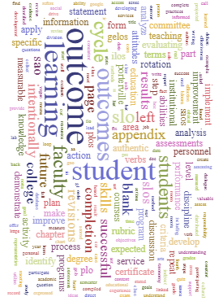
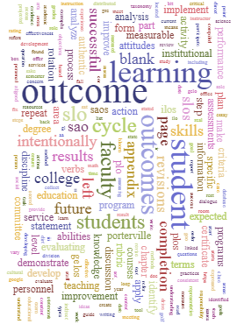
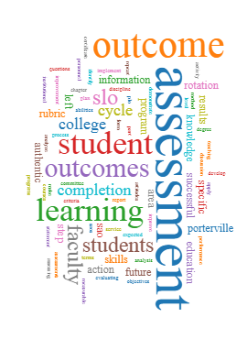
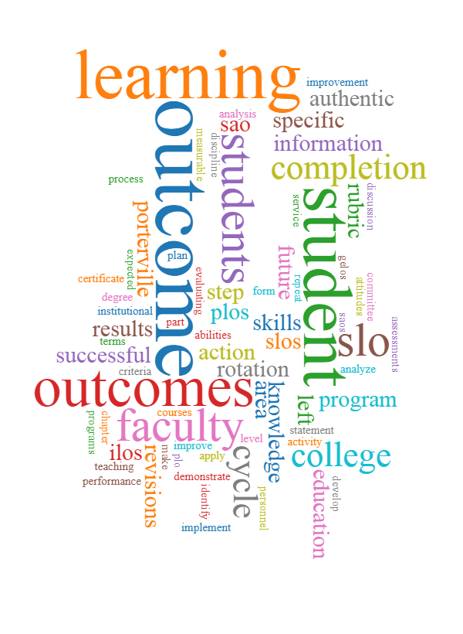
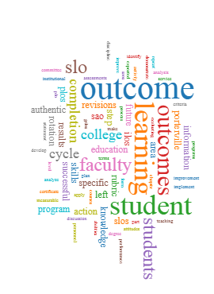
Word | Frequency
assessment | 266
outcome | 180
student | 159
learning | 145
outcomes | 132
students | 101
slo | 94
faculty | 88
cycle | 83
completion | 72

Cathy Barrette, “Course vs. Program Learning Outcomes: A Quick Tutorial,” Wayne State University, last accessed August 2, 2017, https://goo.gl/BEs8UT
“Bloom’s Taxonomy,” The Glossary of Education Reform, revised March 5, 2014, last accessed August 2, 2017, http://edglossary.org/blooms-taxonomy/
“Bloom’s Taxonomy Action Verbs,” Roanoke College, last accessed August 2, 2017, https://goo.gl/mkxj5g
Jon Mueller, “Authentic Assessment,” The Authentic Assessment Toolbox, last accessed August 2, 2017, https://goo.gl/OvgGK
Adaptation of the following source: Office of Planning, Research, & Student Services, “A Guide to Developing Measurable Student Learning Outcomes,” Cañada College, last accessed August 2, 2017, https://goo.gl/vGniii.
Refer to Part III—Discipline-Specific Outcomes Assessment Information for your discipline’s passing percentage.

