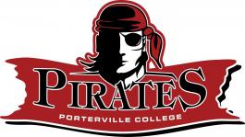
Porterville College Strategic Directions
- Maximize Student Success
- Advance Student Equity
- Ensure Student Access
- Enhance Community Connections
- Strengthen Organizational Effectiveness

Porterville College ILOs
- Communication
- Cognition
- Information Competency
- Social and Cultural Responsibility
- Personal Development

Porterville College Core Values
- Collaboration
- Respect
- Innovation
- Accountability
- Equity
- Participation

Guided Pathways
- Clarify
- Intake
- Support
- Learning

Porterville College Pathways to Success & Equity Committee Agenda
Tuesday, September 3, 2019
AGENDA

- Call to Order

- Welcome and Introductions

- Approval of Agenda

- Approval of Minutes

- DRC Recommendations (Data Team)

- Pathways Report to the State

- Pirate Maps Feedback
  - Next Steps
- 2-year plans

- Equity Institute

- ATD

- Student Representations

- Reports
  - Data Team Update
  - SSSP/Equity Update
  - ASPC Update

- Announcements

- Discussion/Questions

