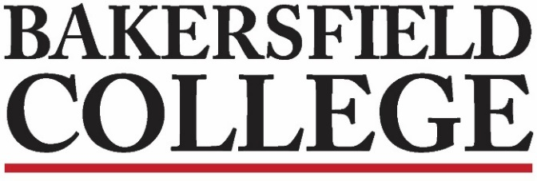
Program Review
Feb. 19, 2019
L 149
4:00 pm-5:00 pm
Meeting Notes
Chairs: Stephen Waller, Dean of Instruction, Admin Co-Chair; Kimberly Nickell, ACDV, Faculty Co-Chair; Kristin Rabe, Media Services, Classified Co-Chair
Members: Mindy Wilmot, Library; Anna Poetker-Collins, Philosophy; Brenda Nyagwachi, FACE; Andrea Tumblin, Mathematics; Heather Baltis, Agriculture; Brent Burton, Fire Technology/EMS; Neeley Hatridge, Communication; Nicole Hernandez, Nursing; Keri Wolf, English; Klint Rigby, Engineering and Industrial Technology; Jason Dixon, Engineering and Industrial Technology; Katie Ganster, Biology; Brent Wilson, Assessment Liaison, F. Javier Llamas, Social Science. Vikki Coffee, Workforce Development
Administrators: Michelle Bresso, Dean of Instruction
Classified Meg Stidham, CSEA designee
Student Government: Elisabeth Sampson, SGA Senator 8

2018-19 Goals
- Align the Program Review questions to ACCJC Standards and Strategic Directions for Spring 2019
- Fully implement eLumen
- We need to do a survey this cycle
- Guided Pathways
- District Program Review
- Rubric aligning resource requests and prioritization with Mission and Strategic Directions.

1. | Call to Order  Note taker-Kristin
2. | Approval of Minutes-Feb. 5, 2019  Approval of Agenda Items
3. | - Spring Survey  We will be reviewing and updating question for the Spring 2019 survey.  Meeting Notes:  No quorum for 2/19  Changes to notes – Adding Javier to the listserve and to the list of members. Steve Waller made motion to approve minutes – approved.  AUO’s Steve mentioned one to be created for each ILO and will present them to Liz and Zav. Will also take them to EAC/SALT and FAST committees for info gathering  1 AUO for each ILO – there will be 4-main AUO’s and the areas have the ability to add more but must address at least one.  How is data collected?? Students Served per $$ - looking for improvement over time… will have to look at how to collect data for those areas (like library/tech services) that do not get data from OIE.  Spring Survey: Last one completed 2016  Question #1: I understand why we complete Program Review but have a hard time getting to it. Hard time getting it done  Question #2: General Info (Swap with Question #1)  Question #3: Your role with completing the document – you can also write in an answer  Why is it not relevant/meaningful? Need feedback on how to identify data – Need help from areas on what works best for them. Do we need survey of students? Worst case scenarios.  Challenges with data for instructional programs – often having to compile data on their own.  What would be catastrophic in your area that you could measure? Exit Surveys – OIE – AQUSQL – can do quick survey – how often can we utilize a service. Still don’t have full compliance with Library card scan in/student check in with AQUSQL. Trend data for instructional areas.  TASK: Come up with video script and set up shoot dates

