PC Academic Senate Constitution Amendment Request
Submitted by Dustin Acres, Math Professor/Curriculum Committee Chair

Request 1: Addition to Article III, Section 2: Add student’s 9+1 rights. Title 5 §51023.7 (listed in section b)
https://casetext.com/regulation/california-code-of-regulations/title-5-education/division-6-california-community-colleges/chapter-2-community-college-standards/subchapter-1-minimum-conditions/section-510237-students#:~:text=Section%2051023.7%20%2D%20Students%20(a),in%20district%20and%20college%20governance
Request 2: Addition to Article IV: Add student representative as part of the membership (voting member).
Request 3: Addition to Article V: Add Student Representation (voting member)
Request 4: Removal to Article VII: voting members changed to remove Immediate Past President as voting officer. This creates a potential contradiction to Article V, Section 1, Faculty Representation (see below):
For the Past President specifically, having them stated as a voting member in Article VII contradicts Section 6 of Article VII (see below) as voting is not included as duties and Past President is specifically stated as an advisory position:
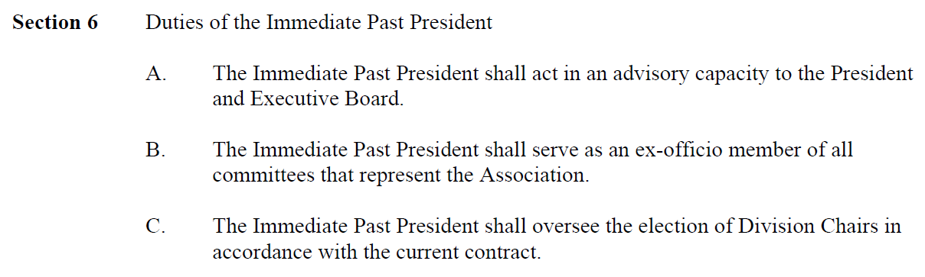
I would ask that these amendments be considered for consistency in language and to meet the legal obligations of Title V. Assuming there are enough votes and/or signatures to follow the process described in Article XI (see below):
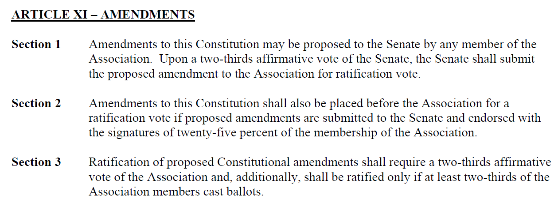

Related By-laws that would need to be modified:
Article III- Representation
Add Section 4: A student member shall be represented on the Senate. A student member may be nominated or may volunteer for consideration by the Senate President.

