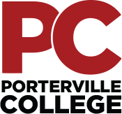

Our Mission

Outreach Committee Meeting
Thursday, March 23, 2021
4:30 pm – 5:30 pm
Zoom

With students as our focus, Porterville College provides our local and diverse communities quality education that promotes intellectual curiosity, personal growth, and lifelong learning, while preparing students for career and academic success.

Last month’s minutes have been uploaded and are available at the following link:
https://kccd.sharepoint.com/sites/groups/pcoutreach/SitePages/Home.aspx

Call Meeting to Order

Approval of the Agenda

Approval of the Minutes

2020-2021 Outreach Committee End of the Year Report

Events:
- McFarland Junior High College and Career Day March 2
- Virtual Events
- PC Connection: April 7 & 8-Erin
- RegFest March 31, April 1-2 and April 5-6-Erin
- Upcoming workshops:
  - Campus Virtual Workshops
- Marketing – Roger
- Open Discussion/Recruitment Ideas

•

