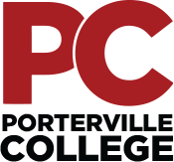

Our Mission

Outreach Committee Meeting
Thursday, April 15, 2021
4:00 pm – 5:00 pm
Zoom

With students as our focus, Porterville College provides our local and diverse communities quality education that promotes intellectual curiosity, personal growth, and lifelong learning, while preparing students for career and academic success.

Last month’s minutes have been uploaded and are available at the following link:
https://kccd.sharepoint.com/sites/groups/pcoutreach/SitePages/Home.aspx

Call Meeting to Order

Approval of the Agenda

Approval of the Minutes

Dr. Solano: Logic Model

2020-2021 Outreach Committee End of the Year Report
- Marketing – Roger
- Open Discussion/Recruitment Ideas

•

