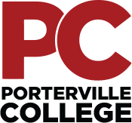

Our Mission

Outreach Committee Meeting
Thursday, July 15, 2021
3:00 pm – 4:00 pm
Zoom

With students as our focus, Porterville College provides our local and diverse communities quality education that promotes intellectual curiosity, personal growth, and lifelong learning, while preparing students for career and academic success.

Last month’s minutes have been uploaded and are available at the following link:
https://kccd.sharepoint.com/sites/groups/pcoutreach/SitePages/Home.aspx

Call Meeting to Order

Approval of the Agenda

Approval of the Minutes

Tulare County Job Fair

CFF- California Farmworker Foundation

Pirate in a day July 15, Aug 5

ESL Enrollment Express 8-18

Welcome Week Festivities

Enrollment Campaigns

Advertising/Marketing
- Open Discussion/Recruitment Ideas

Accessibility Note: If you are an individual with a disability and need accommodations, please contact Analicia Jauregui at 559-791-2221.

•

