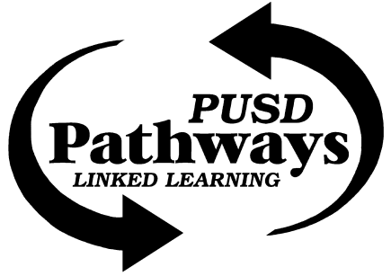
ESA Advisory Agenda
Draft
Sept. 19, 2017 3:45 p.m. (3rd Tuesday)
MHS Mrs. Driver's classroom

Members: Brian Rueger, Bud Darwin, Jason Biagio, Kevin Elliott, Nancy Bruce, Richard Goode, Brenda Merzoian, Juanita Souther, Sam Weiser, Ex Officio: Diane Rankin, Amanda Driver, Mimi Schuler, Pamela Ramos , Matt Shearer

Welcome and Introductions
Pathway Office (Mimi Schuler)
Empower the Future event on Sept 6. Unveiled new Foundation that can receive donations and 100% money is directed to student programs. 5 years ago 45% students entering pathway, now 70% students in Pathway. Many questions: Name of foundation? How to earmark $ to certain Pathway & project. Email Jason with any questions.
Need to advertise Pathways locally- continue to get the word out and ENGAGE people to join in on Pathways.
October 25-26 Galaxy Showcase where new ESA video will be shown to students.
Student Representatives (none present)
Administration (Diane Rankin)
Just beginning to find out about students who may be struggling- support with tutoring, Saturday school, a quiet place to work,
Porterville College (Richard Goode)
Bridge between PC and CSU or UC.
Will be in Senior Projects class- Tuesday morning 9:15- 10:05 (Period 2)
Agriculture, Public Health, get Board Members who represent these interests- let’s reach out
Jason Pommier, PIO for Pathways – Good photos of ESA students? Send pictures & synopsis of events
Academy Lead (Amanda Driver)
Goals and action plan for year needed. Goal 1: Increase enrollment- Goal is 35 incoming freshmen. Environmental Sciences Pathway outreach: What factors influence students in deciding Pathway? Peers important! Career spectrum in Environmental Sciences, Environment concerns affect everyone- we all live here!
Met with teachers to integrate projects to the ESA. Write an article in English classes about why it is important to plant native plants in our area? Integrates project, public outreach, is contact for Academy.
P8 Report & City of Porterville (Jason Biagio)
No P8 meeting this month
There is a broad spectrum of careers in Environmental Sciences, we need to tell more about the range of careers. Content of old video put off his elder son as he couldn’t see how to make a career. It is a matter of public perception, and we need to educate the public on importance of environmental sciences! Change people’s perception- the public doesn’t know. Add advisory board members- from AG, Environmental Health, Energy, Air Quality, Water Production. As much as possible, have a presence, and mention about environmental careers!
Dept. Water Resources on Urban Water Management Plan. CA state is ramping up monitoring of ground water. 30% of water produced from wells needs to be recharged back into aquifer. Sustainable Groundwater Management Act (SGMA) – Eastern Tule GSA. Jason produces maps, wants to talk about water quality.
Sequoia Riverlands Trust (Bud Darwin, Sam Weiser)
Sam Wieser is Education Coordinator w/ SRT! Wow!
Blue Oak Day November 4; Bud & Sam will present Sept 26 in Matt Shearer on Carbon Sequestration Project. Ongoing project- 10 years!
Success Lake/USACE (Jaunita Souther)
National Public Lands Day Saturday, Sept 30th from 8:00 AM – Noon. Volunteer work projects. Would ESA consider hosting a booth?
Circle J Ranch (Nancy Bruce)
Circle J Research & Restoration Saturday October 28; Teacher meeting is Sept 20 @ 3:30 p.m.
Will share “Project Deliverables” and sample rubrics for Senior projects to discuss @ next meeting

Adjournment

Next Meeting: October 17, 2017

