Local GE Recommendations
- Humanities increased to 3 units to meet Title 5 language
- Area E: Biological & Area F: Physical Sciences could be combined (requiring only 3 units instead of 6)
- Area C: Communication & Area I: Analytical Thinking could be combined (requiring only 3 units instead of 6)
- Do we need a Area A: Leadership and Success? (Potential reduction of 1 unit)
- Do we need a Area G: History/Political Science? (Potential reduction of 3 units)
- Do we need a Area K: Health/Kinesiology? (Potential reduction of 3 units)

Language/Course Changes:
- Change Area A from “Education” to “Leadership and Success”
- Change Area D from “Mathematics” to “Mathematical Concepts & Quantitative Reasoning”
- Remove Area D courses:
CHEM P101A (5), P101B (5) PHYS P102A (4), P102B (4), P104A (4),P104B (4)
ENGR P120 ENGR P132
- Could we add language to the Catalog explicitly stating PsyTech and Nursing fulfilling both areas E AND K?
- Combine Area H: Social/Behavioral Science and area J: Multicultural Studies into a new category (name pending) that has 2 subcategories. Add language “Choose 1 course from group a and 1 course from group b. At least 1 course in group a or b must fulfill the Ethnic Studies requirement. These are indicated by asterisks (*).
  - Social/Behavioral Science
*
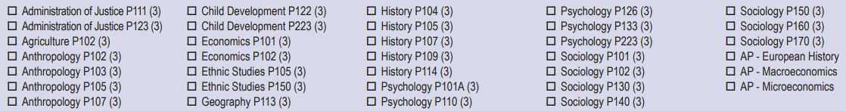
*
*
*
*
  - Multicultural Studies
*





