Local Degrees Awarded to Students 17 or Younger
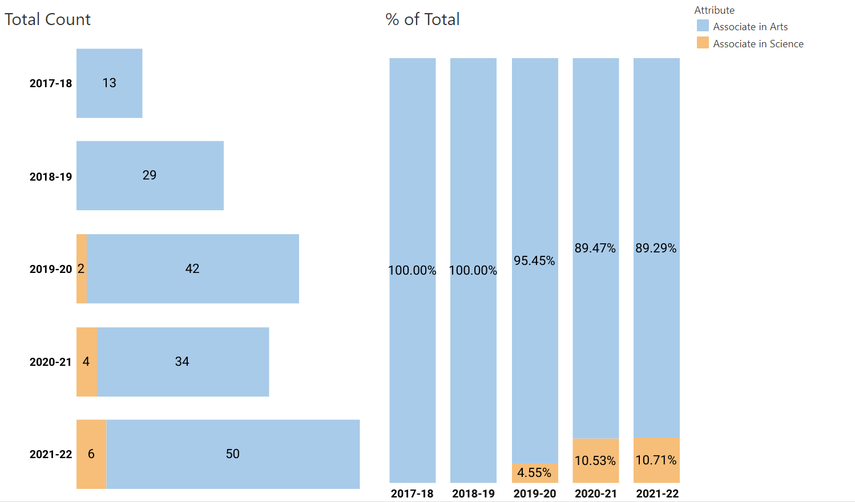
Majors included Agricultural Production (1 student), Biological & Physical Science (15 students), Child Development (1 student), Liberal Arts (10 students), Public Safety (1 student), Social Sciences (28 students)
Key Takeaways
- We are growing in our degrees awarded to concurrent students
- One HS campus anticipates 24 graduates for this year alone
- Award types are limited
- Outreach opportunity for students
  - Students who may never have come to PC
  - Students who don’t see themselves as college students
- Potentially accelerates incoming students’ access to their professional/educational goals
- What else do you see?

Student Experience After Receiving Degree
- Could take 2 or more years to complete the degree they want for their career
- Loss of priority registration
- Depending on GE Pathway used, my need courses for degree AND to complete transfer GE

Additional Data
Transfer Degrees Awarded to Students 17 or older
