Porterville College Mission Statement:

With students as our focus, Porterville College provides our local and diverse communities quality education that promotes intellectual curiosity, personal growth, and lifelong learning, while preparing students for career and academic success.

In support of our values and philosophy, Porterville College will:

- Provide quality academic programs to all students who are capable of benefiting from community college instruction.
- Provide comprehensive support services to help students achieve their personal, career and academic potential.
- Prepare students for transfer and success at four-year institutions.
- Provide courses and training to prepare students for employment or to enhance skills within their current careers.
- Provide developmental education to students who need to enhance their knowledge and understanding of basic skills.
- Recognize student achievement through awarding degrees, certificates, grants, and scholarships.

Guided Pathways Framework:

- Clarify the Path: Create clear curricular pathways to employment and further education.
- Enter the Path: Help students choose and enter their pathway.
- Stay on the Path: Help students stay on their path.
- Ensure Learning: Ensure that learning is happening with clear outcomes.

Program Mission Statement:

(Please list the mission statement of the program or department here.)

The mission of the Porterville College Library is to develop, provide, and maintain the information and library resources needed by members of the college community in their study, teaching, research, public service, and professional development; and to support the educational processes described in the college mission statement. In fulfilling this mission, the Library is committed to the following objectives:
• Acquire materials in appropriate formats including electronic and in sufficient quantity, depth, and diversity to support teaching and basic research in the subject areas of the current and future curriculum.
• Maintain an effective liaison between the faculty (full-time and adjunct), student services division, and administrators to assist in the planning and development of effective programs and services.
• Support the freedom of access to all library resources and the confidentiality of all library patrons’ rights of privacy.
• Promote information literacy through individual and group instruction, appropriate uses of technology and electronic information resources, and adequate staff development activities.
• Provide all community members access to information regardless of format and regardless of where the information is stored and make the access available from anywhere in or outside of the immediate college location. Some database electronic information due to contractual proprietary agreements is available only to PC students and staff.
• Provide the campus community, especially PC students, with a welcoming place for study, self -education outside the classroom, and tools for lifelong learning.
• Establish collaborative partnerships with other area libraries and outside agencies via networks, collection sharing, and other reciprocal agreements so as to improve information access to students and the community at large.
• Provide for all library staff a work environment that encourages individual development, a thoughtful approach to problem-solving, clear and open communication, mutual respect, initiative, cooperation, and the development of expertise.

Service Area Outcomes (SAOs):

(For each Service Area Outcome (SAO) identified by your program, please complete the table below describing how the assessment results have been discussed in the program and how they impact your goals and needs. If your program has more than two SAOs, please add rows.)

SAO Statement | Describe assessment results and discussion of this SAO | Describe how the results impact your goals and needs going forward
1.  Students will report satisfaction with the Lending Library. | We had 52 students respond. All respondents said their happiness with the Lending Library was Satisfactory to Above Average. The survey did come back with a split vote for physical books vs eBooks. The most common response when asked why they used the Lending Library cost of textbooks was the number one response. | Our goal for the Lending Library is to continue to expand it. This survey told us what areas we should expand. Which means we will need to continue to find financing for the Lending Library.
2.  After attending a library orientation, students will indicate they are prepared to conduct research.  . | We had 45 student respond. Over 90% of respondents said they found the presentation informative, that it made them more comfortable using databases, and that it would help them with their upcoming assignment. | Knowing that students are happy with the research orientations and using the database we are hoping translates into more students using library materials to do their research. Which will hopefully lead to higher usage numbers in the future for the library.

Program Analysis and Trends:
(This section is intended to evaluate your program, including data review, changes over the past three years, progress on previous goals, strengths of the program, and areas for improvement.)

The Library directly supports the fourth Institutional Level Outcome -- Technology, Information Literacy, and Information Competency: Students will effectively use multiple formats, including print, computer and emerging technologies to locate, access, analyze, evaluate, and utilize information that facilitates learning and critical inquiry.” The Library’s primary function is to serve the Porterville College community (students and staff: faculty, administrators, classified) with the information resources and services needed by this educational institution. The Library is typically open from 7 a.m. – 9 p.m., M – TH, and 8 a.m. – noon on Fridays during the fall and spring semesters. Library open hours for summer session are typically 7:00 a.m. – 7:00 p.m., M – TH). The number of library users in the 2019 calendar year (only full year of data since COVID) was 101,873. The average number of daily entrants was 555. Many of these visitors were going to go to classes held in the Library’s classroom, L449. A typical student count of Library users at any given morning hour is about 60 with as many as 80+. Afternoon and evening visitors average number is 10.

Some of the most important services offered by the library techs are: “checking out” to students Lending Library materials, reserve, and circulating books; processing into and out of the catalog, new and discarded books; and answering directional and informational questions about the library and the campus. Reserved textbooks and other materials provided by faculty and the Library may be the only way some students can read assigned materials.

Another important function performed by library staff is answering informational and directional questions. The Library serves as a secondary information center during the day, and the unofficial information center when the campus information desk is closed at night. Librarians provide reference assistance to students which is really teaching students how to find the information they need for assignments. Depending on the time of the semester, the full-time librarian averages 5 – 15 questions/day. A reference session may last five minutes or 25 minutes depending on the complexity of the question and the starting point. Often students have no ideas for their topic of research nor where to find the information they will need. Helping students narrow or broaden their topics to fit the information available is critical to reference librarian service. In addition to instructional one-on-one reference work with students, librarians teach information literacy presentations to classes at instructor request, designing these orientations specifically for the student’s assignments. The current librarian averages 20 classroom teaching sessions/semester. If the average class size is 20, that means that 400 students/semester are given information literacy instruction. The Library is the information hub for the campus community. It provides information resources in many formats: print, media, and digital/electronic/online:
• 49 online databases of magazine, journal, newspaper, media, and book resources, 24/7.
• Two full-text, free-to-students and staff, e-book databases with over 180,000 digital titles.
• Library Webpage is the access portal for library online and print resources, 24/7.
• The Library provides current print subscriptions (and back issues) for two newspapers and 36 magazines and journals. For students to access the above online resources, the library has 19 computers, 4 media viewing stations and Wi-Fi access. The Library provides 2 copiers, and 2 printers for the computer work stations, and a full-service workstation for students with Disability Resource Center learning technologies. Facility and space resources available in the library are listed below.

For many students, the provision of study spaces is essential to their success as they may not have quiet space at home to do their work.
• 6 study rooms
• 32 seats in the Reading Room & 10 in the entry for individual and group quiet study and laptop access
• 11 study tables – 7 in the building and 4 in the lobby
• 44 individual study carrels
• 2 conference rooms
• Anthropology Library
• Center for Instructional Technology for staff
• 9 office spaces for librarians, faculty, and staff

As can be seen in the previous discussion, the Library and library staff support the Porterville College Mission Statement to “provide comprehensive support services to help students to:
• achieve their personal, vocational, and academic potential
• prepare students for transfer and success at four-year institutions
• provide developmental education to students in information competency instruction”

The Library and its staff are instrumental in student success and retention because of the resources, services, and study spaces they provide for students from all disciplines. “Teaching librarians” help students choose viable topics for their research assignments; show students how to find and evaluate relevant information for their topics; and help them to document their sources.

Data Review

(Please review data provided by the KCCD Office of Institutional Research here. Discuss trends in your program including things such as enrollment, offerings, demographic trends, course success rates, and awards. Be sure to address any equity issues in your data, including course success rate differences.)

●Gate Count: The library began keeping daily gate count statistics beginning in the Fall of 2017. This allows an accurate count of how many people are coming into the Library on any given day.

Starting in Spring of 2019 to when we closed our doors in March of 2020 we had 123,311 people enter the building. In 2019 we averaged 544.7 people per day.

Not all of these people were coming into the building to use library materials but were there to utilize the classroom and conference rooms. The library is busiest between the hours of 10am and 4pm

●Number of books checked out: We began keeping checkout stats beginning in Fall 2017. The library checked out 1651 physical books between 2019 – 2020. This number is low because we switch to a library system half way through 2019 and lost the data in the old system. Also, because of COVID our checkouts of Stack books dropped significantly. We hope to get more consistent stats for the next Program Review.

●Database usage – Beginning in Fall 2017 we began keeping database usage statistics. These stats typically consist of Database Sessions, Total Searches and Total Requests. Covid affected our database usage according to our numbers. Ebsco Academic Search Complete in Spring 2019 had 22,194 searches, in Spring 2021 there were 12,712. JSTOR searches in Spring 2019 were 2,502 and Spring 2021 were 1,791. Our Gale Opposing Viewpoints usage stayed about the same.

●Lending Library – The Lending Library served about 627 students and checked out 1,409 items in Fall 2021 and 1,447 items in Spring 2021. Through Fall of 2021 we have saved PC students $853,607.04 on books and other items, and $508,690 on hotspots and laptops by having them checkout items from the Lending Library. The Lending Library currently has 3,005 items. We plan on adding more materials to the Lending Library every year. With the additional material we believe our numbers will continue to increase. We are working on better outreach for the Lending Library in the hopes of increasing these numbers.

Term | Number of Items Checked Out LL | Number of Students | Estimation for Total Amount of Savings for Students
Spring 2018 | 207 | 181 | $23,522.33
Summer 2018 | 25 | 25 | $3,650.00
Fall 2018 | 344 | 279 | $22,120.59
Spring 2019 | 540 | 384 | $33,948.35
Summer 2019 | 83 | 83 | $8,147.76
Fall 2019 | 600 | 438 | $37,437.76
Spring 2020 | 432 | 386 | $62,555.25
Summer 2020 | 192 | 159 | $67,040.00
Fall 2020 | 1673 | 746 | $129,820.00
Spring 2021 | 1184 | 586 | $181,820.00
Summer 2021 | 239 | 127 | $64,320.00
Fall 2021 | 1127 | 627 | $219,225.00
TOTAL | 6646 | 4021 | $853,607.04

PC Technology Lending Library
Term | Sprint Wi-Fi Hotspots | Verizon Wi-Fi Hotspots | Laptops | Chromebooks | Total Number | Total Amount Students Saved
Spring 2020 | 0 | 0 | 24 | 0 | 24 | $24,000
Summer 2020 | 37 | 2 | 49 | 15 | 103 | $57,040
Fall 2020 | 93 | 93 | 85 | 34 | 305 | $116,895
Spring 2021 | 74 | 98 | 80 | 11 | 263 | $103,360
Summer 2021 | 46 | 0 | 54 | 1 | 101 | $55,810
Fall 2021 | 50 | 81 | 146 | 5 | 282 | $151,585
TOTAL | 300 | 274 | 438 | 66 | 1078 | $508,690.00

Changes in Program over Last Three Years
(Please review significant changes in your division in the past three years, including things such as new or revised curriculum, programs added or discontinued, program growth or decline, significant changes in personnel or policy, local, state or federal policy changes that might impact the program, new or reduced resources, or changes in how the program is organized and managed at the college.)

LSP Project – The library finished switching to our new Library Service Platform.

Oxford Music Database – The library added Oxford Music Database to help support our growing Music Department

Nursing Databases – The library added multiple databases for the Nursing Program. They were paid for by the Nursing Department

Libguides – The library added a content management system to assist with research and class assignments

LibAnswers – The library added an online chat

Expanded Lending Library – The Lending Library has expanded to add Laptops, Hotspots, Webcams, and many new textbooks

Lending Library Cont. – During Covid the library assisted the Science Department in checking out lab materials for their online classes

Expanded Stress Relief Games – The library began offering stress relief games back in 2017, since then we have added online games to help our online students. We have also added Corn Hole, and Jenga for students to play outside of the Library. We also added Stress Relief games online for our online students

New Hire – Hired new Library Tech in 4/21, this person left 8/21

Coordinator – We had a coordinator, but this individual was removed from this position

Chess – Added Chess table to comfortable seating area

Zoom – Began doing Library Orientations over Zoom

Recorded Classes – Began recording library presentations for professors to upload to their Canvas pages

Child Development Center – With the loss of the Child Development Center we no longer read on Fridays to their students. We also have stopped purchasing childrens literature

Short Story Collection – Weeded and interfiled this collection into the General Collection

Barnes and Noble Donation – We no longer get this donation from Barnes and Noble. It was money given to Barnes and Noble by Student Government, and the Student Government stopped giving that money to Barnes and Noble. Therefore we have not added any new books to the Reserve section other than those books donated by faculty.

Report on Previous Goals

(In this section, report on goals established in your previous program review. Please include progress to date, including whether the goal is complete, revised, and how any circumstances might have impacted your completion of the goal. If you had more than three goals, please add rows.)

Goal | Status/Progress
1. Put Reserve Books into the catalog | Not Finished – This was started, but because of staffing issues it has not been completed.
2. Weed, Catalog, and shelve into General Collection the Short Story Collection | Complete
3. Implement new Library Service Platform | Complete
4.Create “Popular Reading” section | Not Started – Because of staffing and the pandemic we did not start this goal.
5.Establish Presentation group study room | Not Finished – We had funding, but funding fell through. Are currently working on creating one soon.
6.Incrase student usage of the library/library materials | Complete - We had more students in 2019 (101,873) in the building than in 2018 (68,366).

Program Strengths

(Based on a review of your outcomes assessments, data, recent changes, and anything else you would like to highlight, please review your current areas of strength.)
Library Program Strengths:
• Providing students with vetted online information (now 41 database resources and two online book collections). Most instructors require their students to use database articles for their information resources in their documented essays and research papers.
• Continuing to add to the Library’s online subject encyclopedias now totaling 88. Subjects include: environment, health, immigration, science, history, psychology, racism, business, energy, etc.
• Checking-out the faculty reserved books and media to students for use in the library enables students unable to buy textbooks a means to take classes.
• Buying books, media, and electronic information resources requested by faculty and students, and purchasing complementary and supplementary information resources.
• Promoting the addition of new books, media, and online information by display and emails.
• Adding to The Valley Writers Collection which is a most unique research and preservation resource for books written by authors who have lived and/or worked in the Great Central Valley.
• Quiet study space for students in study rooms, carrels, and reading room.
• Teaching information literacy to classes at teacher request – average of 20/semester. At an estimated 20 students/class--librarians teach information resources and searching to 400 students a semester.
• Reference service from faculty teaching-librarians for individual students as needed showing them how to become information literacy competent (1-15 sessions/day from five minutes to 25 minutes).
• Late homework and adjunct assignment collection service.
• Sarah Phinney, Educational Media Design Specialist, has her office and Technology Learning Center for staff in the Library. She is available to help students and staff with their online class questions and she is also most willing to help students at the Library’s computer stations with software and technology questions.
• Supporting the campus Cultural and Historical Awareness Program (C.H.A.P.) by buying books, online resources, and media materials for student information research on the yearly changing theme.
• Providing glass-enclosed display space in the library lobby for campus groups and classes as well as for community service organizations for exhibits.
• By default, the Library is the unofficial information center for questions from students, faculty, staff, and the community when the Information Desk and campus offices are closed.
• By default, the Library is also the place to ask for help in emergencies when the Information Desk and campus offices are closed.
●Created a Lending Library: To help battle the rising cost of text books the library teamed with the Program Director Title V, and Equity. We have since purchased 1,733 textbooks, 300 hotspots, 300 laptops. We also have and 166 iClickers, and 150 Chromebooks. The math department donated 358 calculators to add to the lending library. So far in the Fall & Spring of 2021 we have checked out 2,856 items which otherwise would have been purchased or rented by our students. To help increase the course success rates for students utilizing the Lending Library, the Learning Center and Innovation Center will create a cohort of Lending Library participates in Navigate to regularly reach out to students to offer them academic support services.

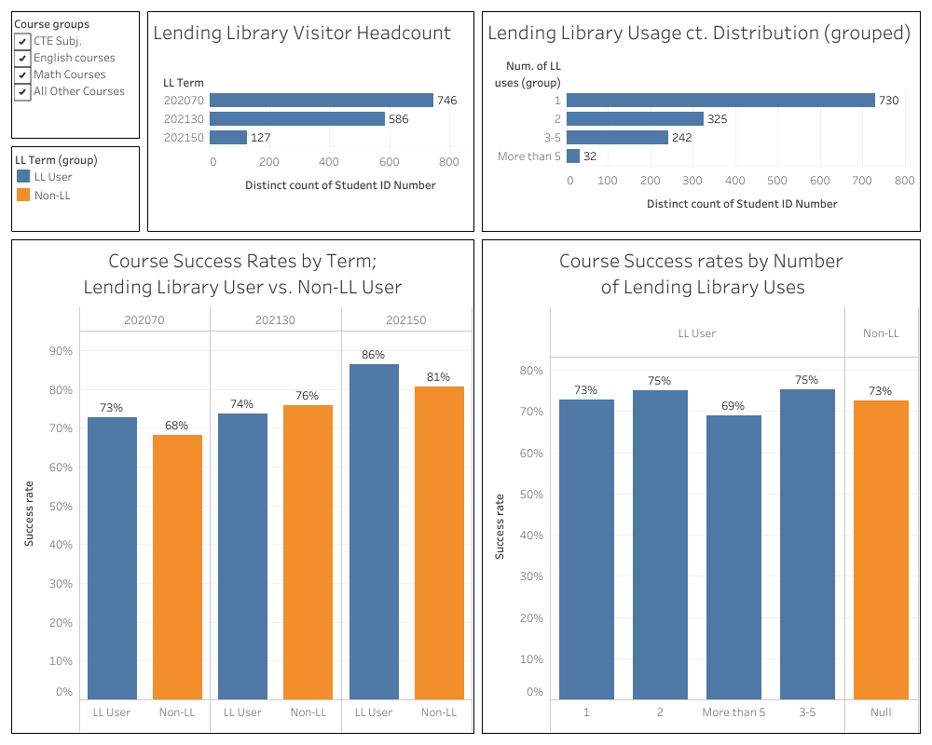

Areas for Improvement

(Based on a review of your outcomes assessments, data, recent changes, and anything else you would like to highlight, please review your current areas for improvement. Note that the areas of strength and improvement identified here should inform the goals, budget, and other resource requests later in the document.)

Technology– The library is a nice building but needs to keep up with the needs of students. Students have requested places to practice group presentations in front of a screen. This is something most four year institutions offer. The library offers the ability to scan materials through one scanner that is attached to a desk top computer, the type you would purchase for your home. We need better scanning options for students, this allows students to send materials to themselves for free.

STRATEGY – Work with Head of I.T. department to come up with a plan to add technology to the study rooms. Finding funding or use Library funding over time to purchase technology.

Security Gates – The security gates in the library are beginning to malfunction. The gates are outdated and the model is no longer being created. Further, the company stopped making spare parts for this model and it is only a matter of time before the gates fail and we are unable to repair.

STRATEGY – Keep these gates working for as long as possible, and begin to work with Arlitha on a plan to pay for the new gates.

• Adding Reserve Books into the Catalog – Our Reserve Books are one of the library’s most popular collections. Adding the Reserve books into the Catalog will allow us to keep statistics on which books are being used for which classes, and to inform the faculty on the books they may want to keep on Reserve. Reserve book collection statistics will be utilized for surveys the library has to do each year. This will also allow students to search for Reserve Books using the library catalog.

STRATEGY – We will ask the faculty to come and remove any items that are not currently being used. We will then create a “Reserve Book” field in the catalog and begin to barcode and catalog the collection.

• Coordinator (director/manager/supervisor) for the Library - A “coordinator” is needed to provide vision and supervision of classified staff, to do the critical administrative tasks like accreditation, program review, SAO, technology and education plans, campus committee meetings and governance, grants, community networking and participation, budget, and other typical “coordinator” responsibilities performed by the retired library director. Having a library coordinator would free the current librarian from the director duties she has been doing beyond the allotted three release hours/week so she can get back to doing the full-time reference librarian work that she has was originally hired to do. In order to get the essential librarian tasks accomplished to keep the college library functioning to meet the needs of the campus community, the current full-time librarian has documented the hours beyond her 44 hour contract week.
STRATEGY – Continue to ask for a coordinator position that oversees the library and the learning center.

Goals (This section is for you to report on progress on new goals. If your program is addressing more than 3 goals, please add rows.
Note that for the Mission Statement column, please list the numbered goal(s) from the college Mission Statement and Guided Pathways Pillars (see page 1) that would be furthered if this goal were accomplished.)

Goal(s) | Timeline for completion | Needed resources | Person(s) Responsible | Obstacles to completion (if any) | Mission Statement | Guided Pathways Pillars
1.  Add technology to the study rooms | 2023 | Financial Resources | Librarian/I.T. Director | Lack of financial resources | 2,3,4 | 3
2.  Purchase digital archives | 2023 | Financial | Librarian | Lack of financial resources | 2,3,4 | 3
3.  Create recreational reading collection | 2025 | Financial | Librarian | Lack of financial resources | 4 | 4

Staffing:

Current Staffing Levels

Please use the table below to describe current staffing levels, by employee type. Raw numbers are sufficient, not FTE.

Full-time |  | Part-time
Faculty | 1 | Faculty | 5
Temporary |  | Temporary
Classified | 1 | Classified
Management |  | Management

Request for New/Replacement Staff

Use one line for each position requested. Justify each position in the space below.

 | Title of Position | Classification  (Faculty, Classified, or Management) | Full or Part  Time | New or Replacement
Position 1 | Library Tech | Classified | Full | Replacement
Position 2 | Coordinator/Director | Administrator | Full
Position 3

Justification:(Address each position requested. Note that a position need should be demonstrated in earlier sections, such as your needs for improvement or to meet specific goals)

Library Tech - Replacement Library tech for the one we lost in 8/21. We would also like this new hire and our current Library Tech to be full time. Having these positions be eleven month hurts our ability to assist our students. The turn around time for the Lending Library materials between semesters and summer school is very short. Plus adding materials to the Lending Library can only be done between semesters. There are also a lot of behind the scenes work that is done during times that classes are not in session, such as inventory, stack management, and other projects that we don’t have time to do during the semester. Having these staff members here during the off time would allow us to be better prepare come the semester, and make the library a better space. If a Winter Intercession is added in the future we will not be able to provide sufficient coverage for the library for the intersession

Coordinator for the library– see Coordinator (director/manager/supervisor) for the Library under Areas for Improvement

Resource Requests
The following four sections are for requesting resources, such as technology, facilities, safety/security, and professional development. Please include all needs, even if you already have identified funds for them. Requests made here should be linked to needs identified in earlier sections (outcomes, areas for improvement, goals). If you have no needs in a particular area, just type NA.

TECHNOLOGY REQUEST
Use this section to list any technology needs for your program. If you have more than two technology needs, add rows below.

Technology Need | Justification
Item 1  Scanner | Scanner for students so they can scan materials and email them to themselves to save time and money
Item 2

FACILITIES REQUEST
Use this section to list any facilities needs for your program. If you have more than two facilities needs, add rows below.

Facilities Need | Justification
Item 1

Item 2

SAFETY & SECURITY REQUEST
Use this section to list any safety & security needs for your program. If you have more than two safety & security needs, add rows below.

Safety & Security Need | Justification
Item 1  Security Gates | Our security gates are old, and parts are no longer built to fix them.
Item 2

PROFESSIONAL DEVELOPMENT REQUEST
Use this section to list any professional development opportunities you would like to have available for your program. If you have more than two professional development needs, add rows below.

Professional Development Need | Justification
Item 1

Item 2

Budget

(Please include all budget needs, even if your program is funded entirely by categorical funds. (Do not include staffing n this section.)

 | Current Budget | Amount of Change | Revised Total
2000 (Student Workers Only) | 0 | 0 | 0
4000 | 4,000 | 0 | 4,000
5000 | $57,390 | 0 | $57,390
Other | $28,700 | $35,421.00 | $64,121

Justification:

(Please justify all significant expenditures. Note that budget needs should be demonstrated in earlier sections, such as your needs for improvement or to meet specific goals)

The book budget has not increased since 2011in fact, it has decreased. By increasing the budget by three thousand dollars it will allow us to update our physical collection and purchase additional eBooks

Our current security gates are no longer being built. According to Bibliotheca, the company that built them, they will only supply parts as long as they have them. They are no longer making repair parts for our gates and we should therefore begin the discussion of replacing the gates. This is an old quote from the previous program review, the cost was $32,421.00.

