Porterville College, Language Arts Division
Addressing AB 705
Meeting Notes
April 14, 2018
9:00 a.m. to 4:00 p.m.
Location: Best Western (350 Montgomery Avenue, Porterville)

I. START
A. Check In
B. Process Check, Rumor Control, Heads Up, Elephants
C. Logistics
D. Agenda for Today
- N/A
E. Revisiting LA Division Norms from 4/13/2018
F. Recollections Review
- N/A

II. HOMEWORK (what, when, who)
- N/A
III. ISSUES/TOPICS
A. Brief overview of AB 705 (PP - Ann Marie)
B. Using Interest Based Decision Making to address AB 705
1. The Story/Perspective
- Guided Pathways: guidance from faculty and counselors for students in specific majors and outline a path for transfer. PC Senate wanted to provide students with choices and kinds of GE could take and help not to take multiple classes/classes in the wrong path. New vision for CCDs and larger than AB 705. Complete classes and graduate sooner. Related to AB 705 with funding.
- Question: how to make students literate in one year? To read college level text.
- CCDs have a mixture of ages and experience and don’t want to lose the mixture. Have some students with bad attitudes because in 101A - can’t challenge them b/c of what’s happening in class.
- Question: How to proceed when disparate levels of students are in same class?
- Reading: want to make sure students are critical readers and sad to see reading classes are gone with AB 705. Some students reading skills are not that great.
- Distress coming from both logical and emotional place. Someone who has done poorly in K12 may need more than one year to improve and get to the place need to be. Lump students who are quick in with those that need help and could make for a nice mix or a toxic setting.
- Job to set up students for rewards not failure.
- Students that have seen in 50 and 71 classes were not good high school students - students robbed of a rich education in favor of a bare bones education. CCD founded on open door policy. Have changed focus on open door.
- Agree about mixture but also agree about toxic environment statements. Some students ready to write at higher level and some not; it’s a good challenge. See students in 73X but could have gone in 101 but have continue 73X through the end of semester - didn’t really need a whole semester of 73X. Writing interesting but don’t know what to do about it.
- Question: how much funding are we receiving to implement these? Why is there no middle ground?
- CSU only has transfer level English: regular English is two semesters and accelerated English is one semester. Also have the same tutor and throughout semester and use writing center for the semester. Three units total. Preferred one year b/c could take time.
- Reading: straw design removed reading - kept standalone composition classes (mandatory). Hear students need literacy but removing reading doesn’t make sense. Don’t see why can’t formalize relationship b/t reading and composition classes.
- Reading SLOs have been strengthened when revisited classes.
- Accelerated model built upon reading is more critical than writing. Don’t see this in traditional classes.
- State eliminated reading requirements and reading requirements were option at PC.
- Deficit thinking - looking at what students can’t do vs. thinking about what they can do.
- Fear that passing a law that forces students to do something; causes to look at ways not working vs. what students can do
- Don’t think should equate deficit thinking with preparation. We are united in getting students prepared and ready to achieve. Want to make sure preparation is real. Students are surface ready but not deep ready. All interested in preparation. How to make this work will involve reading.

1A. SUGGESTION - Open-ended issue questions:
- How can the English program best prepare Porterville College students to:
- read,
- write,
- and think critically and creatively
- at the transfer level when all incoming students are initially placed at the transfer level?
- How can we best achieve the above within the time constraints of AB 705 (1 semester or 1 year)?

2. Stakeholders and Interests
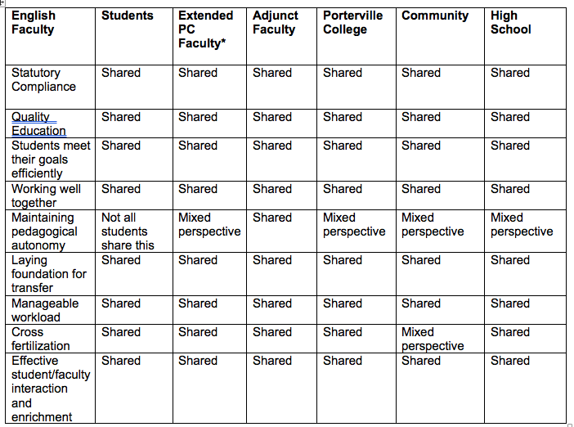

Extended PC Faculty: Sociology, Math faculty

3. Options and Evaluating Options

Note: Communication applies to all the Option Clusters

a. Option Clusters

Courses
- More deliberate and formal (written into courses) integration of reading
- Create a transfer level critical reading class (standalone and/or co-requisite)
- Create other co-requisites (aside from 101AX), including ESL and reading co-requisites, and explore other models
- Create other 1 unit classes
- Research class (1 unit not a full semester)
- Two semester 101A (research, possible DRC option)
- Promote student autonomy through instructional scaffolding and other means
- Consider expanding dual and concurrent enrollment in 101A
- Figure out unit value for classes (considering adjunct load), consider: 1 unit classes and not full semester and non-credit classes (see Homework item)
- Stipends for creating course curriculum

Courses: Interests and Options evaluation:
6) may not be statutory compliance or efficient
8) may not have pedagogical autonomy
1) through 9) may not meet manageable workload interest

Resources
- Literacy center - workshops, classes, tutoring, and mentoring
- Expand Embedded Tutoring, Tutoring Certification Program, and PASS program

Resources: Interests and Options evaluation:
All interests met

Faculty Development
- More reading training for LA faculty and an in-service from reading specialist
- In-service for PC faculty on reading and writing across the curriculum
- More paid opportunities/workload adjustments in order to collaborate
- Find ways to work with other PC faculty to incorporate writing into their classes to help students to succeed in that writing
- Fully inform selves about 101A and 101AX co-requisite; begin qualitative and quantitative research on current offerings
- Paid staff development for adjuncts to maintain consistency of the program
- Promote student autonomy through instructional scaffolding and other means (under Courses as well)
- More norming to maintain rigor in 101A class - for example, through a portfolio program

Faculty Development: Interests and Options evaluation:
All interests met

Placement
- Determine how would like incoming students to be placed
- Plan to effectively communicate with counselors, adjuncts, and high schools prior to fall 2018 (implementation fall 2019)
- Division chair stipend

Placement: Interests and Options evaluation:
NA - maintaining pedagogical autonomy
21) and 22) manageable workload interest not met in the short term

Next Steps
- Develop a plan for students who do need more than 1 semester to make their goal
- Develop plan for students who fail 101A on the first or second attempt
- Develop a resource repository of University-level assignments for transfer for success in future writing assignments
- Follow up qualitative data/research on how changes are perceived by students; making sure collecting in a way that is useful to us

Next Steps: Interests and Options evaluation:
23) through 26) manageable workload interest not met in the short term

4. Straw Design
- Agreed by consensus and review hardcopy

5. Action Plan
A. Next steps
1) Division faculty talk to Kailani on ESL co-requisite AnnMarie and Clara complete curriculum by Fall 2018
2) Create transfer level critical reading class by Fall 2018 (Elizabeth)
3) 1 unit advance grammar class (TBD)
4) Asking whether 2 semester 101A class is compliant with AB 705 at the May 4, 2018 CCCCO meeting at BC (Melissa L.)
5) Kailani meeting and agenda either on April 17, 8:00,
April 19, 8:00 (AnnMarie send meeting maker to attendees)
      - Dual and concurrent enrollment
      - Option 10) stipends
      - Literacy center
      - Expand Embedded Tutoring, Tutoring Certification Program, PASS program
      - Division chair stipend
      - Program review
6) Faculty development options - meet, review, and triage order of options and decide on an action plan from triaging order; LA division meeting May 11, 2018 (put a soft hold morning/afternoon; once confirm meeting time AnnMarie send out a meeting maker)
7) AnnMarie speak to Araceli and Anna about scheduling sufficient time early in semester to convey a unified message to students
8) PP explaining what new English program and support for students (Melissa L - once have clear, concrete picture)
9) Review ‘Next Steps’ options in fall 2018 at LA division meeting

IV. NEXT STEPS
A. Homework (if needed)
1. Offering non-credit classes as a viable option for integrating basic skills into transfer curriculum (Ann Marie)
2. Norms - revisit as a LA Division (LA faculty meeting; Fall 2018)
B. Communication with relevant stakeholder groups/summary of topics

V. PARKING LOT
- Shared vision of what workload should be
- CTE English course (for those required to take Eng 50); Embedding basic skills into certificate programs - discussion with CTE faculty;
- Consider district-wide curriculum needs (for students that take classes at multiple campuses)

VI. MEETING EVALUATION

Plus Delta
Listened to each other No cookies/need sugar/no afternoon snack
Stayed conscious Room
Respectful
Got a lot done
Stuck to task
Follow the process

