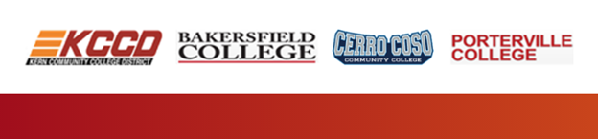

KCCD Student Government
Training and Development Workshop
August, Monday 19, 2019
Bakersfield College, Levinson Hall 40

The three Student Governments from the colleges within the Kern Community College District are pleased to participate in a Student Leadership Conference at the Bakersfield College’s campus.

This Student Government Leadership training and development workshop will facilitate a collaborative and inclusive educational environment, which will inspire the campus communities, provide valuable peer-to-peer learning experiences, and engage students as they share and develop their leadership skills effectively within KCCD.

The workshop will provide the student government officers the means to expand their individual and group leadership potentials as well as avenues to apply those skills in a broader student advocacy within KCCD, local, and statewide initiatives.

Schedule of Events:

8:30 am 9 am Small breakfast samplings provided by BC
9 am 9:15 am Welcome (Tyson, Benny, Kimanthi)
9:15 am 10:15am Intro Icebreaker and Campus Tour (Presidents)
10:15am 11 am True Colors (Benny)
11 am Noon Team Builder (Kimanthi)
Noon 1 pm Lunch provided by BC
1 pm 2 pm Visions for Success (Grace Commiso)
2pm 3pm Breakout Session: (Tyson)
- Vision for Success Goals for Students
3 pm 4 pm What’s Happening at the DO (Chancellor Burke)
Fiscal Responsibilities (CFO Martin)
4 pm 4:15 pm Closing

Learning Outcomes
By attending and actively participating in the Student Government workshop, student officers will:

- Gain Personal Competencies
  - Obtain and strengthen campus leadership skills such as conflict and risk management, communication, increasing equity for underrepresented populations, veterans, foster youth, disabled students, non-traditional students and so forth, teamwork, time management, proactive event planning, goal setting, and risk taking
  - Utilize internal practices that support organizational sustainability
- Better understand the ability to work productively within the government to assist with campus-wide and community-wide efforts to ensure student access through extensive student outreach, both on and off campus, course completion and degree completion, and the transfer process
  - Develop an understanding of how members of an organization can work together through various obstacles and challenges
- Develop an understanding of how members of an organization can work together through various obstacles and challenges blockading student success, such as degree completion, course completion, and the transfer process, as well as obstacles and challenges blockading student equity, particularly with regard to underrepresented and nontraditional student populations
- Cultivate further ideas that continue to build community within the District
  - Meet and create friendships or partnerships for the future to assist with student equity and student success issues at the district level
  - Participate in idea-sharing as it relates to their experiences as student officers
  - Exposure of new ideas and ways to partner with others, recognize members, strategize, and further the mission of student government
- Obtain knowledge of the role of community colleges with regard to underrepresented student population groups and non-traditional students
  - Exposure of new strategies on ways to increase retention rates: transfer rates, course completion, and degree completion
  - Obtain strategies on improving participation in student government and how this in itself can increase completion rates by building mentorships and community
  - Obtain strategies on recruiting students to the community college through outreach

TAG US ON:
#KCCDStudVoice
Bakersfield College Cero Coso College Porterville College
Like us: SGABC SGCC ASPC
Follow us: BCSGA
Post on: BCSGARenegades

