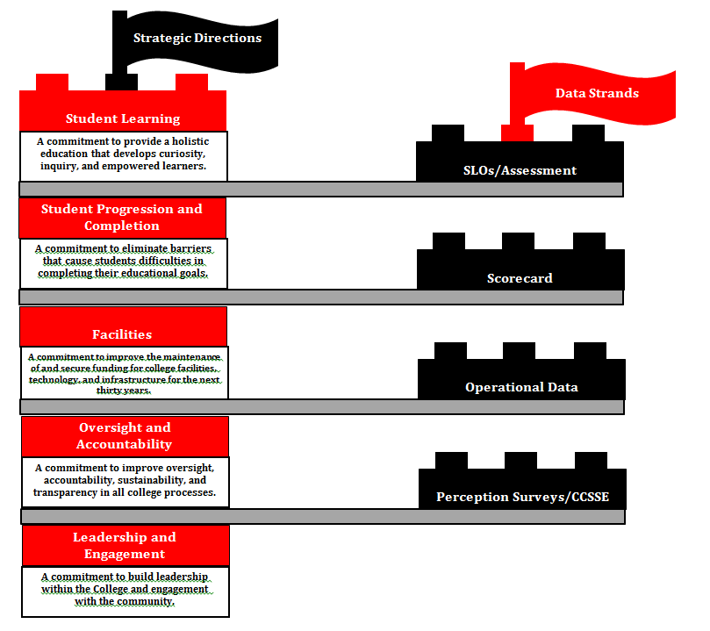

**A commitment to improve the maintenance of and secure funding for college facilities, technology, and infrastructure for the next thirty years.**

**Facilities**

**Data Strands**

**Strategic Directions**

**Student Progression and Completion**

**A commitment to build leadership within the College and engagement with the community.**

**Leadership and**

**Engagement**

**Oversight and**

**Accountability**

**A commitment to improve oversight, accountability, sustainability, and transparency in all college processes.**

**Perception Surveys/CCSSE**

**Operational Data**

**A commitment to eliminate barriers that cause students difficulties in completing their educational goals.**

**Student Learning**

**SLOs/Assessment**

**Scorecard**

**A commitment to provide a holistic education that develops curiosity, inquiry, and empowered learners.**