**Porterville College Mission Statement**:

With students as our focus, Porterville College provides our diverse local communities quality education that promotes intellectual curiosity, personal growth, and lifelong learning, while preparing students for career and academic success.

In support of our values and philosophy, Porterville College will:

1. Provide quality academic programs to all students.
2. Provide comprehensive support services to help students achieve their personal, career and academic potential.
3. Prepare students for transfer and success at four-year institutions.
4. Provide courses and training to prepare students for employment or to enhance skills within their current careers.
5. Provide comprehensive support systems tailored to each student’s skill level.
6. Recognize student achievement through awarding degrees, certificates, grants, and scholarships.

**Guided Pathways Framework**:

1. Clarify the Path: Create clear curricular pathways to employment and further education.
2. Enter the Path: Help students choose and enter their pathway.
3. Stay on the Path: Help students stay on their path.
4. Ensure Learning: Ensure that learning is happening with clear outcomes.

**Program Mission Statement**:

The Office of Institutional Research provides useful, relevant, actionable, and user-friendly data and reports to administration, faculty, staff, students, and the community for short- and long-term planning, decision-making, accountability, program review, evaluation of the effectiveness of institutional planning, student learning, equity and success, and federal- and state-mandated reporting.  As researchers, we commit ourselves to the goals of data accuracy, clear communication, timely reporting, integrity, objectivity, and where appropriate, confidentiality of sensitive data.  Lastly, we adhere to the code of ethics for institutional researchers as established by the Association for Institutional Research.  This code can be found at <http://www.airweb.org/Membership/Pages/CodeOfEthics.aspx>.

**Service Area Outcomes (SAOs)**:

(For each Service Area Outcome (SAO) identified by your program, please complete the table below describing how the assessment results have been discussed in the program and how they impact your goals and needs. If your program has more than two SAOs, please add rows.)

|  |  |  |
| --- | --- | --- |
| SAO Statement | Describe assessment results and discussion of this SAO | Describe how the results impact your goals and needs going forward |
| 1. Faculty and staff will find the information on the Institutional Research website, data warehouse reports, dashboards, and requested ad hoc reports to be useful, relevant, and user-friendly. | SAO was assessed via survey and results are below. We added the part about dashboards this year. We noted that there was improvement on a couple of key items. We would like to see increased usage of dashboards between now and the next program review. | We would like to continue to devote resources into developing additional dashboards and supporting usage across the college. This will likely require additional Tableau licenses |

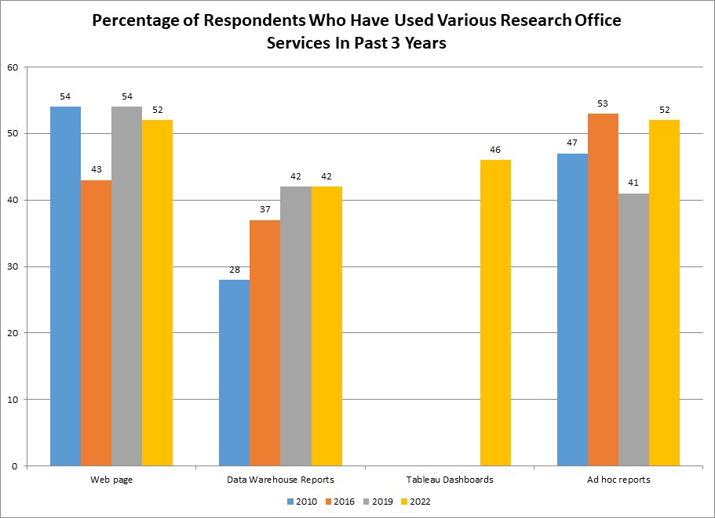

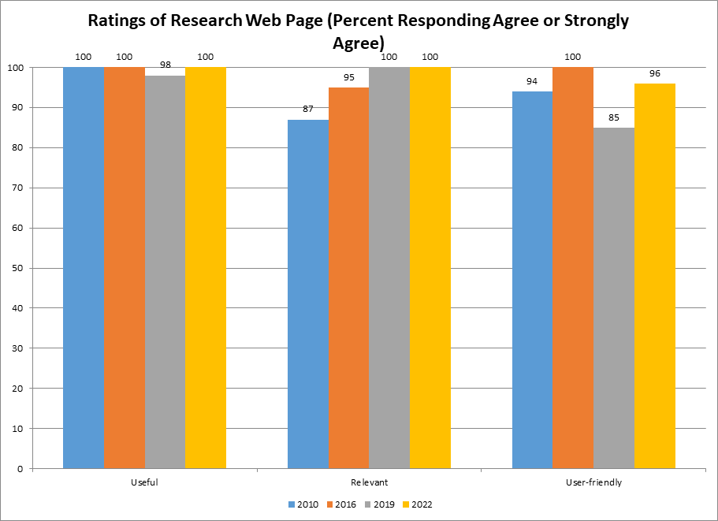

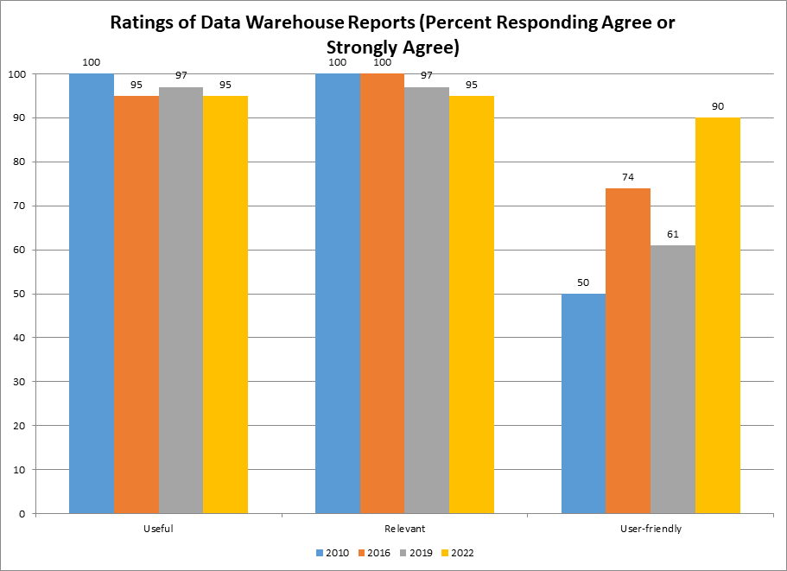

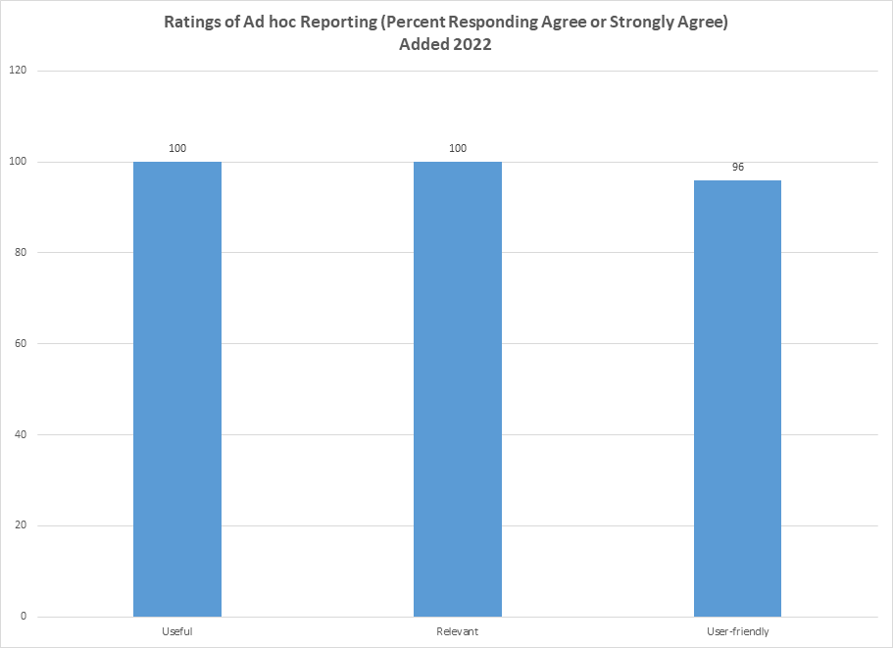

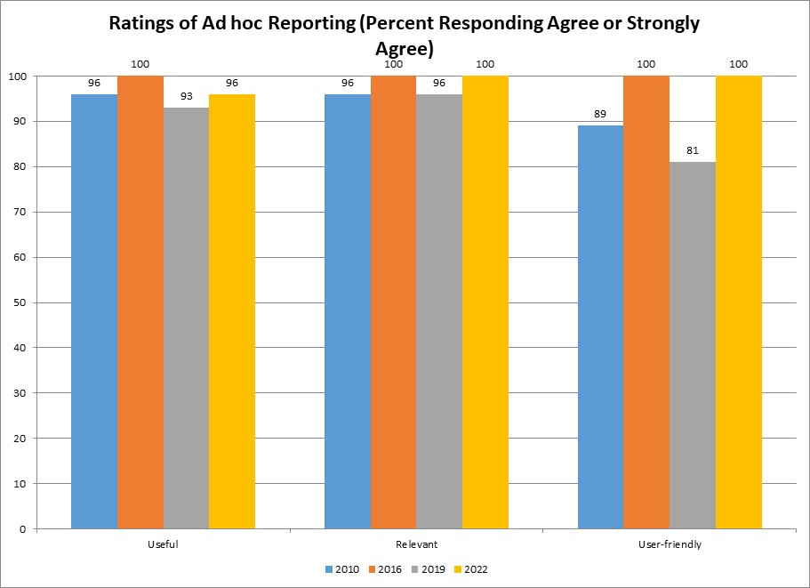

**Program Analysis and Trends**:

(This section is intended to evaluate your program, including data review, changes over the past three years, progress on previous goals, strengths of the program, and areas for improvement.)

***Data Review***

(Please review data provided by the KCCD Office of Institutional Research here. Discuss trends in your program including things such as enrollment, offerings, demographic trends, course success rates, and awards. Be sure to address any equity issues in your data, including course success rate differences.)

In the spring of 2020, we implemented the Office’s first Research Request Form, an online form that allows users (or IR staff from discussion with stakeholders) to input requests for research projects. Not every project is included. We tend to leave off ongoing cyclical projects that have been part of our work for some time, as well as small requests that take only a few minutes or are just about guiding users to existing resources. Since implementation, 99 research requests have been made through this form. Below are three charts showing a bit of information on the types of projects requested.

A slight majority of requests from administrative staff, with faculty and classified staff roughly equally represented. A handful also come from outside people or organizations with whom the college is working on projects. Committees request projects often, with other purposes including student success and equity work, enrollment management, planning projects, grant evaluation and proposals, etc. Among the most common requests are student lists of various types, often for programmatic outreach, as well as data summaries, evaluation work, surveys, and others.

***Changes in Program over Last Three Years***

The Office of Institutional Research has been largely stable over the past three years, no staffing changes. There have been a number of things that have impacted the department, including the pandemic. This led to staff working from home through most of two years, but had little practical impact as most of our work can be performed equally well from any location. The pandemic also impacted aspects of our work. Two student surveys and one employee survey were implemented to assess the impact on the college. These surveys contributed to the college’s understanding of the impact on the pandemic and how it would respond and allocate resources.

Surveys were also impacted by the pandemic in another way. The college was in the process of administering the Community College Survey of Student Engagement (CCSSE) in the spring of 2020 as classes were moved online. That survey had to be delayed until the spring of 2022, and that administration was still affected by the pandemic and resulting smaller class sizes. Other surveys were also delayed, including the Student Satisfaction Survey. Districtwide surveys, such as the Climate Survey, may have their cycles affected, by the pandemic, other colleges’ cycles, and other issues. We are also in discussions regarding implementing a Student Climate Survey.

Currently, we are working to get the survey cycle back in sync.

A staff development survey was planned for the fall of 2020, but has been delayed while responsibility for staff development is under discussion.

Data Team was restructured as part of the implementation of the college’s Guided Pathways implementation. As the Pathways to Success & Equity Committee (PSEC) was converted to the Guided Pathways Committee, the role of Data Team has changed. Whereas the previous iteration of the group focused on reviewing college data from a variety of sources and brainstorming recommendations to send up to PSEC or other groups, the new, larger version of Data Team will work to support the success and equity work of each of the Guided Pathways work groups, with members of all groups included in Data Team. Currently, as of fall 2022, the group is reviewing data from program review and student success dashboards, with other items waiting to be discussed. Not all members of the Team will immediately have Tableau licenses, an issue that may limit their ability to access data between meetings.

We have expanded the use of Tableau dashboards, for program review, general data gathering, enrollment management, student success work, and program planning and evaluation. This work is important as these dashboards are more user-friendly than Cognos reports, but we are currently moving to individual Tableau accounts, which must be purchased. The college has purchased some, but funds will need to be identified for more if we wish to broaden data access and use of data for success and equity work.

***Report on Previous Goals***

(In this section, report on goals established in your previous program review. Please include progress to date, including whether the goal is complete, revised, and how any circumstances might have impacted your completion of the goal. If you had more than three goals, please add rows.)

|  |  |
| --- | --- |
| Goal | Status/Progress |
| 1. Improve data access and usability through the use of dashboards | We have 8 dashboards in regular use for areas ranging from program planning to student services. Additionally, we create a number on request for ad hoc purposes.  Additionally, we have expanded the use of dashboards created and maintained by the District Office of Institutional Research. Among the most commonly used are those for program review, the student success cohort dashboards, and the enrollment dashboard. But there are many others that get occasional use. The PC IR Office serves as a campus liaison to help various constituencies find and locate data on district dashboards. |
| 2. Work with PSEC and Guided Pathways Completion Teams to support their data needs | We continued with Data Team until PSEC was restructured into the new Guided Pathways Committee with a new version of Data Team supporting GP work. It is now less a brainstorming group, but rather works to support data needs of GP efforts across campus and within each team. |
| 3. More fully integrate planning process, through the strategic planning crosswalk and other tools | The crosswalk was created, with input from Strategic Planning, Enrollment Management, and Accreditation Committee, and approved by College Council. A new Strategic Plan was created and approved by the board in March 2022. Several other plans are out-of-date and need updates. |

***Program Strengths***

Stability in the Institutional Research office has allowed us to contribute to the college in substantial ways. In recent years, we have developed a Research Request Form that allows us to track many of our ad hoc and ongoing requests and we maintain a high level of responsiveness, with quick turnaround times for requests. Additionally, the development of ongoing and ad hoc Tableau dashboards allow us to engage with various campus constituencies in their work improving student success.

The IR Office has contributed substantially to those success efforts, having been a key factor in improving rates of English and math completion, student unit completion, and award and transfer rates.

We have a collegial relationship with the district IR Office, collaborating on projects, providing input on districtwide initiatives that affect PC, and serving as a liaison between the district and the college, particularly on data projects, accuracy of dashboards, and user feedback on districtwide projects.

In the area of planning, we have worked to integrate planning efforts with a crosswalk that shows all college goals in one place and the IR director, as chair of Strategic Planning Committee, worked with that group to develop a new Strategic Plan, adopted by the Board of Trustees in March 2022, with a heavy focus on student success and equity.

***Areas for Improvement***

The college has now fully transitioned to Cognos and Tableau as data platforms and both work well for their intended purposes. As Tableau dashboards have come into greater use, Cognos use may decline and those who use it may do so only occasionally. We work with users to help them navigate the system as their infrequent use, combined with a not quite user-friendly platform, leads to questions.

Tableau expansion needs to continue, particularly with Guided Pathways work. There is interest among GP pathway teams in using dashboards set up for the Education Careers program as templates for other pathways. IR will need to coordinate to see whether we need a single set of pathways dashboards or a series of them for each pathway. An additional challenge is that KCCD is transitioning Tableau to individual accounts which must be purchased. District HERFF funds are being used for 20 accounts initially, with college HERFF funds to be used for an additional 11. However, if we want data to be disseminated and used broadly across the college, we will need to expand the number of Tableau users and find funding for as many as possible. Our initial priority will likely be members of the Guided Pathways Data Team.

Surveys are an additional challenge. Despite a survey policy, adopted in fall 2019, various campus constituencies often conduct surveys outside the policy and this creates confusion and duplication, likely reducing response rates for important college and district surveys. Additionally, the California Community Colleges Chancellor’s Office and the RP Group are increasingly sending out statewide surveys that they expect the college to implement, without the knowledge or understanding of local survey cycles. And, the Covid-19 pandemic interrupted the existing survey cycle, necessitating a reset of multiple surveys we regularly implement. The staff development survey has been delayed for more than two years while the college determines how that function will be structured within the college.

In the area of planning, while we were able to create a Strategic Plan and a crosswalk that integrates several of the college’s planning processes, several other college plans have fallen behind or off schedule. While the IR Office is not responsible for these plans, Strategic Planning Committee is working to re-establish and document the cycle for each, getting the college back on track.

The program also faces a challenge of sustainability. Since the Director of Institutional Research returned to PC full-time in 2016, the position and office has been paid for partially through categorical funding (SSSP, Student Equity, and Guided Pathways). The Institutional Research Analyst position is paid from a grant which ends in 2023. Although the Director of Institutional Research is now funded partially from general funds, the Office is still precariously dependent on resources that may disappear at any time. At a time when research needs are increasing, this leaves the Office in a difficult position, should any of these sources dry up.

**Goals** (This section is for you to report on progress on ***new goals***. If your program is addressing more than 3 goals, please add rows.

Note that for the Mission Statement column, please list the numbered goal(s) from the college Mission Statement and Guided Pathways Pillars (see page 1) that would be furthered if this goal were accomplished.)

|  |  |  |  |  |  |  |
| --- | --- | --- | --- | --- | --- | --- |
| Goal(s) | Timeline for completion | Needed resources | Person(s) Responsible | Obstacles to completion (if any) | Mission Statement | Guided Pathways Pillars |
| 1. Work with Guided Pathways groups to provide dashboards and other resources to implement GP work for success and equity | 2022-25 | Ideally, additional Tableau licenses | IR Director & IR Analyst | None | 1-6 | 1-4 |
| 2. Get surveys back on cycle after pandemic disruption | 2022-24 | None | IR Director | None, other than coordination from other offices | 1-6 | 1-4 |
| 3. Coordinate Student Services survey needs | 2022-23 academic year | None | IR Director, working with Student Services | None, other than coordination with Student Services | 1-6 | 1-4 |
| 4. Implement Student Climate Survey (districtwide) | Possibly spring 2023 | Funding | IR Director, working with district IR team | Coordination across district | 1-6 | 1-4 |
| 5. Implement Staff Development Survey, add to regular cycle | Possibly fall 2023 | None | IR Director, undetermined college individuals or committees | Waiting for college to determine future structure of staff development across the college | 1-6 | 1-4 |
| 6. Work with Strategic Planning Committee and campus constituencies to get planning documents/cycles back on track | 2022-25 | None | IR Director, Strategic Planning | Cooperation from those responsible for planning documents | 1-6 | 1-4 |

**Staffing:**

***Current Staffing Levels***

Please use the table below to describe current staffing levels, by employee type. Raw numbers are sufficient, not FTE.

|  |  |  |  |
| --- | --- | --- | --- |
| Full-time | | Part-time | |
| Faculty |  | Faculty |  |
| Temporary |  | Temporary |  |
| Classified | 1 | Classified |  |
| Management | 1 | Management |  |

***Request for New/Replacement Staff***

Use one line for each position requested. Justify each position in the space below.

|  |  |  |  |  |
| --- | --- | --- | --- | --- |
|  | Title of Position | Classification  (Faculty, Classified, or Management) | Full- or Part-Time | New or Replacement |
| Position 1 | Institutional Research Analyst | Classified | FT | Replacement |
| Position 2 |  |  |  |  |
| Position 3 |  |  |  |  |

Justification:

Our current research analyst is paid from a Title V grant that ends in 2023. Although the college had always planned that the position would be permanent, the position needs to be institutionalized with general funds.

**Resource Requests**

The following four sections are for requesting resources, such as technology, facilities, safety/security, and professional development. Please include all needs, even if you already have identified funds for them. Requests made here should be linked to needs identified in earlier sections (outcomes, areas for improvement, goals). If you have no needs in a particular area, just type NA.

TECHNOLOGY REQUEST

Use this section to list any technology needs for your program. If you have more than two technology needs, add rows below.

|  |  |  |
| --- | --- | --- |
|  | Technology Need | Justification |
| Item 1 | Tableau licenses | These are key to student success and equity conversations, particularly if we wish to broaden access to and use of data across campus |
| Item 2 |  |  |

FACILITIES REQUEST

Use this section to list any facilities needs for your program. If you have more than two facilities needs, add rows below.

|  |  |  |
| --- | --- | --- |
|  | Facilities Need | Justification |
| Item 1 | NA |  |
| Item 2 |  |  |

SAFETY & SECURITY REQUEST

Use this section to list any safety & security needs for your program. If you have more than two safety & security needs, add rows below.

|  |  |  |
| --- | --- | --- |
|  | Safety/Security Need | Justification |
| Item 1 | NA |  |
| Item 2 |  |  |

PROFESSIONAL DEVELOPMENT REQUEST

Use this section to list any professional development opportunities you would like to have available for your program. If you have more than two professional development needs, add rows below.

|  |  |  |
| --- | --- | --- |
|  | Professional Development Need | Justification |
| Item 1 | Travel funds for conferences | Two conferences per year for each IR staff member, funds requested in budget information below. |
| Item 2 |  |  |

**Budget**

(Please include all budget needs, even if your program is funded entirely by categorical funds. Do not include staffing in this section.)

|  |  |  |  |
| --- | --- | --- | --- |
|  | Current Budget | Amount of Change | Revised Total |
| 2000 (Student Workers Only) |  |  |  |
| 4000 | $200 | 0 | $200 |
| 5000 | $6,600 | $900 | $7,500 |
| Other |  |  |  |

Justification:

The information above regarding the current budget is slightly misleading as the IR department has been funded by a variety of sources in recent years, including the Guided Pathways, Title V grant, SSSP, and Student Equity. The amounts listed above only include general funds.

Office supplies are unchanged from our request from last cycle.

The 5000 accounts include three items:

$550 for the College’s RP Group membership.

$500 for software licensing, specifically Remark Office and Remark Web survey software. This is a reduction from last time as we are leaving SPSS software off as the license is already paid.

$6,000 for travel. This is an estimate to send two people to two conferences or events per year. The number of conferences is unchanged from last time, but the cost is higher due to changes in conference costs.

The above includes all of our needs; the funding sources for the office may be multiple and vary from year to year.

We do the Community College Survey of Student Engagement every three years. This cost is only incurred in the years in which we do the survey (2022, 2025, etc.) and has thus far been paid from the president’s office budget.