Porterville College

Integrated Planning, Assessment, and Action
A Model of Effective Institutional Planning at Porterville College

Fall 2023

Table of Contents

Introduction 2

The IPAA Model 3

Strategic Planning Calendar 9

Timeline of Major Institutional Processes 10

Summary 11

Introduction

The purpose of this document is to describe the phases and activities relating to institutional planning at Porterville College. The four words within the IPAA Model – integrated, planning, assessment, and action - are intentionally included in the name to emphasize important aspects relating to effective institutional planning.

- Integrated

This term is included to emphasize that planning is not an isolated activity, but one that includes the participation of all employee constituent groups, involves coordination with the various committees and groups on campus, and utilizes planning documents necessary to make informed decisions about all aspects of the college.

- Planning

Planning involves not only dealing with present circumstances, but also looking to where we want to be in the future. In order to move our college and students into the future, we must plan now. Institutional dialogue needs to be continuous and utilize all data, reports, and documents available in order to make informed decisions.

- Assessment

Porterville College values continuous assessment in its efforts to improve services to our students, employees, and community. These assessments are maintained through program review, surveys, data review, and other activities that may provide the college with relevant information regarding its progress in meeting it stated goals and objectives.

- Action

Planning for the sake of planning does little in terms of institutional improvement. The result of any planning should be action. The actions taken in response to the planning and assessments conducted are those that not only improve our services now, but also take into consideration actions that may affect our students, our college, and our community in the future.

The IPAA Model

I — Integrated

Effective planning cannot be realized if not all constituent groups on campus are involved. Before planning can take place, there needs to be active involvement among the employees of the college. As noted below, the various groups or committees relating to planning at Porterville College include representation from faculty, staff, administration, and students. When involved, each employee feels integrated into the overall operations of the college.

Since there are many committees, activities, or groups within Porterville College that relate in some part of planning, not all employees are expected to be involved in every phase of planning; however, every employee should or is encouraged to participate in at least one aspect of planning. This participation might take the form of serving on a committee that relates to budget, enrollment management, or institutional governance, but it might also be playing a role in an area’s program review process. Regardless of how they may participate, this involvement allows employees an opportunity to connect their daily work with the overall efforts of the college.

In addition to being involved in areas relating to planning, employees should adhere to the following excerpt from the college’s Participatory Governance statement which emphasize emphasizes the college’s commitment to broad participation of employees in the governance and planning structures of the institution:

“Participatory governance at Porterville College takes place on multiple levels. It is a process that ensures the students, staff, faculty and administration the right to participate effectively in the governance of the college, providing the opportunity for input and ensuring this input is given every reasonable consideration and that all decisions are well informed. Through the participatory process, the campus community engages in ongoing dialogue about quality, learning assessment and implementation of institutional changes that improve student success. This dialogue promotes trust and broadens the sense of participation within the campus community.”

Within the various committees and councils, all constituent groups actively participate. This broad representation not only allows employees the opportunity to participate, but also enhances and improves the overall planning and effectiveness of the learning and support services offered by the institution.

As indicated in the following flow chart, while each committee or group on the College Council oversees a specific area, the general oversight of collegewide planning occurs in the College Council. Not only does this body include broad representation from all the constituent groups on campus, it also includes representatives from the various committees on campus where more focused planning occurs.

Planning and Decision-Making Flow Chart
This flow chart illustrates the integration of employees, committees, etc. into the planning process.

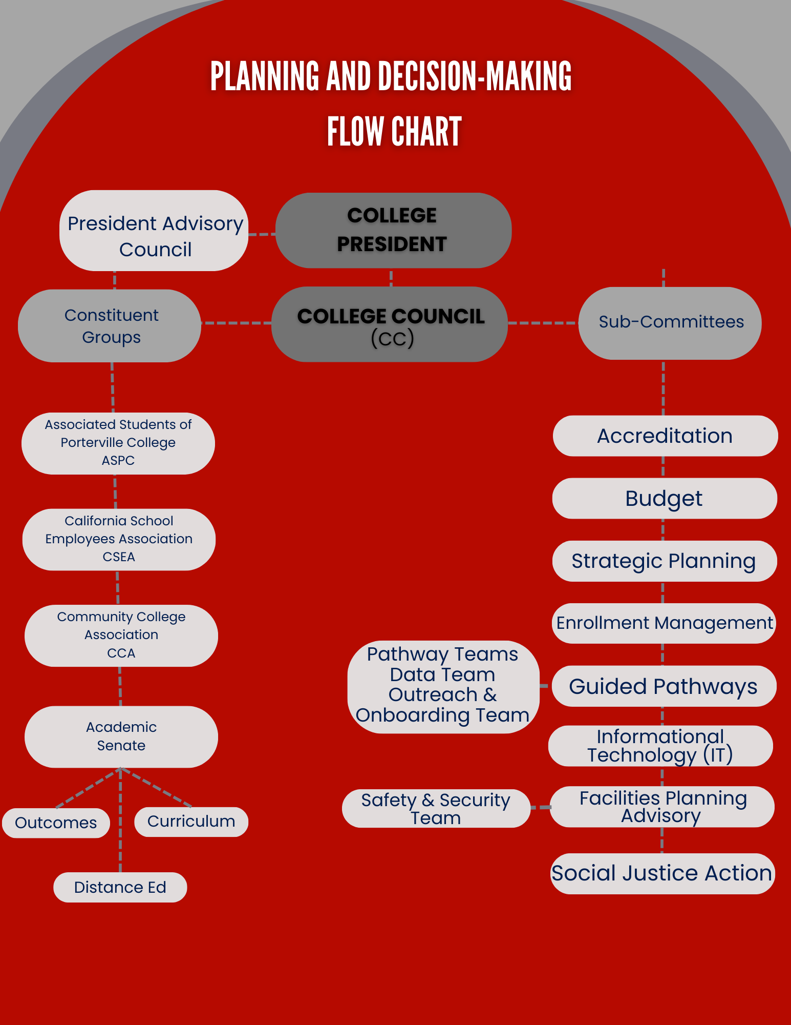

P — Planning

Various documents have been created to assist the college in institutional planning. These plans include information such as data, demographics, current circumstances, projection of future trends, and findings from program review. Those listed below are not, however, all inclusive of the plans that may be developed and utilized as part of institutional planning. In addition, ongoing review of these plans occurs both within the specific committee or group from which the plan originated and within the College Council.

- Program Reviews

Program reviews at Porterville College are conducted on a three-year cycle. Each of the academic divisions compiles a review on that cycle. The administrative areas are also on a three-year cycle, determined by the administrator to whom they report. Completed program reviews are assessed by the Strategic Planning Committee according to a rubric, then sent on to College Council. Once they have gone through College Council, they are available for use in planning by the various planning committees: Enrollment Management, Strategic Planning, Budget, Grants Oversight, and others.

- Educational Master Plan

During fall 2016, the college began working with the consultant MAAS Companies on the creation of a new Educational Master Plan. The process involved gathering data on community needs, population and demographic projections, and enrollment patterns at the college, including projections through 2030 and recommendations for space needs. The plan was adopted in 2017 and forms the basis for facilities and other planning at the college.

- Facilities Master Plan

The Educational Master Plan (EMP) outlines the program needs of the College through about 2030. The Facilities Master Plan uses the EMP as a guide to plan facilities needs throughout the college. The current plan, completed in 2018, includes information on current facilities, including building and landscape conditions, zoning rules, bicycle and pedestrian traffic, and water use. It is linked not only to our Educational Master Plan, but to other aspects of our planning processes, including enrollment trends and projections for the future, space needs, and maximizing resource availability, such as bond measure funds approved by voters in 2014.

- Porterville College Strategic Plan

In the 2020-21 academic year, the College developed its most recent Strategic Plan. The process involved a review of data, including progress on previous goals and a discussion with various campus stakeholders. The Strategic Planning Committee developed a set of four goals, primarily focused on increasing student success and reducing equity gaps. The plan was approved by College Council in fall 2021 and by the Board of Trustees in March 2022. The Kern Community College District will use the Porterville College plan, along with those of Bakersfield College and Cerro Coso Community College, as the starting points for discussion of a district-wide Strategic Plan. There are ongoing discussions about possible changes in plan timelines at both the college and district level, but no decision has yet been reached.

- Enrollment Management Plan

Porterville College developed its first Enrollment Management Plan in the 2011-12 academic year and updated it during 2017-18. The plan includes data on enrollment trends and a set of goals based on four strategic directions: recruitment, clarifying a path, persistence, and completion.

- Information Technology Plan

The Information Technology Plan guides the college in terms of processes for providing new and upgraded technology equipment and software, repairing IT equipment, establishing minimum computer standards, wireless policies and procedures, use of computer procedures, and guidelines regarding media services and web pages. The plan also includes the organizational and reporting structure of the staff in addition to related KCCD board policies and procedures regarding computer use and network prohibitions.

- Distance Education Plan

The Distance Education Plan, most recently updated in 2023, defines the various types of distance education opportunities provided at Porterville College, lists the policies and procedures affecting distance education, and includes a set of goals for the near future.

- Student Equity Plan

Our most recent Student Equity Plan, completed in 2022, establishes goals and activities designed to reduce achievement gaps among demographic groups at the college.

- Guided Pathways Workplan

Guided Pathways is a statewide program established across all 116 California Community Colleges, designed to streamline processes and procedures to promote student success. The Porterville College Workplan, based on a statewide template, identifies activities the college will use to roll out guided pathways efforts across the college and its programs.

- Staff Development Plan

The Staff Development Plan was compiled in the 2018-19 academic year and is designed to document the college’s process for overseeing flex and other professional development activities and opportunities provided across the college from various funding sources.

A — Assessment

One of the major activities on campus in which the college and its programs assess their effectiveness is the program review process. Each instructional and non-instructional program conducts a program review every three years. These reviews include the compilation of various data and information including the division/program mission statement; outcomes; program analysis and trends; how the goals link to the college mission statement; staffing levels and requests for new or replacement positions; technology, facilities, safety/security, and budget requests with a justification for any increases noted.

When the division completes its program review, it is forwarded to the Strategic Planning committee for evaluation to ensure that it contains the required information and meets the standards according to the program review evaluation rubric. Those reviews that are missing necessary elements are referred back to the division or program for modification and those that contain the necessary elements are forwarded to the College Council for review and approval. Once approved, the program reviews are then forwarded to and reviewed in the Budget Committee to be used when making decisions about budget allocations, and to other committees for use in planning work.

In addition to information obtained from the regular program review process, the Porterville College Strategic Plan, Enrollment Management Plan, and various other college plans each have within them various goals and objectives that are measured and assessed.

A — Action

The final stage of this model is action. Once goals and objectives have been established, action should be taken. Goals may change, processes may be modified, or services may be added; regardless, using the assessments to improve the college’s student learning and support services is important.

The IPAA model is not just for general collegewide planning, but can be used for program-specific planning, too. For example, each employee in a program should be involved in the program’s planning (integrate); each program should use data and dialogue when setting goals (planning); each program should assess and measure its effectiveness through program reviews, surveys, etc. (assessment); and each program should utilize what it learns about itself in improvement of its services (action).

Linking Program Reviews to the Planning and Decision Making Process

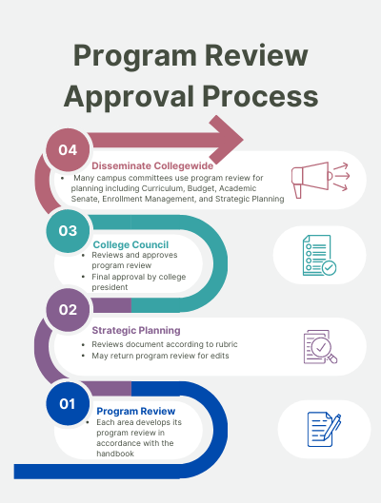
Strategic Planning Calendar

July
- Implement new or revised plans
August
- Implement new or revised plans
- Send email notification of program review and planning document deadlines by end of August
September
- Divisions/departments to begin scheduled program reviews
- SP Committee begins review of previous year’s goals & objectives
- SP Committee Bi-Monthly Progress Report to CC
- KCCD BOT adopts final budget
October
- Academic Senate reviews faculty positions
- Academic Senate, CSEA, and Administrative Counsel submit position requests to CC
- Budget development process for next year begins
- Program review updates/budget worksheets due to Budget Committee by Oct. 15th.
November
- SP Committee Bi-Monthly Progress Report to CC
- Send email reminder of program review and planning document deadlines (Nov. 1st )
- Divisions/departments to report on progress of program reviews to CC
December
- Review progress of Strategic Plan
January
- State Budget Report issued
February
- Budget development process continues
- SP Committee Bi-Monthly Progress Report to CC
- CC to review Mission Statement
- Program reviews submitted to SP for review by Feb. 1st
March
- All sub-committees submit plans to Strategic Planning (i.e. Facilities, Ed Master, IT, Enrollment Management, Staffing) by March 1st
- Program reviews submitted to College Council for review by March 31st
April
- Budget Committee to complete next year’s tentative budget
- CC to review goals & objectives (for following year)
- SP Committee Bi-Monthly Progress Report to CC
- CC reviews and approves collegewide plans (i.e. IT, Facilities, etc.)
- Begin SP Committee end of the year review and identify areas of improvement
- Program reviews approved by College Council April 30th
May
- CC to recommend approval of next year’s tentative budget
- State May Revision budget report issued
June
- KCCD BOT adopts tentative budget

Porterville College Timeline of Major Institutional Processes
PROCESS | 2022-23 | 2023-24 | 2024-25 | 2025-26 | 2026-27 | 2027-28
Accreditation Cycle | Mid-term report |  |  | Visit (f25)
Strategic Plan |  | Revise | Implement |  | Revise | Implement
Distance Education Plan | Revise | Implement |  | Revise | Implement
Educational Master Plan | Revise | Implement |  |  |  | Revise
Enrollment Management Plan |  | Revise | Implement
Facilities Master Plan |  | Revise | Implement
Guided Pathways Workplan | Revise | Implement |  | Revise | Implement
Information Technology Plan |  | Revise | Implement |  | Revise | Implement
Student Equity Plan | Revise | Implement |  | Revise | Implement
Staff Development Plan |  | Revise | Implement |  | Revise | Implement
Program Review | Selected division/dept | Selected division/dept | Selected division/dept | Selected division/dept | Selected division/dept | Selected division/dept
Budget Development | Yearly | Yearly | Yearly | Yearly | Yearly | Yearly
Planning Surveys | Climate (F) | Staff Dev(F)  Student Climate (S) | Strategic Planning (F) CCSSE (S) | Climate (F)  Student Satisfaction (S) | Staff Dev(F)  Student Climate (S) | Strategic Planning (F) CCSSE (S)

Summary
Porterville College is committed to the implementation of institutional planning and review processes that are integrated across campus and involve the college’s constituent groups. Effective planning leads to effective processes. To that end, the college will continue to evaluate and implement processes that are efficient, effective, and improve the institution’s student learning and support services.

