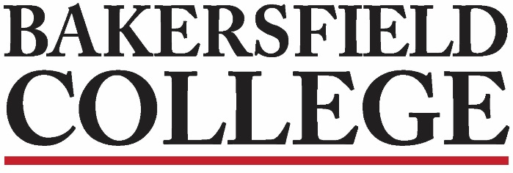
Guided Pathways Strategies (GPS)
Faculty Leads Meeting
March 14, 2022
12:00 – 1:00 pm via Zoom

Minutes
Attendees: Grace, Jessica, Marisa, Travis, Brent, Ben, Angie, Rony, Kimberly, Jennifer, and Gloria

Set Notetaker: Gloria  Review Minutes: Minutes approved | 2 minutes
Chair Report – Grace, Marisa, Jessica  Grace said that small group is meeting at 1:00 with CRCC. We are at scale for all the points we need to hit for the Accreditation Midterm Report. The midterm team has been going to the majority of campus committees to present the report. March 23 is the deadline for feedback.  SOAA/CRCC Update  Midterm  Progress Surveys  Graduation Campaign  It is Week Nine; we are in the middle of Week Eight progress surveys; they will close this weekend. 913 out of 1208 have not responded. Grace sent an email this morning to all people who had not responded. Some students who had dropped or been dropped appeared on the reports; they are working on this so that it will not happen in Week Twelve. Faculty are improving at completing progress surveys.  Marisa said they have a really great project: the “graduate to increase initiative.” They are working with approximately 13 thousand students; there are students who are qualified for graduation but may not realize it. They are also reaching out to students who are close to graduation (who may graduate this spring or in summer). On May 12 in Memorial Stadium we will have an in-person commencement. Educational advisors and counselors are working on a completion report spread sheet according to areas. Advisors are looking at students’ transcripts to see what majors they qualify for. In some cases, students qualify for more majors than they realize. Team A are working on graduation checks and Team B will be personally reaching out to students. In some cases they can let students know if there are late start classes or summer classes that will enable the students to complete their degree. SID hours have been extended to 4:00 pm. Also, Ocelot messaging has been very efficient for reaching out to students. Marisa says the Financial Aid and Scholarships virtual lobby is helpful. https://www.bakersfieldcollege.edu/finaid.  The Center for Student Success and the STEM Center are not at this point meeting with students face to face.  Rony mentioned that it is disheartening for students who have completed their programs in automotive technology to have to wait to get their certificates. Marisa said they are working on making this faster and more efficient. Marisa said that in many cases students have not filed. Jessica mentioned work on “badges.” VP Moseley and Pam Rivers are leading a college-wide effort to assign badges to courses based upon course SLO's. These badges are portable and easy for students to share with their employers. At FCDC, chairs were asked to review the badge recommendations - contact Pam Rivers for details. | 10 minutes
Roundtable Discussion:  Faculty Leads Share Current Pathway Work  Jennifer announced that financial aid technicians are assigned to each pathway. Instructors can give extra credit for students who fill out applications. Financial aid people can give presentations to classes. They can “front” students vouchers to use at the bookstore for books and Chrome books.  Jessica says that the Agriculture, Nutrition, and Culinary Arts Pathway have created a Canvas shell for every member of that pathway that can be used as a resource for information. They are also developing non-credit courses.  Kimberly shared the Education Pathway site in Canvas. They are creating modules to send out. There are banner Tutorial Videos, etc.  Travis says that the STEM Pathway is also implementing a Canvas shell and having weekly meetings. | 30 minutes

