Guided Pathways Strategies (GPS)
Faculty Leads Meeting
February 6, 2022
12:00 pm CC 233

Agenda
Attendees

Set Notetaker  Review Minutes | 5 minutes
Chair Report: Grace and Christie  College Council  Enrollments  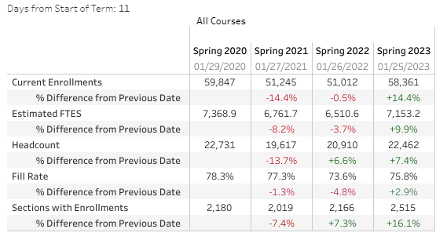  Progress Reports/Starfish | 10 minutes
Ensure Learning: Grace and Christie | 15 minutes
Pathway Spring Goals: All | 20 minutes

