Guided Pathways Strategies (GPS)
Faculty Leads Meeting
November 21, 2022
12:00 pm CC 233

Agenda
Attendees

Set Notetaker  Review Minutes | 5 minutes
Chair Report: Grace and Jessica  Enrollments  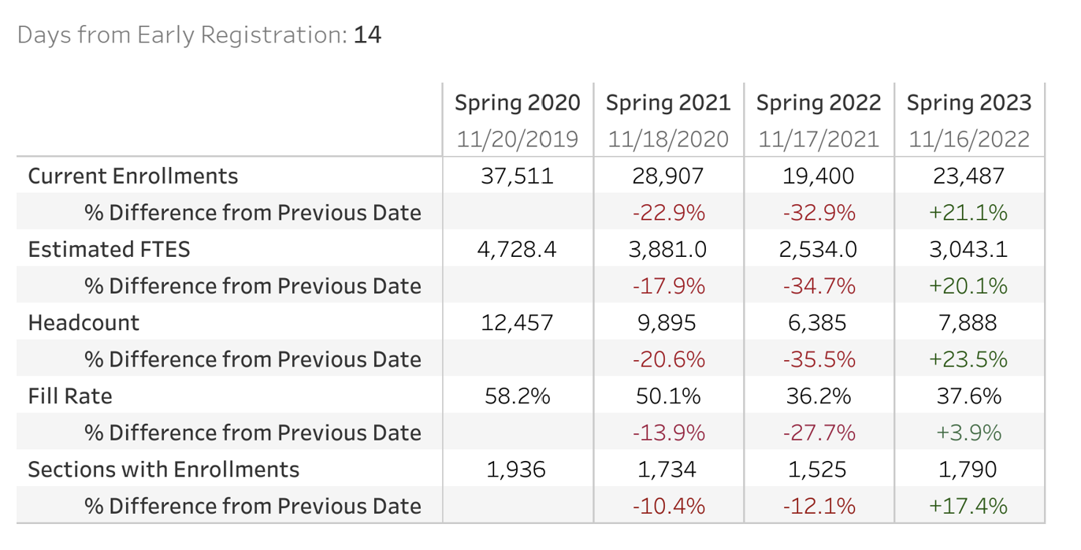  Progress Reports/Starfish | 10 minutes
Pathway Program Mapper Update Meeting How To  Anna and Jessica | 10 minutes
ACH Course Combinations: Helen | 10 minutes
Pathway Report Out: All | 15 minutes

