Faculty Chairs & Directors Council
September 23, 2022 8:30 a.m. – 10:30 a.m. Campus Center Ballroom (West)
https://committees.kccd.edu/bc/committee/fcdc

- VPI Updates

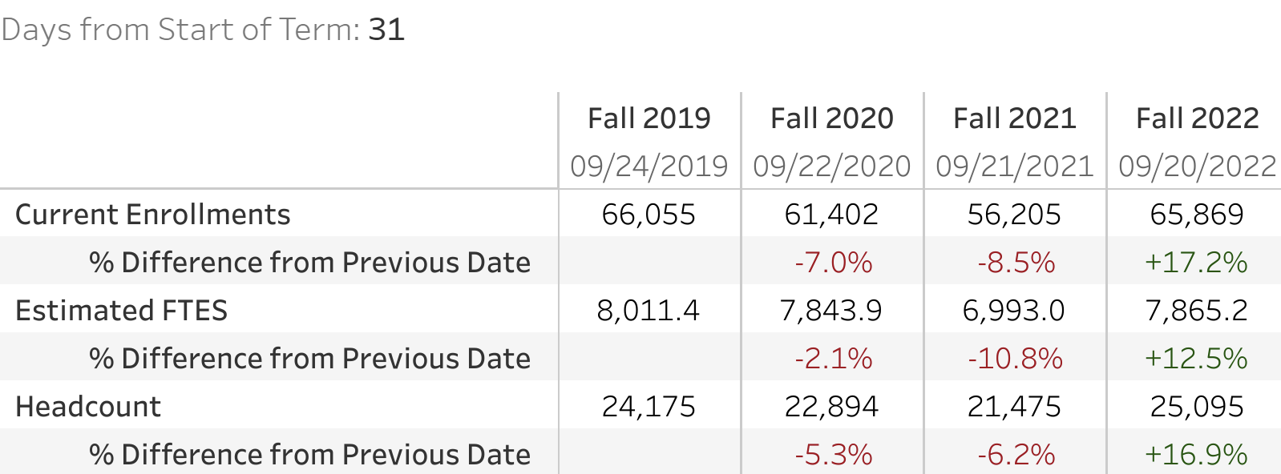

- AIQ: Institution Set Standards – Stratton & Wojtysiak

- Renegades Persist! – Acosta, Lohmann & Farley

- Finish-in-4 Convening – Wojtysiak

- Outreach Updates – Ward

- Diverse Faculty Fellowship – Wright

- College Council Report – Stratton & Loken

