Faculty Chairs & Directors Council
May 5, 2021 2:30 p.m. – 4:00 p.m. Zoom
https://committees.kccd.edu/bc/committee/fcdc

Completion Agenda

- VPI Update – Rice

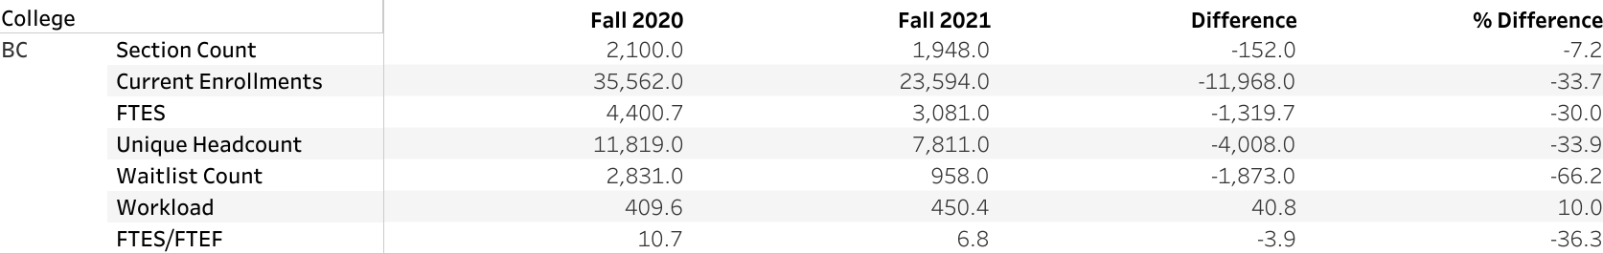

- College Council Report – Stratton & Baltis

- Ad Astra Training – Mourtzanos & Moseley

- Competency Based Education – Johnson & Menchaca

- Bookstore Advisory Committee Update – McNellis & Thorson

- Distrcitwide Accessibility Update – Jones & Thorson

