Faculty Chairs & Directors Council
April 7, 2021 2:30 p.m. – 4:00 p.m. Zoom
https://committees.kccd.edu/bc/committee/fcdc

Completion Agenda

- VPSA Update – Dadabhoy

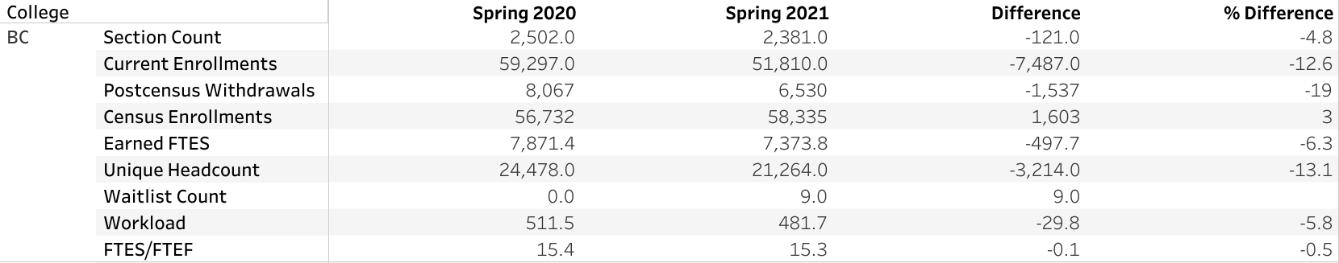

- Program Pathway Mapper Update – Menchaca & Hayward

- Graduation Rates – Pena & Hayward

- SLO Completion Dashboard – Wilson & Larkin

- College Council Report – Stratton & Baltis

