Faculty Chairs & Directors Council
April 22, 2022 10:30 a.m. – 12:00 p.m. CC Ballroom
https://committees.kccd.edu/bc/committee/fcdc

- Facilitator – Jessica Wojtysiak

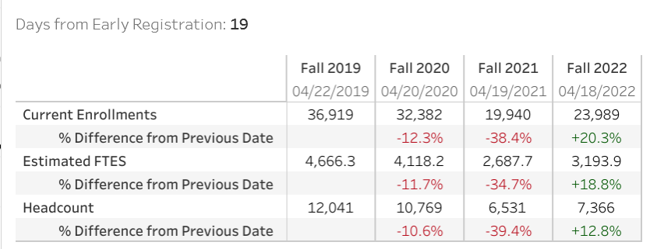

- College Council – Stratton & Baltis

- 22-23 Program Maps with AB705 – Menchaca

- GE Competency Based Education Competencies – Melby & Menchaca

- Action Research Fellowship – Rockey

- Graduation – Smith & Scott

- Covid-19 Response Team – Collom & Thoms

