Faculty Chairs & Directors Council
April 1, 2022 8:00 a.m. – 9:30 a.m. Levan Center
https://committees.kccd.edu/bc/committee/fcdc

- VPID Update – Moseley

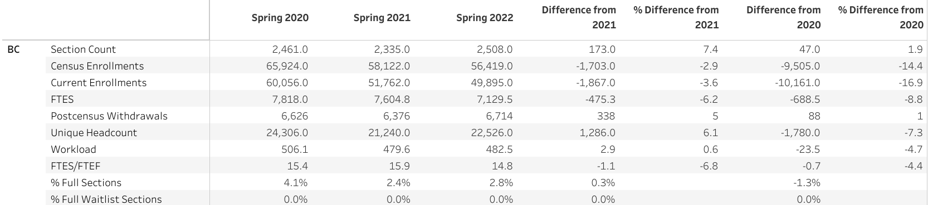

- College Council – Stratton & Baltis

- Strategic Investment Proposal – Moseley & Rice

- Graduation Increase Initiative – Marquez, Smith, Hall, Perlado & Valdez

- Hyflex Classrooms/Meeting Spaces – Rockey & Moseley

- Graduation – Smith & Scott

- Covid-19 Response Team – Collom & Thoms

