Faculty Chairs & Directors Council
March 3, 2021 2:30 p.m. – 4:00 p.m. Zoom
https://committees.kccd.edu/bc/committee/fcdc

Completion Agenda

- VPI Update – Rice

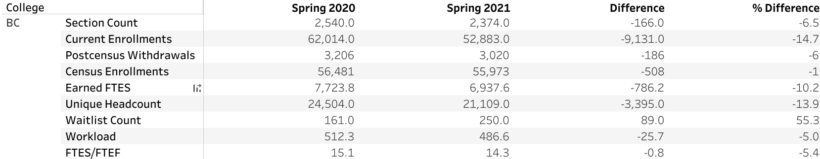

- College Council Report – Stratton & Baltis

- Competency Based Education – Johnson & Menchaca

- Spring 2021 Flex Week Report/Fall 2021 Planning – Rivers

- Guided Pathways: Connecting with Students – Commiso & Melby

- BC Access to Electronic Resources – Achan & Damania

- Person Up Expansion – Rockey & Moseley

