Faculty Chairs & Directors Council
March 18, 2022 8:00 a.m. – 9:30 a.m. Levan Center
https://committees.kccd.edu/bc/committee/fcdc

- VPI Update – Rice

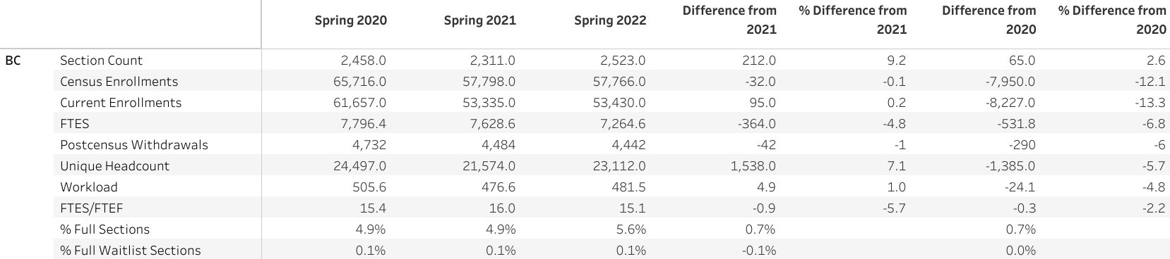

- Dual Enrollment Quality Assurance Update – Saldivar, Campbell & Jett

- Program Review – Nickell, Rabe & Waller

- Regional Collaboration – Cordova

- Community Engagement – Baltis & Moseley

- Graduation – Smith & Scott

- Covid-19 Response Team – Collom & Tohms

