Faculty Chairs & Directors Council
March 17, 2021 2:30 p.m. – 4:00 p.m. Zoom
https://committees.kccd.edu/bc/committee/fcdc

Completion Agenda

- VPI Update – Rice

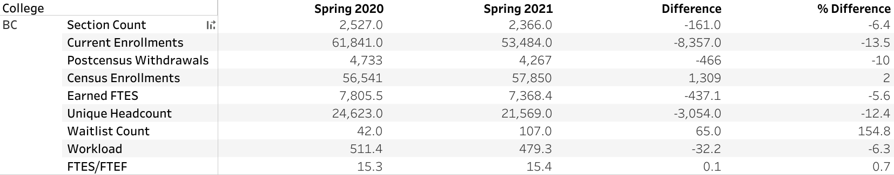

- College Council Report – Stratton & Baltis

- Renegade Leaders Update – Johnson

- NC Course Grades – Menchaca & Moseley

- ConferZoom Recordings – Rivers

- Updates to the 21-22 Program Review Cycle– Nickel, Rabe,& McCrow

- Campus Return Instruction Team Discussions – Loken, Zoller & McCrow

