Faculty Chairs & Directors Council
February 4, 2022 8:00 a.m. – 9:30 a.m. Zoom
https://committees.kccd.edu/bc/committee/fcdc

- VPI Update - Rice

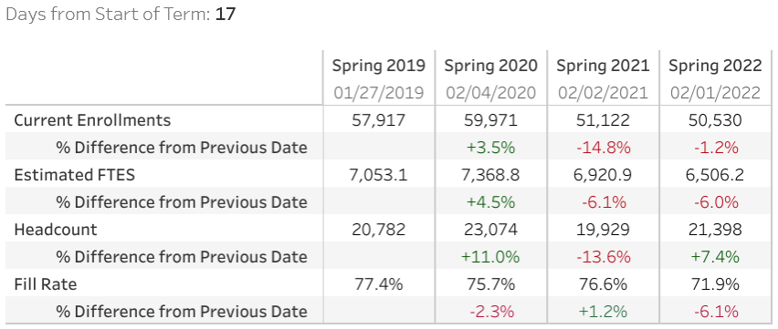

- College Council Report – Stratton & Baltis

- AB927/ Baccalaureate – Dixon, Waller & Moseley

- Banner 9 Updates - Smith

- Covid Data at BC – Moseley

- Covid-19 Response Team – Collom & Damania

