Faculty Chairs & Directors Council
February 3, 2021 2:30 p.m. – 4:00 p.m. Zoom
https://committees.kccd.edu/bc/committee/fcdc

Completion Agenda

- VPI Update – Rice
  - College Council Rep
  - Vaccination clinic
  - Scheduling Updates
  - Load banking form

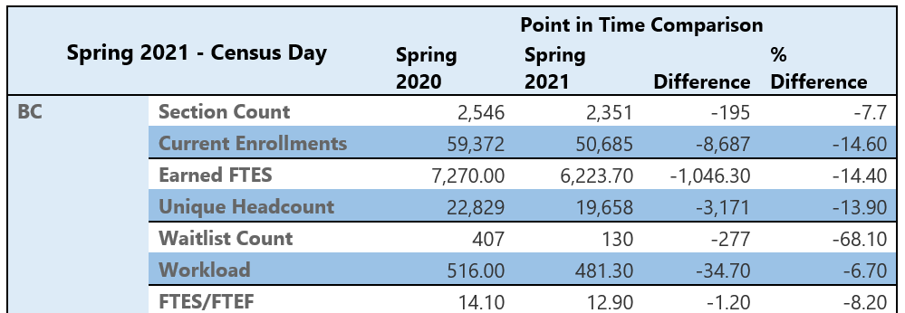

- Progress on UC Merced 2+2 Curriculum Mapping - Hayward & McGarrah

- Admissions & Records Forms – Pena & Lau

- Inmate Scholars Program – Mourtzanos & Hirayama

- College Council Report – Stratton

