Faculty Chairs & Directors Council
February 17, 2021 2:30 p.m. – 4:00 p.m. Zoom
https://committees.kccd.edu/bc/committee/fcdc

Completion Agenda

- VPI Update – Rice

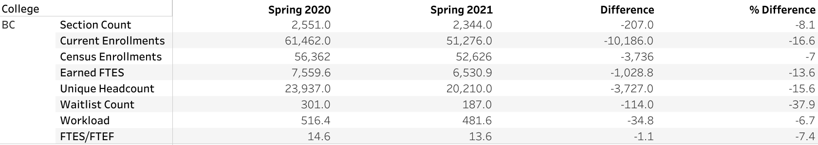

- College Council Report – Stratton & Baltis

- Competency Based Education – Johnson, Menchaca, & Wojtyzsiak

- Enrollment Management: Ad Astra Training – Moseley & Mourtzanos

- Work Experience – Baltazar

- LinkedIn Learning – Rodriguez & Baltazar

