Faculty Chairs & Directors Council
December 9, 2022 8:30 a.m. – 10:00 a.m. Campus Center Ballroom (East)
https://committees.kccd.edu/bc/committee/fcdc

- VPI Updates
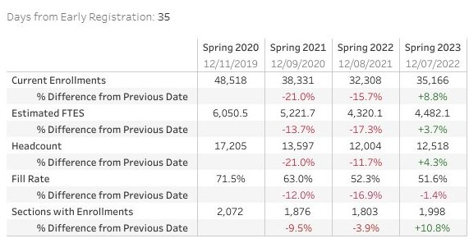

- HyFlex Classrooms – Jones, Rivers, Rabe, Rockey

- Dual Enrollment Course Review Implementation – Rice

- Scheduling – McCauley, Wojtysiak

- Title 5 Changes to Excused Withdrawal – Wojtysiak

- Spring FCDC Academy – Rice

- College Council – Loken, Stratton

