Faculty Chairs & Directors Council
November 18, 2022 10:30 a.m. – 12:00 p.m. Campus Center Ballroom (East)
https://committees.kccd.edu/bc/committee/fcdc

- VPI Updates

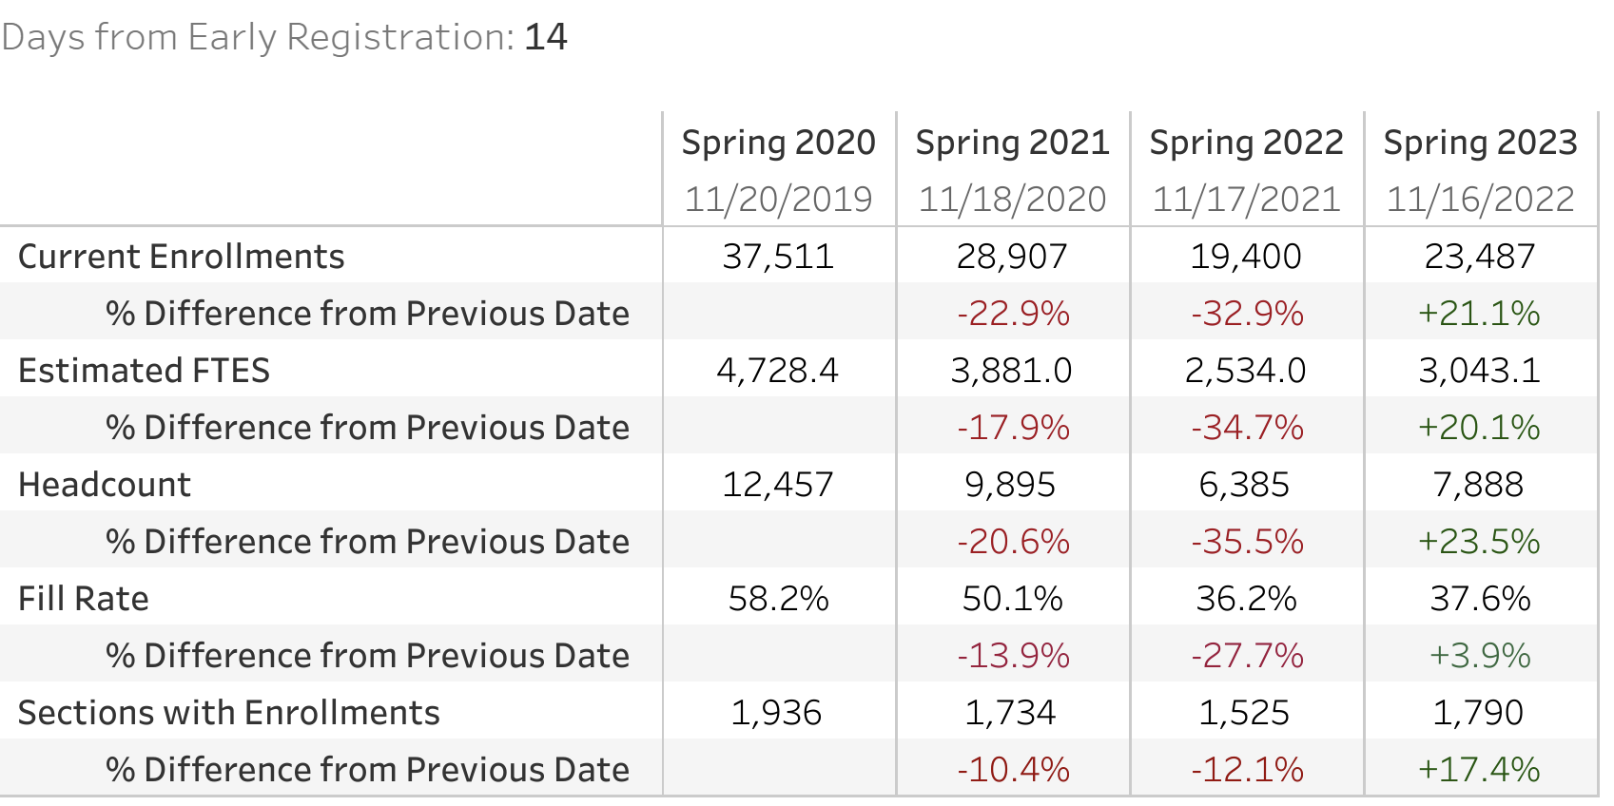

- 23-24 Faculty Voting Results

- Summer/Fall Scheduling

- College Council - Loken

