Faculty Chairs & Directors Council
October 14, 2022 8:30 a.m. – 10:30 a.m. Campus Center Ballroom (East)
https://committees.kccd.edu/bc/committee/fcdc

- VPI Updates

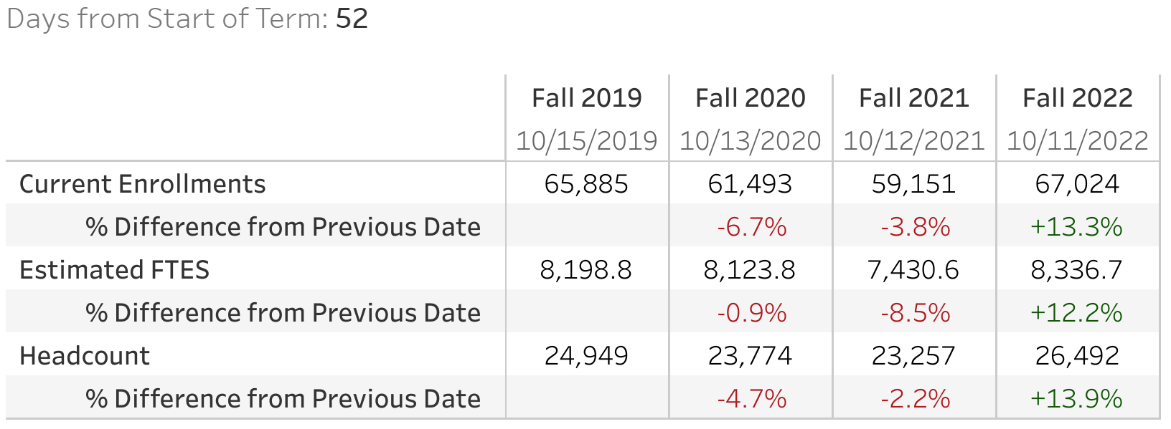

- Student Equity Plan 2.0 – Simos Valdez & Kim

- Financial Aid Presentation – Achan

- ZTC & OER – Rivers, Bradham & Howell

- Program Review Dashboard Data – Stallworth & Farley

