Faculty Chairs & Directors Council
October 1, 2021 8:00 a.m. – 9:30 a.m. Zoom
https://committees.kccd.edu/bc/committee/fcdc

- VPI Update – Rice

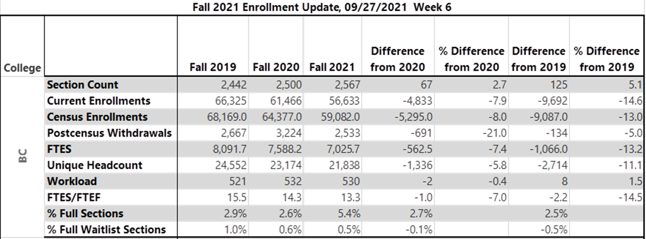

- SCFF Presentation – Giacomini & Mourtzanos

- Enrollment Management Committee – Moreland, Acosta & Wojtysiak

- Meet the Faculty Mentors – Rockey & Skipper

- Booksote Committee – McNellis & Jett

- College Council Report – Stratton & Baltis

- Covid 19 Response Team – Johnson & Damania

