Faculty Chairs & Directors Council
January 20, 2021 2:30 p.m. – 4:00 p.m. Zoom
https://committees.kccd.edu/bc/committee/fcdc

Completion Agenda

- VPI Update – Rice
  - Scheduling Updates
  - 21-22 Faculty Hiring Update

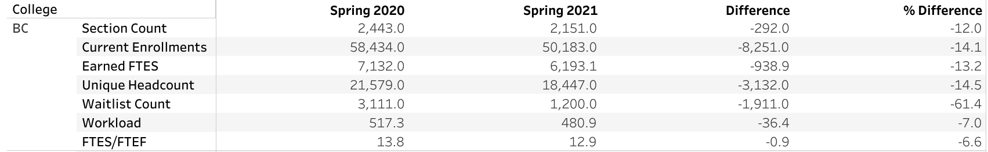

- Enrollment Management: Ad Astra – Moseley & Mourtzanos

- Covid-19 Team – Collier, Balderrama & Harris

- PSYC B61NC Resilience Skills Training – Acosta & Reiss

- Adobe Sign – Waller

- Competency Based Education – Johnson & Menchaca

- College Council Report – Stratton

