Mission Statement
Porterville College Mission Statement:

With students as our focus, Porterville College provides our local and diverse communities quality education that promotes intellectual curiosity, personal growth, and lifelong learning, while preparing students for career and academic success.

In support of our values and philosophy, Porterville College will:

- Provide quality academic programs to all students who are capable of benefiting from community college instruction.
- Provide comprehensive support services to help students achieve their personal, career and academic potential.
- Prepare students for transfer and success at four-year institutions.
- Provide courses and training to prepare students for employment or to enhance skills within their current careers.
- Provide developmental education to students who need to enhance their knowledge and understanding of basic skills.
- Recognize student achievement through awarding degrees, certificates, grants, and scholarships.

Program Mission Statement:

The mission of the Fine and Applied Arts Division arises from the premise that the arts and other forms of communication are integral to human society and that creativity, imagination, expression, and interpersonal communication are defining, essential human attributes. The Fine and Applied Arts Division prepares students for a culturally complex world by training them to think critically about visual, verbal, and musical information in their lives. Through studio, performance, and lecture courses, we foster in our students the creativity, communication skills, problem-solving abilities, and cultural appreciation necessary for personal, economic, and academic success.
SLOs, Program Analysis, Goals (Grouped By Discipline)

Discipline: ART

SLOs

The Art department offers both an Associate in Arts Degree in Commercial Art and an Associate in Arts Degree for Transfer in Studio Art.

Program Learning Outcomes:

Commercial Art Associate in Arts Degree
- Use a variety of techniques in various media to construct engaging and dynamic layouts and illustrations by applying the principles of design to the concept and components of the projects.
- Apply a range of approaches to using typography in projects.
- Identify the elements of good storytelling and apply these elements to his/her illustrations and designs.
- Describe, deconstruct, and evaluate contemporary and historical examples of illustrations and layouts for their purposes and use of visual language.
- Create an original design or illustration for a specific client or audience by applying the creative process of research, brainstorm, refinement, critique, and finished project.
- Assemble a portfolio of finished drawings, paintings, illustrations, digital media, and graphic designs that exhibit the technical skills and artistic vision necessary for entry-level work in illustration and graphic design.

All the Commercial Art AA Program Learning Outcomes (PLOs) have gone through one cycle of assessment. These PLOs are assessed using the Student Learning Outcomes (SLOs) from the individual courses in the degree. The course SLOs are all on assessment cycles as well (most courses having gone through several cycles of assessment), with the results used to make improvements in the teaching of the courses. Based on analysis of PLOs assessed for the Commercial Art AA program and discussion with colleagues, revisions to most of the program’s PLOs have occurred. These revisions occurred in 2018-19. The revisions have led to a revised, new assessment timeline (see below). The assessments outlined in this new timeline (which starts this year) will be assessed in the next program review.

PLO Assessment Mapping & Timeline:
Program Learning Outcomes  (Revised PLOs 2/12/19) | 1st Year (2022-23) |  |  | 2nd Year (2023-24) |  |  |  | 3rd Year (2024-25) |  |  |  | 4th Year (2025-26)
 | Course Outcomes from the Courses Below |  |  | Course Outcomes from the Courses Below |  |  |  | Course Outcomes from the Courses Below |  |  |  | Course Outcomes from the Courses Below
1. | ART 106 | CMRT  102 | CMRT 103
2. | ART 106 | CGRA  110 | CMRT 102
3. |  |  |  | ART 117 | ART 119 | CMRT 103 | PHOT 101
4. |  |  |  |  |  |  |  | ART 106 | ART 114 | ART 116 | PHOT 103
5. |  |  |  |  |  |  |  | CGRA 111 | CMRT 102 | CMRT 103
6. |  |  |  |  |  |  |  |  |  |  |  | CGRA 112 | ART  103 | ART  116 | ART  124

Studio Art Associate in Arts Transfer Degree
- Create basic 2-D, 3-D, and digital art projects.
- Use drawing, painting, sculpture, photography, and digital arts to generate ideas, solve visual problems, and enhance perception.
- Recognize, describe, analyze, and employ the visual language inherent in all art forms and visual media.
- Identify and describe the historical and cultural contexts of works of art in order to evaluate the relationship between works of art and their time and culture.
- Assess the role of the visual arts in contemporary culture as a vehicle of human expression in order to recognize, evaluate, and value that creative impulse in their own lives.

All the Studio Art AA-T PLOs have also gone through one cycle of assessment. These PLOs are assessed using the Student Learning Outcomes (SLOs) from the individual courses in the degree. The course SLOs are all on assessment cycles as well, with the results used to make improvements in the teaching of the courses for the degree. Assessments from the current timeline are ongoing (see below).

PLO Assessment Mapping & Timeline:
Program Learning Outcomes | 1st Year (2019-20) |  |  |  | 2nd Year (2020-21) |  |  | 3rd Year (2021-22) |  |  | 4th Year (2022-23)
 | Course Outcomes from the Courses Below |  |  |  | Course Outcomes from the Courses Below |  |  | Course Outcomes from the Courses Below |  |  | Course Outcomes from the Courses Below
1. | ART 103 | ART 123 | CGRA 110
2. | ART 106 | ART 116 | ART 124 | PHOT 101
3. |  |  |  |  | ART 106 | ART 107
4. |  |  |  |  |  |  |  | ART 113
5. |  |  |  |  |  |  |  |  |  |  | ART 114

As an example of an assessment for the Studio Art AA-T, PLO #4—Identify and describe the historical and cultural context of works of art in order to evaluate the relationship between works of art and their time and culture—was assessed using data from SLO #2—Analyze, discuss, and differentiate works of art and architecture in terms of historical context and cultural values—from ART P113 (CRN: 70050) for the Fall 2021 semester.

This course outcome assessment, which is also aligned with the program learning outcome, was conducted using the second essay question for the final exam for the course. A rubric was used for the scoring of this essay. 28 students attempted the assessment. 24 students passed the assessment with a 70% or higher score. In other words, 86% of the students succeeded with a 70% or higher score. This result compares to a success rate of 73% (where 27 of 37 students passed the assessment with a 70% or higher score) for the assessment of the same SLO in ART P113 from 2017 (4 years ago). Changes in teaching methods as a result of this earlier assessment were: to provide more frequent feedback on their reading assignments (focusing on comprehension) and to integrate the same type of analysis in the SLO into more class activities and assignments.

After this latest assessment of SLO #2 and after discussion with other faculty, it seemed that, because of the success rate, little change was needed. Though, minor changes to teaching the material might be worthwhile, such as to refine current methods rather than to overhaul these methods; for example, working to integrate the above SLO into even more class activities and assignments (including, more frequent modeling of this type of analyses with more of the artworks discussed in class).
It was agreed that the assessment clearly addressed and measured the outcome for the course.
It was also agreed that the course outcome assessment assuredly assessed the program learning assessment as well, and that PLO #4 is still an essential outcome for the Studio Art AA-T degree and currently doesn’t need revision.
The above discussed changes to teaching methods will be implemented the next time this course is offered in Fall of 2022.
The next time this course outcome and program learning outcome will be assessed will be in 2025.

Program Analysis and Trends

Changes in Program Over the Last Three Years

Diran Lyons was hired in 2019 as full-time faculty in the art program to replace the position left vacant since 2010 by the retirement of Daryl Nelson. His training and experience working with a variety of media is an asset to our diverse program, but especially his expertise in video has been utilized in the writing of the curriculum for two new courses in video production and the creation of a new certificate in this area. CGRA P113 Digital Video Production and CGRA P114 Advanced Video Production will be added to the Fall 2022 schedule. We are also adding the CGRA P113 course to the Commercial Art AA. This course is also needed for the purpose of collaborating with Monache High School and the PUSD Pathways, which has been identified as a goal in the 2016 and 2019 Fine and Applied Arts program reviews.

The other 18 courses in the Art program and the Studio Art AA-T have not changed in the last three years.

To accommodate the video production course and potential new courses in the future (the curriculum for a second course is being planned), the art program is in the process of converting the darkroom into a video production studio/lab. Planning for the conversion began in 2016 when the photography classes became fully digital and no longer taught darkroom techniques. Video equipment has also been purchased for this new program.

The Art Program now has two full-time faculty members (with the hired position in 2019) and three adjunct instructors.

Data Review
https://www.kccd.edu/institutional-research/reports/subject-1

 |  | 2016-17 | 2017-18 | 2018-19 | 2019-20 | 2020-21
Enrollment at Census (Page 2) |  | 695 | 629 | 755 | 829 | 821
Number of Course Sections |  | 22 | 23 | 26 | 29 | 33
Avg. number of students per section |  | 31.6 | 27.3 | 29.0 | 28.6 | 24.9
First Day Waitlist (Page 2) |  | 60 | 99 | 119 | 150 | 96
FTEF | TOTAL | 6.4 | 6.5 | 7.2 | 7.5 | 8.1
 | Full-Time | 1.999 | 2.066 | 1.865 | 4.000 | 3.998
 | Overload | 0.267 | 0.133 | 0.200 | 0.668 | 0.866
 | Adjunct | 3.797 | 3.997 | 4.797 | 2.532 | 2.532
 | Summer | 0.333 | 0.333 | 0.333 | 0.333 | 0.733
FTES (Page 2) |  | 99.55 | 86 | 103.02 | 113 | 104
Degrees & Certificates (Page 4)  Studio Art AA-T  Commercial Art AA  Liberal Arts and Humanities AA |  | 5  1  42 | 2  5  66 | 10  5  113 | 8  2  136 | 9  4  76
Student Retention &Success Rates  Art Courses  Porterville College Courses  (From KCCD Program Review Course Success Dashboard) |  | 89% and 78%  89% and 73% | 93% and 84%  90% and 74% | 92% and 83%  91% and 77% | 89% and 80%  88% and 74% | 87% and 73%  89% and 73%

Enrollment Data
The Art program has shown growth in enrollment over the past five years of 695 students in 2016-17 to 821 students in 2020-21 and growth in the number of course sections offered from 22 in 2016-17 to 33 in 2020-21. The number of students per section has stayed fairly constant for the first 4 of the last 5 years with an average of 28.3 students per section for 5 years. The 5th year shows a modest reversal in the upward trend in enrollment (likely due to the effects of Covid-19 on enrollment) and a drop to 24.9 students per section, likely, because of a lag in planning for the effects of Covid-19 on enrollment due to the 6 month earlier scheduling of classes.

Awards
The number of degrees awarded in the Art program (totaling Studio Art AA-T and Commercial Art AA degrees) has shown growth over the last 5 years, as well, with 10.2 total degrees the average and 13 total degrees for the most recent year (2020-21).

Retention and Success Rates
Student retention over the last 5 years in the Art program is somewhat better than for the College as a whole, averaging 90% retention versus 89.4% retention for the college as a whole (though showing a modest drop to 87% in 2020-21, possibly related to the effects of Covid-19). Success rates over the last 5 years in the Art program are higher than the college as a whole, averaging 79.6% success versus 74.2% success for the college as a whole. However, the success rates in the Art program dropped significantly to 73% versus the 5-year average of 79.6% (possibly related to the effects of Covid-19, as well).

Program Strengths

The Art program offers 2 degrees and 18 courses in our area (and in Fall 2022, we will offer an additional course in Video Production and a Video Production certificate). The degrees are the Studio Art AA-T (a transfer degree) and Commercial Art AA (a local degree where students acquire video production and digital photography skills, and illustration, including 2D animation, and graphic design skills and knowledge, including computer graphics literacy). Our department also shares a Liberal Arts: Arts and Humanities AA with the Music, Language Arts, History, Communication, and Philosophy programs.

We have been seeing growth in enrollment in our courses (though in 2020-21 we are seeing a modest drop in enrollment, most likely because of Covid-19), growth in the number of sections of Art courses offered, and growth in the number of degrees awarded in the Studio Art and Commercial Art programs.

The student Art Club has continued to be active during this period until the suspension of in-person activities because of Covid-19. The club has been active in Art program activities (such as working on and participating in the annual student art exhibition) and community and campus projects and activities.

As an important pedagogical tool for the Art program, there has been a full calendar of PC Art Gallery exhibitions from local and regional artists (though interrupted for over a year because of a suspension of in-person activities do to Covid-19, the in-person exhibitions did resume Fall 2021), along with the annual exhibition of student art (also interrupted in-person but continuing as a virtual exhibition online during Covid-19).

Art professor Jim Entz took on the role of Coordinator for the college-wide Cultural and Historical Awareness Program (C.H.A.P.) in 2021, bringing a series of events and guest speakers to campus each year. He is Gallery Director for the Porterville College Art Gallery, putting on exhibitions of local and regional artists. He, also, has had periodic solo and group exhibitions at Fig Tree Gallery in Fresno and at other regional and local venues.

Art Professor Diran Lyons has developed the curriculum for and taught courses in video production at CSU Fresno and Reedley College and is a professional videographer with extensive exhibition experience, YouTube presence, and published scholarly articles in the field. Recent scholarship and publications include the essay, “Embracing Creative Transience: From Political Remix Video to Digital Collage.” A paper for the special issue on Forking Paths in New Media Art Practices: Investigating Remix. Media-N Journal of the New Media Caucus. 2021. Also, Notes and Narratives collage work featured in Studio Visit Magazine (pp 113-116). April 2021. Lyons’ work was also featured in critical writing by Dr. Colin Gardner in the following monographs: Redefining M.A.G.A. in Diran Lyons’ Notes and Narratives (2021). Land Art as Political Remix: Diran Lyons’ Suprahistorical Ecosophy with No Known Name (2021). Bankrupting the ‘Accountant’s Truth’: Petroglyphs as Critical Remix in Diran Lyons’ Oil and War (2021). The Splitting Image: The Mise en Abyme as Time-Image in Diran Lyons’ ‘To Infinity’ (2021). On Political Remix Video: An Interview with Dr. Colin Gardner (2013). Affirming the Creative Lie: Diran Lyons and the Will to Deception (2008). Lyons has given the artist lectures, Critical Responses with Political Remix Video and Digital Collage, on March 23, 2021, at the University of Western Australia. Perth, Australia. ARTF2021: Cinematic Spaces, and The Creative Lie: ENGULFED, No Known Name, and Notes and Narratives on October 9, 2020, at CSU, Fresno for Art 101 Content and Form, Art Theory course. Lyons recent exhibitions have included, Shadows of the Giants, Solo Exhibition at Kathy Sacks Art Gallery, Bethel University, McKenzie, TN. April 2022. Shadows of the Giants, Solo exhibition at Corridor 2122 Gallery, Fresno, CA. June 2022. Notes and Narratives, Solo exhibition at Porterville College Art Gallery. Nov 2019. Solo exhibition at Corridor 2122 Gallery in Fresno, CA. June 2019. EASE: Finding One’s Place, a group exhibition at Spectrum Art Gallery, Fresno, CA. August 2021. Drive By, a group exhibition at M Street Art Complex, Fresno, CA. May 2021. Pandemical, a group art exhibition with CSU, Fresno. Oct 2020.

Adjunct instructors Glen Hill, Edwin Macaraeg, and Thomas Howell are practicing artists as well, who exhibit their artwork at various venues, locally and regionally.

Areas for Improvement

Aging facilities are a continuing problem in our program area with the Fine Arts Building, and the Art Gallery, arguably, the oldest buildings on campus. Since the last program review where aging facilities were highlighted as a problem area in our program, there has been little to no renovations or upgrades to these aging facilities. Students have been aware for some time of the lower quality of these facilities (these buildings house mostly studio/lab, lecture, and exhibition spaces—see #19 in the following survey) as compared to those others across campus. The following student survey reveals little growth in improvement over the course of the survey period as barely more than half of the students feel these facilities are “excellent” or “good”. All the other facilities across campus have shown real improvement in the students’ assessment of their quality as seen below.

2018 Student Satisfaction Survey Report (there is no more recent report at this point in time)
There are four questions on facilities and all four showed improvement over the course of the survey period. [Though question #19 shows only a very small improvement, well below the degree of improvement in the other areas.]

Facilities (% who answered 'excellent' or 'good' for each question)

 | 8. Classroom facilities | 9. Computer labs | 18. Science lab facilities | 19. Studio & practice facilities (art, music, sports)
2007  2009  2012  2015  2018 | 59.6%  61.3%  69.0%  67.6%  74.9% | 68.5%  75.9%  86.9%  83.0%  85.5% | 58.2%  63.0%  64.8%  68.4%  70.3% | 51.3%  48.4%  57.1%  58.0%  55.6%

Our facilities are inadequate for handling current growth (even with the modest declines in enrollment in the Art program due to Covid-19) and inadequate for handling future growth projections.

The Fine Arts building, and Art Gallery are outdated and inadequate for the current needs of our students.

Note: The planned conversion of the darkroom into a video studio/lab for our upcoming new Video Production class (as the first of several classes in this new program) is one bright light in the otherwise mostly dim picture of our aging Art facilities that our students’ find deficient compared to facilities in the rest of the campus (according to Student Satisfaction Surveys).

A new art faculty member would address the growth, challenges, and changes the Fine Art department is experiencing. ART P101 Art Studio Fundamentals (ASF) courses continue to have sizable waitlists each semester. Due to a lack of personnel and the challenge of finding qualified and available adjunct faculty in art, we are not able to offer new sections of ASF. Each semester both full-time faculty members have been overloaded and all our adjunct instructors have full teaching loads. With the Video Production program scheduled to launch in Fall 2022, one of the full-time faculty will concentrate his teaching load in that new area. Consequently, the courses he teaches in ASF will be left vacant and need to be filled. The new art faculty position will remedy this problem and enable further growth. And if this faculty member also has expertise in 3D Animation, it would allow us to accomplish Goal #2 as well. There are enough art courses in the current schedule to hire 2 additional full-time faculty. We are only asking for one art faculty member
Goals (All goals for the Art department start with the letter “A”)

Goal A1: More Closely Align with PUSD Pathway with Video Production curriculum (ongoing) | Comments:  This goal is to align our Commercial Art program more closely with the Digital Design and Communications and Multimedia and Technology PUSD “Pathways” by continuing to offer photography courses and by creating and adding a Video Production class to the schedule.  The adding of the newly created Video Production class to the Fall 2022 schedule, the creation of the new Video Production Certificate, and the recent purchase of video equipment for the program will help us to achieve Goal 1. A classroom studio dedicated to video production is one element remaining that we are working on (Spring 2022) to provide an environment for video production where students will have all the tools available to create the highest quality work. This dedicated space for video filmmaking will provide areas that are devoted exclusively to green screen activity and formal interviews, an area that can be isolated for audio recording, and finally, room for a number of computer editing stations with enough space to properly accommodate large video monitors (which make it easier for collaborative teams to work together.
Timeline: Summer 2020 – Fall 2022
Needed Resources: Current staffing levels are adequate but would need to add one more class to the schedule.
Person(s) Responsible: Art Faculty
Obstacles (if any):
Goal A2: Clarify & improve marketing of Art programs (ongoing) | Comments:  This goal is to Clarify and publicize the pathways to completion of Studio Art and Commercial Art Degrees. Offer a Studio Art Certificate of Achievement as a stepping-stone to the AA-T. Included in this goal is the addition of a Commercial Art Video Production Certificate (a steppingstone to the Commercial Art AA—or a standalone record of the skills required for jobs in the field).  The number of degree completers for our two Art degrees has lagged the growth in majors for these two degree programs. We are working on ways to clarify and publicize the pathways to the completion of the two degrees in our program in order to increase the number of degree completers. We are working on offering a Studio Art Certificate of Achievement (18 units) as a stepping-stone toward the completion of a Studio Art AA-T (24 units). Commercial Art/Video Production Certificate is ready to be offered in the Fall of 2022. So, this goal will be partially complete by the Fall Semester of 2022.
Timeline: Since Fall 2019 & Ongoing
Needed Resources:
Person(s) Responsible: Art Faculty
Obstacles (if any):
Goal A3: More closely align with PUSD Pathway with Digital Animation curriculum (new) | Comments:  This goal is to align our Commercial Art program more closely with the Digital Design and Communications and Multimedia and Technology PUSD “Pathways” by creating an animation computer graphics course. The course will utilize software from the Adobe Creative Suite). Provide staffing for the course.  To better align our Commercial Art program with the Digital Design and Communications and Multimedia and Technology PUSD “Pathways” Programs, the Art program should offer a course or courses in Computer Graphic Animation: the creation of an animation course or courses and the hiring of an Adjunct or Full-Time Instructor to teach the course or courses, along with other digital media courses, would meet the needs of more graduating high school area students who are following these “Pathways.
Timeline: Fall 2024
Needed Resources:
Person(s) Responsible: Art Faculty
Obstacles (if any): Locating a qualified Adjunct or Full-time Instructor.

Discipline: COMM & DRAMA
SLOs

We offer both a Certificate of Achievement as well as an Associate of Arts for Transfer in Communication Studies.
Program Learning Outcomes
- Construct and deliver a presentation with communicative competence and confidence.
- Demonstrate the dynamics of effective communication in a variety of settings and contexts.
- Also demonstrate General Education Learning Outcomes (GELOs) for the school. [Students will read, write, speak, and listen effectively.]

*NOTE: Students who earn a Certificate only need to demonstrate the first two (1 & 2)

PLO Assessment Mapping:
PLO # | Assessed by: | Course | cSLO #
1 |  | COMM 101 | 2
 |  | COMM 102 | 2
 |  | COMM 103 | 2
 |  | COMM 105 | 1
 |  | COMM 140 | 2
 |  | COMM 170 | 3
2 |  | COMM 101 | 2
 |  | COMM 102 | 2
 |  | COMM 103 | 2
 |  | COMM 105 | 6
 |  | COMM 140 | 4
 |  | COMM 170 | 3,5

The PLO assessment cycle is ongoing, but was put behind by the pandemic, ensuing shutdown, and distance learning. The last assessment was done in 2019, with plans to assess PLO #1 in Spring 2022 with data from randomly selected COMM P101, P102, P103, and P105 courses.

PLO #2 was assessed in 2019. PLO #2 was assessed by using the number of students who earned a “B” or better on an informative speech assignment in 3 randomly selected sections of COMM P101 and 3 randomly selected sections of COMM P102. A letter grade of “B” would be earned only if each student had constructed an oral presentation that was delivered dynamically, contained competent (college level) content, and an outline typed in APA format.

Across 3 randomly selected sections of COMM P101, results showed that 92 out of 96 students attempted the informative speech. Of those 92, 65 met the standard of demonstrating effective communication (71% earned a “B” or better on the assignment). Across 3 randomly selected sections of COMM P102, results showed that 70 out of 78 total students attempted the assignment. Of those 70, 59 met the standard of demonstrating effective communication (84% earned a “B” or better). The results of this assessment were extremely positive. Moreover, this assessment only calculated its results from students who performed at a higher standard: “B” or better.

While the results of the assessment were positive, the Communication faculty are developing ways to increase student success on PLO #2. First, faculty are curious about reasons why there was a higher success rate in COMM P102 than in COMM P101. Faculty are devising ways to standardize evaluation methods across courses (insofar as it is possible to standardize evaluations).

Course Level Student Learning Outcomes

The course level student learning outcomes have not kept pace with our plan and cycle of assessment since our previous program review. Among other reasons, a primary reason we feel that we have not been able to keep assessing and discussing the CSLOs is due to our overall strategy of looking at one or two CSLOs per class per year. After discussing this moving forward, we have decided that we will accelerate the assessment process by looking at all outcomes for a given course all within the same semester and evaluate them at the start of the subsequent terms.

Program Analysis and Trends

Changes in Program Over the Last Three Years

Since our latest 2019 program review, Mass Communication and Small Group Communication are newly designed courses that have been approved and we are working to integrate them into the schedule. However, due to the ongoing pandemic beginning in the Spring of 2020, our intent to offer new courses in our discipline such as: Nonverbal Communication and Organizational Communication have been halted at this time. It is our hope that when our campus enrollment begins to increase, we can then move forward with our original intent to introduce additional courses.
Despite the Covid 19 pandemic, our main objective for the department continues to focus on more students pursuing and completing their certificates and/or degrees in Communication Studies. One of our newest strategies is to invest more heavily in our dual enrollment partnerships such as our newly developed collaboration Lindsay High School in an effort to build interest and new momentum with potential future students in our discipline to assist in achieving this goal.
Since our last program review, we also have the successfully launched a student organization named “WECOMM” (We Communicate) on campus in the fall of 2021. Active members will be involved in recruitment efforts and we plan to collaborate on a variety of activities such as visiting local high schools in the Porterville service area. They will be informing students about majoring in Communication as well as sharing their experiences attending Porterville College as a whole. We also plan to provide promotional items about the program and the college to high school students.
Finally, we plan to launch our “Goal Mentorship Program” in the spring 2022 semester. This program is designed to offer adjuncts the opportunity to be evaluated each semester by our full-time faculty (in a more informal setting). It is our hope that adjunct instructors take advantage of this opportunity to continue to obtain valuable feedback, grow in their pedagogical practices, and in return – continue to enhance their learning with each of their evaluations to provide our students a richer experience in the classroom.

Data

Communication Studies | 2016-17 | 2017-18 | 2018-19 | 2019-20 | 2020-21 | 5 yr. avg.
Census Enrollment | 1,345 | 1,315 | 1,489 | 1,720 | 1,515 | 1200
Section Count | 43 | 46 | 51 | 63 | 62 | 31
Students Per Section | 31.3 | 28.6 | 29.2 | 27.3 | 24.4 | 31
First Day Waitlist Total | 153 | 58 | 127 | 170 | 50 | 137
FTES | 141.47 | 138.70 | 156.58 | 188.04 | 156.81 | 129.2
FTEF | 8.60 | 9.10 | 10.20 | 12.60 | 12.40 | 7.7
FTES to FTEF Ratio | 16.4 | 15.2 | 15.4 | 14.9 | 12.6 | 16.9
Retention | 90% | 92% | 93% | 88% | 90% | 90%
Success* | 74% | 74% | 82% | 74% | 69% | 75%
Majors | 89 | 78 | 87 | 88 | 67 | 82**
Degrees + Certificates | 24+7=31 | 21+17=38 | 38+18=56 | 38+22=60 | 33+12=45 | 31+15=46
*Excused Withdrawals are not included in these tables (Covid 19 related 2019-2021 years)
** Our previous Program Review 5 Year Average was 74. This is a slight increase

If we look back at our previous program reviews, we can gain a better picture and context for what this most recent data means. The 5-year data from Fall 2013 to Fall 2017 for subject majors in Communication Studies showed a 5-year average of 74 majors with 79 majors in the Fall of 2017 (7% above the average). The 5-year data of degrees and certificates from 2013-14 to 2017-18 for the Communication Studies AA-T showed a yearly growth from 10 to 21 degrees awarded (with 91 degrees awarded in 5 years), for the Communication Studies certificate shows a yearly growth from 7 to 17 certificates awarded (with 78 certificates awarded in 5 years). A noteworthy data point from the 2020-21 academic year showed a slight dip in majors to 57 in total. In addition, the latest 2020-21 program review data shows that we have decreased in both the number of certificates and degrees completed. Like many other disciplines, we feel this is due to the impact of dealing with the COVID-19 in this same time period. This has really impeded the student enrollment in higher institutions all over the country much like we see in our discipline. Despite this reality, our program will continue to find innovative strategies to grow and maintain our success as a discipline in the FA Division.

Program Strengths:

Since the last program review, we have realized the projections made in that evaluation in terms of the popularity of the Communication Studies courses and programs. Even through the pandemic, we have continued to maintain a steady number of degree completers. For example, as it indicates in our most current program review, there is an average of 41 major graduates per year in the Communication Studies discipline alone. Our courses continue to offer a wide variety of General Education opportunities to all students on campus whether pursuing a local degree or intending to transfer to a 4-year school.

Areas for Improvement:

The following are a condensed set of summaries on areas for improvement along with notations about which of our goals we have identified to address these areas.

- Reduce Communication class size from 35 to 30 per section (See Goal C1)

We are concerned about the large size of the Public Speaking classes.
As an example, CSU’s typically accept that approximately 30 minutes of total presentation time in class should be allocated for each student per semester.

- Promotion/Identity/Recruitment (See Goal C3)

Starting in spring 2022, we will invest in new promotional items (e.g. flyers, posters, banners, etc.). Our vision is to have posters in the CA building that identify the exact courses that are needed to obtain a certificate or degree in Communication Studies from our institution.

- Increase Adjunct Support: (See Goal C4)

Similar to the data in our last program review, we are continuing to move forward with additional support for our adjunct faculty. As a department, we can improve in providing part-time instructors the opportunity to join certain committees on campus, continue to provide and promote a space for them on campus to hold office hours with their students, and provide our part-time instructors an opportunity to be evaluated in a more informal environment.

- An Increase in Online Courses Offered: (See Goal C2)

With the onset of COVID-19: staff, administration, faculty, and above all, our students, have had to make drastic adjustments to their college experience. However, with these times we have learned how to adjust and continue to find innovative ways to accommodate our students here at Porterville College.

- Greater Diversity in Communication Studies Courses (See Goal C2)

In our last program review in 2019, we planned to develop and introduce new/alternative courses in Communication Studies in order to better serve the growing interest in our discipline and to satisfy more student demand. classes here at our institution – we can then proceed to move forward in getting these courses approved.

Goals (All goals for the Communication Studies department start with the letter “C”)

Goal C1: Reduce Communication class size from 35 to 30 per section (ongoing) | Comments:  While we are enjoying high success rates, we are over-enrolling these courses at noticeably higher levels than other colleges in our discipline. As a consequence, we are continually requiring students to learn more of the content on their own outside of class lecture time in order to accommodate more in-class presentation time. As an example, CSUs typically accept that approximately 30 minutes of total presentation time in class should be allocated for each student per semester. So if you have 38 students vs. 25, then you have 390 fewer minutes of possible class lecture time per semester. That number works out to over 6.5 fewer hours or two weeks of class time. There has been no progress on this issue since the last program review.
Timeline: Fall 2022
Needed Resources: none
Person(s) Responsible: Comm. faculty / Office of Instruction
Obstacles (if any): Agreement from Office of Instruction
Goal C2: Develop new Communication courses including online formats (ongoing) | Comments:  We plan to continue proposing new courses to be rotated into the course offerings in order to allow more student certificate and degree completions and give them a greater ability to customize their course work to suit their goals. Courses that are currently being considered for adding include Nonverbal Communication, Organizational Communication, Drama, and others.  Strategies for achieving Goal #6:  Online Courses  The pandemic created an opportunity for all Fine Arts faculty to develop experience with online courses. Collectively, we have worked on creating synchronous, asynchronous, and hybrid/flex courses, and have experimented with teaching strategies to create the best learning experience for our students. Some courses will permanently be offered online.  Organizational Communication Course  With the understanding that we might not be able to expand our course offerings much more, the Communication Department will look at existing courses from other community colleges in subjects like Interviewing that provide practical skills and could increase the pool of potential Communication Studies students.
Timeline: Fall 2021 & ongoing
Needed Resources: none
Person(s) Responsible: Comm. faculty
Obstacles (if any): Agreement from Office of Instruction
Goal C3: Regain lost enrollments and COMM majors (new) | Comments:  We had a goal of doubling the number of COMM majors in the previous program review but did not achieve that for a number of reasons including the onset of the global Covid 19 pandemic only 1 year in to that previous goal. As such, we looked at our current data and have seen significant drops in both enrollments as well as declared majors.  Strategies for achieving Goal #5:  - More Promotion  We will increase our efforts to promote the Communication Major with both our individual instructor and student “WeComm” club daily contact as well as take advantage of our one semester temporary position that will help with both on and off campus promotion.  Step #1: Pitch communication as a major in Public Speaking/Interpersonal Courses on the 2nd Day of instruction, as an addition to existing discussions about the importance of studying those specific subjects. The pitch will involve a uniform PowerPoint for all COMM. faculty members to discuss the benefits of majoring in Communication. It will also outline the clear path to degree completion, emphasizing how easy it is to double major in Communication. We will update all promotional items (e.g. flyers/banners, posters located in the CA building, PowerPoints that we use to promote our discipline) with an all-new design that outlines what classes to take for certificate/degree completion.  Step #2: Ensure a presence at senior day. Make sure we have a table staffed all morning, and host a breakout session describing the benefits of majoring in COMM.  Step #3: In addition to Senior Day, have a Communication Outreach Day (once each semester) to head out to local high schools e.g. Strathmore, Porterville High, and Monache High School and “pitch” our Dept. in person.  Step #4: E-mail students in 101 and 102 a clear guideline of what classes to take to earn an AA-T Degree. We will continue to utilize this strategy and hope this creates more growth in our discipline.  - Improved Department Branding  Identity in CA Building/Personal Bios  Having a poster somewhere in the CA building where all Communication (and other Fine Arts faculty) have their personal photo, what classes they teach, and some interesting facts about each of them to make this a more personal experience for current/potential students.  Posters Regarding Classes  Similar to Bakersfield College, we plan to have a poster in the CA building where students can read up on each class that we offer in Communication e.g. Public Speaking, Interpersonal Communication, Persuasion, etc.
Timeline: Fall 2022
Needed Resources: none
Person(s) Responsible: Comm faculty
Obstacles (if any):
Goal C4: Improve the adjunct experience by finding space for a Communication Lab, expanding our network of adjunct hires, and offering adjuncts the opportunity to be involved with committees (new) | Comments:  - Communication Lab / Office Space:  A space was located and developed in conjunction with the Office of Instruction to create the “Faculty Work Room” which is located on the back of campus near the faculty mailboxes. This room has several tables, chairs, internet connected computers, printers, a water cooler, refrigerator, and a couch. While this is intended more as a work room than a space for office hours, it would allow for both. In the CA building specifically, we have set up a networked computer station in the “Music Library” where there is also a printer, scantron machine, refrigerator, and microwave.  We also want to improve adjunct opportunities to receive feedback on their instruction by offering the opportunity for full time faculty to audit classes and review course materials. We also intend to start offering mock interviews to adjuncts to help them find full time faculty positions. With this in mind, the full-time instructors will design a mentorship program exclusively for our current pool of part-time instructors. This voluntary program would be designed to offer adjuncts the opportunity to be evaluated each semester by our full-time faculty (in a more casual setting). It is our hope that adjunct instructors take advantage of this opportunity to continue to obtain valuable feedback, grow in their pedagogical practices, and in return – continue to learn more with each of their evaluations to provide our students a richer experience in the classroom.  - Networking/Expand Hiring Pool of Adjuncts  This is an ongoing goal to build a robust program with quality instructors.  - Offering part-time instructors opportunities to join committees  Since establishing the goal of integrating adjuncts more into the department and campus, we’ve successfully had higher attendance at department meetings among adjuncts, and had several adjuncts join PC committees. This is an ongoing goal.
Timeline: Fall 2021 & ongoing
Needed Resources: funding
Person(s) Responsible: Comm. faculty
Obstacles (if any): Budget
Goal C5: Increase opportunities for students to apply new skills and/or showcase talents (new) | Comments:  Strategies for achieving Goal #8:  - Service Learning: WECOMM (We Communicate) Communication Club  Effective Fall 2021, full-time faculty will launch our brand-new Communication Club, WECOMM (We Communicate). This club is designed for students to showcase their communication talents with hands-on volunteer work experience in Porterville and surrounding areas. In addition, the club will be bringing events to campus such as guest speakers, volunteering at athletic events, and host comedy shows that are open to the public to raise money.  - Communication Ambassadors Program:  Effective Spring 2022, 4-6 WECOMM members will be assigned to visit local high schools in the Porterville community. They will be informing students about majoring in Communication, and their experiences attending Porterville College. Our new promotional items will be provided to high school students.  - PCDC Speech Night  As an ongoing goal, all of the Communication faculty can get together for one night a year (preferably in Spring) to showcase some of our best student talents. This would be a chance for students that have gone above and beyond will be personally invited for this event to display their memorable speeches. Students can invite family and friends to attend, with free entry to PC students/community.  - PCDC Talent Showcase  The speech event could be ramped up to include other student talents like art, drama, and music, and could maybe be branched off into a debate or speech tournament  - Network with Fresno State Debate team to provide out of class opportunities for students.
Timeline: Fall 2021 & ongoing
Needed Resources: none
Person(s) Responsible: Comm. faculty
Obstacles (if any):
Goal C6: Examine and address equity gaps in alignment with the Porterville College equity plan (new) | Comments:  Data indicate a few potential equity gaps, including low enrollment and lower success rates among African-American students, American Indian students, and other student groups identified by the PC Equity Plan.  Strategies for achieving Goal #9:  Diversify course content so that there are more articles and textbooks by people of color. Diversify examples used in courses so they reflect the cultural diversity of the PC student population. Make extra efforts to reach out to students who are underperforming in courses. Incorporate graded assignments with feedback earlier in the semester so that students have an opportunity to get used to course expectations and adjust to instructors’ expectations. Diversify outreach efforts before students enroll, during the enrollment process, etc.
Timeline: Fall 2023 & ongoing
Needed Resources: none
Person(s) Responsible: Comm. faculty
Obstacles (if any):

Discipline: MUSIC
SLOs

The Music department offers both a Certificate of Achievement as well as an Associate of Arts for Transfer in Music.

Program Learning Outcomes:

Music Certificate of Achievement:
  - Demonstrate fluency in the written and performance language of music.
  - Identify and explain the similarities and differences among various musical styles, composers, and forms.
  - Demonstrate facility at the keyboard (piano), voice, or musical instrument.
  - Demonstrate knowledge of literature through rehearsal and public performance

PLO Assessment Mapping:
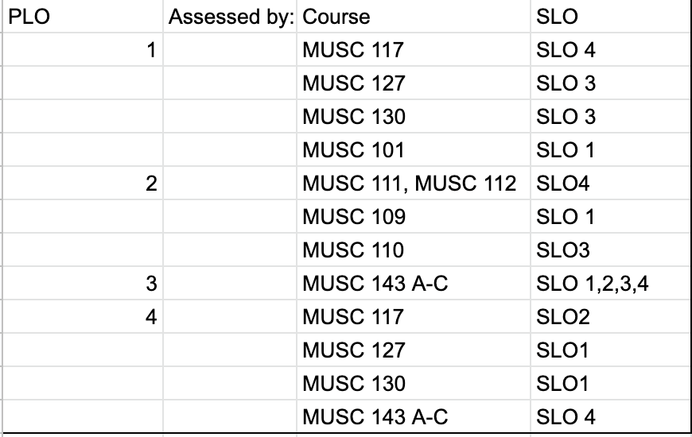
Associate of Arts for Transfer:
  - Demonstrate an understanding of the fundamental melodic, harmonic, and rhythmic structure of music through music theory.
  - Develop basic technical proficiency and demonstrate artistic growth in musical performance on a given instrument and/or voice in both solo and ensemble context.
  - Demonstrate fluency in audiation such as sight singing, rhythmic execution and harmonic, melodic and rhythmic dictation.

PLO Assessment Mapping:
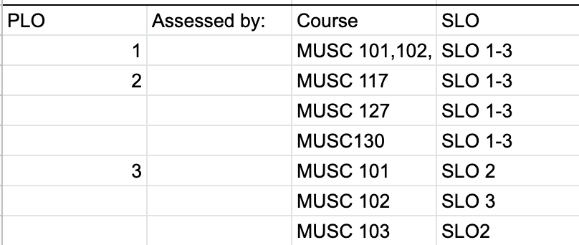

Assessment Cycle:
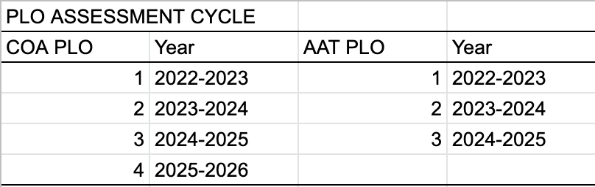

Due to both the certificate and degree programs launching essentially at the same time as our deep enrollment loss due to the Covid pandemic, we did not schedule a PLO assessment out of concern for too little data to analyze. As you see above, however, we do have those assessments planned in this next three-year cycle and beyond.
Course Level Student Learning Outcomes

Due to only having one full-time music faculty the course-level student learning outcomes have not kept pace with our planned evaluation timeline. In the future, we plan to create a more manageable assessment calendar to ensure the completion of the assessment and evaluation process.

Program Analysis & Trends

Changes in Program over Last Three Years

The music department has added an AA-T degree in Music with additional courses required by the degree. In 2020 we updated the piano lab to the industry standard with a new Yamaha Lab and smart TV. We added a performance ensemble, MUSC 130 – College Orchestra, to reflect the musical make-up of the city of Porterville.

Data Review

Music | 2016-17 | 2017-18 | 2018-19 | 2019-20 | 2020-21* | 5 yr. avg.
Census Enrollment | 369.0 | 391.0 | 501.0 | 802.0 | 554.0 | 523
Section Count | 24.0 | 18.0 | 30.0 | 37.0 | 40.0 | 30
Students Per Section | 15.4 | 21.7 | 16.7 | 21.7 | 13.9 | 18
First Day Waitlist Total | 0.0 | 14.0 | 11.0 | 21.0 | 16.0 | 12
FTES | 36.80 | 39.92 | 50.52 | 81.00 | 54.93 | 53
FTEF | 3.07 | 2.60 | 3.58 | 4.94 | 5.00 | 4
FTES to FTEF Ratio | 12.0 | 15.3 | 14.1 | 16.4 | 11.0 | 14
Retention | 92% | 96% | 93% | 88% | 94% | 93%
Success | 65% | 83% | 83% | 81% | 80% | 78%
Majors | 1 | 4 | 12 | 26 | 14 / 26** | 16
Degrees + Certificates*** | 0 | 0 | 0 | 0 | 0 | 0
* Due to the Covid-19 pandemic the data for 2020-2021 is not an accurate representation of the growth trends of the department. Sarah Rector took over as music instructor in Fall 2017 and the growth trends after 2017 and prior to 2020 are a more accurate representation of growth.
**26 was included value as it represents Fall 2021 majors count (rebound from Covid year)
*** May 2022 will be the first semester students would be eligible for the AA-T in music.

Due to Covid-19 our enrollment has dropped. However, in spite of the reduction of enrollment Music major numbers have increased since the start of the AA-T Degree. Our hope is to make a swift recovery as current pandemic issues improve.

The 5-year data of majors and degrees and certificates awarded shows major growth in all programs in the division (though the Music Certificate program is just underway). As our programs work to make our students more successful in attaining their degrees and certificates, the growth in majors will be a further driver of student awards over time in our programs.

Music Program Strengths:

The Porterville College Music Department offers a diverse range of courses. Along with our various lecture courses ranging from music appreciation to world music, we also offer several performance-based courses. The high schools in Porterville produce quality musicians who then are able to continue performing in our College Chorale or Concert Band.

We are working alongside PUSD to help navigate our dual enrollment courses along with collaborations with local high schools. We are also working with the “Porterville Strings” group to promote music education.

We currently have one full-time faculty and four adjunct faculty members. This is a strength as it represents an increase in faculty from our previous review.

Since our last review we have added an AA-T in Music and updated the current Certificate of Achievement in Music.

Music Programs Areas for Improvement:

Our most immediate goal is to recover in the area of enrollment since the Covid-19 pandemic. Like other disciplines, we experienced a heavy drop in enrollment and majors in our courses. However, due to the nature of performance courses, the Music discipline experienced a larger than average drop. Additionally, performance art areas such as music typically take much more time and effort for students to complete programs of study and for faculty to recruit new students in to those programs.

In order to give a realistic shot at a regular stream of completers of Music degrees and certificates, we really do need another full-time instructor with an instrumental background. This position would be to complement our single Music instructor whose expertise is vocal ensemble with another who would focus on instrument ensembles (band and/or orchestra). This position would also serve to better meet Music majors course needs and desires rather than to rely too heavily on one full-time instructor to carry regular overloads so that students can complete certificates and degrees. To simplify and shorten this document, we would refer details on this request to the formal request for faculty submitted to the Academic Senate during the Fall 2021 semester

Goals (All goals for the Music department start with the letter “M”)

Goal M1: Increase practice & performance space (facilities) (new) | Comments:  The music building currently only has four practice rooms that are used frequently. We are in need of more spaces for students to practice. We also do not have an adequate performance space for concerts.
Timeline: Spring 2022
Needed Resources: building space
Person(s) Responsible: Sarah Rector, college President, Office of Instruction, M&O Director
Obstacles (if any): funding
Goal M2: Offer piano concerts in the theater (CA 4) (new) | Comments:  If the music department hosts any piano concerts, we currently have to have concerts in the piano room which is not an appropriate concert facility. With the purchase of a grand piano for use in the theater, we could have more concert opportunities for students and guest performers.
Timeline: Spring 2022
Needed Resources: building space
Person(s) Responsible: Sarah Rector
Obstacles (if any): funding
Goal M3: Increase sheet music library for all ensembles (ongoing) | Comments:  We currently only have adequate sheet music for choral ensembles. Though we have a few items for the band we currently have no music at all for the orchestra ensemble. An increase of music could help us grow our newer music ensembles.
Timeline: Spring 2022
Needed Resources: funding and space
Person(s) Responsible: Sarah Rector
Obstacles (if any): funding and space
Goal M4: Create courses in the area of Commercial Music (new) | Comments:  With the goal of developing a Commercial Music certificate, we must first create the courses for said certificate. In addition to the time and faculty needed to write these courses and program, the purchase of software and MIDI keyboards is also necessary. With the addition of music software such as Ableton, Protools, Finale, etc., music students could better prepare for transfer to music schools. The additional software would also make it possible for us to have a commercial music certificate.
Timeline: Spring 2022
Needed Resources: funding & space
Person(s) Responsible: Sarah Rector
Obstacles (if any): funding & access to computer lab
Goal M5: Create Commercial Music Certificate (new) | Comments:  Commercial music is a growing field that is in demand. The addition of the certificate could help students wishing to pursue careers in music business and technology instead of performance and education which is what our current programs are aimed at.
Timeline: Spring 2022
Needed Resources: faculty help for creation and teaching of courses
Person(s) Responsible: Sarah Rector
Obstacles (if any): The time needed to write the certificate/ skilled faculty member to teach music technology courses
Goal M6: Create Guitar Ensemble course (new) | Comments:  The most often requested course from students and the community is a guitar class. Many of our feeder schools offer guitar ensemble courses but cannot continue their studies at PC due to the lack of courses. The course could also potentially help us serve a more diverse group of students especially music students with a mariachi background.
Timeline: Spring 2022
Needed Resources: guitars
Person(s) Responsible: Sarah Rector
Obstacles (if any): faculty member to write the course, faculty member to teach course, guitars for students who cannot afford their own

Staffing
Current Staffing Levels  Full-time Staff (FTE) |  | Part-time Staff (FTE)
Faculty | 6 | Faculty |  | 15
Temporary |  | Temporary
Classified |  | Classified |  | 1
Management |  | Management
Request for New/Replacement Staff
Use one line for each position requested. Justify each position in the space below.
 | Title of Position | Classification  (Faculty, Classified, or Management) | Full or Part Time |  | New of Replacement
Position | Music Instructor(instrumental) | Faculty | Full |  | Replacement
Position | Art Instructor | Faculty | Full |  | New

Justification:
Music Instructor:
This position would be to complement our single Music instructor whose expertise is vocal ensemble with another who would focus on instrument ensembles (band and/or orchestra). This position would also serve to better meet Music majors course needs and desires rather than to rely too heavily on one full-time instructor to carry regular overloads so that students can complete certificates and degrees. To simplify and shorten this document, we would refer details on this request to the formal request for faculty submitted to the Academic Senate during the Fall 2021 semester.

Art Instructor:
A new art faculty member would address the growth, challenges, and changes the Fine Art department is experiencing. ART P101 Art Studio Fundamentals (ASF) courses continue to have sizable waitlists each semester. Due to a lack of personnel and the challenge of finding qualified and available adjunct faculty in art, we are not able to offer new sections of ASF. Each semester both full-time faculty members have been overloaded and all our adjunct instructors have full teaching loads. With the Video Production program scheduled to launch in Fall 2022, one of the full-time faculty will concentrate his teaching load in that new area. Consequently, the courses he teaches in ASF will be left vacant and need to be filled. The new art faculty position will remedy this problem and enable further growth. And if this faculty member also has expertise in 3D Animation, it would allow us to accomplish Goal #2 as well. There are enough art courses in the current schedule to hire 2 additional full-time faculty. We are only asking for one art faculty member

Resource Request
NOTE: Please note that all of the following requests are not ranked in order of priority but rather just grouped by general area of discipline alignment. This was done for a more convenient/efficient way to utilize this document in the future.

TECHNOLOGY REQUEST

Item 1: For Art Gallery

- In anticipation of the forthcoming Video Production program, a permanent video projector installed in the Art Gallery would bolster screening opportunities for students while also supporting visiting artists that use video or filmmaking in their work. A projector, CPU, and stereo sound equipment (speakers) would be appropriate.
  - Electric projection screen / 87” x 49” / $133.17 (Home Depot)
  - A portable monitor, CPU, and speakers. This station will provide versatility and extra digital exhibition opportunities for students and exhibiting artists and does not require low light conditions for maximal image quality.

Item 2: For FA-4 – 3D Studio/Lab

- Tech Cart: Video projector, monitor, CPU, audio
- Electric projection screen / 87” x 49” / $133.17 (Home Depot)

Item 3: FA-2 – For Video Production Studio/Lab/Classroom (Darkroom Conversion)

- New computers for 4K video editing.

Item 4: For FA-1 – Computer Graphics Studio/Lab

- 3D printers for use in digital design and animation courses

Item 5: Midi keyboards for Commercial Music courses. (20 qty)

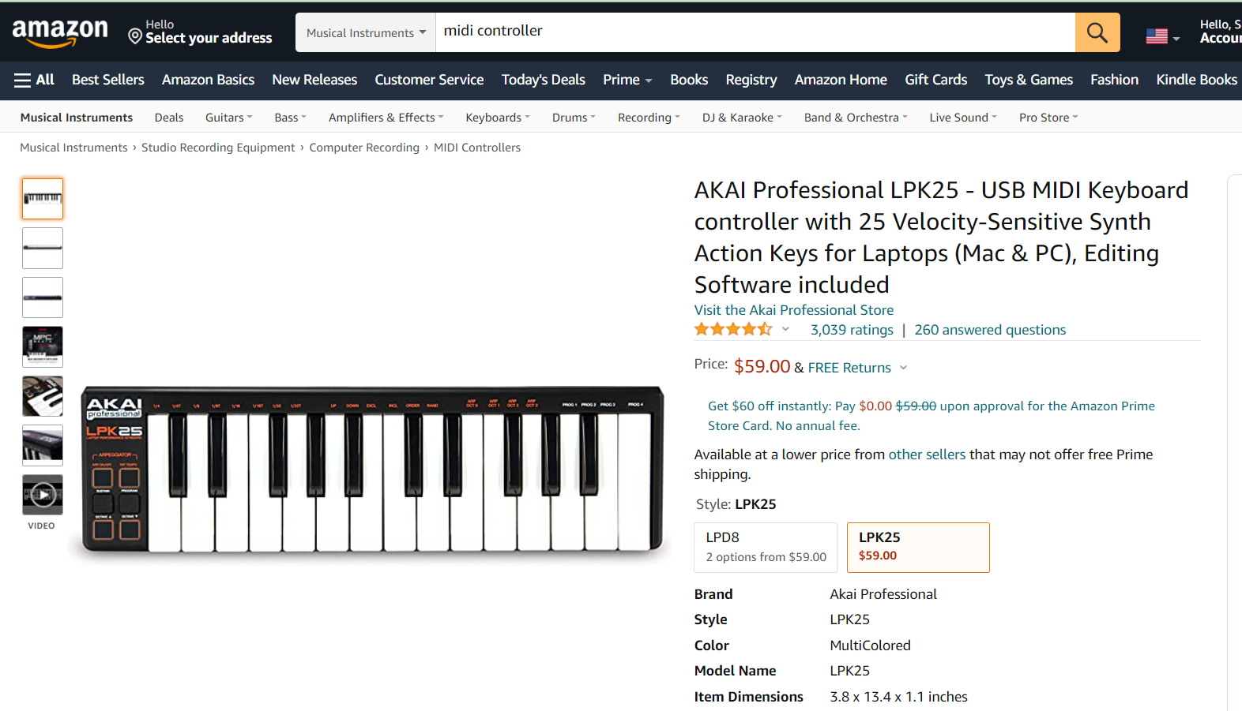
Amazon Listing - MIDI Keyboards

- At roughly $60 each and the purchase of 20 keyboards, this would be somewhere around $1400 in total.

Item 6: Grand Piano for CA 4

- There is a range of prices for a new grand piano, but we are likely to spend at least $50,000 – 100,000 for an adequate piano. Below is only a sample comparing prices of Yamaha piano models.
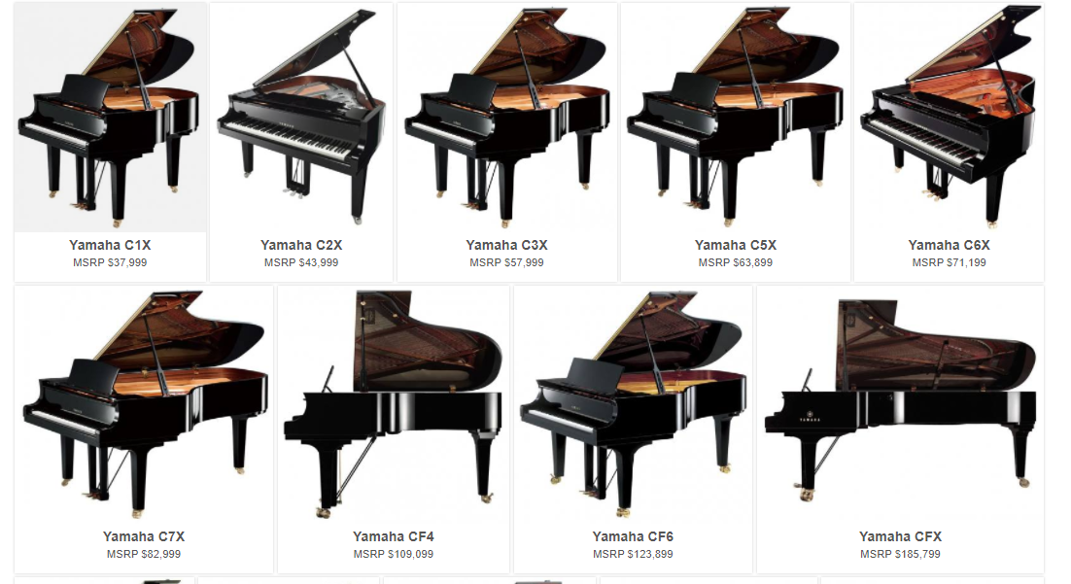

FACILITIES REQUEST

Item 1: Art Gallery

- Remove wall carpet, revealing the plywood currently on all wall surfaces, add plywood to cover the windows on the east walls for increased wall exhibition space and darkened environment for video projection. Cover all walls with 1/2" Sheetrock and white paint for final appearance.
- Place all gallery wiring (including current wires that run on the surfaces of the walls) under the plywood that is currently on the walls.
- Replace 40-year-old partially and poorly functioning track lighting in the main gallery space with new track lighting. Or new track lighting for all gallery spaces.
- Replace old, worn carpet with new carpet on floor.

Item 2: FA-2 – Darkroom Conversion

Convert photography darkroom to video production studio/classroom.
- We need a video studio/lab classroom for our new Video Production class that we will offer in Fall 2022. Since the art program is no longer teaching traditional photography with the use of a darkroom, we would like to convert the darkroom to a classroom and production studio to accommodate this new course offering which will be a required course for the Commercial Art Video Certificate that will be offered in Fall 2022.
- In preparation for the Fall 2022 launch of our new video production program, we have been planning a studio environment designed specifically for video production—a real benefit for our students and their success in our program (as outlined in our 2015-16 and 2018-19 Program Reviews). The planning for this video lab and the conversion of this darkroom for this purpose began in 2016 when the photography classes became fully digital and no longer taught darkroom techniques
- The attached planning document for the upgrade of the darkroom into a digital video lab is an important complement to the state-of-the-art video equipment that we have already obtained for the program, the course created for the program (with the creation of a second course planned), the creation of a certificate in video production (as well as adding this course as an elective in our Commercial Art AA), and the faculty to teach the course.

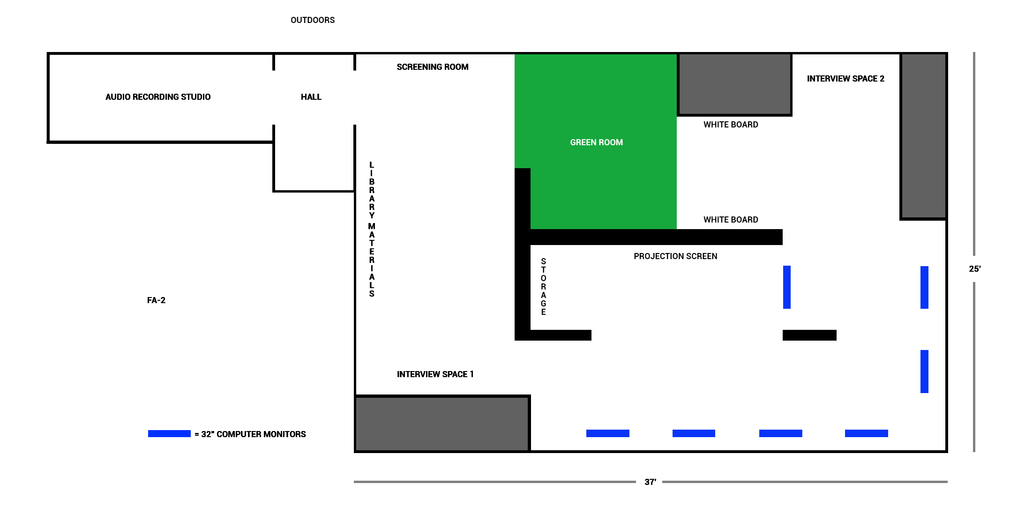
- The new space will feature areas that are devoted exclusively to green screen activity and formal interviews, an area that can be isolated for audio recording, and finally, room for a six or so computer editing stations with enough space to properly accommodate large video monitors (where students will be able to collaborate on projects in teams of 4 or 5 students—filmmaking is often a collaborative process). This studio arrangement with dedicated areas will provide spaces for students to participate in all the various functions necessary for producing high quality videos, and to provide continuity, efficiency, and organization in the filmmaking process. This will be an environment for video production where students will have all the tools available to, collaboratively and individually, create the highest quality work.

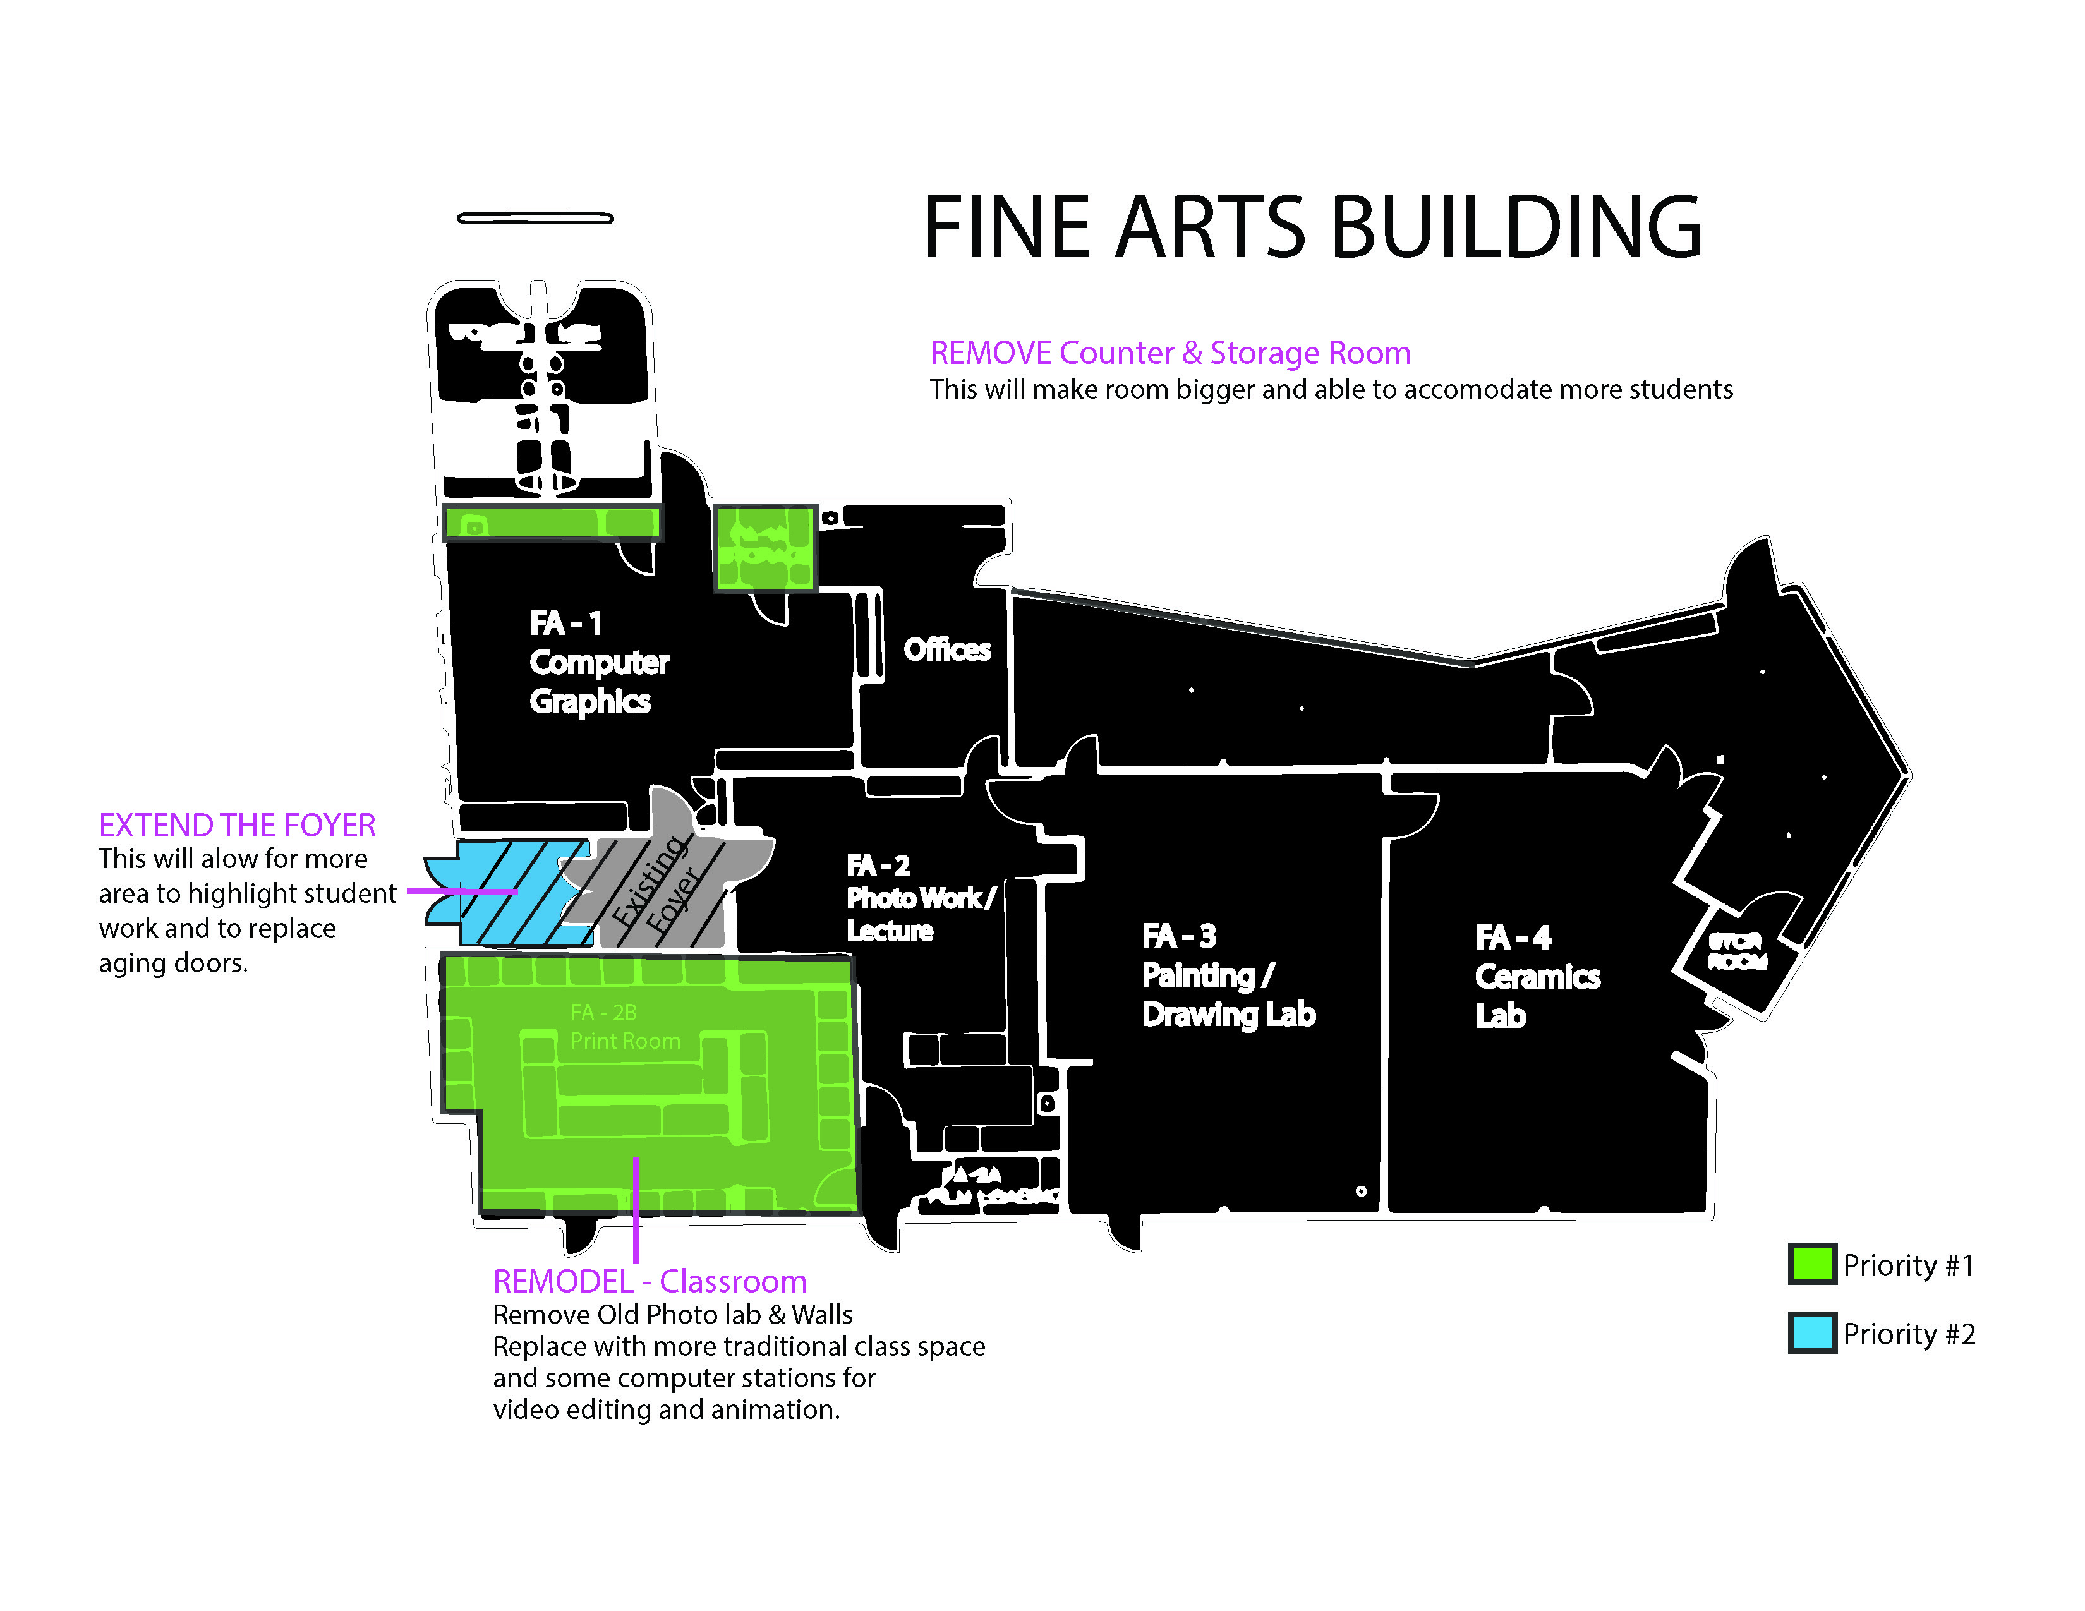
Item 3: FA-3 – 2D Studio/Lab

- Update track lighting (3 tracks—currently we have one 40 or 50-year-old track—even 2 tracks would be far better than the single partially operational track that we have now)—so students can spread out and are not clustered under one track for certain projects where directed lighting is needed. Estimate needed for track lighting and installation costs.
- New curtains for the studio/lab—so we can effectively darken or lighten the lab as needed. Old curtains are lacking functionality (they are also some 40 or 50 years old).
- 12’ x 30’ = $800 - $4000?
- 3’ x 28’ = $300 - $1500?

Item 4: FA-4 – 3D Studio/Lab

- Curtains—so we can effectively darken for video projection or lighten the lab as needed (unknown cost).
- 12’ x 22’ = $600 - $3000?
- 7’ x 6’ = $200 - $1000?

Item 5: FA Building – Extend Foyer

- By providing more exhibition studio space to showcase student work, and providing track lighting for the space, it will provide positive reinforcement for students who excel in their studio classes in the Art Program and reinforce and improve student success in these classes. [See diagram].

Item 6: CA Building – Theater Lighting

- The lighting in CA 4 is inadequate to facilitate proper learning for daily class lectures which is the overwhelming majority of how the space is used. In addition, hosting of ceremonial and other special events such as performances is also inadequate. The primary lighting of the theater seating area used for classroom instruction is still too dark. The auditorium “can-style” lights do not all function and the stage lighting bar (hanging above the front row of seats) doesn’t work. The theatre lighting system is in need of repair and upgrading or even a thorough redesign and remodel. While Maintenance and Operations do regularly try to fix the fluorescent lights in the room, they simple cannot keep up with the rate at which they stop working. In addition, the can-style lights (aka “house lights”) are virtually beyond repair and need to be replaced. In the last 3 years there has been some progress in these areas. There are still multiple areas that should be upgraded in terms of both sound and particularly in stage lighting which were not addressed at all in the last 5 years. The update that is most relevant is happening during the Fall 2021 with regards to the stage lighting system. The college has received quotes to replace the entire stage lighting system with a modern, computer controlled, all-LED light system that will also replace the “house lights” over the seating area and flood lighting over the stage. This renovation quote also includes state of the art video recording software for synchronous live streaming of both classrooms and events. The quotes range in price but are in the range of $800,000.

Item 7: FA Building – Instrument Storage

- The instrument storage area (backstage and off back stage) needs renovation to efficiently and safely maximize the storage of instruments. Currently the storage area (in its unfinished state) is inadequate for the number of instruments used in the program. Currently they are not stored neatly enough to even make accessing them effectively for class. Some instruments should be stored on stage, but as we have no secure storage area in that location what typically happens is we overfill the current off stage storage room.

SAFETY & SECURITY REQUEST
Use this section to list any safety & security needs for your program. If you have more than two safety & security needs, add rows below.

Safety & Security Need | Justification
Item 1 | None
Item 2 | None

PROFESSIONAL DEVELOPMENT REQUEST
Use this section to list any professional development opportunities you would like to have available for your program. If you have more than two professional development needs, add rows below.

Professional Development Need | Justification
Item 1 | none
Item 2 | none

Budget
 | Current Budget | Amount of Change | Revised Total
1000 | 5,200 | 0 | 5,200
2000 (Student) | 1,000 | *-1,000 | *0
4000 | 5,350 | 0 | 5,350
5000 | 3,000 | *8,600 | *11,600
Other (6000) | 0 | **70 – 150,000 | **70 – 150,000

1000—Gallery Director and Music Director Stipends

4000—Art, Photography, Commercial Art, Computer Graphics, Music, and Communication instructional supplies and materials support quality academic programs, prepare students for transfer to four-year institutions, as well as develop skills and provide career training.

*5000—For student travel in Music and Art programs. Also includes regular maintenance and tuning of instruments and related equipment. For maintenance of video production equipment. Both the areas of Music and Art have acquired a significant number of pieces of equipment in the past two years that will need to be cleaned and maintained on an annual basis. This includes multiple pianos, band and orchestra instruments, video equipment (recorders, lenses, tripods, etc). The increase in budget requests reflects the need to maintain and service this equipment to ensure quality programs for students.

*Previously student travel had been coded as a 2000 expense but moved to 5000 after consultation with Vice President of Finance in Fall 2021.

**6000—This is for various equipment that we would like to purchase including an additional grand piano to leave in the theater (CA 4) for performances, MIDI keyboards for commercial music courses, facilities improvements to Art gallery building, technology cart for FA 4, Computers for Video editing class, and 3D printers for Art courses. The items we do have rough estimates for total approximately $70,000 on the low end and upwards of $150,000 on the high end. See “Resource Request” section for more details.

One special note on 6000s is the exclusion of the lighting repair and upgrade to the theater (CA 4). This was intentionally left off of this summary as it appears we have secured funding and this project will be completed by the end of the summer 2022 semester.

