Porterville College Mission Statement:

With students as our focus, Porterville College provides our local and diverse communities quality education that promotes intellectual curiosity, personal growth, and lifelong learning, while preparing students for career and academic success.

In support of our values and philosophy, Porterville College will:

- Provide quality academic programs to all students who are capable of benefiting from community college instruction.
- Provide comprehensive support services to help students achieve their personal, career and academic potential.
- Prepare students for transfer and success at four-year institutions.
- Provide courses and training to prepare students for employment or to enhance skills within their current careers.
- Provide developmental education to students who need to enhance their knowledge and understanding of basic skills.
- Recognize student achievement through awarding degrees, certificates, grants, and scholarships.

Program Mission Statement:

The mission of the EOPS/CARE program is to provide “over and above” support services to eligible students challenged by language, social, economic, and educational barriers. EOP/CARE is committed to assisting students with successfully completing their educational goals and objectives.

(Note: This program mission statement is linked to the Office of Student Services Mission, Values and Philosophy Statement on the Porterville College website (click here to view); therefore, EOPS/CARE supports the same vision.)

Services Area Outcomes:

EOPS/CARE/NextUp SAO Cycle

Term | EOPS/CARE/NextUp SAOs
Fall 2018 | SAO #1: EOPS/CARE/NextUp New Student Orientation
Spring 2019 | SAO #3: EOPS/CARE/NextUp Student Satisfaction Survey  SAO #4: EOPS/CARE Campus Trip
Fall 2019
Spring 2020 | SAO #2: EOPS/CARE/NextUp Educational Goal(s)
Fall 2020
Spring 2021
Fall 2021 | SAO #1: EOPS/CARE/NextUp New Student Orientation
Spring 2022 | SAO #3: EOPS/CARE/NextUp Student Satisfaction Survey
Fall 2022
Spring 2023 | SAO #2: EOPS/CARE/NextUp Educational Goal(s)
Fall 2023
Spring 2024
Fall 2024 | SAO #1: EOPS/CARE/NextUp New Student Orientation
Spring 2025 | SAO #3: EOPS/CARE/NextUp Student Satisfaction Survey
Fall 2025
Spring 2026 | SAO #2: EOPS/CARE/NextUp Educational Goal(s)

The following SAOs have been completed. The program will continue improving on the performance of the noted SAO’s:

SAO # 1 Students who attend the EOPS/CARE Orientation will be able to demonstrate knowledge of the purpose of the program, the services provided, and the student responsibilities.
The SAO was assessed in June 2016, and then again in Fall 2018.
Results for June 2016: The 70% criteria for satisfactory outcome have achieve in question number4. The other questions were below the 70% mark.
Reflection process: Counselors determined questions were confusing and made changes to the questions, and decided to conduct SAO # 1 again in fall 2018.

Results for Fall 2018: Overall the results of the post-test improved, met the benchmark in 2 out of 5 questions.
Reflection process: The orientation was updated to emphasize areas of services the program provides, student responsibilities, and why it is important to complete a comprehensive Student Educational Plan. Analyzing the data can be time consuming; we will look into conducting the assessment online during the orientation to save time in analyzing data and make it interactive.

SAO # 2 After completing the second counseling appointment, students will be able to communicate their short and long-term educational goals.
Results: Thirty students were assessed and twenty-nine were able to communicate their educational goals.
Reflection: Counselors will use MyDegreePath Audit to teach the students how to read and interpret the audit instead of completing the paper lesson plan since students refer to the audit when viewing their educational and academic progress. The counselors will continue to use the career section in the lesson plan to explore and prove career questions.

SAO # 3 After completing the third counseling appointment/exit interview, students will demonstrate satisfaction with EOPS/CARE/NextUP services.
One-hundred-seventy students were surveyed and demonstrated high satisfaction in the program in the following services:
Office – over 90% satisfaction:
courteous and respectful, knowledgeable, hours of operation and appointment availability.
Counseling – over 91% satisfaction:
Time spent in counseling appointment, knowledge, encouraging & supportive
Book voucher award and service – over 87% satisfaction
Meal-Card award and process – over 88% satisfaction
Priority registration – 99% satisfaction
CARE Grants – over 88% satisfaction
CARE Luncheon – over 90% satisfaction

SAO # 4 After visiting a UC/CSU campus, students will have more knowledge of the transfer requirements, transfer opportunities, and interest in transfer to a four-year university.
Results: Students rated the overall experience to the CSU Campus as excellent. One-hundred percent of the students demonstrated an increase in knowledge of the transfer requirements and 88% of the students showed an interest in transfer after completing the trip.

Program Analysis and Trends

Changes in Program over Last Three Years
The EOPS program has experienced growth in student count and award completion up until Spring 2020. Seven-hundred-twenty-three students completed a degree or certificate from 2017 through 2020 with a total of 972 awards conferred.

The program experienced a decline in ‘Success’ and ‘Completion’ in spring 2020 due to COVID. Low enrollment continued in the fall 2020 due to all instruction being delivered in a virtual format. Some students struggled with technology and others needed access to technology. In spring 2020, students in the program were referred to Students Services to checkout a computer and to obtain a Wi-Fi hotspot. In fall 2020, a survey was conducted through Survey Monkey to identify students in need of technology. The program awarded 50 technology grants to support EOPS students to continue their education. The college has also hired student workers in fall 2020 to assist students with technology support.

The program is regaining its strength as we move forward. The program staff has been able to serve and provide all program services by meeting students where they are through various online platforms, email or over the telephone. Counseling is being provided through Cranium Café, program orientations are delivered through Zoom and the utilization of Canvas and Navigate is being utilized to create campaigns and to text students.

The program had transitioned to paperless files in Fall 2019 with a structure that maintained all student files in a Cloud environment. All forms and student files are stored in the secured campus network and accessible from any secured internet access point. This new filing system allowed for an easier transition to the virtual counseling environment once Stay At home orders were implemented in March 2020 due to COVID-19. We are expanding on this paperless project through the implementation of NextGen Dynamic forms which will help students’ complete forms online in a secure environment using their Porterville College secured log-in information. Forms will be delivered to the appropriate member of our team who will add them to the student file.

There have been staff transitions in the program due to retirement, transfers and turnover. The program hired a new Director of Student Services in July 2020, a new program coordinator transferred in January 2018, and one adjunct counselor was replaced in fall 2018. One full-time counselor was out on leave fall 2019 and fall 2020. The program shared an adjunct counselor to help students in the program in the absence of the full-time counselor during fall 2020. Another adjunct counselor transferred to the Disability Resource Center and has not been replaced.

Data Review

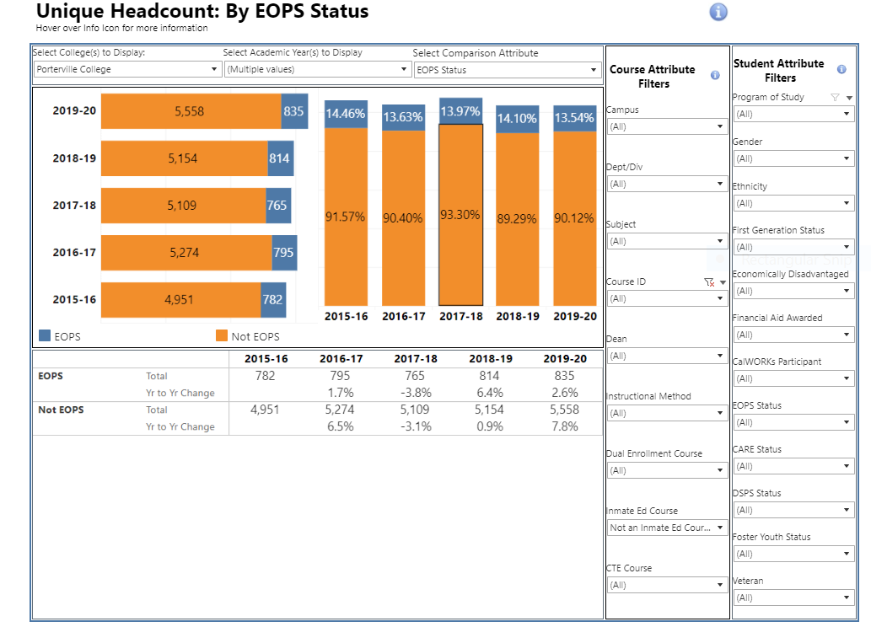
Unique Headcount: the unduplicated student headcount for the academic year, summer, fall and spring.
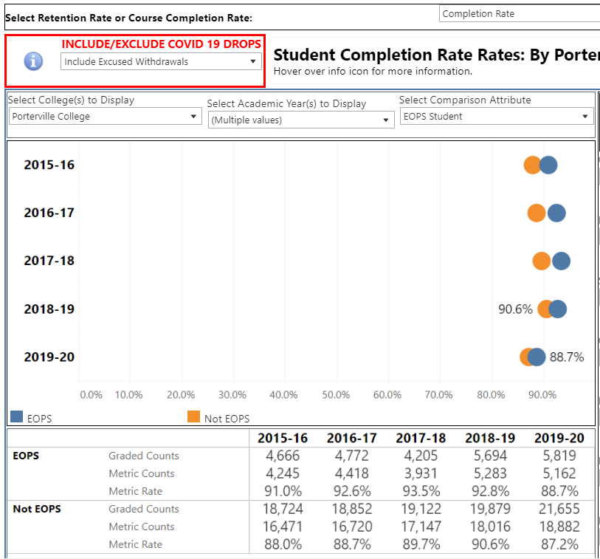

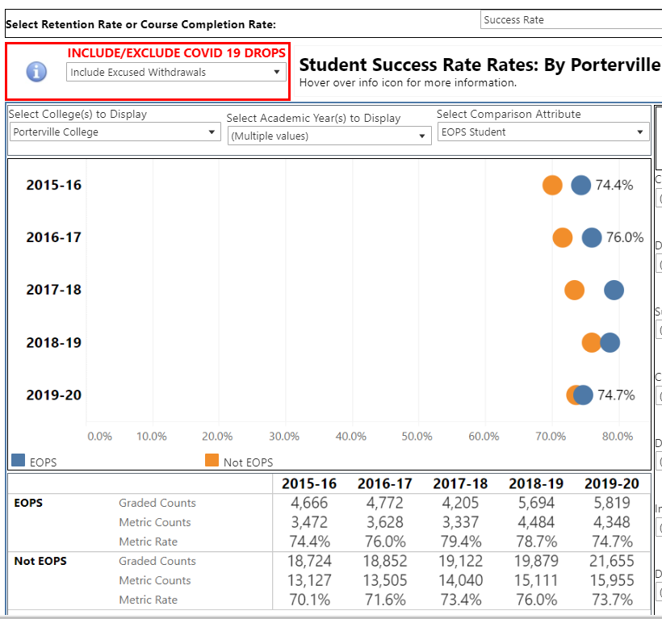

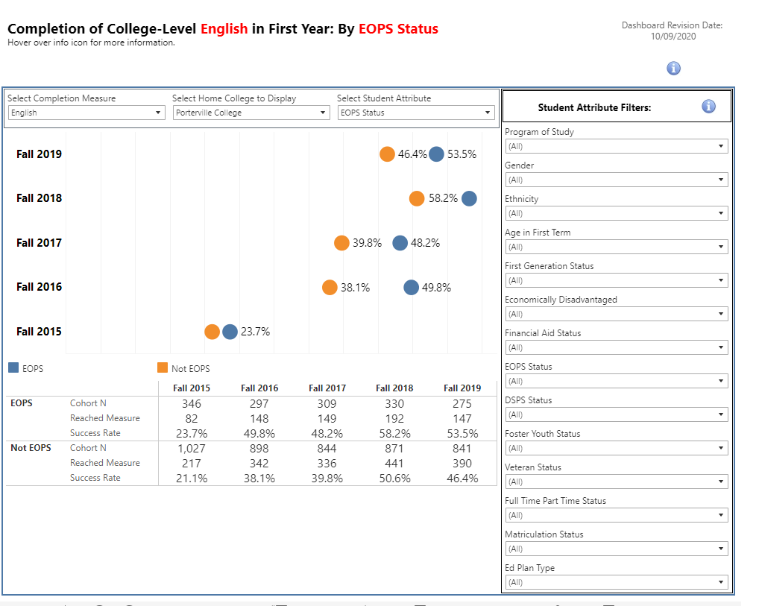

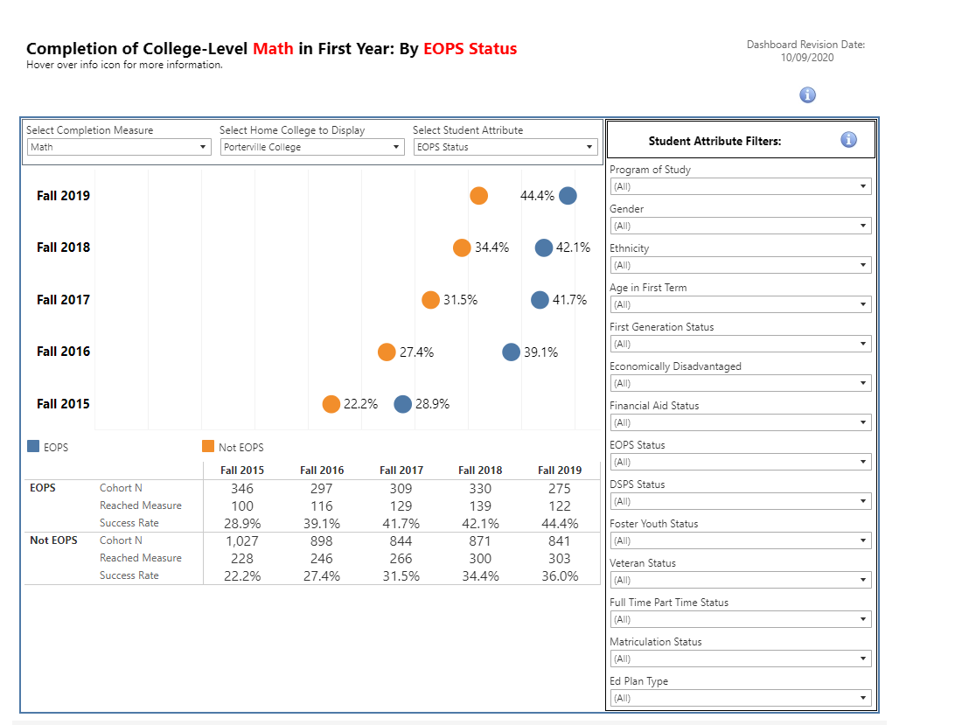

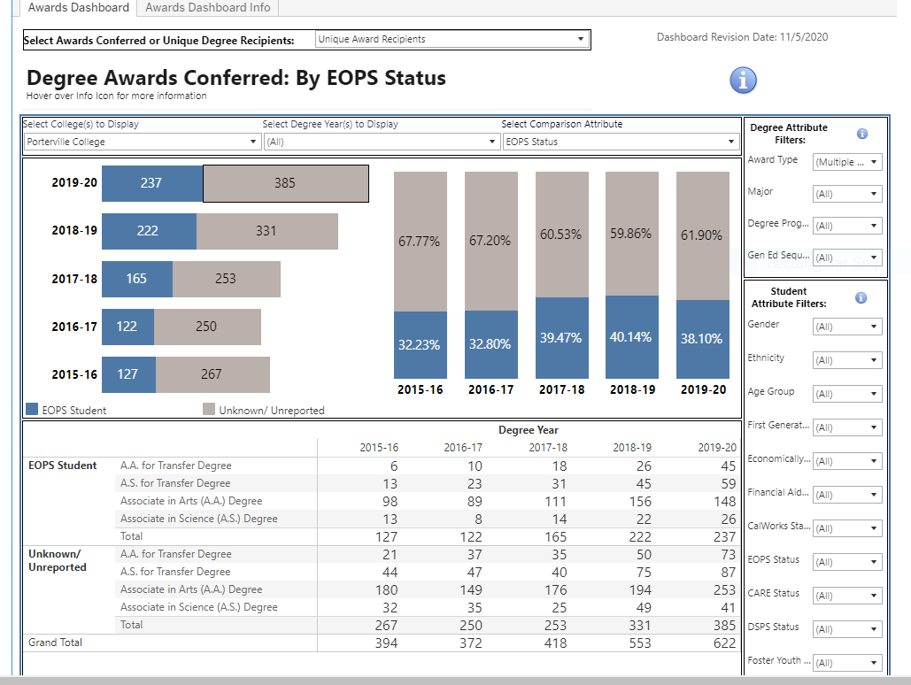
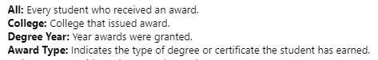
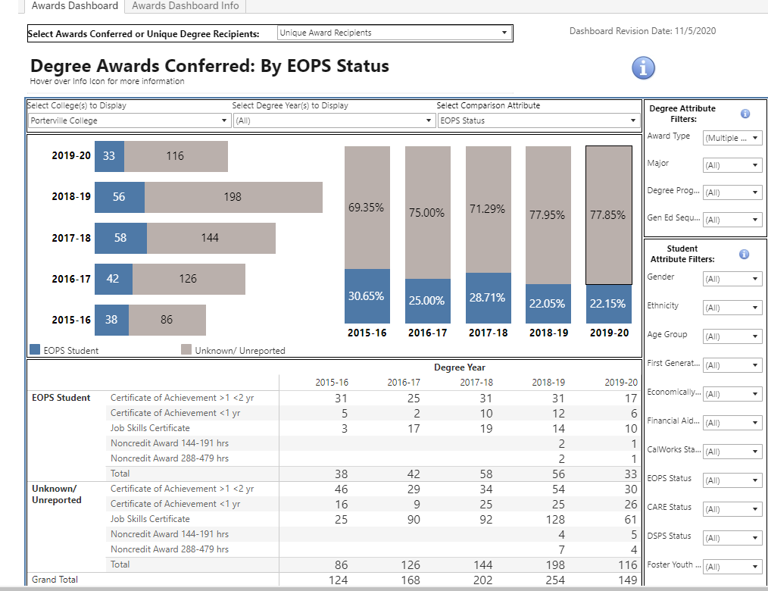

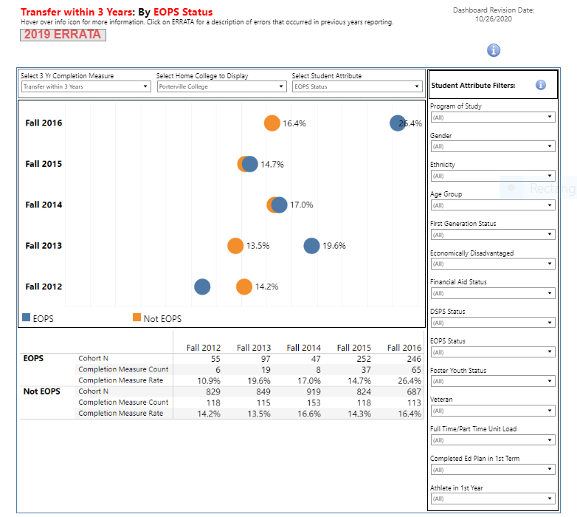

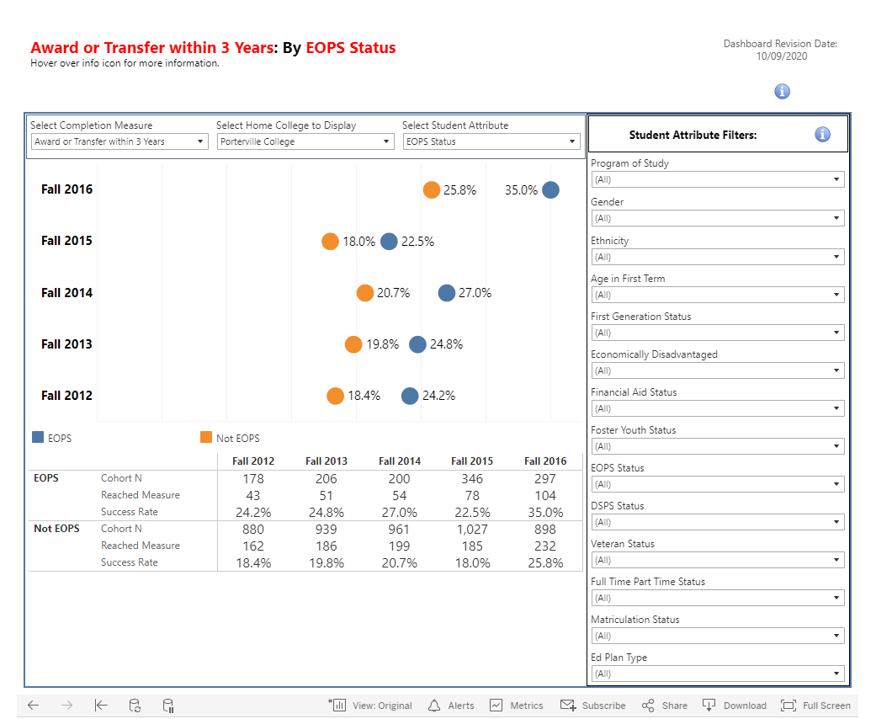

Program Strengths
The EOPS/CARE staff and faculty provides excellent support services to their students. The team is committed not only to their students, but also to the college and district in general. They are actively involved in many campus and district committees as well as community events and partnership opportunities.

EOPS program staff participate in the Porterville College Welcome Week event to provide EOPS Program information and services. Program counselors collaborate in the Annual PC Transfer Fair, and participate in outreach activities at the local high schools to promote Porterville College and complete abbreviated Educational Plans for potential students. In addition, the program participates in Become a Pirate in a Day, Reg Fest, College and Financial Aid Night, Senior Day and PC Connection. The Educational Advisor does regular high schools visits throughout the year to provide information and outreach services. The program coordinator works closely with the AB 540 liaison to provide support services to students in this classification.

The program collaborates with the Tulare County Health and Humans Services Agency to identify students that are eligible to receive services through the EOPS/CARE/NextUp and CalWORKs program. The program has partnered with the South County Collaborative to create a safety net for students including Foster Youth, students in need of Mental Health services and/or other needs. The program collaborates in events with the Tulare Office of Education to provide a smooth transition from high school to college.

In addition to the collaboration and outreach efforts mentioned above, the program participates in the following:

- Participation in Pirate Path to Success Program meeting on campus at PC
- Presentation at the Employment Connection/Employment Development Department in Porterville
- Outreach at Owen’s Valley Career Development Center in the Native American Community
- Outreach at Tulare Health and Human Services to increase CARE numbers
- Presentations in Porterville College classes across all disciplines (Faculty/Staff can submit an online request and an EOPS staff person will market and show the EOPS PREZI presentation to the students in an effort to bring awareness of the support services available to students)
- Presentation at Butterfield Charter School and Porterville Adult School
- Outreach at the College and Career Expo at College of the Sequoias
- Videos on the EOPS/CARE page on the PC website have student testimonials
- Utilization of EOPS interns who are also EOPS students to help out with EOPS office work

As mentioned earlier, the program staff has been able to adapt and transition to an online environment providing all services virtually. The program staff is fully committed to the success of the students. The counselors have many years of experience serving disadvantaged populations and provide quality counseling tailored to the individual needs of each student. The students receive wrap around services: tutoring referrals, referrals to other departments and outside agencies. A CARE workshop/Luncheon with a Guest Speaker is provided each term to further support the needs of the CARE students in the program.

One of the keys to student success is monitoring students’ progress and providing early interventions. Creating and monitoring a student’s Education Plan is one of the key factors that helps students in our program succeed. Each student is required to bring in a completed progress report form in which the instructors indicate the student’s current class status. The progress report allows the EOPS staff to provide interventions and solutions to academic concerns that may potentially prohibit a student from achieving his or her educational goal. The students receive intrusive counseling to identify solutions that will promote the well being of the student allowing him/her to take charge of their education. Interventions may result in the following: tutoring referrals, encouraging students to meet with their professors during office hours, formation of study groups, withdrawing from courses prior to the withdrawal deadline, change class schedule, major change, amending or developing a new educational plan.

The EOPS program continues to provide “over and above” support services to eligible students:

- Priority Registration
- In Person/Online Orientation to EOPS/Campus Services
- 3 REQUIRED Counseling Contacts
- EOPS Book Vouchers
- Meal Cards
- Grants
- Educational Field Trips to University Campuses
- UC & CSU Application Fee Waivers
- Survival Kit (school supplies)
- Free Tutoring
- Educational/Enrichment Workshops
- Lending Library
- Phi Theta Kappa Honor Society Membership Fees
- PC Salute Veterans National Honor Society Membership Fees
- Graduation Cap and Gown
- Graduation Medallion

The EOPS/CARE program has streamlined processes and bundled services which ensures efficiency of allocated human resources, thus supporting student success. Many EOPS students are receiving services in EOPS/CARE and CalWORKs. Staff refers and encourages eligible students to apply for and receive services in multiple programs. We feel this is a benefit to our students because they can maximize the utilization of all support services.

Areas for Improvement

The college transitioned to Navigate as a new student appointment scheduling system in the December 2019. Navigate has brought many challenges during its implementation as it requires extra steps to accomplish simple tasks such as scheduling an appointment or moving appointments. There are many areas that need to be addressed: creating alerts for office staff to provide the student support services needed, filtering daily reports to identify program compliance and case management, etc. The Navigate system has created additional work and complexity to the daily office tasks which is affecting office efficiency.

An area to be strengthened is the partnerships with the California State University and University of California Educational Opportunity Programs (EOP) to assist in the transfer process from Porterville College to a four-year university and to continue to increase the student transfer rate. These partnerships will also establish a support system that will help students matriculate to the CSU/UC campus. Additional office space with furniture for EOP University Rep visits including EOPS student lounge with computers would be key to promote and facilitate the transfer of our students. The student lounge would also be utilized to assists students with registration and tutoring services. A lounge environment also nurtures the peer to peer empowerment as they build study groups and networking skills that will help them in the professional world.

EOPS must explore new ways of recruiting students to the program to fill in the space created by students who complete their educational goal(s) at Porterville College and to add growth. Cohort data shows the award and transfer completion rate have steadily increased every year. The transfer cohort rate for fall 2016 was 26.4%; fifteen and a half percentage points higher than in 2012. The yearly data shows a yearly increased in award completion as well. There was an 87% increase in the total number of students who completed a degree in the 2015-2016 academic year, 127 students awarded, versus the 2019-2020 academic year, 237 students awarded.

The pandemic has exacerbated a low enrollment this fall which seems to be continuing through the spring 2021. The online environment is negatively affecting student completion and retention. The program counselors and staff are continuously reaching out to students, but the pressure remains high given the program has been understaff this fall 2020. One full-time counselor was out the entire fall 2020 term without a temp replacement. There is an adjunct position that needs to be replaced. The program will not meet the three counseling appointment contacts required for fall 2020. In addition, office space in needed within the EOPS Department for the adjunct counselor position to be replaced. The program lacks office space for student counseling appointments and student worker.

Goals (This section is for you to report on progress on previously established goals. If your program is addressing more than 2 goals, please duplicate this page)

Goal(s) | Completion Date | Needed resources | Person(s) Responsible | Obstacles to completion  (if any)
Increase Students’ Awareness of Transfer Opportunities and Interest in Transferring to a 4-year University | Spring 2019 | None | Counselors

Which of numbered items under the Mission Statement (see page 1 of this document) will be furthered if this goal is completed? (select all that apply)

Item 1___ Item 2 _X_ Item 3_X__ Item 4___ Item 5___ Item 6___

Progress on Goal:

__X__Completed (Date Spring 2019)
____Revised (Date )

Comments: This goal was reworded as a new goal to increase the percentage of students who transfer: New Goal - 2. The percentage of students from entering EOPS cohorts who transfer within three years, will increase from 26.4% for the 2016 cohort to 32% for the 2019 cohort.

Goal(s) | Completion Date | Needed resources | Person(s) Responsible | Obstacles to completion  (if any)
Implement Student Satisfaction Exit Survey to measure Support Services are meeting Participants’ Needs | Fall 2018 | None | Counselors and support staff

Which of numbered items under the Mission Statement (see page 1 of this document) will be furthered if this goal is completed? (select all that apply)

Item 1_X__ Item 2___ Item 3___ Item 4___ Item 5___ Item 6___

Progress on Goal:

__X__Completed (Date Spring 2019)
____Revised (Date )

Comments: There is no need to have this stated as a goal since it is assessed through the program SAO # 3.

Goal(s) | Completion Date | Needed resources | Person(s) Responsible | Obstacles to completion  (if any)
3. Increase Students’ awareness of Alcohol Abuse and the Effects it can have on a Student’s Educational and Personal Goals. | Fall 2019 | None | Counselors | Staff Time

Which of numbered items under the Mission Statement (see page 1 of this document) will be furthered if this goal is completed? (select all that apply)

Item 1_X__ Item 2 __ Item 3___ Item 4___ Item 5___ Item 6___

Progress on Goal:

_X___Completed (Date Fall 2017)
____Revised (Date )

Comments: This goal was accomplished through a workshop; the workshop is no longer offer.

Goals (This section is for you to report new goals for your program. If your program is creating more than 2 goals, please duplicate this page)

Goal(s) | Timeline for Completion | Needed resources | Person(s) Responsible | Obstacles to completion  (if any)
1. Evaluate the progress of the EOPS/CARE/NextUp care unit in Navigate and work with the Navigate Rep to explore ways for the scheduling system to support the needs of the students and program. If Navigate is unable to meet the program/student needs, find a new vendor that would be able to provide the needed support. | Evaluate progress by May 2021.  Contract a new vendor by end of the fall 2021 if needed. | None  Funding | Student Services Director | Staff Time  Funding

Which of numbered items under the Mission Statement (see page 1 of this document) will be furthered if this goal is completed? (select all that apply)

Item 1___ Item 2_X__ Item 3___ Item 4___ Item 5___ Item 6___

Progress on Goal:

____Completed (Date )
____Revised (Date )

Comments:

Goal(s) | Timeline for Completion | Needed resources | Person(s) Responsible | Obstacles to completion  (if any)
2. The percentage of students from entering EOPS cohorts who transfer within three years, will increase from 26.4% for the 2016 cohort to 32% for the 2019 cohort. | Fall 2022 | Office space with a computer and furniture for EOP university reps to provide in-person transfer assistance and for EOPS students to hold virtual appointments with the university reps. | Program EOPS Transfer Counselor, Coordinator and Director of Student Services | Office space  Computer  Furniture

Which of numbered items under the Mission Statement (see page 1 of this document) will be furthered if this goal is completed? (select all that apply)

Item 1___ Item 2_X__ Item 3_X__ Item 4___ Item 5___ Item 6___

Progress on Goal:

____Completed (Date )
____Revised (Date )

Comments:

Goal(s) | Timeline for Completion | Needed resources | Person(s) Responsible | Obstacles to completion  (if any)
3.Office space for adjunct counselor, student worker, and a student lounge for registration, tutoring and transfer assistance. | Spring 2021 Office Space for Adjunct Counselor  Fall 2023  Office Space for student worker and student lounge | Office Space  Computers and Furniture | Director of Student Services | Office Space computers and furniture

Which of numbered items under the Mission Statement (see page 1 of this document) will be furthered if this goal is completed? (select all that apply)

Item 1___ Item 2_X__ Item 3_X__ Item 4___ Item 5___ Item 6___

Progress on Goal:

____Completed (Date )
____Revised (Date )

Comments:

STAFFING REQUEST

Staff Resources:
Current Staffing Levels  Full-time Staff |  |  | Part-time Staff
Faculty |  | 3 full-time counselors (One counselor is 34% EOPS, 33% CARE, ]33% CalWORKs; second counselor is 25% EOPS, 25% CARE, 50% CalWORKs; third counselor is 100% EOPS Counselor) | Faculty |  | 1 Adjunct Counselor  28 hrs/wk EOPS/CalWORKs)
Temporary |  |  | Temporary |  | 1 Temp Counselor  8hrs/wk EOPS/CalWORKS
Classified |  | 1 Department Assistant III 50% EOPS / 50%CalWORKs  1 Program Tech  25% EOPS/25% CARE/50% CalWORKs  1 Educational Advisor  100% EOPS | Classified
Management |  | 1 Director () | Management
Project dates of temporary staff:

Request for New/Replacement Staff
Use one line for each position requested. Justify each position in the space below.

 | Title of Position |  | Classification  (Faculty, Classified, or Management) | Full or Part  Time |  | New or Replacement
Position 1 | Adjunct EOPS Counselor |  | Faculty | Part-time |  | Replacement
Position 2
Position 3
Justification: Replacement is needed to meet the three contacts required and to continue to support the success and completion of students in the program.
(Address each position requested)

The adjunct counselor position is a replacement of the adjunct counselor that transferred to the DRC. This replacement is necessary to meet the requirements of the program and to support the success and completion of the students in the program.

TECHNOLOGY REQUEST
Use this section to list any technology needs for your program. If you have more than two technology needs, add rows below.

Technology Need | Justification
Item 1 | Standard setup for new Adjunct Counselor
Item 2

FACILITIES REQUEST
Use this section to list any facilities needs for your program. If you have more than two facilities needs, add rows below.

Facilities Need | Justification
Item 1  Counselor Office | An office for the adjunct counselor replacement
Item 2  Office area for student worker | The EOPS/CARE and CalWORKs Programs share office space. In a regular year both programs serve close to 1000 students. Currently, the program does not have space for student workers.
Item 3  Transfer Office | Office for EOP university visits to assist students in the program with the transferring process, or for students to use this space to meet with university reps virtually.
Item 4  Student Lounge | There is no office space to assist students with their needs: transfer applications, registration and/or tutoring. Students are referred to general counseling to receive additional support.

SAFETY & SECURITY REQUEST
Use this section to list any safety & security needs for your program. If you have more than two safety & security needs, add rows below.

Safety & Security Need | Justification
Item 1

Item 2

PROFESSIONAL DEVELOPMENT REQUEST
Use this section to list any professional development opportunities you would like to have available for your program. If you have more than two professional development needs, add rows below.

Professional Development Need | Justification
Item 1  Training in new or software updates | In the last year, the program has adopted new software programs: Canvas, Cranium Café, and Navigate with minimal professional training.  Training with new software updates: Banner 9, and MyDegreePath.
Item 2

BUDGET REQUEST
(Do not include staff increases in this section)

 | Current Budget | Amount of Change | Revised Total
2000 (Student Worker Only) | $ 0 | $ 0 | $ 0
4000 | $23, 637.67 | $ 0 | $23, 637.67
5000 | $9, 500.00 | $ 0 | $9, 500.00
Other | $ 0 | $ 0 | $ 0

Justification:
No Changes

